# **INSPIRE Good Practice – Data-Service Linking Simplification Webinar**

**Date and time**: Monday, November 21, 2022 – 16:00 – 17:30 CET

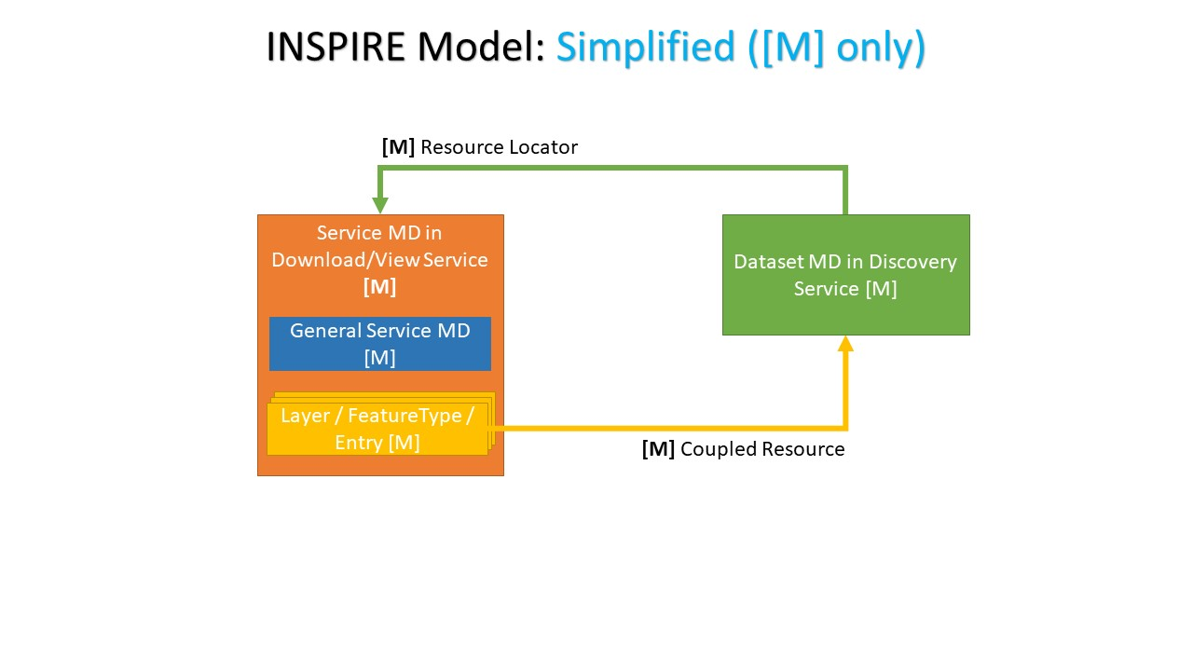

Online **INSPIRE Webinar** on [Data-Service Linking Simplification](https://github.com/INSPIRE-MIF/gp-data-service-linking-simplification) good practice, presenting the outcomes and implementation evidences as a result of the work performed under [INSPIRE MIWP 2021-24 Action 2.3](https://wikis.ec.europa.eu/display/InspireMIG/Action+2.3+Simplification+of+INSPIRE+implementation) Task 3.

**Webinar connection**: <https://ecconf.webex.com/ecconf-en/j.php?MTID=m2df8c0b49bc1452d6cf67ac1bab98cc8>

For more details, including agenda and overview of activities click below

(Webinar Details button)

**Category**:

INSPIRE

**Tags**:

webinar

good practice

metadata

network-services

data and service accessibility