ST10493814 INSY6112 EXAM

Question 1:

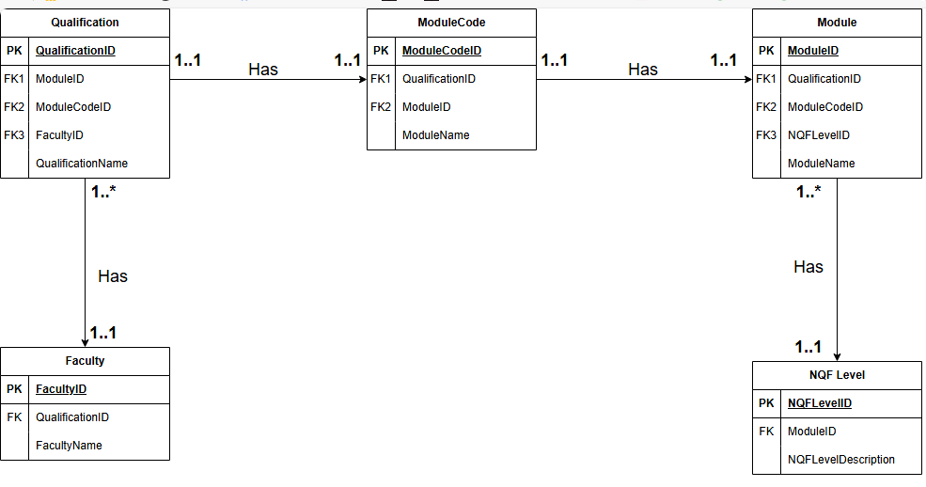

Question 2:
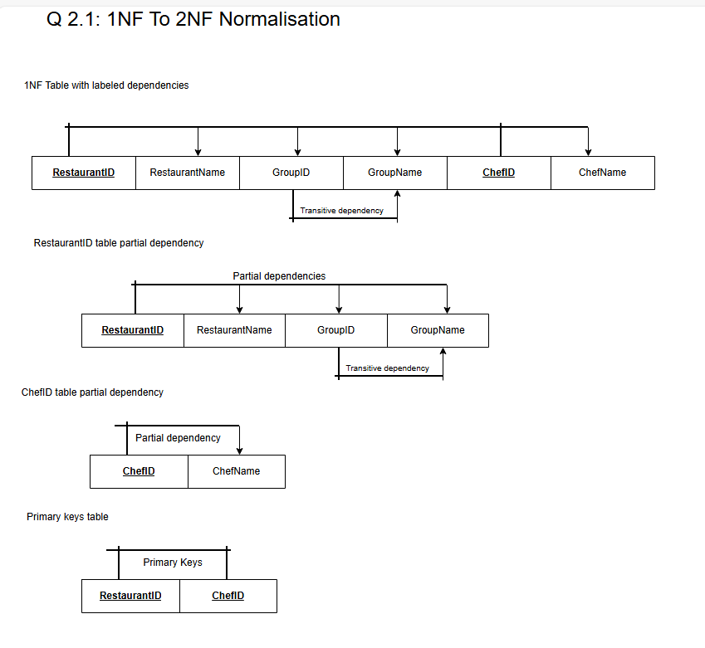

Question 3:

CREATE SCHEMA IF NOT EXISTS Patients_st10493814;
USE Patients_st10493814;

-- Add drop table to prevent duplicates
DROP TABLE IF EXISTS Appointment;
DROP TABLE IF EXISTS Patient;
DROP TABLE IF EXISTS Doctor;

-- Q3.1

CREATE TABLE IF NOT EXISTS Patient (
Patient_id INT AUTO_INCREMENT NOT NULL,
PatientName VARCHAR(250) NOT NULL,
PatientSurname VARCHAR(250) NOT NULL,
PatientDOB DATE NOT NULL,
PRIMARY KEY(Patient_id)
);

-- do not include id it will be auto created
-- Q 3.4 Patient table insert

INSERT INTO Patient (PatientName, PatientSurname, PatientDOB)
VALUES ("Debbie", "Theart", "1980-03-17"),
("Thomas", "Duncan", "1976-08-12");

SELECT*
FROM Patient;

-- Q 3.2
CREATE TABLE IF NOT EXISTS Doctor (
Doctor_id INT AUTO_INCREMENT NOT NULL,
DoctorName VARCHAR(250) NOT NULL,
DoctorSurname VARCHAR(250) NOT NULL,
PRIMARY KEY(Doctor_id)
);

-- Q 3.4 Doctor table insert
INSERT INTO Doctor (DoctorName, DoctorSurname)
VALUES ("Zinhle", "Nukani"),
("Ravi", "Maharaj");

Select*
FROM Doctor;

-- Q 3.3
-- drop the table because it had an inconstency and remake it
DROP TABLE IF EXISTS Appointment;

CREATE TABLE IF NOT EXISTS Appointment (
Appointment_id INT AUTO_INCREMENT NOT NULL,
Patient_id INT NOT NULL,
Doctor_id INT NOT NULL,
AppointmentDate DATE NOT NULL,
AppointmentTime TIME NOT NULL,
AppointmentDuration INT NOT NULL,
PRIMARY KEY (Appointment_id),
FOREIGN KEY (Patient_id) REFERENCES Patient(Patient_id),
FOREIGN KEY (Doctor_id) REFERENCES Doctor(Doctor_id)
);

-- Q 3.4 APPOINTMENT TABLE INSERT
INSERT INTO Appointment (Patient_id, Doctor_id, AppointmentDate, AppointmentTime, AppointmentDuration)
VALUES
(1, 2, '2025-01-15', '09:00:00', 15),
(2, 2, '2025-01-18', '15:00:00', 30),
(1, 1, '2025-01-20', '10:00:00', 15),
(1, 2, '2025-01-21', '11:00:00', 15);

SELECT *
FROM Appointment;

-- Q 3.5
-- finding appointments during a specific time
SELECT*
FROM Appointment
WHERE AppointmentDate >= "2025-01-16" AND AppointmentDate <= "2025-01-20";

-- Q 3.6 using INNER JOIN
SELECT p.PatientName, p.PatientSurname,
COUNT(a.Appointment_id) AS TotalAppointments
FROM Patient p
INNER JOIN Appointment a ON p.Patient_id = a.Patient_id
GROUP BY p.Patient_id, p.PatientName, p.PatientSurname
ORDER BY TotalAppointments DESC;

-- Q 3.7
-- creating a view showing Dr 2 patients
CREATE OR REPLACE VIEW PatientsWithDoctor2 AS
SELECT DISTINCT
p.PatientName,
p.PatientSurname
FROM Patient p
INNER JOIN Appointment a ON p.Patient_id = a.Patient_id
WHERE a.Doctor_id = 2
ORDER BY p.PatientSurname ASC;

SELECT * FROM PatientsWithDoctor2;

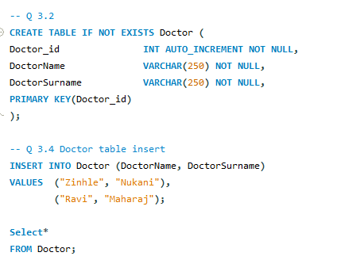
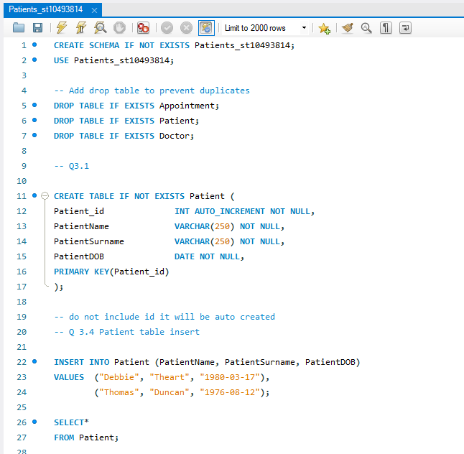
SQL screenshots:
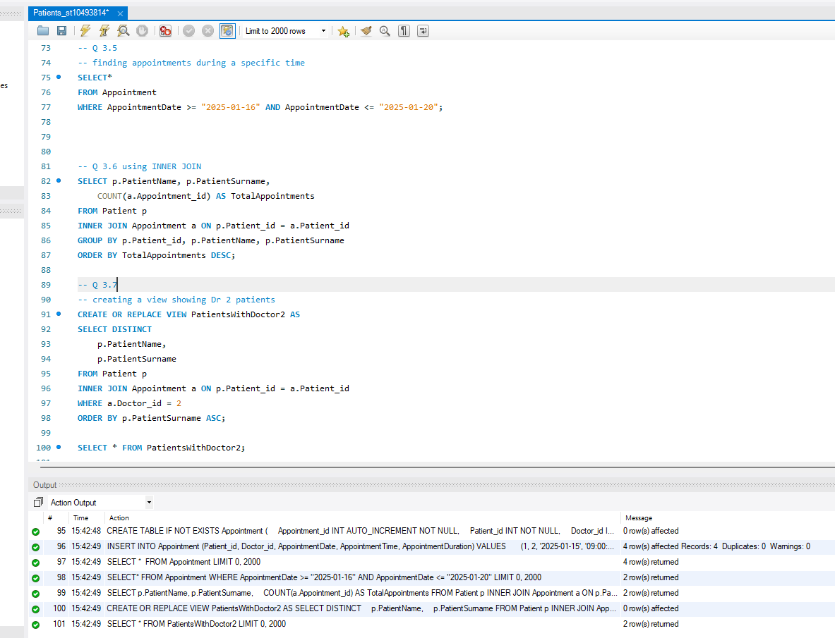
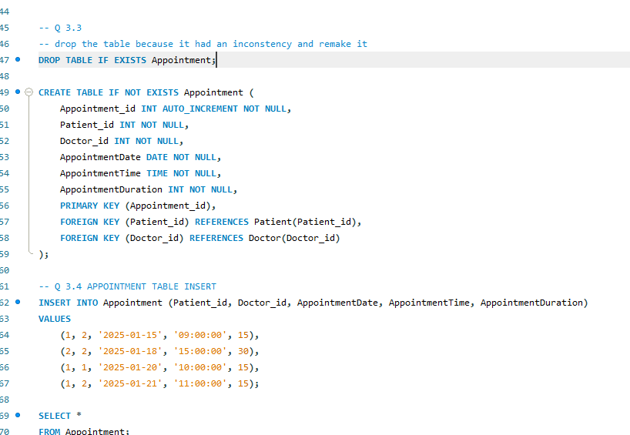
Question 4:

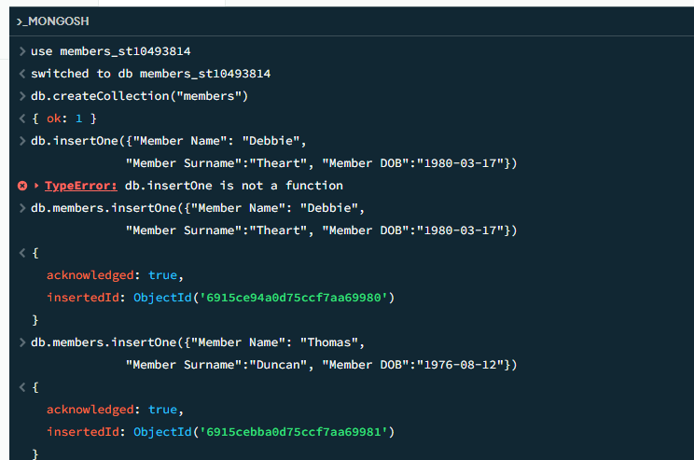
4.1 and 4.2

4.3 and 4.4
