Traitawat Jitchana (027) : 100%

Class Model Entity

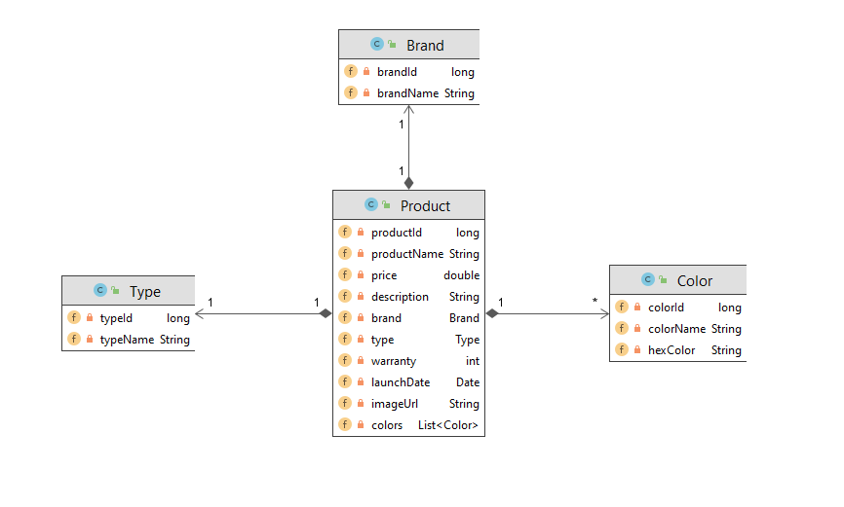

Properties file

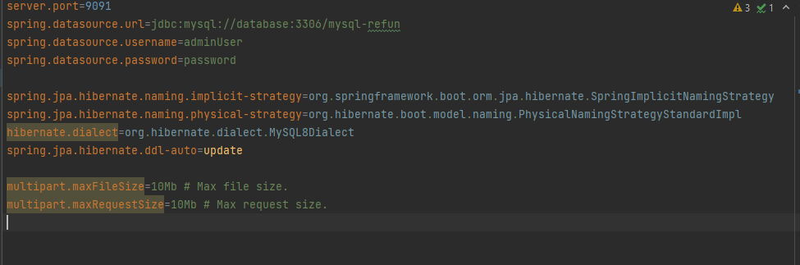

Application url

Product:

1. GET <http://database:9091/product/list> (Get all products in the table)
2. GET http:// database:9091/product/{productId} (Get product by the number of product id)
3. POST http:// database:9091/product/add (Add product by send RequestBody of product in the table)
4. DELETE http:// database:9091/product/delete/{productId} (Delete product by the number of product id)
5. POST http:// database:9091/product/update (Edit product by send RequestBody of product in the table)
6. GET [http://137.116.145.41/refun/product/getbyname/{nameOfProduct}](http://137.116.145.41/refun/product/getbyname/%7bnameOfProduct%7d) (Get product by the name of product)

Image:

1. GET [http://137.116.145.41/refun/image/get/{imageName.fileName}](http://137.116.145.41/refun/image/get/%7bimageName.fileName%7d) (Get image by the name of image)
2. POST <http://137.116.145.41/refun/image/add> (Add image to images folder with Param file)
3. PUT [http://137.116.145.41/refun/image/update/{imageName.fileName}](http://137.116.145.41/refun/image/update/%7bimageName.fileName%7d) (Edit image by the name of image)
4. DELETE [http://137.116.145.41/refun/image/delete/{imageName.fileName}](http://137.116.145.41/refun/image/delete/%7bimageName.fileName%7d) (Delete image by the name of image)

Color:

1. GET <http://137.116.145.41/refun/color/list> (Get all color in the table)

Brand:

1. GET <http://137.116.145.41/refun/brand/list> (Get all brands in the table)

Type:

1. GET <http://137.116.145.41/refun/type/list> (Get all type in the table)