**Docker containers list**

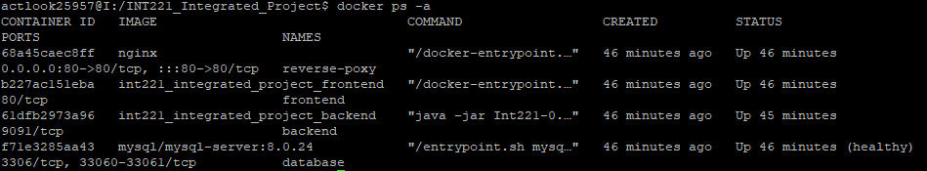

**Docker network list**

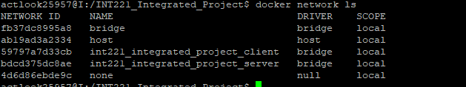

**docker network inspect int221_integrated_project_client**

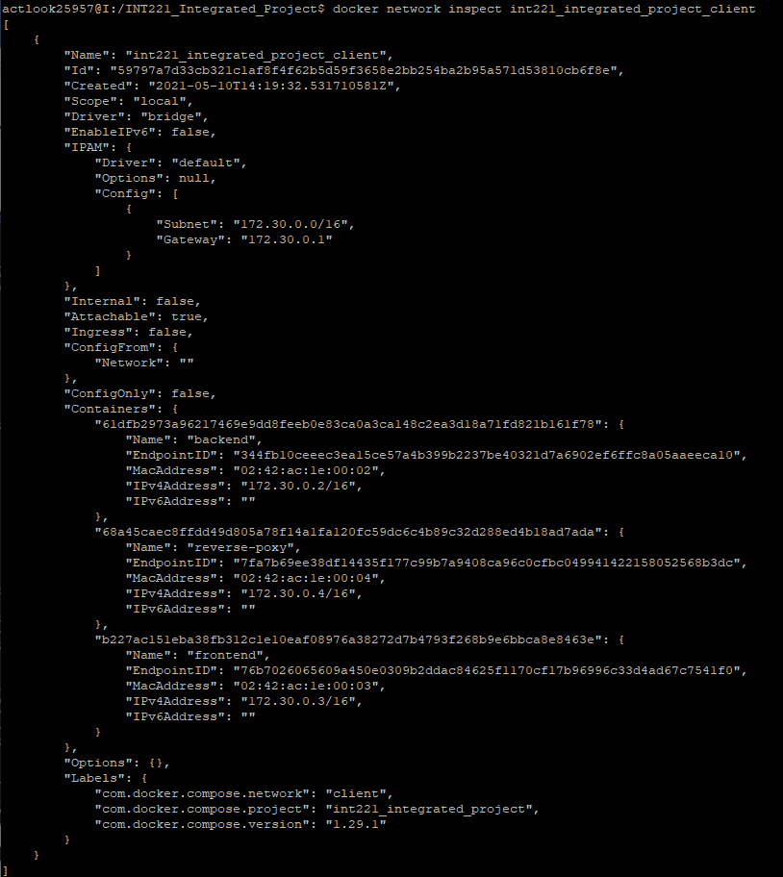

**docker network inspect int221_integrated_project_server**

