Multi-Agent TM Forum Based Intent, Fulfillment and Observation Simulation Platform
Short partner discussion note for the 5G4Data use case in the INTEND project
Purpose. This platform extends TM Forum intent authoring into a live simulation environment that can synthesize properly formed intents, fulfillment status reports and low-level observation reports for the 5G4Data use case. The concept is aligned with the broader INTEND vision of intent-based operation across cloud and edge.

1. Architectural overview
Core idea. Use an agent-based orchestration layer to translate natural-language goals into TM Forum intents and to coordinate runtime simulation services that generate dynamic fulfillment status and observation data (i.e.TM Forum formatted status reports and observation reports related to the generated intents).
Background. Intents, intent status reports and intent observation reports forms a complete "Intent level abstraction" of the intent based 5G4Data use-case. We assume that this abstraction is enough to create an observational twin and possibly even a digital twin that tools like inCoord, inSustain and inExplain can observe and act on.
- Implement the main agent (OpenHands could be part of the implementation)
- TM Forum intent authoring skill governs how intents are created and updated.
- Mock-up workloads can be implemented as agents that monitor workload state and emit status and observation reports.
- A mock-up inNet agent simulates a global view of active network intents, free resources, conflicts and varying conditions and emits status and observation reports for each slice that was created from intents.
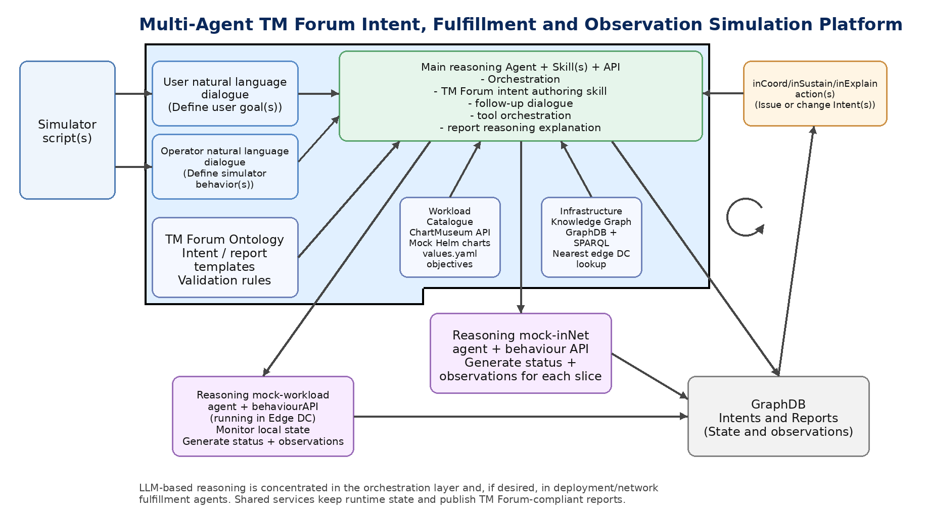
Figure 1. Logical architecture for the proposed platform.

2. How the TM Forum intent authoring skill works
The skill grounds TM Forum intent authoring in live infrastructure and catalogue data, then combines that with natural-language input, example intents, and the scope constraints in the intent authoring skill.
- GraphDB and SPARQL: When placement, geography, or infrastructure facts matter, the skill queries the infrastructure knowledge graph in GraphDB using SPARQL—for example to resolve edge data centers and related infrastructure—so deployment and network expectations align with the stored graph rather than assumptions.
- Workload Catalogue API: Available workloads are discovered and validated only through the Workload Catalogue (ChartMuseum-style HTTP API): listing charts and versions, inspecting chart payloads, and ensuring every DeploymentExpectation references a real catalogue entry.
- Intent generation: SPARQL results and catalogue facts are merged with the user's natural-language goals, the TM Forum ontology and example intents, and the allowed constructs and workflow in the skill to produce a valid TM Forum–style Turtle intent (identifiers, expectations, thresholds) within the supported 5G4Data subset.

3. Main agent roles
Agent / component | Primary responsibility | Typical inputs
Intent authoring agent | Natural-language dialogue, intent creation, tool orchestration, explanation of generated artifacts | User goals, TM Forum ontology, workload catalogue, knowledge graph
Mock-up workload agents | Simulate deployed workloads, emit simulated status and observation reports | DeploymentExpectations, chart objectives, kpi metrics, runtime state
Mock-up inNet agent | Simulate tracking of overlapping network intents, available resources and varying network conditions, then generate status and observation reports for each slice | NetworkExpectations, resource model, contention model, network telemetry simulator
inCoord/inSustain/inExplain agents | Monitor intents, intent status and observation reports. Coordinate (act on) to keep intents fulfilled. The act part (if used) is done by issuing new or change existing intents. | Intents, status reports and observation reports (from inGraph)

4. End-to-end flow
- A user or another stakeholder expresses a goal or a modified goal in natural language.
- The OpenHands orchestration agent applies the TM Forum intent authoring skill, resolves location and workload constraints, and generates or updates a formal TM Forum intent.
- DeploymentExpectations are mapped to mock Helm charts from the workload catalogue; chart objectives from values.yaml determine deployment-side metrics to be monitored and reported on if ObservationReportingExpectation is specified in the intent.
- Agents monitor synthetic environment state, produce low-level observations and evaluate whether expectations are currently fulfilled.
- The platform publishes dynamic intent status reports and observation reports, including changes caused by updates, resource contention or varying conditions.
Prepared as a discussion note for partner dialogue.

