Week 10

What is Abstraction in Java?
Abstraction is a process of hiding the implementation details and showing only functionality to the user. In Java, abstraction is achieved by interfaces and abstract classes. We can achieve 100% abstraction using interfaces

Explain Java Abstract classes and Java Abstract methods
- An abstract class is a class that is declared with an abstract keyword.
- An abstract method is a method that is declared without implementation.
- An abstract class may or may not have all abstract methods. Some of them can be concrete methods
- A method-defined abstract must always be redefined in the subclass, thus making overriding compulsory or making the subclass itself abstract.
- Any class that contains one or more abstract methods must also be declared with an abstract keyword.
- There can be no object of an abstract class. That is, an abstract class can not be directly instantiated with the new operator.
- An abstract class can have parameterized constructors and the default constructor is always present in an abstract class.

When to use abstract classes and abstract methods?
There are situations in which we will want to define a superclass that declares the structure of a given abstraction without providing a complete implementation of every method. Sometimes we will want to create a superclass that only defines a generalization form that will be shared by all of its subclasses, leaving it to each subclass to fill in the details.
Consider a classic “shape” example, perhaps used in a computer-aided design system or game simulation. The base type is “shape” and each shape has a color, size, and so on. From this, specific types of shapes are derived(inherited)-circle, square, triangle, and so on — each of which may have additional characteristics and behaviors. For example, certain shapes can be flipped. Some behaviors may be different, such as when you want to calculate the area of a shape. The type hierarchy embodies both the similarities and differences between the shapes.
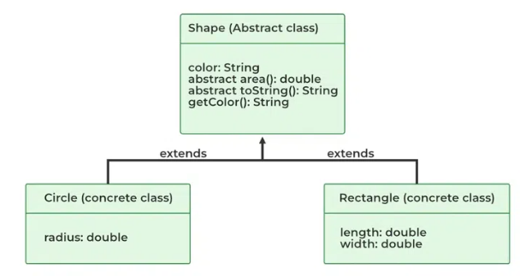

Advantages of Abstraction
- It reduces the complexity of viewing things.
- Avoids code duplication and increases reusability.
- Helps to increase the security of an application or program as only essential details are provided to the user.
- It improves the maintainability of the application.
- It improves the modularity of the application.
- The enhancement will become very easy because without affecting end-users we can able to perform any type of changes in our internal system.
- Improves code reusability and maintainability.
- Hides implementation details and exposes only relevant information.
- Provides a clear and simple interface to the user.
- Increases security by preventing access to internal class details.
- Supports modularity, as complex systems can be divided into smaller and more manageable parts.
- Abstraction provides a way to hide the complexity of implementation details from the user, making it easier to understand and use.
- Abstraction allows for flexibility in the implementation of a program, as changes to the underlying implementation details can be made without affecting the user-facing interface.
- Abstraction enables modularity and separation of concerns, making code more maintainable and easier to debug.

Interface in Java
An interface in Java is a blueprint of a class. It has static constants and abstract methods.
The interface in Java is a mechanism to achieve abstraction. There can be only abstract methods in the Java interface, not method body. It is used to achieve abstraction and multiple inheritance in Java
An interface is declared by using the interface keyword
A class that implements an interface must implement all the methods declared in the interface.
Syntax:
interface <interface_name>
{

// declare constant fields
// declare methods that abstract
// by default.
}
The interface in Java is a mechanism to achieve abstraction. There can be only abstract methods in the Java interface, not the method body. It is used to achieve abstraction and multiple inheritance in Java.
Why do we use an Interface?
- It is used to achieve total abstraction.
- Since java does not support multiple inheritances in the case of class, by using an interface it can achieve multiple inheritances.
- Any class can extend only 1 class but can any class implement infinite number of interface.
- It is also used to achieve loose coupling.
- Interfaces are used to implement abstraction. So the question arises why use interfaces when we have abstract classes?

Week 11

File handling in Java using FileWriter and FileReader
Java FileWriter and FileReader classes are used to write and read data from text files (they are Character Stream classes).
FileWriter
FileWriter is useful to create a file writing characters into it.
- This class inherits from the OutputStream class.
- The constructors of this class assume that the default character encoding and the default byte-buffer size are acceptable. To specify these values yourself, construct an OutputStreamWriter on a FileOutputStream.
- FileWriter is meant for writing streams of characters. For writing streams of raw bytes, consider using a FileOutputStream.
- FileWriter creates the output file if it is not present already
FileReader
FileReader is useful to read data in the form of characters from a ‘text’ file.
- This class inherited from the InputStreamReader Class.
- The constructors of this class assume that the default character encoding and the default byte-buffer size are appropriate. To specify these values yourself, construct an InputStreamReader on a FileInputStream.
- FileReader is meant for reading streams of characters. For reading streams of raw bytes, consider using a FileInputStream.

Explain Constructors used in FileWriter and FileReader

Constructors in Filewriter
- FileWriter(File file) – Constructs a FileWriter object given a File object.
- FileWriter (File file, boolean append) – constructs a FileWriter object given a File object.
- FileWriter (FileDescriptor fd) – constructs a FileWriter object associated with a file descriptor.
- FileWriter (String fileName) – constructs a FileWriter object given a file name.
- FileWriter (String fileName, Boolean append) – Constructs a FileWriter object given a file name with a Boolean indicating whether or not to append the data written.

Constructors in Filereader:
- FileReader(File file) – Creates a FileReader , given the File to read from
- FileReader(FileDescripter fd) – Creates a new FileReader , given the FileDescripter to read from
- FileReader(String fileName) – Creates a new FileReader , given the name of the file to read from

Exceptions in Java
Exception Handling in Java is one of the effective means to handle the runtime errors so that the regular flow of the application can be preserved.

Major reasons why an exception Occurs
- Invalid user input
- Device failure
- Loss of network connection
- Physical limitations (out of disk memory)
- Code errors
- Opening an unavailable file

Hierarchy of Java Exception classes
The java.lang.Throwable class is the root class of Java Exception hierarchy inherited by two subclasses: Exception and Error. The hierarchy of Java Exception classes is given below:
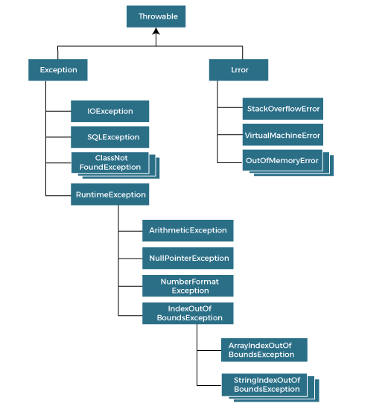

Types of Java Exceptions
There are mainly two types of exceptions:
- Checked Exception
Checked exceptions are called compile-time exceptions because these exceptions are checked at compile-time by the compiler. The classes that directly inherit the Throwable class except RuntimeException and Error are known as checked exceptions. For example, IOException, SQLException, etc. Checked exceptions are checked at compile-time.
- Unchecked Exception
The unchecked exceptions are just opposite to the checked exceptions. The compiler will not check these exceptions at compile time. In simple words, if a program throws an unchecked exception, and even if we didn’t handle or declare it, the program would not give a compilation error..The classes that inherit the RuntimeException are known as unchecked exceptions. For example, ArithmeticException, NullPointerException, ArrayIndexOutOfBoundsException, etc. Unchecked exceptions are not checked at compile-time, but they are checked at runtime.

Java Exception Keywords
Java provides five keywords that are used to handle the exception. The following table describes each.
Keyword | Description
try | The "try" keyword is used to specify a block where we should place an exception code. It means we can't use try block alone. The try block must be followed by either catch or finally.
catch | The "catch" block is used to handle the exception. It must be preceded by try block which means we can't use catch block alone. It can be followed by finally block later.
finally | The "finally" block is used to execute the necessary code of the program. It is executed whether an exception is handled or not.
throw | The "throw" keyword is used to throw an exception.
throws | The "throws" keyword is used to declare exceptions. It specifies that there may occur an exception in the method. It doesn't throw an exception. It is always used with method signature.

Week12

Interface Segregation Principle in Java with Example
The Interface Segregation Principle states that clients should not be forced to implement interfaces they don't use. ISP splits interfaces that are very large into smaller and more specific ones so that clients will only have to know about the methods that are of interest to them.

Explain Interface Segregation Principle Example
- Interface Segregation Principle says is that your interface should not be bloated with methods that implementing classes don’t require.
- For such interfaces, also called “fat interfaces”, implementing classes are unnecessarily forced to provide implementations (dummy/empty) even for those methods that they don’t need.
- The Interface Segregation Principle advocates segregating a “fat interface” into smaller and highly cohesive interfaces, known as “role interfaces”.
- Each “role interface” declares one or more methods for a specific behavior. Thus clients, instead of implementing a “fat interface”, can implement only those “role interfaces” whose methods are relevant to them.
- Both the Interface Segregation Principle and Single Responsibility Principle have the same goal: ensuring small, focused, and highly cohesive software components.
- Interface Segregation Principle is easy to understand and simple to follow. But, identifying the distinct interfaces can sometimes be a challenge as careful considerations are required to avoid the proliferation of interfaces. Therefore, while writing an interface, consider the possibility of implementation classes having different sets of behaviors, and if so, segregate the interface into multiple interfaces, each having a specific role.

Example:
Step 1: Interface for playing video
Step 2: Interface for playing audio.
Step 3 : Div Media player implements both VideoMediaPlayer,AudioMediaPlayer
Step 4: VLC Media player implements both VideoMediaPlayer and AudioMediaPlayer.
Step 5: Winamp Media player only implements AudioMediaPlayer. Here Winamp Media player only implements Audio Media Player as it supports

AudioMediaPlayer.java
public interface AudioMediaPlayer {
public void playAudio();
}

VideoMediaPlayer.java
public interface VideoMediaPlayer {

// Play video implementation
public void playVideo();

}

DivMediaPlayer.java
public class DivMediaPlayer implements VideoMediaPlayer, AudioMediaPlayer {

@Override
public void playVideo() {
System.out.println(" Playing video ..........");

}

@Override
public void playAudio() {
System.out.println(" Playing audio ..........");

}
}

VlcMediaPlayer.java
public class VlcMediaPlayer implements VideoMediaPlayer, AudioMediaPlayer {

@Override
public void playVideo() {
System.out.println(" Playing video ..........");

}

@Override
public void playAudio() {
System.out.println(" Playing audio ..........");

}
}

WinampMediaPlayer.java
public class WinampMediaPlayer implements AudioMediaPlayer {

@Override
public void playAudio() {
System.out.println(" Playing audio........");

}
}

Week 13

Database Connectivity

Explain Establishing JDBC Connection in Java
JDBC is an acronym for Java Database Connectivity. JDBC is a standard API specification developed in order to move data from frontend to the backend. This API consists of classes and interfaces written in Java. It basically acts as an interface (not the one we use in Java) or channel between your Java program and databases i.e it establishes a link between the two so that a programmer could send data from Java code and store it in the database for future use.
Explain Steps For Connectivity Between Java Program and Database with example
- Import the Packages
- Load the drivers using the forName() method
- Register the drivers using DriverManager
- Establish a connection using the Connection class object
- Create a statement
- Execute the query
- Close the connections

import java.io.*;
import java.sql.*;

class GFG {
public static void main(String[] args) throws Exception
{
String url = "jdbc:mysql://localhost:3306/table_name"; // table details
String username = "rootgfg"; // MySQL credentials
String password = "gfg123";
String query
= "select *from students"; // query to be run
Class.forName(
"com.mysql.cj.jdbc.Driver"); // Driver name
Connection con = DriverManager.getConnection(
url, username, password);
System.out.println(
"Connection Established successfully");
Statement st = con.createStatement();
ResultSet rs
= st.executeQuery(query); // Execute query
rs.next();
String name
= rs.getString("name"); // Retrieve name from db

System.out.println(name); // Print result on console
st.close(); // close statement
con.close(); // close connection
System.out.println("Connection Closed....");
}
}

