Peti
Technical Design Document
GitHub repository: https://github.com/INVgrimmjaw/Isocode_Labs
Problem chosen: FMCG distributor's retailer ordering app with AI order capture. Client: Company A, Jabalpur. Run instructions and demo logins are in deployment.md.

1. Summary
Peti lets the distributor's kirana shops see their own prices, schemes and stock and order in a minute, and turns WhatsApp order messages into orders the office only has to check. The Core Build works end to end on the client's sample data. I also built the other Must Have items that build on that core. Salesman mode and photo or voice capture are cut, as section 10 explains.
What the brief asks for | State
Retailer catalogue with prices, schemes and stock status | Built
Cart and order | Built
AI capture from a text order | Built, with Groq and a fallback matcher
Scheme engine: free goods and slab discounts | Built. The most heavily tested code
Order desk with Tally export | Built, as an XML file
Installable web app with OTP login | Built. SMS is mocked
Repeat order and credit limit | Built
Credit holds and van loading lists | Built
Retailers with no order in 14 days | Built
Hindi and English | Built for shopkeeper screens [A20]
Salesman mode, working offline | Cut (section 10)
AI capture from a photo or voice note | Cut (section 10)

What it is worth, using the brief's own figures. Today's process costs ₹52.5 lakh a year. If the success targets are met, errors falling from 5% to under 1% saves at least ₹25.2 lakh of the ₹31.5 lakh in returns, and going from 6 to 3 order entry staff saves ₹7.8 lakh. That is ₹33 lakh a year against a ₹7 lakh build, paying back in about two and a half months, before counting stock-outs.

2. Architecture
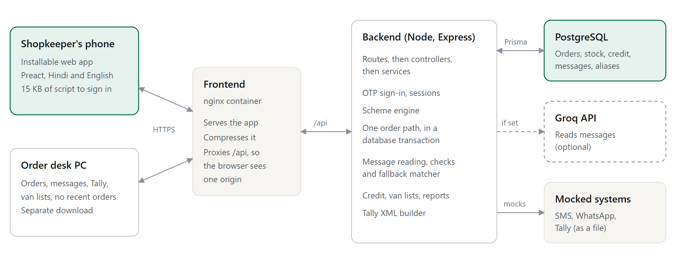
Figure 1. Two containers and a database. The browser only ever talks to nginx.
Decision | Why | Rejected
Separate Frontend and Backend containers, with nginx in front | Each builds and scales on its own. Nginx compresses and caches files, and because it forwards /api the browser sees one origin, so there is no CORS and the HttpOnly cookie just works | An API on its own domain, which needs CORS and a looser cookie
PostgreSQL with Prisma | Orders need real transactions and row locks. The credit check and stock must hold when two requests arrive together | SQLite (one writer at a time), document stores (order data is relational)
Express in layers: routes, controllers, services, wired in container.ts | Business rules stay out of HTTP code and each service states what it depends on | Logic inside route handlers
Preact instead of React | The same component model at about 4 KB rather than about 45 KB, because first load has to fit in 3 seconds on 3G | React, or server rendering, which still ships the framework
Prices decided only on the server, through a quote endpoint | One implementation of the hardest rules. Requests wait until tapping stops, so quick taps cost one request | A copy of the engine in the browser, which can drift from the server
A model on Groq reads the message, deterministic code decides what to trust | The model handles messy Hinglish that rules cannot cover. Code enforces what must be auditable (section 5) | Rules alone (brittle), or a model alone (unchecked)
Opaque session tokens, hashed in the database, in an HttpOnly cookie | Can be revoked, and page scripts cannot read them | A JWT in browser storage

3. Data model
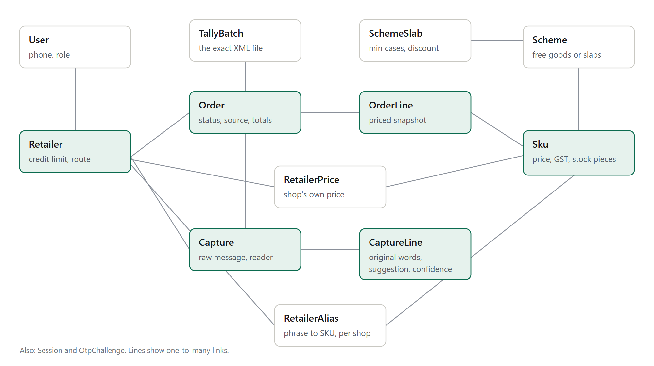
Figure 2. The main tables. Green tables hold the order and capture flow.
- Money is integer paise and percentages are basis points, so totals never drift by a paisa.
- Stock is held in pieces, because loose pieces can be sold from a case, while the catalogue reads in cases [A1].
- RetailerPrice overrides the dealer price per shop. It is how one shop's price stays separate from another's.
- OrderLine is a priced snapshot. A later price or scheme edit cannot change a placed order.
- CaptureLine keeps the shopkeeper's original words, the suggested SKU, the confidence and the two alternatives.
- RetailerAlias is unique per shop and phrase, so one shop's slang cannot affect another.
- TallyBatch stores the exact file, so downloading it again never regenerates different content.

4. Main flows

Placing an order in the app
- The shop signs in with an OTP. Codes are stored only as hashes, expire in 5 minutes and allow 5 tries [A19].
- The catalogue shows this shop's price per case with GST marked, the current scheme and stock status.
- The cart asks the server for a quote and shows free cases, discounts, GST and whether the order is within credit.
- Place order sends the items, the total the shop saw and an idempotency key.
- In one transaction the server locks the shop's row, re-prices the order, refuses a total that has changed, takes stock with a conditional update, checks credit and stores the snapshot. Within credit the order is Ready. Over the limit it goes on Credit hold [A12].

An order from a message
- A message arrives. WhatsApp is simulated: the desk pastes it in, as a webhook would deliver it [A23].
- The message is read, checked and resolved into lines (section 5). No order exists yet.
- The desk reviews each line. Confirm order stays off until every line has an item, a quantity and a unit, or is left out.
- Confirming uses the same order path as the app, so schemes, stock and credit cannot differ by channel. Corrections become aliases for that shop in the same transaction.

Credit hold and Tally export
- The desk sees the amount over the limit and the shop's credit position, then releases the hold or rejects with a reason. Rejecting returns the stock, free cases included.
- Create Tally file exports all Ready orders. Moving them to Exported happens in the same transaction that writes the file, so an order can never be billed twice. Held orders are left out.
- Exporting moves each order's value from open orders to outstanding, so credit is not counted twice [A11].

5. How the AI part works
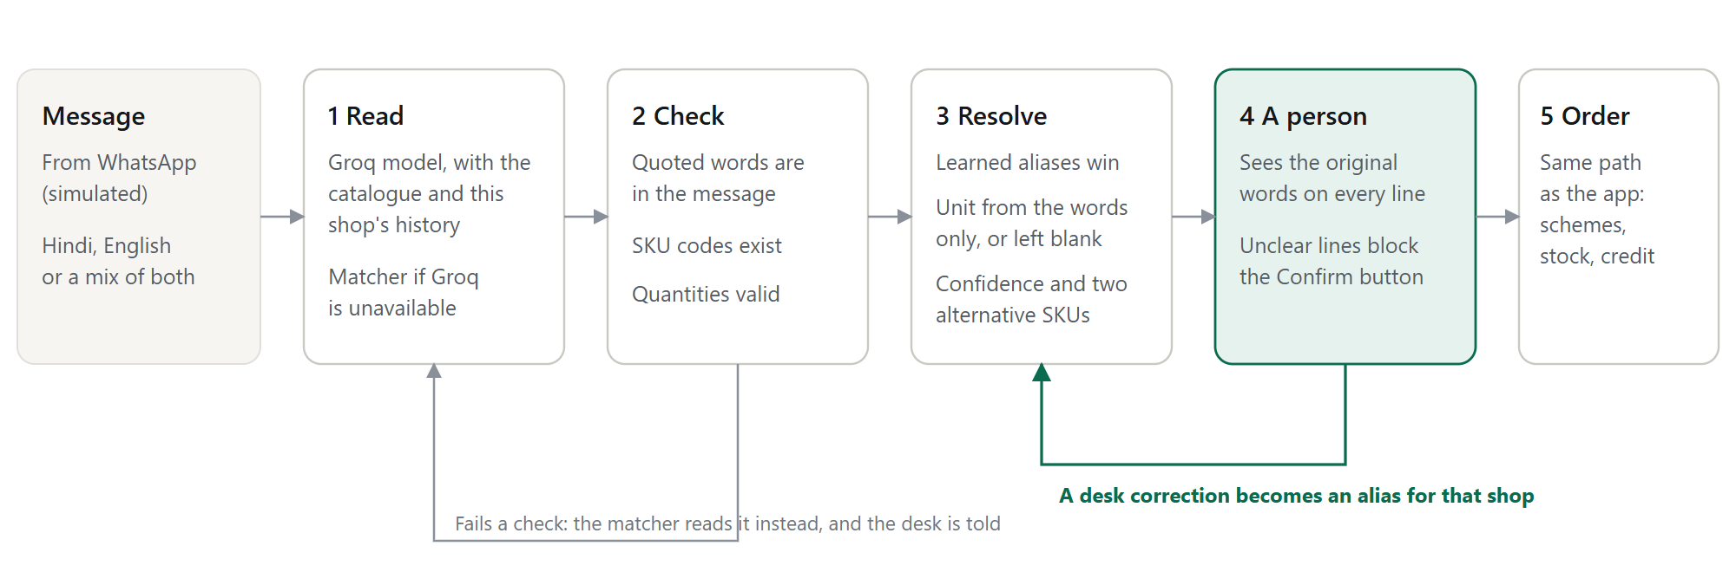
Figure 3. The model proposes. Code checks, and a person decides.
Read. A model running on Groq receives the catalogue with the words shopkeepers use, this shop's past orders and learned phrases, and the message marked as data. Strict structured output returns JSON in a fixed shape: the original words, quantity, unit and up to three SKUs for each item.
Check. Quoted words must appear in the message, SKU codes must exist and quantities must be positive whole numbers. Any failure, an API error, a timeout or a cut-off reply sends the message to the built-in matcher, and the desk is told which reader ran. The matcher is rules and fuzzy matching, not AI: it exists so an outage slows the desk rather than stopping orders.
Resolve. A learned alias wins outright. Otherwise a line is high confidence only when the model and the matcher, which read the words differently, agree. Model confidence on its own is not calibrated enough to trust. The result is High, Medium or Low [A22], with exactly two alternatives. Only High lines are pre-selected.
When it is wrong or unsure | What happens
Wrong item | The line shows the original words, a confidence level and two alternatives, and any other SKU can be chosen. A desk correction becomes an alias for that shop
No unit stated ("biscuit 5") | Unit left blank and asked. Confirm is blocked until a person chooses case or piece
"dabba" or "box", which can mean either [A10] | Treated as unstated. The model's opinion is ignored
Quantity missing or a half ("dedh peti") | Left empty and asked, never rounded
Pack size not stated, or several SKUs fit | Held below High, so nothing is pre-selected
Item not sold ("kali mirch") | Low confidence, nothing pre-selected, and the line can be left out
Item out of stock (the client's tea) | The line is left out unless another pack is chosen
Groq down, slow or returning bad output | The matcher reads the message and the desk sees a note
Model invents a line or a SKU | Rejected by the checks
Instructions hidden in a message | The message is passed as data, the output must fit a fixed schema, and a person still confirms

The client's sample message, "bhaiya 5 peti biscuit chhota, 2 peti washing powder 1 kilo, chai patti 250 wala 1 peti":
Original words | Matched SKU | Qty | Result
5 peti biscuit chhota | SKU-BS-075 | 5 cases | High. ₹3,888
2 peti washing powder 1 kilo | SKU-DT-1KG | 2 cases | High. ₹4,060
chai patti 250 wala 1 peti | SKU-TE-250 | 1 case | High, but out of stock, so left out

Total ₹7,948 plus ₹925.20 GST, so ₹8,873.20. Neither scheme triggers: 5 is short of 10, and 2 is short of 5.
Model and cost. The model is openai/gpt-oss-120b on Groq, a production model with strict structured output, and AI_MODEL changes it. I checked it against the live API with seven messages covering the client's sample, Hindi script, unclear units, an item not sold and a prompt-injection attempt. All were read correctly, usually in under 3 seconds. Each message used about 1,270 input and 450 output tokens, so 300 AI-read messages a day costs about ₹3,600 a year [A24], against ₹33 lakh saved.

6. The scheme engine
This is the hard part of the brief. It is a pure function with no database or clock of its own, so every rule below is directly tested.
Rule | Example
Free goods repeat per full multiple [A4] | Buy 10 get 1: 9 earns 0, 10 earns 1, 19 earns 1, 20 earns 2
Stock goes to paid goods first, and free cases come from what is left [A8] | 21 cases in stock and 20 ordered: 1 free granted, 1 reported short
A slab applies to the whole line once reached, and the highest slab wins [A5] | 5 cases of detergent: 3% of ₹10,150 = ₹304.50
Schemes never stack. The one worth more applies, and ties break the same way every time [A6] | A free case worth ₹2,030 beats 3% off
Only whole cases count [A7] | 4 cases and 19 pieces of detergent earns no slab. 4 cases and 20 pieces does
Validity: start inclusive, end exclusive | A scheme ending at 12:00 does not apply at 12:00
GST is charged after discount. Free goods carry none [A9] | Taxable value is gross minus discount
A SKU entered twice is combined before thresholds | 6 + 6 cases earns the free case
Each shop's own price feeds the calculation | The discount is taken on the retailer price
A line stock cannot fill blocks the order | The total leaves it out and the shop is asked to fix it

7. UI and design decisions
The client asked for clean layouts, white space, a restrained palette and clear type, with nothing on screen that lacks a purpose. So there is one accent colour, warm neutrals, and colour appears only where something needs attention. System fonts and product art drawn in code avoid any extra downloads. Buttons, steppers and inputs are 48 pixels tall, for quick use between customers.
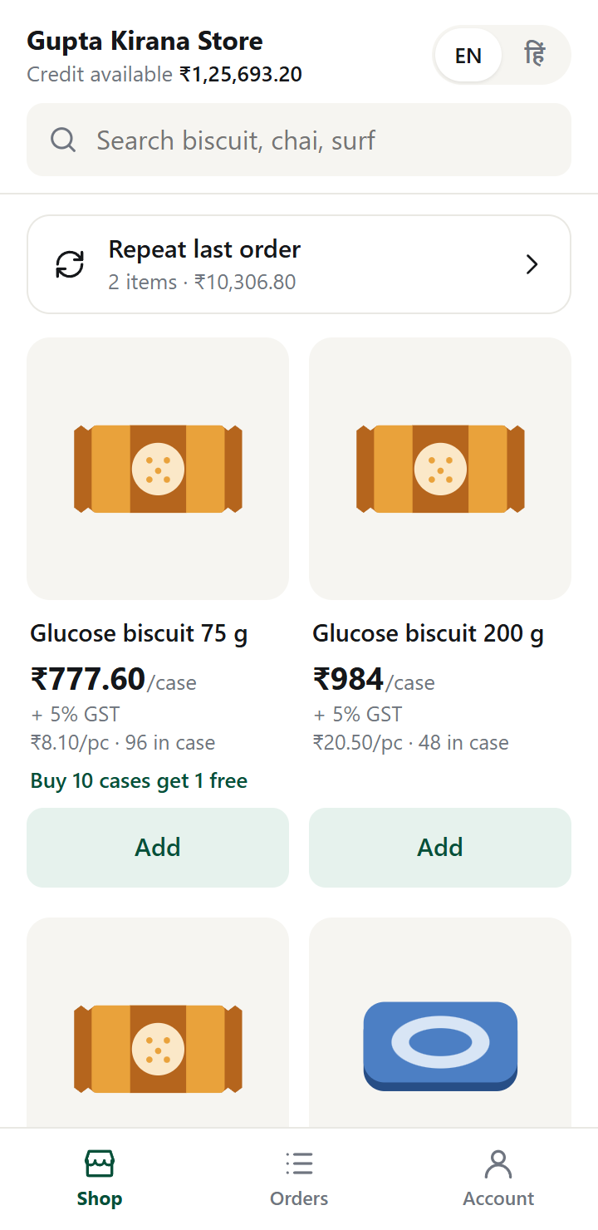  Catalogue  Large images and one big price per case. Every price says + GST. Only search stays pinned, so products get the screen. | 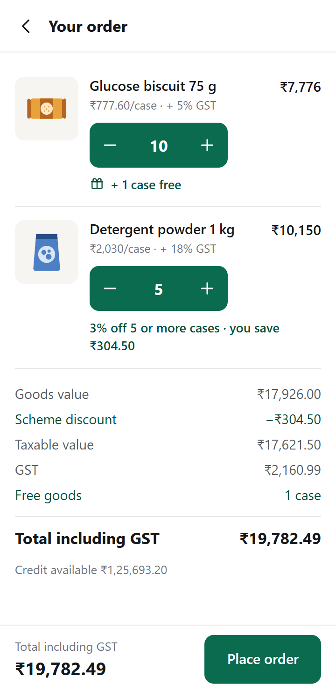  Cart  Schemes appear on the line they apply to. The total includes GST and the action stays in reach. | 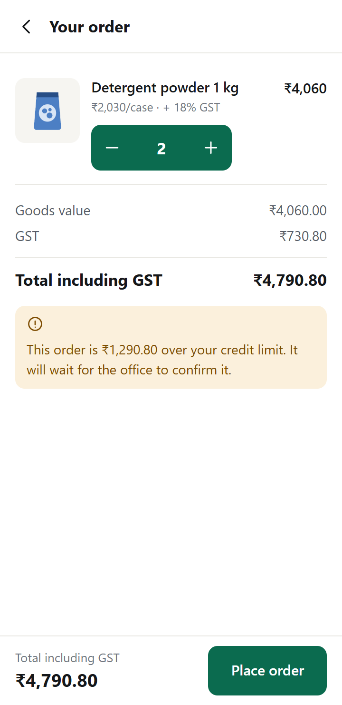  Credit warning  The shop learns about a hold before ordering, not after.
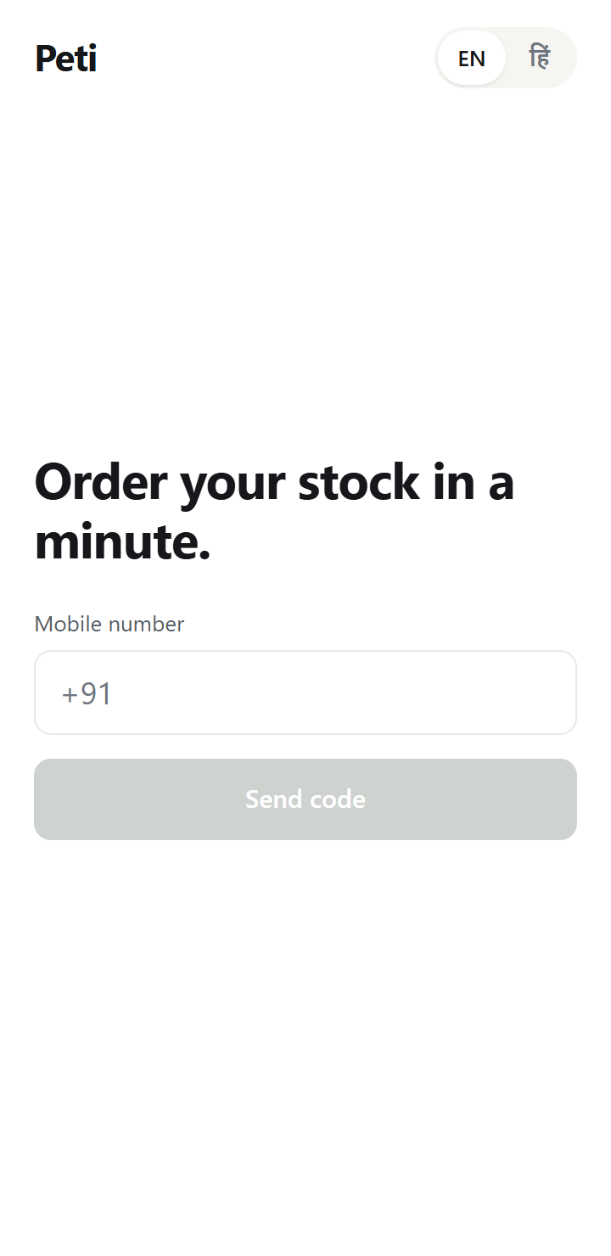  Sign-in  One field, one action, and the language switch is visible straight away. | 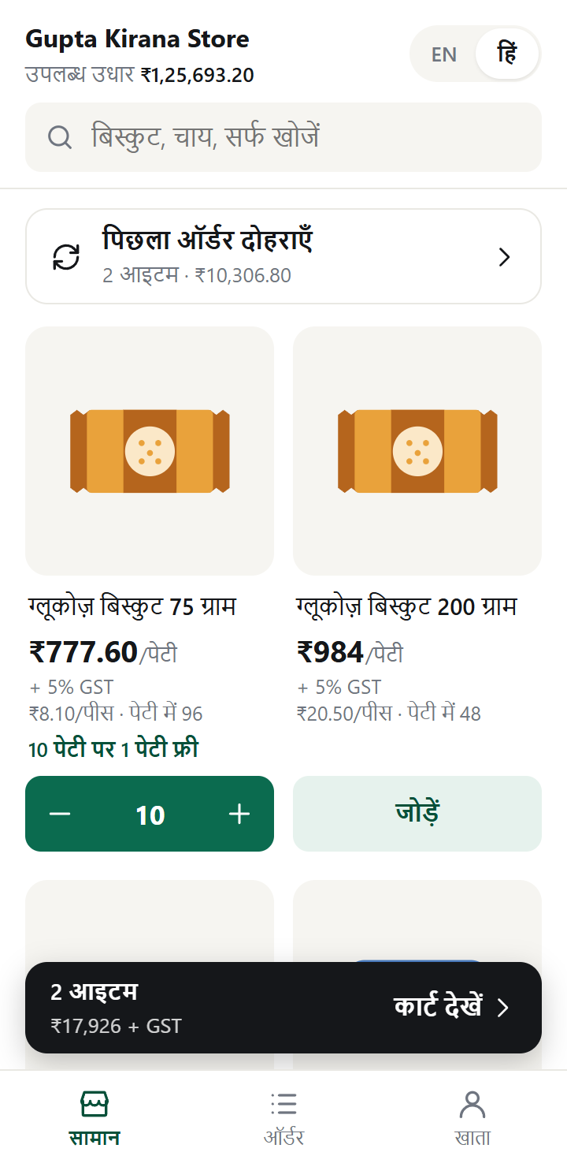  Hindi  Names, schemes and labels all switch. "Peti" is the word shopkeepers actually use.
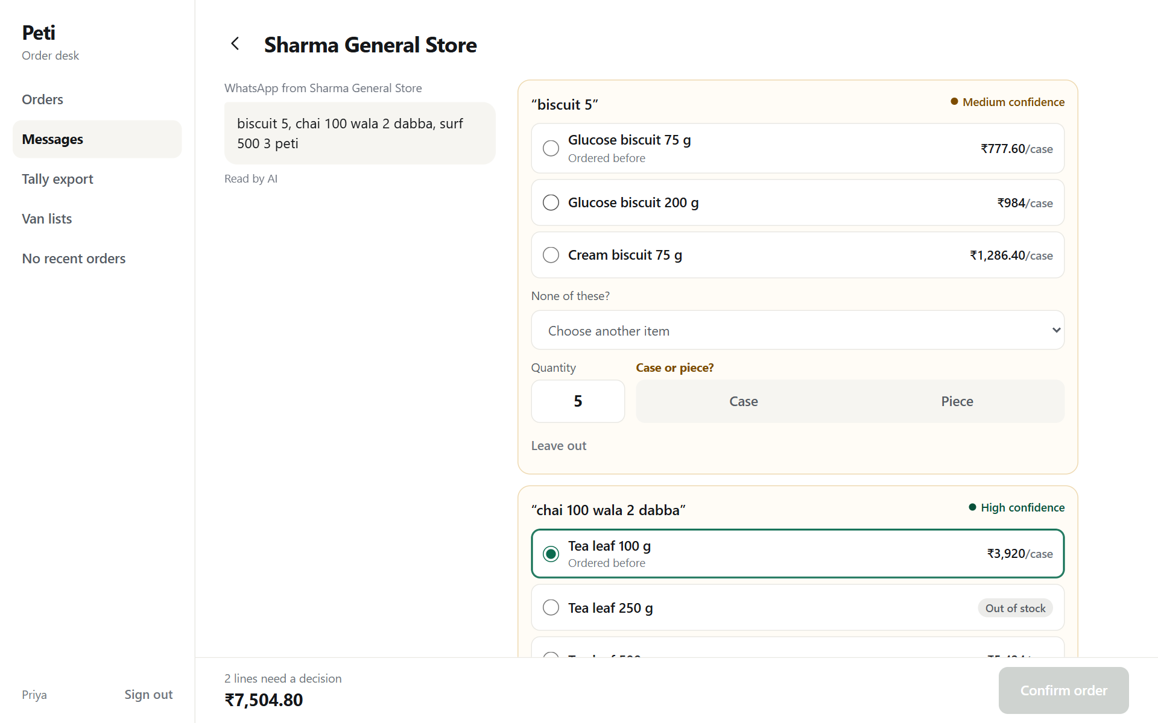
Message review. The message stays in view beside its lines so the desk can compare without scrolling. Lines needing a decision are tinted, and "Case or piece?" appears where the unit is missing. Nothing uncertain is pre-selected.
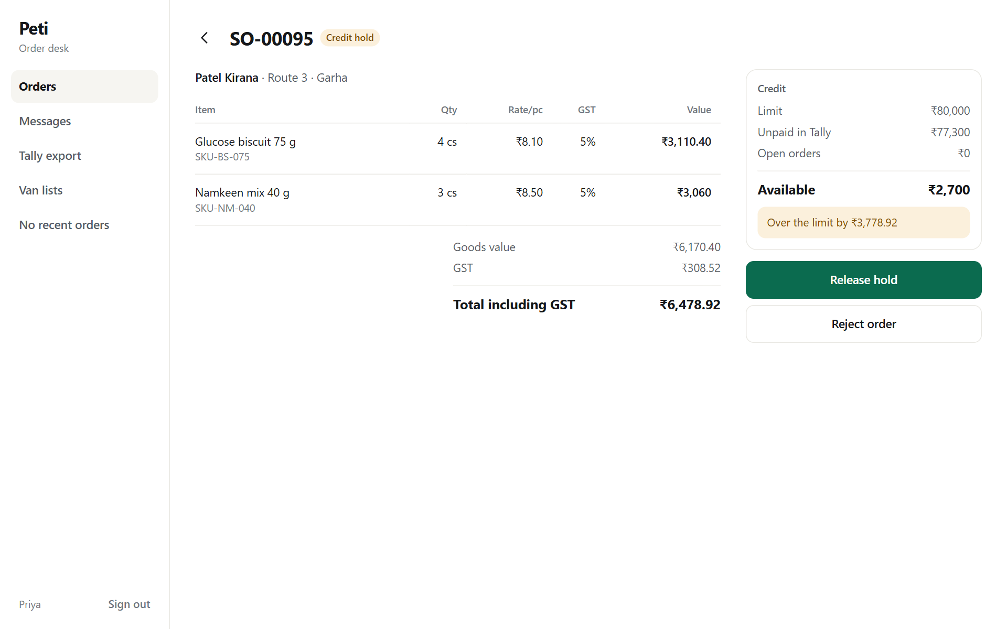
Credit hold. The numbers needed to decide sit beside the only two actions.
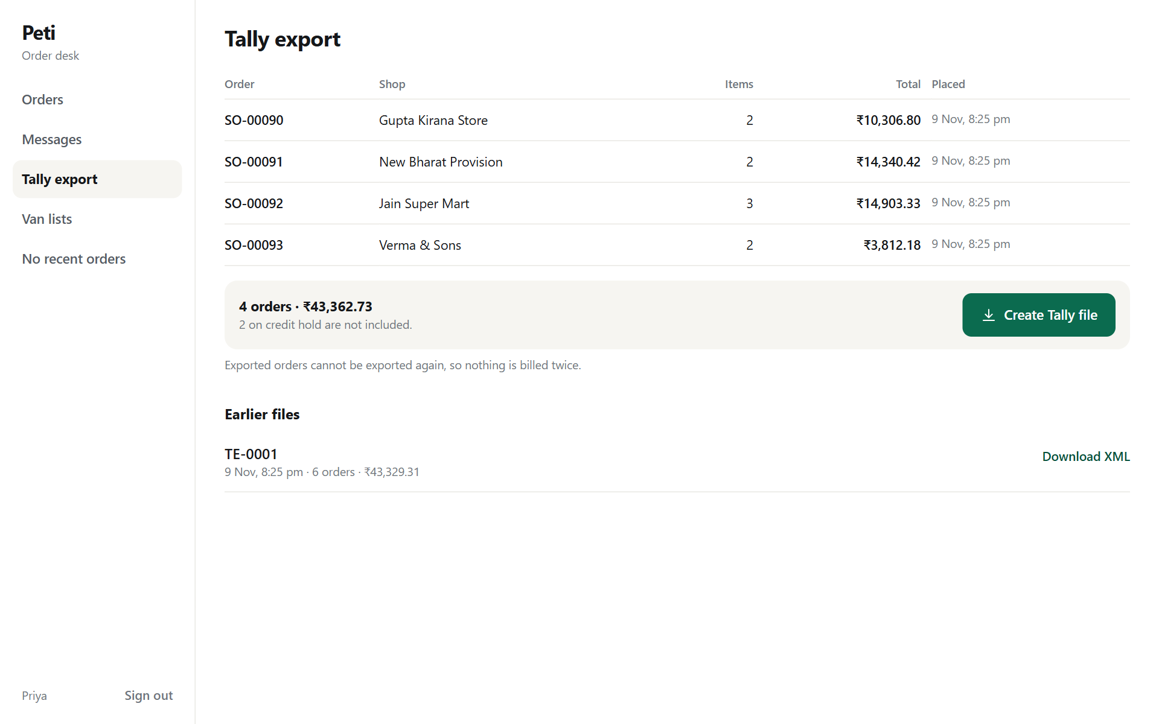
Tally export. It shows what will go, and says plainly what is held back.
The desk is denser than the shop app because it is used all day on an office screen, and it reflows to a phone. Every screen has loading, empty and error states.

8. Security and reliability
- One shop cannot reach another's data. The retailer id always comes from the session, never from the URL or body, and another shop's order returns the same 404 as one that does not exist.
- Roles are enforced on each router. A retailer gets 403 from every desk route, and the desk gets 403 from retailer routes.
- Inputs are validated with Zod at every endpoint, with upper bounds on quantities and text.
- Secrets are read from the environment and only their names are in the repository. The OTP is never returned outside demo mode or written to logs.
- Rate limits cover sign-in and message reading. Helmet sets security headers on the API.
- Bad networks. A retried order reuses its idempotency key, so a lost reply cannot create a second order. A failed send keeps the cart.
- Concurrency. Row locks and conditional updates stop double credit approval, overselling and double export.

9. Testing and measured results
Suite | Tests | Covers
Scheme engine | 33 | Every rule in section 6, and the client's sample order
Message reading | 55 | Hinglish, Hindi script, units, sizes, aliases, guards on model output, fallback
Groq request | 8 | The real SDK against a local stand-in: request shape, strict schema and reply handling
Tally XML | 9 | Vouchers balance, free goods, discounts, escaping
API, on real Postgres | 94 | OTP, access control, orders, races, credit, capture flow, alias learning, export, van lists, 14-day report

All 199 pass. I also drove every flow in a real browser at phone and desktop size against the app running in Docker, including a lost reply followed by a retry, which created exactly one order.
First load, on 400 kbps with 400 ms latency and a 4x slower CPU [A21] | Measured
First paint | About 1.4 s
Sign-in screen usable | About 1.6 s (21.3 KB)
Products visible after signing in | About 1.8 s
Returning visit, products visible | About 1.4 s

These are medians of six runs in throttled Chrome against the Docker containers on a local machine, which leaves out DNS and TLS. A real first visit adds about three round trips, roughly 1.2 s, for about 2.8 s to a usable sign-in screen. The slowest run took 2.3 s, which would be about 3.5 s on a real first visit and over the 3-second target.

10. What I cut, and what I would do next
Cut | Why | How it would be added
Salesman mode, working offline | The brief makes it optional, and offline sync done properly is large. A small part built well was the instruction | A salesman role scoped to assigned shops and a local order queue. The idempotency key already makes replay safe
AI capture from photo or voice | The Core Build asks for text | Only the Read step changes. Check, Resolve and review stay the same
Real SMS, WhatsApp and Tally links | The brief says to mock outside systems | SMS is one interface. WhatsApp is a webhook that creates a capture. Tally needs a two-way sync
Admin screens for prices, schemes and shops | Not in the brief. They are seeded | Standard forms over tables that already exist

Next, in order:
- Measure capture accuracy on a real sample of the client's messages, and set the confidence thresholds from that data.
- Connect the WhatsApp Business API and a real SMS provider.
- Sync stock and outstanding with Tally, since both are only as fresh as the last update.
- Build salesman mode, then photo and voice capture.
- Add a report on the success targets: Order.source already records app and AI orders.

11. Limits
- AI accuracy is only spot-checked. Seven messages against the live Groq API all read correctly, but it has not been measured on a real sample of the client's messages. Without a key, or during an outage, the matcher runs and the desk is told.
- The Tally file has not been imported into real Tally. It follows the import format and its vouchers balance.
- It is not hosted publicly. It runs in Docker on a local machine, and the brief asks for a live link only if deployed.
- Load times come from throttled desktop Chrome, not a real low-end phone on real 3G.
- The matcher knows only the seeded vocabulary. It is a fallback, not a substitute for the model.
- Stock and outstanding are seeded. There is no live sync with Tally.
- Hindi text has not been reviewed by a native speaker.

12. Assumptions
Everything the brief does not state, and where it is used.
ID | Assumption
A1 | Dealer price in the sample is per piece. At ₹8.10 per case of 96, a packet would cost 8 paise. Stock is converted to pieces internally.
A2 | Dealer prices exclude GST. The brief requires clarity on this but does not say which.
A3 | GST rates are illustrative and stored per SKU: 5% for food, tea and bathing soap, 18% for detergents and cleaners. Tally remains the authority on tax.
A4 | Buy 10 get 1 repeats for every full 10 cases.
A5 | A slab discount applies to the whole line once reached, not only the cases above the threshold.
A6 | Schemes do not stack. If two run on one SKU, the one worth more to the shop applies.
A7 | Schemes count whole cases. Loose pieces count only when they add up to a case.
A8 | Free goods are the same SKU, and stock goes to paid goods first.
A9 | GST is charged on the value after discount, and free goods carry no charge in this estimate.
A10 | "Peti" means one case. "Dabba" and "box" could mean a case or a retail box, so they are asked about.
A11 | Credit used is unpaid bills in Tally (seeded) plus released orders not yet billed. Held orders do not count.
A12 | An order over the limit is held for the desk, not refused. An order within credit needs no manual approval.
A13 | Tally export uses Sales Order vouchers (billing and e-invoicing stay in Tally), stock in pieces, ledgers named Sales, CGST and SGST, and local sales within the state.
A14 | Low stock means 10 cases or fewer.
A15 | Shops are added by the distributor. There is no self sign-up.
A16 | Besides the 3 SKUs and the raw message in the brief, all data is invented: 13 SKUs, 4 brand names, 10 shops, names, phone numbers and 60 days of history.
A17 | Each shop belongs to one route and each route has one van. A van list is today's Ready and Exported orders.
A18 | An alias is learned for the words of a line, excluding quantity and unit, per shop.
A19 | OTP lifetime of 5 minutes and 5 tries. Sessions last 30 days for retailers and 12 hours for the desk.
A20 | Desk screens are English only, as an office tool used beside Tally.
A21 | Slow 3G means 400 kbps and 400 ms latency. A low-end phone means a 4x slower CPU.
A22 | Confidence bands: High from 0.85, Medium from 0.60. To be tuned on real messages.
A23 | WhatsApp is simulated by pasting messages, as the brief asks for messages to be mocked.
A24 | AI cost assumes half of 600 daily orders are read by AI on 300 days, the token use measured above, Groq's price of $0.15 input and $0.60 output per million tokens as reported by third-party price trackers, and ₹86 to the dollar. A 500-SKU catalogue would raise it to about ₹20,000 a year.

