QASWA ERP
Change Request & Defect Report
Functional enhancements and fixes identified during system review
Document type | Change Request / Defect Log
Date | 21 October 2026
Prepared by | Asath M

Purpose
This document records the changes and fixes requested for the Qaswa ERP system following a review of the existing screens. Each item identifies the affected module, the current behaviour (with a screenshot), the requested change and proposed acceptance criteria to guide development and testing.

Summary of Requests
No. | Module | Request
1 | System | Company field on Employment Information
2 | System | Conditional Aadhaar and PAN evidence for Indian nationals
3 | Company | Logo upload instead of path/URL entry
4 | Projects | Company ownership for projects
5 | Contractor | Company-scoped Reporting Manager and Project lists
6 | Asset | Asset location / organisation field
7 | Asset | Asset list filter dropdowns not working

Detailed Requirements

1. Company field on Employment Information
Module: System
Current behaviour
The section captures Department, Designation, Joining Date, Employment Type, Reporting Manager, Work Location and Status. There is no way to record which registered company the employee belongs to.
Requested change
Add a Company dropdown next to the Branch field, populated with the companies already registered in the system.
Proposed acceptance criteria
- Company dropdown is displayed beside the Branch field.
- Options are loaded from the registered companies master list.
- The selected company is saved with the employee record and shown on the profile.
Reference screenshot
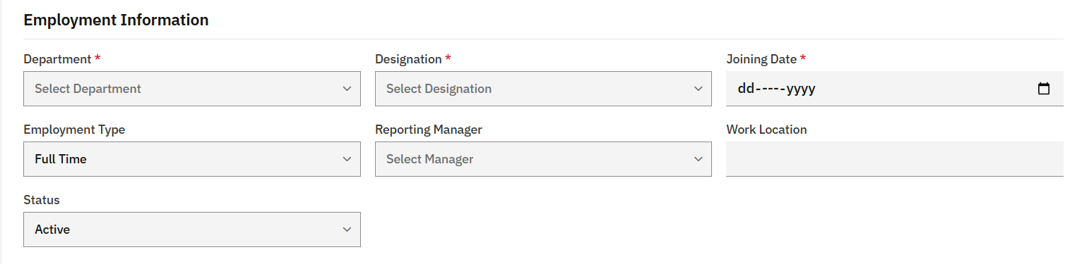
Figure 1 – Employment Information section (current)

2. Conditional Aadhaar and PAN evidence for Indian nationals
Module: System
Current behaviour
Identity fields are limited to Passport, Visa, Emirates ID and Employment Contract. No national identity evidence is captured for employees of Indian nationality.
Requested change
When Nationality is set to India, display fields to capture Aadhaar and PAN details as supporting evidence (number and document upload).
Proposed acceptance criteria
- Aadhaar and PAN fields appear only when Nationality = India and are hidden otherwise.
- Number format is validated for both fields.
- Document scans can be attached, following the existing upload rules (PDF, JPG, PNG, GIF or DOC, max 5 MB).
Reference screenshot
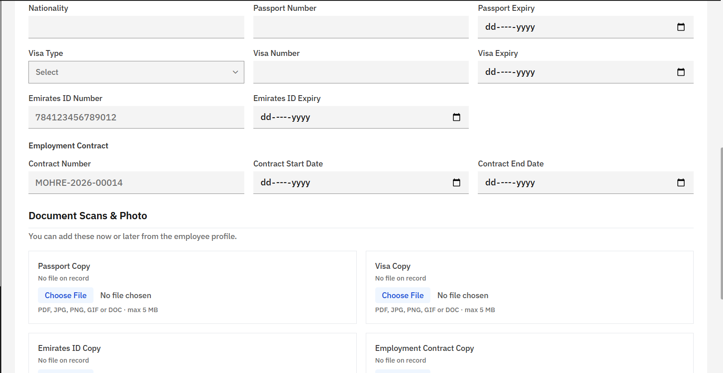
Figure 2 – Identity, contract and document scan section (current)

3. Logo upload instead of path/URL entry
Module: Company
Current behaviour
The logo is supplied as free text (“Logo Path or URL”). This is error-prone and requires the user to host the file elsewhere.
Requested change
Replace the text input with an image upload. Alternatively, offer both options: a link (URL) or an image upload.
Proposed acceptance criteria
- User can upload a logo image directly from the form, with a preview.
- If both options are kept, only one source is active at a time.
- The logo continues to render on invoices, quotes and statements.
- File type and size limits are enforced and communicated on screen.
Reference screenshot
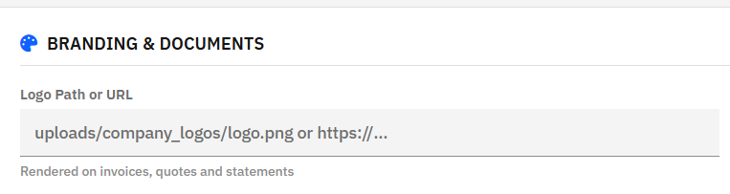
Figure 3 – Logo Path or URL field (current)

4. Company ownership for projects
Module: Projects
Current behaviour
A project cannot be associated with a company; it carries only a free-text Client Name.
Requested change
Add a Company dropdown listing registered companies. The selected company becomes the owner of the project, and the project is grouped under it.
Proposed acceptance criteria
- Company dropdown is available on Create New Project.
- Saved projects are linked to the selected company.
- Projects can be filtered or listed by company.
Reference screenshot
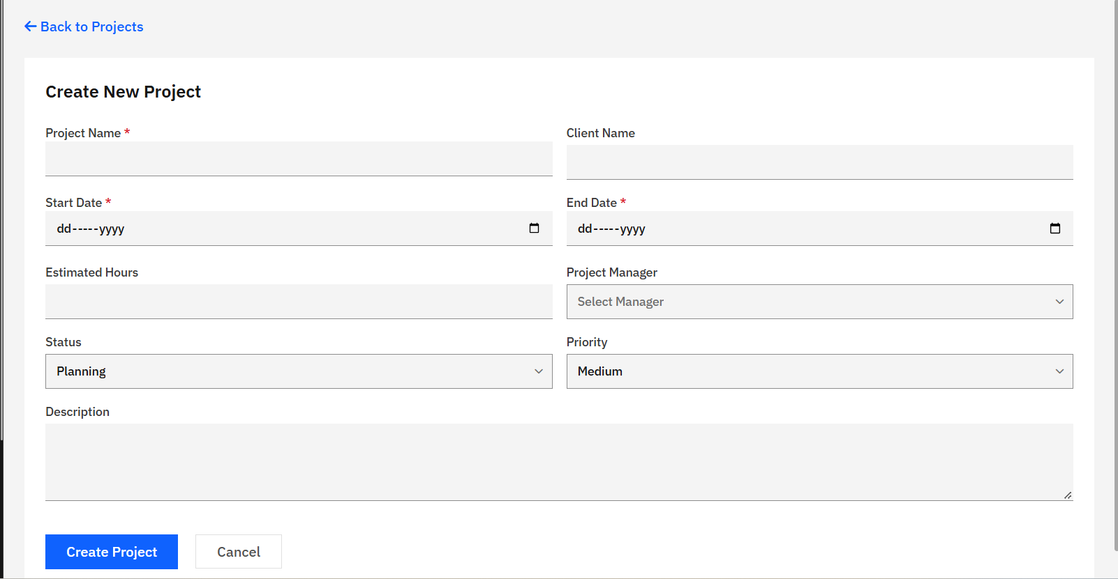
Figure 4 – Create New Project form (current)

5. Company-scoped Reporting Manager and Project lists
Module: Contractor
Current behaviour
Reporting Manager and Project dropdowns show all values regardless of company.
Requested change
Add a Company dropdown before Reporting Manager. Once a company is selected, the Reporting Manager and Project dropdowns must list only entries belonging to that company.
Proposed acceptance criteria
- Company field is placed before Reporting Manager.
- Reporting Manager and Project options are filtered by the selected company.
- Both dependent fields reset when the company changes.
- Dependent fields are disabled until a company is chosen.
Reference screenshot
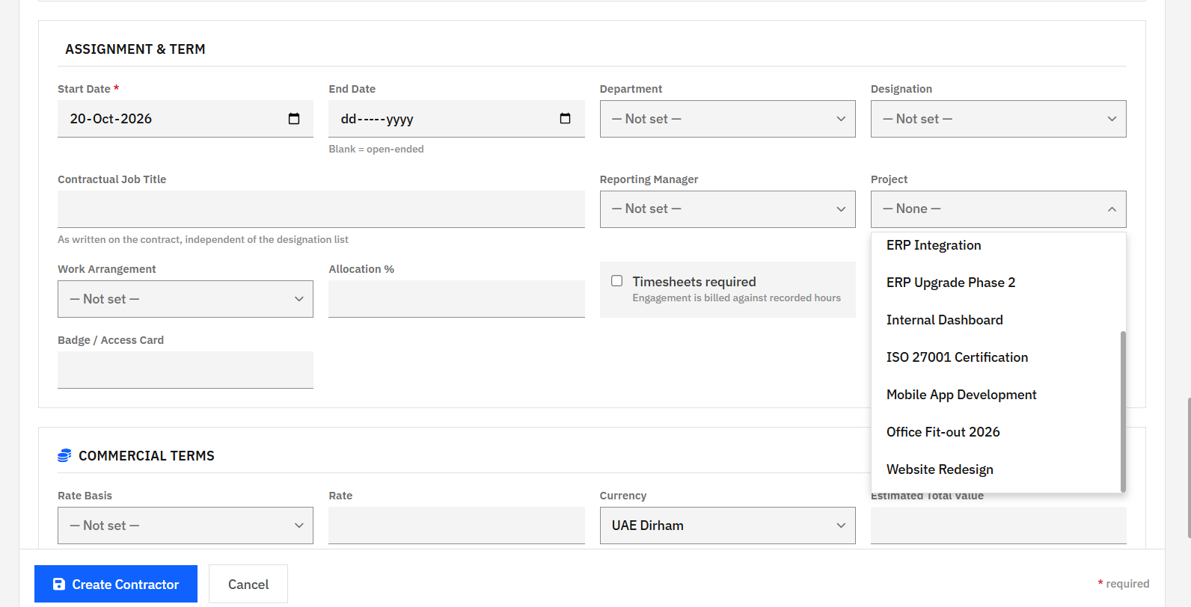
Figure 5 – Assignment & Term section with Project dropdown open (current)

6. Asset location / organisation field
Module: Asset
Current behaviour
There is no indication of where an asset is stored or which organisation it belongs to.
Requested change
Add an input field to record the asset’s storage location and its owning organisation.
Proposed acceptance criteria
- A Location / Organisation field is available on Add New Asset.
- The value is saved and displayed on the asset list and detail views.
Reference screenshot
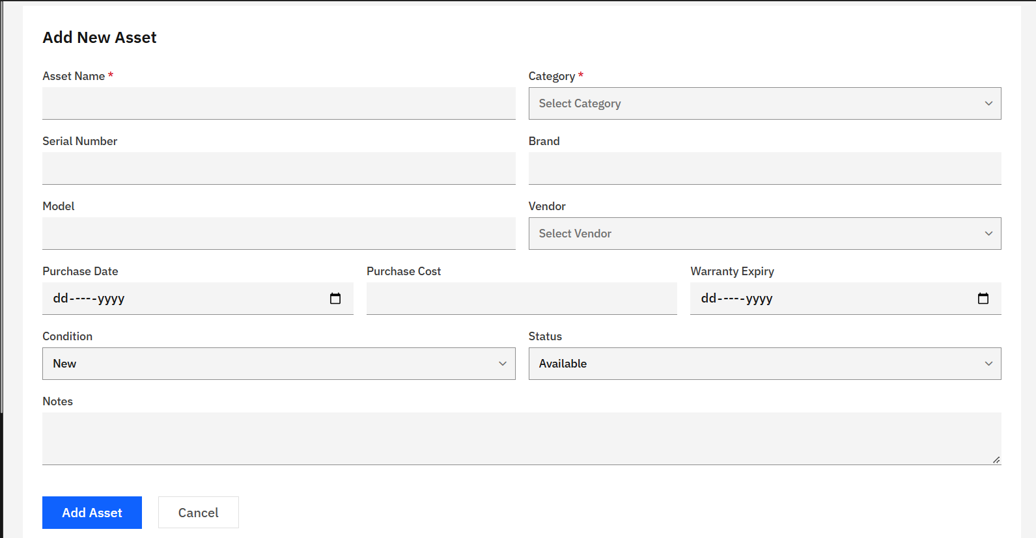
Figure 6 – Add New Asset form (current)

7. Asset list filter dropdowns not working
Module: Asset
Current behaviour
The Category, Status and Condition filter dropdowns do not filter the asset list as expected.
Requested change
Fix the filters so that the list updates according to the selected Category, Status and Condition, alone or in combination with the search text.
Proposed acceptance criteria
- Each filter narrows the list to matching records.
- Filters work in combination with each other and with search.
- Summary counters and the list stay consistent with the active filters.
- Selecting “All” clears the respective filter.
Reference screenshot
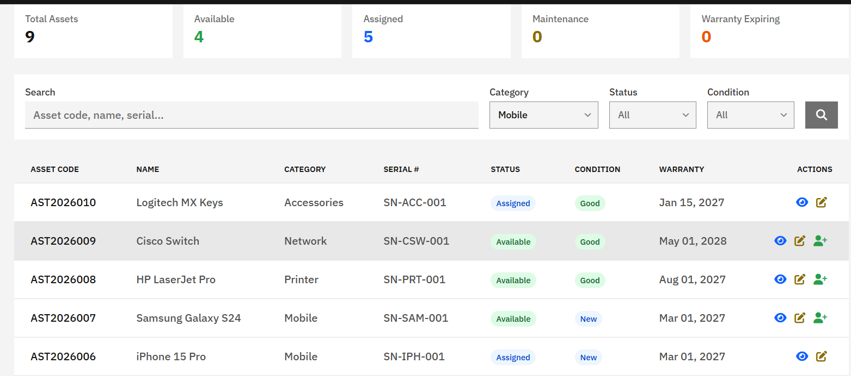
Figure 7 – Asset list with filter controls (current)

