## Front Page

Interaction Design Paper Kubernetes Collaboration Dashboard

Itamar Oren-Naftalovich

**Site Layout** 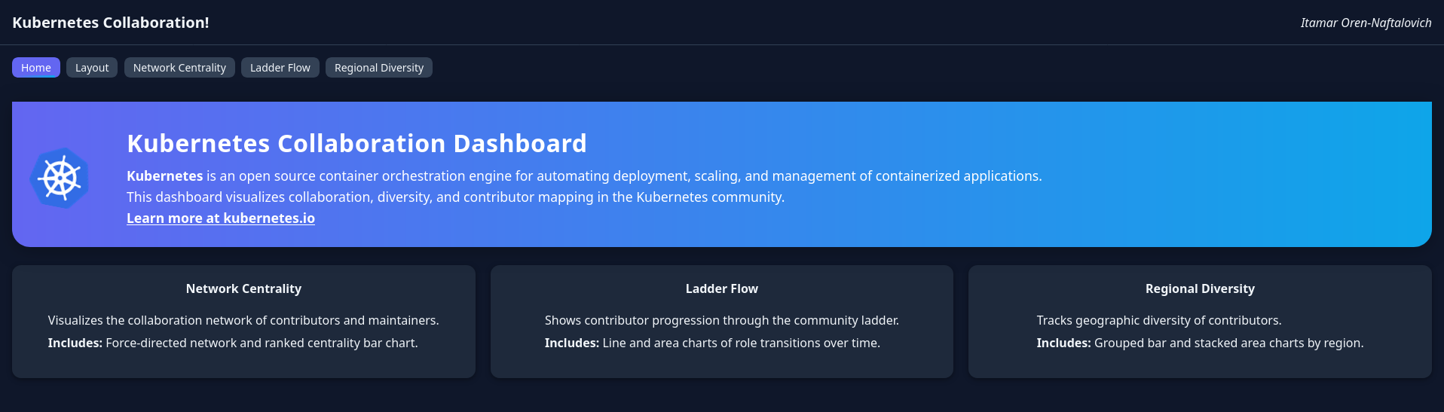

The prototype is of a dark-themed header with the title and author on the left, a horizontal tab bar that switches between five main views (Home, Layout, Network Centrality, Ladder Flow, Regional Diversity), and a “Home” grid of cards linking to each data view.

## PART 1

### Data Relationship #1: Contributor-Ladder Progression Flow

Description: Tracks counts of contributors as they move from their first pull request through role stages up to maintainer status over time.

#### **Chart A – Stacked Area (Cohort Flow)**

* Pre-interaction: 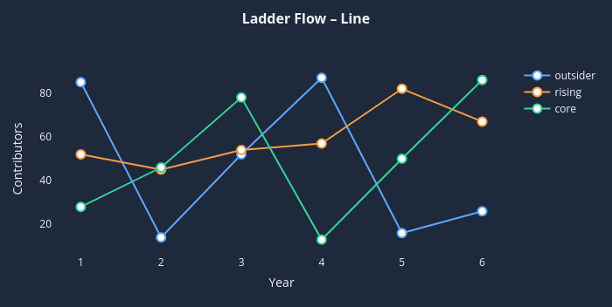
* Post-interaction: 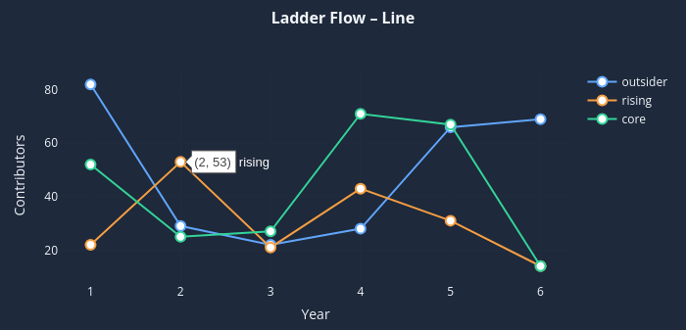

#### **Chart B – Line / Slope Chart**

* Pre-interaction: 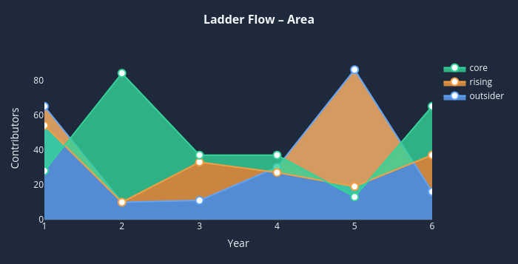
* Post-interaction: 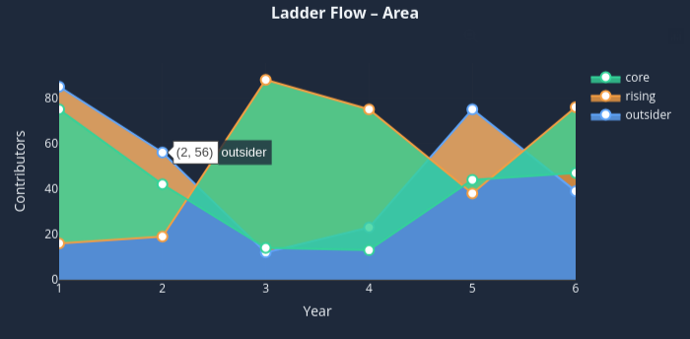

#### **Discussion**

* Chart A
  + Interaction: brush or hover to isolate a cohort, and clicking a stage highlights contributors currently at that rung
  + Strengths: shows overall retention and growth visually, and gives a measure of volume across stages
  + Weaknesses: exact quantities for small cohorts are hard to read, and color stacking can obscure minor flows
* Chart B
  + Interaction: hover shows exact counts per ladder stage, and the legend toggles to show/hide lines
  + Strengths: precise and uncluttered view of trends for each stage
  + Weaknesses: does not communicate inter-stage flow (at all), users need to mentally map the transitions
* Best Choice: Chart A has the strongest storytelling of progression because the stacked area makes retention and drop-off visually immediate.

### Data Relationship #2: Network Centrality vs. Role Rank

Description: Compares node-degree and betweenness centrality scores against contributor role hierarchy.

#### **Chart A – Scatter Plot**

* Pre-interaction: 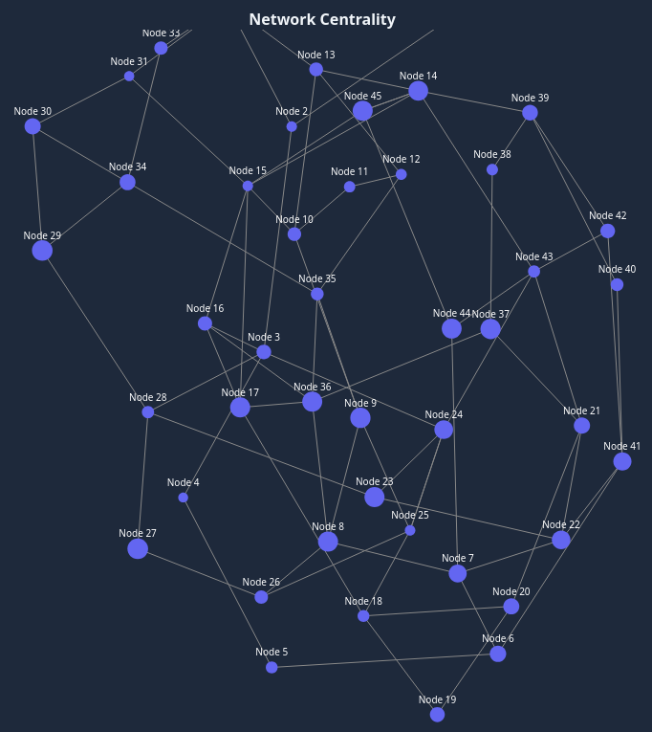
* Post-interaction: 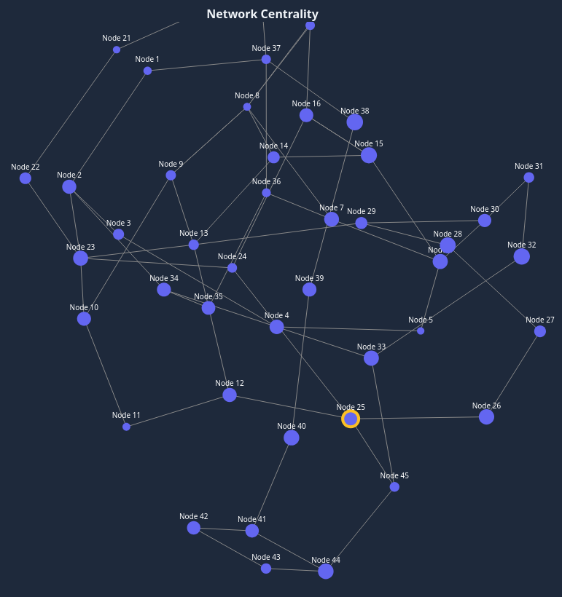

#### **Chart A2 – Scatter Plot - Part II**

* Pre-interaction: 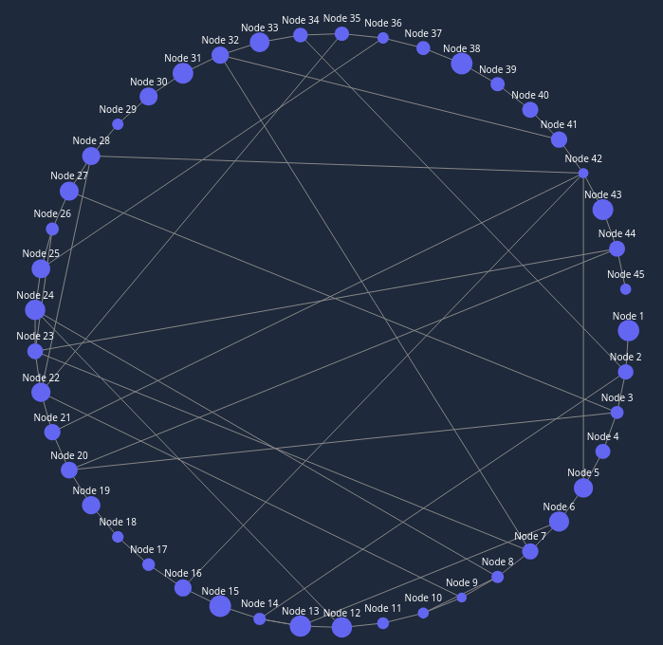
* Post-interaction: 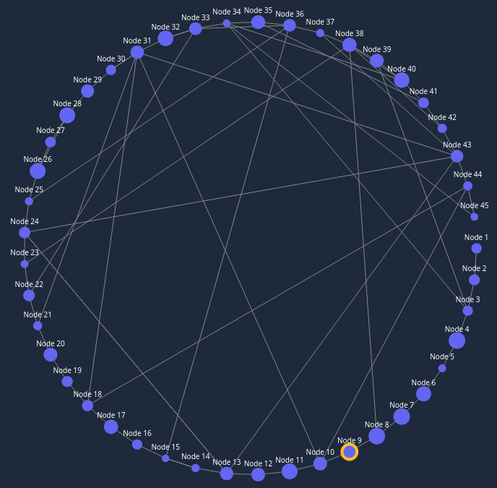

#### **Chart B – Centrality Scores Bar Chart**

* Pre-interaction: 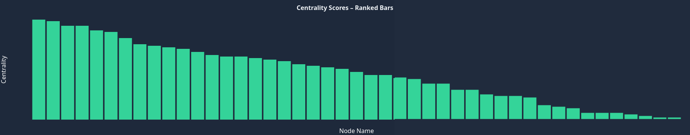
* Post-interaction: 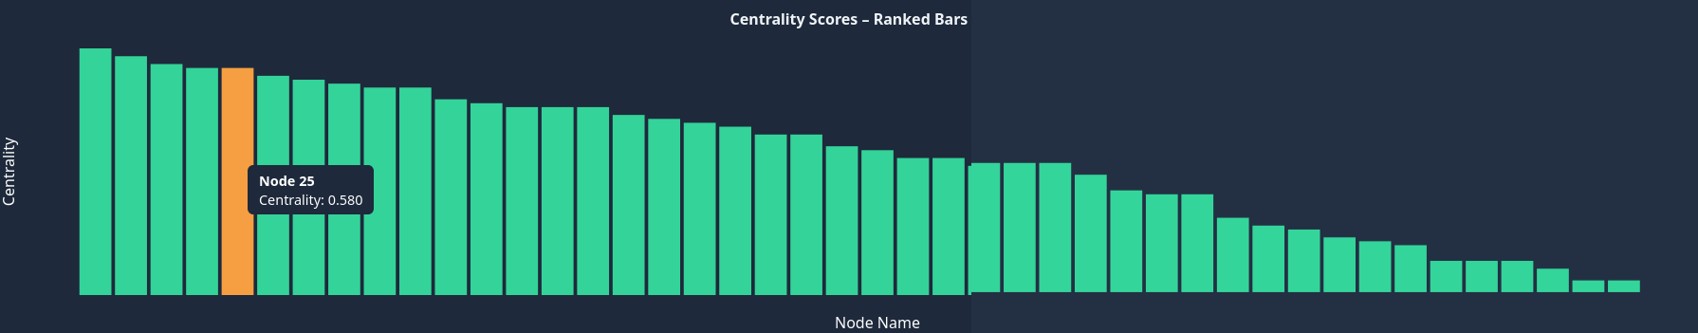

#### Discussion

* Chart A
  + Interaction: hover to show contributor details
  + Strengths: highlights outliers and overlap between roles, and spatial distribution is intuitive
  + Weaknesses: dense clusters can overlap, and might require color saturation for clarity (see chart A2 for fix)
* Chart A2
  + Interaction: same as A
  + Strengths: clearer than A since nodes will not overlap
  + Weaknesses: too many nodes will still be hard to read if the screen is too small. Also too many connections will make this illegable
* Chart B
  + Interaction: click a bar to higlight to individual contributors within that score bucket
  + Strengths: compact rank-ordered view, and easy aggregate comparison
  + Weaknesses: aggregation hides role-specific variance, and shows less engaging than spatial scatter
* Best Choice: Chart A2 preserves individual granularity and visually surfaces outliers critical to governance decisions. While I do like A1 more, putting it on a paper is…difficult.

### Data Relationship #3: Geographic Diversity Over Time

Description: Shows counts of contributors per region across yearly intervals.

#### **Chart A – Stacked Area by Region**

* Pre-interaction: 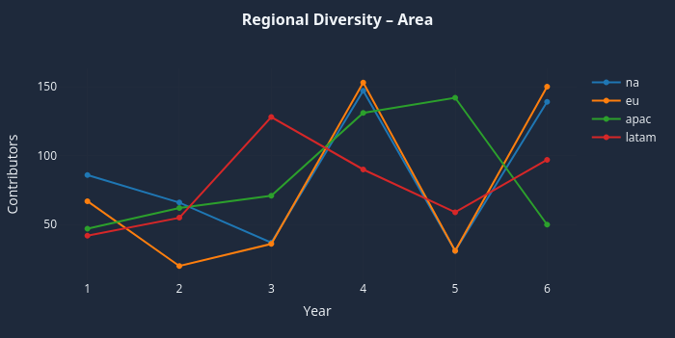
* Post-interaction: 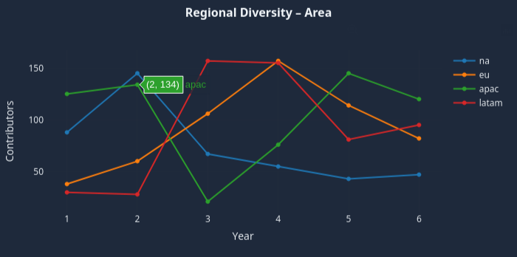

#### **Chart B – Stacked Bars Snapshot**

* Pre-interaction: 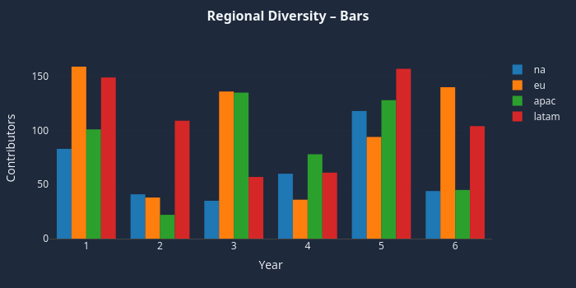
* Post-interaction: 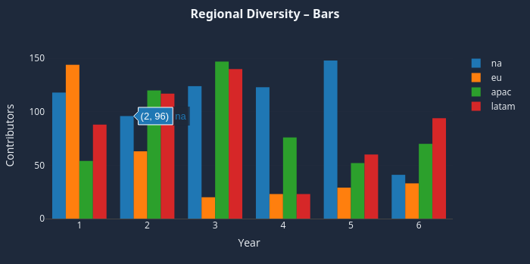

#### Discussion

* Chart A
  + Interaction: hover slice to show absolute and % share, and toggle continents on/off
  + Strengths: demonstrates overall growth and proportional shifts clearly
  + Weaknesses: harder to compare small regions
* Chart B
  + Interaction: click a year to show tooltip with actual number of contributors
  + Strengths: straightforward year-over-year comparison and discrete bars help with exact reading
  + Weaknesses: trend perception is fragmented across many years, visual noise with too many bars
* Best Choice: Chart A provides a continuous view ideal for spotting long-term regional trends.

## PART 2

### Task Analysis

Primary persona workflows:

* Maintainer Dashboard: triage hotspot files, identify overloaded reviewers, review open KEPs
* Contributor On-Ramp: discover good-first-issues, connect with mentors, monitor PR queue
* End-User Incident View: map open bugs to releases, assess lead-time to patch incidents

### DIAGRAM of the Organization of the Interactive Program

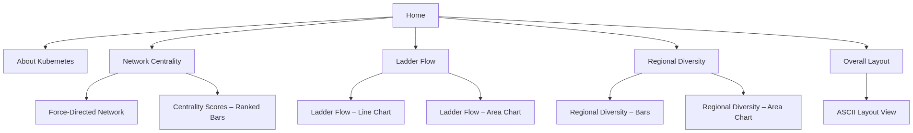

### Performance Objectives & Content Outline

| Section | Performance Objectives | Content Outline | Charts | Filters |
| --- | --- | --- | --- | --- |
| Home (Overview) | orient users to the dashboard’s purpose; provide entry points to each analysis view | header, intro paragraph, three clickable cards | — | — |
| Layout | reveal site navigation structure and user journeys; clarify page interconnections | site-map diagram, legend | static mermaid diagram | — |
| Network Centrality | surface key influencers in the contributor graph; enable exploration of individual and aggregate centrality | force-directed network, ranked-bar chart, descriptive caption | network graph, bar chart | toggle layout view |
| Ladder Flow | reveal contributor retention and progression through ladder stages; enable cohort selection | stacked-area cohort flow, multi-line stage trends | stacked area, line chart | cohort year, ladder stage filter |
| Regional Diversity | highlight geographic expansion of the community; compare regional contributions over time | grouped bar by year, stacked-area timeline | grouped bar, stacked area | region toggle, time slider |

## PART 3

### SCREEN DESIGNS (Storyboard)

#### Opening Screen



* Performance Objectives: welcome and guide users to core analyses
* Text: “Kubernetes Collaboration Dashboard”
* Graphics & Design: high-contrast, color-blind–safe palette, and animations on the cards to indicate you can click on them
* Interaction & Navigation: clicking a card or tab button routes to the relevant view

Below is a filled-in “Final Section” you can paste into your markdown file.  
I kept to one clearly labeled best chart for each pair in your dashboard and answered every prompt.

## Network Centrality — Best image: force-directed network graph



### Data Charts

**What is the data relationship?**  
Each node is a contributor; links represent joint commits or PR reviews.  
 Node size encodes eigenvector centrality (influence), while link thickness encodes frequency of collaboration.

**Why is this type of chart a good choice?**  
 A force-directed network reveals both global clusters and local hubs in one view, something a bar chart cannot do. Viewers immediately see who connects otherwise distant clusters and where collaboration bottlenecks lie.

### Other Interaction

Hover over any node ⇒ a tooltip shows name, role, centrality score, total collaborations.  
 Click a node ⇒ fades unrelated links and pins the node so the user can focus on its ego-network.

### Color

Neon-blue‐to-purple nodes (#0ea5e9 → #6366f1) stand out against the background (#0f172a) and match the overall Kubernetes palette, but it still has enough contrast for color-blind users (tested with CVD simulators).

Below is an updated **“Ladder Flow”** section that assumes you are switching from a stacked-area view to the clearer multi-series **line chart** you just showed.  
 Simply paste it over the old section in your markdown file.

## Ladder Flow — Best image: multi-series line chart

**pre-interaction**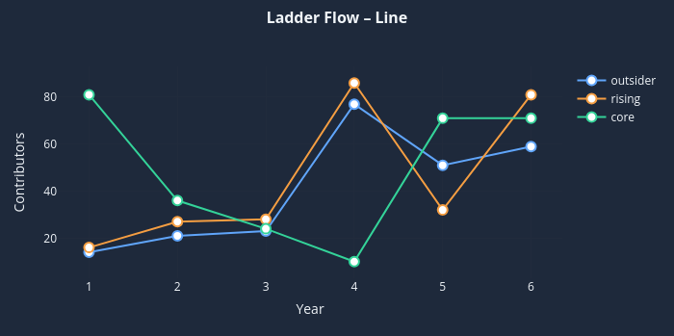

**post-interaction (hover on *rising*, Year 4)**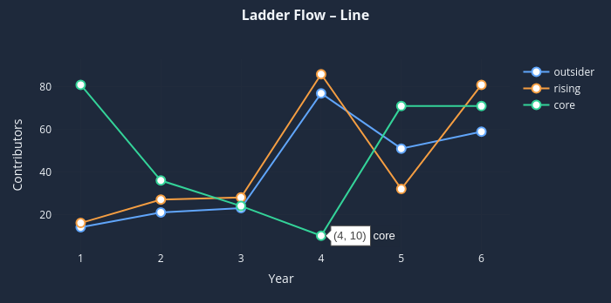

### data charts

**What is the data relationship?** Year-by-year counts of contributors in each ladder tier (outsider, rising, core).  
 Each line shows one tier’s trajectory; the y-value is the contributor count.

**Why is this type of chart a good choice?** Lines make **trends, slopes, and inflection points** obvious and let viewers compare rates of growth or decline between tiers without the visual stacking that can mask changes. The area chart is also rather confusing after review.

### filters

* **year range selection** – focus on any subset of the timeline.
* **contributor-type toggles (or legend clicks)** – show/hide individual tiers for side-by-side or solo inspection.

### other interaction

* **hover** a point → tooltip with *(year, count) tier* (see post-interaction)
* **click** a legend item → toggles that line, which allows the user to filter by tier

### color

Blue (#60a5fa), orange (#facc15), and green (#34d399) form a balanced, color-blind-safe palette; the warm orange sits between two cool tones, keeping all three lines distinct against the dark background.

## Regional Diversity – Area *Best image: multi-series line chart*

## **pre-interaction**

**post-interaction (filter out na and hover on latam, Year 4)**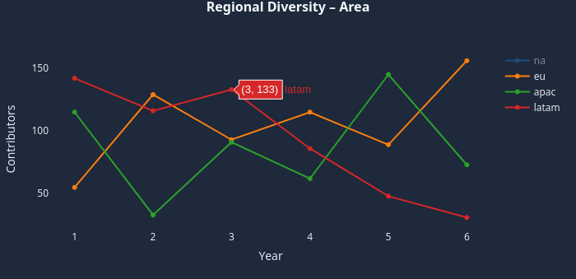

### Data Charts

**What is the data relationship?**Annual counts of contributors **grouped by country** (na, eu, apac, latam). Each line shows how a single country’s contributor pool grows or shrinks over time.

**Why is this type of chart a good choice?**A multi-series line chart makes it trivial to compare **trends, peaks, and cross-overs** between countries. Slope direction immediately signals acceleration or decline, while markers let users read exact values without clutter.

### filters

* **year section selector** – narrow or widen the time window.
* **country multi-select / legend clicks** – show or hide individual countries for focused comparisons.

These controls let teams evaluate, for example, whether a 2022 outreach program in *latam* boosted engagement relative to *apac* or *eu*.

### other interaction

* **hover** any point → tooltip with *(year, count) country* (see post-interaction).
* **click** a legend item → toggles that country’s line on/off; hidden lines are removed from the axis calculations so remaining ones rescale for clarity.

### color

Blue (#3b82f6), orange (#f97316), green (#22c55e), and red (#ef4444) are perceptually distinct and WCAG-AA compliant against the dark navy background, ensuring every country’s trend stays readable—even for color-blind users.