Software Requirement Specification

NHOM7-SRS-001

Version 1.0

**Revision History**

| Date | Version | Description | Author | Revised by |
| --- | --- | --- | --- | --- |
| 18/04/2018 | 1.0 | First version |  |  |
|  |  |  |  |  |
|  |  |  |  |  |
|  |  |  |  |  |
|  |  |  |  |  |

# **Functional Requirements**

## **Feature/Component #1: List Page**

### User Interfaces

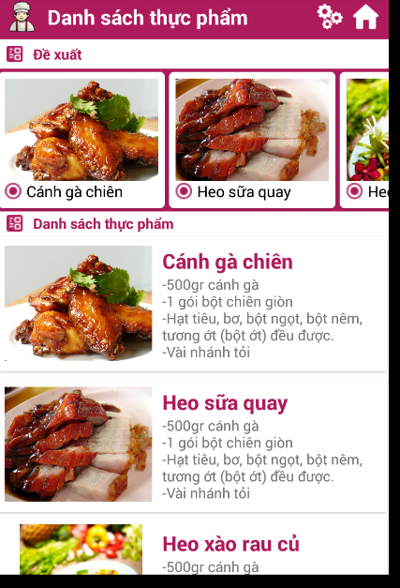

*Image1:* List Page

### Functional Requirements

|  |  |  |  |
| --- | --- | --- | --- |
| **Item** | **Description** | **Action** | **Response** |
| List Page | Include:   * 1 Action bar * 3 icon button * Recycle view * List view * Text View * Image view | N/A | N/A |
| Action bar | Display screen name, logo and 2 icon  button | N/A | N/A |
| Logo | Contains the logo of the application | N/A | N/A |
| Icon | Switch to the filter screen by the material. | click | Switch to the filter screen by the material.. |
| Icon | Back to home page | click | Back to home page |
| Recycle view | Show suggested dishes running horizontally. Include image and name of the dish | N/A | N/A |
| List view | Display dishes with pictures and food names | N/A | N/A |
| Image view | The image of the dish when the user click on it will switch to the details page | click | Switch to the detail page of the dish |
| Text view | Name of the dish, summary of the dish. When the user clicks on, it changes to the details | click | Switch to the detail page of the dish |

## **Feature/Component #2:** **Filtered by materials page**

### User Interfaces

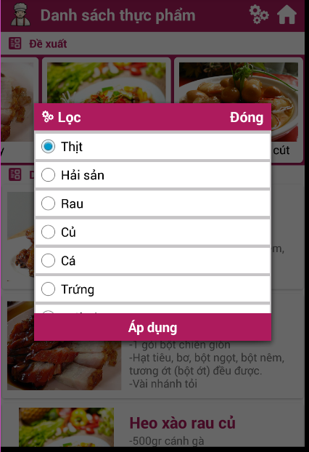

*Image2: Filtered by materials page*

### Functional Requirements

|  |  |  |  |
| --- | --- | --- | --- |
| **Name** | **Description** | **Action** | **Response** |
| Filtered by materials page | Include:   * Text View * 1 icon * Scroll View * Radio button | N/A | N/A |
|  | Displays the name of the screen | N/A | N/A |
| Text view “Đóng” | Close the filter screen back to the list screen | click | back to the list screen |
| Scroll view | Displays the ingredient name and button. | N/A | N/A |
| Radio button | Displays the button for the user to select the material, the user selects only one raw material. When the user clicks on the button, it lights up. | Click | The selected button will light up. |
| Text view “Áp Dụng” | The user will click on the button to switch to the list of selected ingredients | Click | Switch to the ingredients list screen with selected ingredients |

***---------- End of Document ----------***