Smart Display · Group 5א · IoT project 236333, Technion
Enclosure Sketch
Week 8 submission: a desk stand case for the display, for design and production
Shada Nujeidat, Yuval Carmelli, Liat Rokach · 11 October 2026
The whole project is one board, the ESP32-2432S028R (86 × 50 mm, screen on the front), powered by one USB cable. The enclosure is a small desk stand: a front bezel that frames the screen and a back shell with a fold-out leg that tilts the screen back 20° for reading at a desk. Both parts are 3D printed.
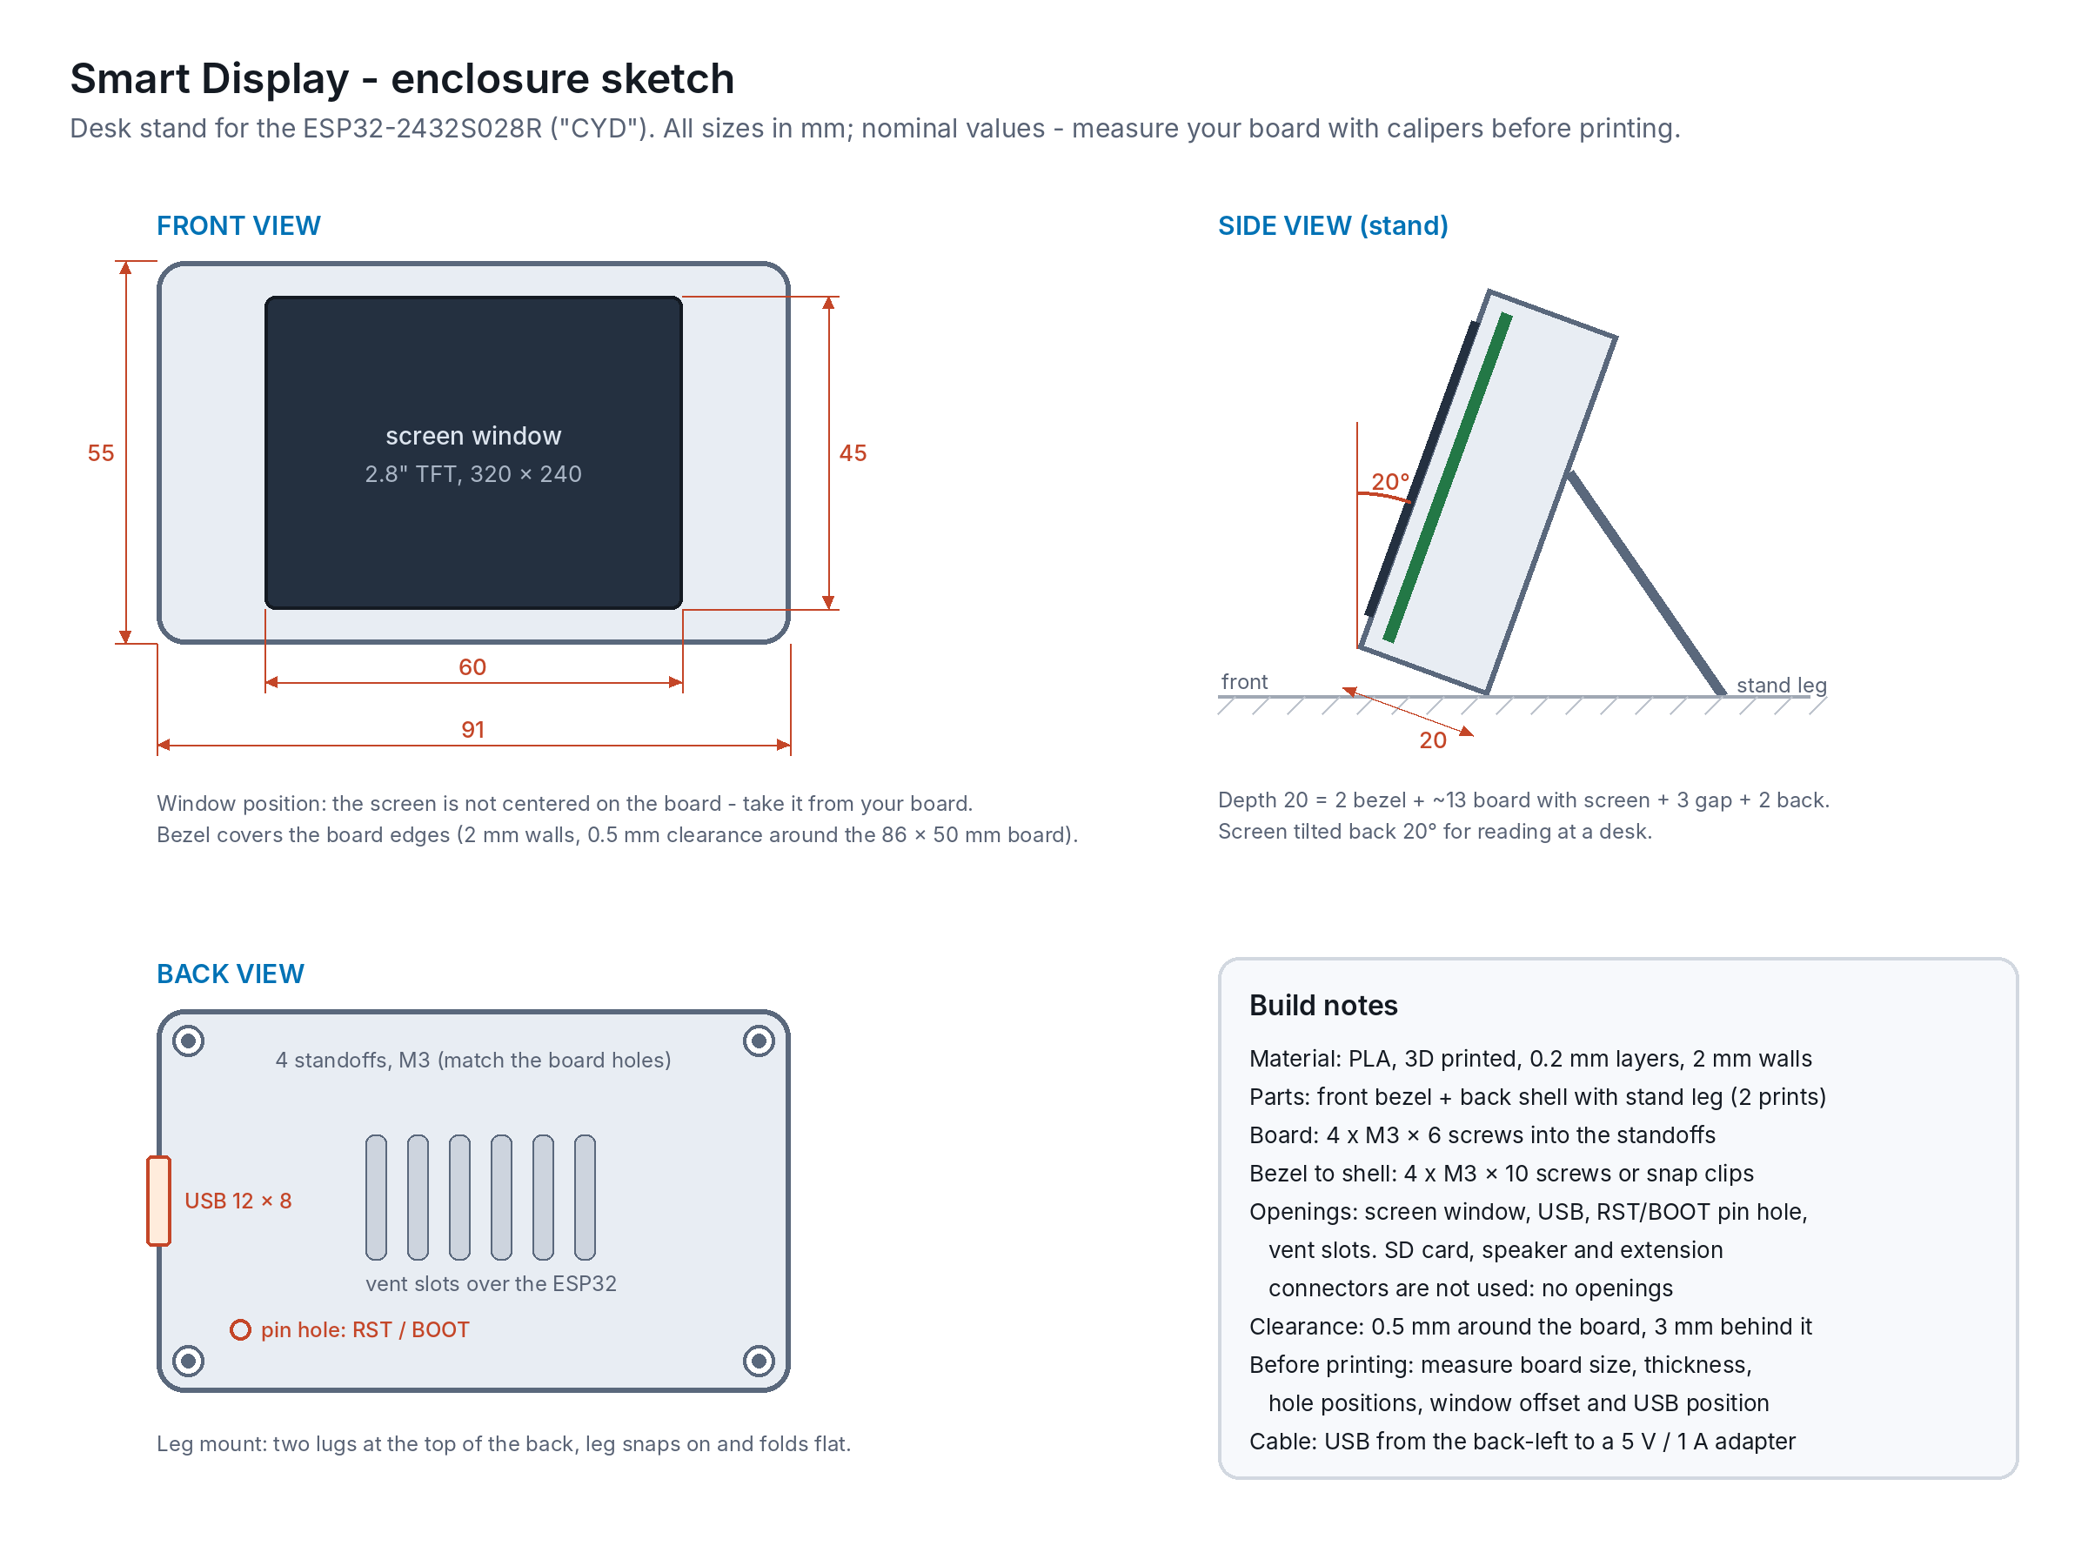
Figure 1. Front, side and back views (mm). Also in the repo: assets/enclosure_sketch.png

1. Requirements
- Holds the board firmly so the resistive touch screen can be pressed without the board moving.
- Leaves the whole screen visible and touchable; the bezel must not press on the screen edge (that causes false touches on resistive screens).
- USB cable can be plugged in while the case is closed; RST/BOOT reachable with a pin for re-flashing and the unit tests.
- Air can leave the back: the ESP32 module and the backlight get warm when WiFi runs all the time.
- Stands on a desk or a kitchen counter at a comfortable reading angle; small (fits in one hand).
- Easy to open for development (screws, not glue).

2. Main dimensions
Item | Size (mm) | Notes
Board (PCB) | 86 × 50 | From the board specification; confirm with calipers
Board thickness incl. screen and parts | ≈ 13 | Measure at the thickest point (USB connector / ESP32 module)
Wall thickness | 2.0 | PLA, 0.2 mm layers
Clearance around the board | 0.5 | Printed parts shrink slightly; adjust after a test print
Outer size (W × H × D) | 91 × 55 × 20 | 86 + 2 × (0.5 + 2) = 91; depth = 2 bezel + 13 board + 3 gap + 2 back
Screen window | 60 × 45 | A little larger than the visible screen area; position taken from the board (the screen is not centered on the PCB)
USB opening | 12 × 8 | On the short side, in line with the board's USB connector
RST / BOOT access | Ø 3 hole | Pressed with a pin or a paper clip
Board mounting | 4 × M3 standoffs | Positions and screw size from the board's 4 corner holes
Stand angle | 20° back from vertical | Fold-out leg on two lugs at the top of the back shell

3. Production
Item | Plan
Method | 3D printing in PLA (front bezel face down, back shell open side up: no supports needed except the leg lugs)
Parts | Front bezel, back shell with leg lugs, leg (3 small prints)
Hardware | 4 × M3 × 6 screws (board to standoffs), 4 × M3 × 10 screws or snap clips (bezel to shell)
Model | Sketch the parts in a CAD tool (Fusion 360, Onshape or Tinkercad) from the measured board; export STL; print a test bezel first to check the window position and the fit
Files | CAD source and STL files go into the Git repository under assets/enclosure/

4. Before printing: measure on the real board
☐ Board outline (86 × 50 mm nominal) and total thickness.
☐ Position and diameter of the 4 mounting holes.
☐ Visible screen area and its offset from the board edges.
☐ Position of the USB connector and of the RST / BOOT buttons.
☐ Height of the tallest part on the back (sets the 3 mm gap).

Openings for the SD card slot, speaker connector and extension connectors are left out on purpose: the project does not use them.

