Smart Display · Group 5א · IoT project 236333, Technion
HW Unit Tests Report
Week 4 submission: every hardware part and service the display depends on, tested on its own
Shada Nujeidat, Yuval Carmelli, Liat Rokach · 12 October 2026

1. What we test and why
The Smart Display runs on one board, the ESP32-2432S028R ("Cheap Yellow Display", CYD): an ESP32 with a 2.8" 320×240 touchscreen. Everything else (weather, time, calendar, voice commands) arrives over WiFi. For each hardware part and each online service we wrote a small stand-alone sketch that tests only that part, outside the full firmware. When something stops working, these tests tell us quickly whether the cause is the hardware, the network, a service, or our own code.
All 9 sketches are in the Git repository under unit_tests/, each with its own folder. Each prints its measurements to the Serial Monitor and ends with one line, RESULT: PASS or RESULT: FAIL. They use the same pins, settings and conversions as the firmware, so a passing test means the firmware's configuration is right too.

Hardware under test
Part | Chip / interface | Pins (GPIO) | Used by the firmware for
Screen | ILI9341 TFT, SPI (HSPI) at 55 MHz | MOSI 13, MISO 12, SCK 14, CS 15, DC 2 | all screens (LVGL)
Touch | XPT2046 resistive, SPI (VSPI) | CLK 25, MOSI 32, MISO 39, CS 33, IRQ 36 | every button, slider, list tap
Backlight | LED driver, PWM 5 kHz, 8 bit | 21 | brightness, dim / screen off
Flash (NVS) | ESP32 internal flash, Preferences | - | settings, shopping / to-do lists
WiFi | ESP32 radio, 2.4 GHz | - | weather, time, calendar, Firebase, setup portal
Not used | RGB LED, light sensor (LDR), speaker, SD card slot | 4/16/17, 34, 26, 5/18/19/23 | not part of the project, not tested

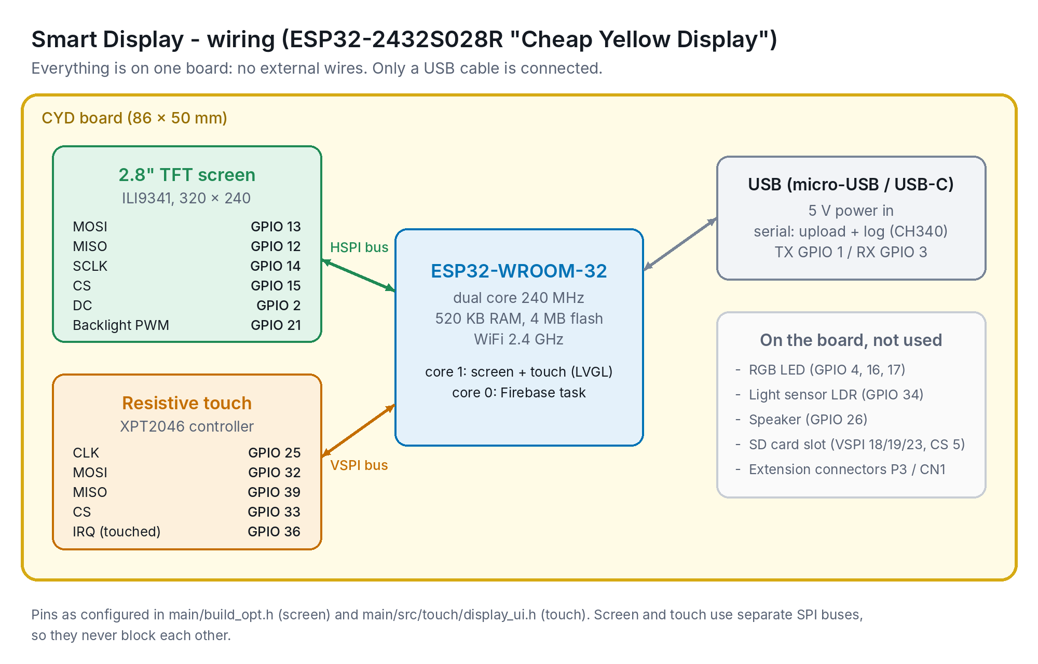
Figure 1. CYD internal wiring (all parts are on the board, no external wiring). Also in the repo: assets/wiring_diagram.png

Test setup
- Arduino IDE 2, board package esp32 by Espressif 3.3.12, board ESP32 Dev Module, Partition Scheme Huge APP.
- Libraries (same pinned versions as the firmware): TFT_eSPI 2.5.43, XPT2046_Touchscreen 1.4.0, ArduinoJson 7.4.3. No extra libraries.
- Serial Monitor at 115200 baud; press RST/EN after opening it to see the output from the start.
- Network tests use the network saved by the display's setup portal (SmartDisplay-Setup), or one typed into TEST_WIFI_SSID. Run them on the network the display will really use (Technion WiFi and a phone hotspot).
- The Firebase and Calendar tests need a copy of main/secrets.h in their folder. These copies are in .gitignore and are never uploaded.

2. Summary of results
Run the tests in this order: hardware first, then network, then the services. If a lower test fails, the ones above it are the first suspects.
# | Test (sketch) | Pass criterion | Result | Measured
1 | Screen  test_display | fill ≤ 60 ms; border, corners, colors, text correct | PASS | fill 31 ms; visual check correct
2 | Touch  test_touch | all 5 taps within 20 px | PASS  (2nd run) | worst error 17 px
3 | Backlight  test_backlight | every step brighter, 0 % dark, no flicker | PASS | visual check correct
4 | Flash storage  test_storage | values match, counter +1 after RST | PASS | 2 KB write 11 ms
5 | WiFi  test_wifi | connect + reconnect ≤ 15 s, 4 names resolve | PASS  (2nd run) | connect 1201 ms, RSSI -44 dBm, reconnect 1101 ms
6 | Clock (NTP)  test_ntp | zone rule right, sync ≤ 20 s, drift ≤ 1 s | PASS | sync 19.6 s, no drift in 60 s
7 | HTTPS / TLS  test_https_weather | 200 with 5 cities, dead server < 10 s | PASS | request 1387 ms, TLS ~49 KB, dead server 8.0 s
8 | Firebase  test_firebase | sign-in, write/read match, delete | PASS | sign-in 1056 ms, average read 962 ms
9 | Google Calendar  test_calendar | 200, start times present, Hebrew intact | PASS | request 1209 ms, 5 events

Tested by: Shada Nujeidat · Date: 12 October 2026 · Board: ESP32-2432S028R (CYD) · Network: home WiFi, 2.4 GHz · Result: all 9 tests passed

3. Test procedures

1. Screen: test_display
Part | ILI9341 2.8" TFT, 320×240, HSPI (pins 13/12/14/15/2)
Goal | The screen is wired and configured correctly: fast enough, nothing cut off or mirrored, correct colors.
Procedure | 1. Upload unit_tests/test_display (its build_opt.h holds the same screen settings as the firmware).  2. The screen fills red, green, blue, white, black; each fill is timed and printed.  3. Then it draws a 1 px white border, a colored square in each corner, a center cross and text in 3 sizes.  4. Check the screen against the list printed in the Serial Monitor.
Pass criterion | Each fill ≤ 60 ms (expected ≈ 22 ms at 55 MHz SPI). Border touches all 4 edges. Red square top-left, green top-right, blue bottom-left, yellow bottom-right. Text sharp.
If it fails | White screen: screen configuration not loaded (sketch opened from the wrong folder). Red top-right: mirrored, wrong rotation. Wrong colors: inversion setting, or a board with an ST7789 panel.
Result | PASS: Full-screen fill 31 ms (limit 60 ms). Border on all 4 edges, corner colors correct, text sharp.

2. Touch: test_touch
Part | XPT2046 resistive touch, VSPI (CLK 25, MOSI 32, MISO 39, CS 33, IRQ 36)
Goal | The touch controller answers and a tap lands where the user pressed, using the same conversion as the firmware (map(x, 200, 3700, …), map(y, 240, 3800, …)).
Procedure | 1. Upload unit_tests/test_touch. A cross appears at each of 5 targets: 4 corners and center.  2. Tap the center of each cross with a fingernail or stylus (20 s per target).  3. The sketch averages 8 readings, converts them to pixels, prints target, tap, raw values and the error in pixels, and marks the tap green (ok) or red.
Pass criterion | Every tap within 20 px of its target. The firmware's smallest button is 44 px, so a 20 px error still hits the right button.
If it fails | No reaction: wrong touch pins or SPI bus. Large error in one direction: adjust the map() limits in display_ui.h using the raw values printed by the test (this is our calibration procedure).
Result | PASS (2nd run): Worst error 17 px (limit 20 px); other taps 14, 8, 10, 11 px. 1st run FAIL (88-169 px), see section 4.

3. Backlight: test_backlight
Part | Backlight LED driver, PWM on GPIO 21 (5 kHz, 8 bit)
Goal | Brightness follows the PWM duty cycle used by Settings → Brightness and by power saving (dim / screen off).
Procedure | 1. Upload unit_tests/test_backlight. The backlight steps through 0 %, 4 % (the firmware's minimum), 10 %, 25 %, 50 %, 75 %, 100 %, 2 s each, then fades up and down.
Pass criterion | Each step visibly brighter than the previous one, 0 % fully dark, no flicker at any level, smooth fade.
If it fails | Always full brightness: GPIO 21 not attached to PWM. Flicker at low levels: PWM frequency too low.
Result | PASS: Every step visibly brighter, 0 % fully dark, no flicker (visual check).

4. Flash storage: test_storage
Part | ESP32 flash, NVS partition (Preferences library)
Goal | Settings and the shopping / to-do lists are saved in flash and survive a restart.
Procedure | 1. Upload unit_tests/test_storage. It writes and reads back an int, a Hebrew string and a 2 KB block (the size of the saved lists), timing the block write.  2. It increases a boot counter on every start. Press RST/EN once: the counter must be one higher.  3. Uses its own namespace ("unittest"), so the display's real settings and lists are not touched.
Pass criterion | All values read back identical, the Hebrew string is unchanged, the counter increases after RST.
If it fails | Read-back differs or counter resets: NVS partition full or corrupted (erase flash and re-upload).
Result | PASS: Int, Hebrew string and 2 KB block read back correctly; 2 KB write 11 ms; boot counter kept across restarts (4); 321 free NVS entries.

5. WiFi: test_wifi
Part | ESP32 WiFi radio (2.4 GHz)
Goal | The radio finds networks, connects, resolves the servers the display uses, and reconnects after a drop.
Procedure | 1. Upload unit_tests/test_wifi. It uses the network saved by the display's setup portal, or the one typed into TEST_WIFI_SSID.  2. Prints a scan (name, signal, channel), connect time, RSSI and IP.  3. Resolves api.open-meteo.com, identitytoolkit.googleapis.com, www.googleapis.com, ntp.technion.ac.il.  4. Disconnects on purpose and measures the reconnect.
Pass criterion | Connects within 15 s, all 4 names resolve, reconnects within 15 s.
If it fails | Phone hotspot not found: switch the iPhone hotspot to "Maximize compatibility" (2.4 GHz). DNS fails: network blocks outside traffic (captive portal).
Result | PASS (2nd run): 3 networks found; connected in 1201 ms, RSSI -44 dBm; all 4 names resolved; reconnect 1101 ms. 1st run FAIL (scan found 0 networks), see section 4.

6. Clock: test_ntp
Part | ESP32 RTC + NTP over WiFi
Goal | The clock shows Israel time, including summer time, synced from a server that works on the Technion network.
Procedure | 1. Upload unit_tests/test_ntp. First, without network, it converts two fixed moments with the firmware's time zone rule: 15 Jan 2026 12:00 UTC must be 14:00, 15 Jul 2026 12:00 UTC must be 15:00.  2. Then it syncs from ntp.technion.ac.il (backups: pool.ntp.org, time.google.com) and prints the local time.  3. After 60 s it compares the clock with millis().
Pass criterion | Both conversions right, synced within 20 s, drift ≤ 1 s per minute.
If it fails | Never syncs on campus: the Technion network blocks outside NTP servers, so the Technion server must stay first.
Result | PASS: Winter/summer conversions right; synced in 19.6 s (limit 20 s); clock moved 60 s in 60 s (no drift).

7. Secure requests: test_https_weather
Part | TLS (mbedTLS) + HTTP client, RAM
Goal | The real weather request works over HTTPS, fits in memory, and a dead server cannot freeze the screen.
Procedure | 1. Upload unit_tests/test_https_weather. It sends the firmware's request: weather for all 5 cities in one call.  2. Prints status, time, size, free memory before and the lowest during the request, and the 5 temperatures.  3. Then it connects to an address that never answers (10.255.255.1) and measures how long it takes to give up.
Pass criterion | HTTP 200 with 5 cities. The dead server gives up in under 10 s (the default would be 120 s).
If it fails | Restart or error -1 during the handshake: not enough free memory (TLS needs about 40 KB).
Result | PASS: HTTP 200 in 1387 ms, 3996 bytes, all 5 cities; free memory 224,840 B before, 175,972 B lowest (~49 KB used by TLS); dead server gave up after 8.0 s.

8. Firebase: test_firebase
Part | Firebase Auth + Realtime Database (REST)
Goal | The display's login works and the database path that voice commands use can be written and read fast enough.
Procedure | 1. Copy main/secrets.h into the test folder (it is in .gitignore). Upload unit_tests/test_firebase.  2. Signs in with the display's email/password, writes a random value to /unit_test, reads it back 5 times (timed), deletes it. /command, /status and /lists are not touched.
Pass criterion | Sign-in OK, the value read back matches every time, delete OK. Average read well under 1 s (the display checks /commands every 2 s).
If it fails | INVALID_PASSWORD / EMAIL_NOT_FOUND: wrong secrets. 401 on write: database rules. Slow reads: weak WiFi signal (see test 5).
Result | PASS: Sign-in 1056 ms; write 200; 5 reads matched, average 962 ms, worst 1118 ms; delete 200. Earlier FAIL was a bug in the test, see section 4.

9. Google Calendar: test_calendar
Part | Google Calendar API v3 (public calendar + API key)
Goal | The calendar ID and API key work and the reply contains what the calendar screen needs, including Hebrew titles.
Procedure | 1. Copy main/secrets.h into the test folder. Upload unit_tests/test_calendar.  2. Requests the first 5 events since 1 Jan 2026 and prints their start time and title.
Pass criterion | HTTP 200, every event has a start time, Hebrew titles print as Hebrew (not ???).
If it fails | 404: wrong calendar ID or the calendar is not public. 400/403: wrong key, or Google Calendar API not enabled in the Cloud project.
Result | PASS: HTTP 200 in 1209 ms; 5 events with start times; Hebrew titles printed correctly.

4. What we learned from the test run
Some tests did not pass on the first try. We kept these runs in the report because each one taught us something about the hardware, the network or the tests themselves.
Test | What happened | Cause and what we did
WiFi | 1st run: the scan found 0 networks and the board did not connect. 2nd run right after: everything passed | The radio was not fully started when the scan ran. The firmware is not affected: it retries the saved network every 15 s
Touch | 1st run: taps landed 88-169 px from the targets, in random directions. 2nd run: worst 17 px | Random errors (not a constant offset) come from pressing too lightly or sliding the finger, which resistive screens read badly. A firm press with a fingernail gives accurate results. The calibration itself is correct; the raw values show the X range could be widened slightly
Clock (NTP) | Synced in 19.6 s, just under the 20 s limit | At home the Technion time server answers slowly, so the board waits before using the backup servers. On campus it is the fast path. The display only shows "Getting the time..." a bit longer after starting
Firebase | 1st run: "value WRONG" although sign-in, write, read and delete all worked | A bug in the test: the random value could be larger than the type used to read it back. Fixed by keeping the value below 1,000,000 and printing any mismatch; the rerun passed
Google Calendar | 1st run: HTTP -1 after 12 s (no connection) | The test sent the request the moment WiFi connected, before the connection was ready. The test now waits until the server name resolves and retries once; the rerun passed. The firmware only asks for the calendar after the clock is synced, so it is not affected
Flash storage | No output in the Serial Monitor | The test finished in under a second, before the monitor was open. It now waits 3 s and repeats the result every 5 s
Screen | Full-screen fill 31 ms instead of the estimated 22 ms | The estimate counted only the pixel data; the board also spends time on commands and the SPI driver. 31 ms is well under the 60 ms limit

5. Problems found while bringing up the hardware
These came up while we first ran examples and the early firmware on the board. Each is now handled in the firmware, and the test in the last column would catch it again.
Problem | Cause | Fix | Caught by
Arduino Blink example: nothing blinks | The CYD has no LED on LED_BUILTIN; its RGB LED is on GPIO 4/16/17 and is active-LOW | Used the RGB pins with inverted logic (LED not used in the final project) | -
Screen white, or colors wrong | TFT_eSPI needs the CYD's pins and driver; this panel also needs color inversion | Screen configuration in build_opt.h (ILI9341_2 driver, HSPI pins, inversion on), no edits to the library | test_display
Touch position off from the finger | Raw XPT2046 values must be converted to pixels; the limits differ slightly per board | Conversion map(x, 200, 3700), map(y, 240, 3800), checked against 5 targets; buttons ≥ 44 px | test_touch
A tap registered twice | Resistive touch bounces when pressed lightly | LVGL acts on one complete press-and-release and ignores presses that turn into a scroll; ticked list items can be undone within 2 s | test_touch (manual)
Could not reliably join an iPhone hotspot | The ESP32 only supports 2.4 GHz; newer iPhones use 5 GHz unless "Maximize Compatibility" is on. The example also did not set station mode | WiFi.mode(WIFI_STA); hotspot set to "Maximize compatibility" | test_wifi
Clock never set on the Technion network | Outside NTP servers are blocked on campus | ntp.technion.ac.il first, pool.ntp.org and time.google.com as backups | test_ntp
Screen froze up to 2 min when WiFi dropped mid-request | Default TLS handshake timeout is 120 s | Handshake timeout 8 s (15 s for Firebase) | test_https_weather
"Sketch too big" after adding LVGL | The default app partition is 1.3 MB | Partition scheme Huge APP (3 MB); firmware is now 1.61 MB (51 %) | build
Hebrew list items and events showed ??? | The built-in fonts have no Hebrew letters | Hebrew fonts with right-to-left support (LVGL BiDi) | test_calendar, test_storage
Light mode looked grey on the panel | The light palette used light-grey backgrounds, which look clearly grey on this panel | Light mode uses pure white backgrounds with outlined rows | test_display (visual)

6. Build check
All 9 test sketches and the full firmware compile and link for ESP32 Dev Module with esp32 core 3.3.12 and the pinned library versions. The full firmware uses 1,606,735 bytes of program space (51 % of the 3 MB Huge APP partition) and 72,772 bytes of RAM for global variables (22 %), leaving room for the secure connections that are created at run time.

7. Where to find it
- Test sketches: Git repository, folder unit_tests/ (one folder per test).
- How to run them and a results table: unit_tests/README.md.
- The pins and settings the tests share with the firmware: main/build_opt.h, Documentation/pinout_wiring.md, Documentation/parameters.md.

