Installation Instructions for OpenCart

Please ensure that all files and your database are backed up prior to installation.

Install vQmod
vQmod must also be installed on your site. Go to, https://code.google.com/p/vqmod/ and download the OpenCart latest version. At this time, vqmod-2.4.1-opencart.zip (https://code.google.com/p/vqmod/downloads/detail?name=vqmod-2.4.1-opencart.zip&can=2&q=)

Please go to your web sites directory structure, normally done using FTP, and in the root of the OpenCart installation and put vQmod there. Then go to the front end of the website and go to, www.yoursitename.co.uk/vqmod/install. If your site is in a sub-directory don't forget to add it to the URL. You should then get a message stating that vQmod has been installed.

Add The XML Files
Using the FTP client copy the XML files from \vqmod\xml\*.xml into the same directory on the web site. There should be one file already in the directory, vqmod_opencart.xml. This is the OpenCart master XML file and should never be changed.

Install InPost Module And Files
The InPost files are held in the various directories shown in Appendix I. All of the files need to be copied onto your web server. Please make sure that all of the files are uploaded.

The directory for the PDF files, pdf_files, needs to have 777 permisions.

Set Up The Modules
Log into the administrative part of your site. Go to the modules list, Main Menu -> Extensions -> Modules. Then click on Install for the InPost Shipping module. After it has installed you will see the Edit option. Click on Edit and apply your settings to the form. The data required is :- API Key, API URL, Maximum weight, Maximum size A, B & C.

Typical Settings
The API Key is a long string of numbers and letters and will be included in the welcome message you should have received from InPost. The API URL is typically, http://api-uk.easypack24.net/ The current maximum weight is 20 kg. Maximum Size A, 8x38x64, Size B 19x38x64, Size C 41x38x64.

Click save and the settings will be stored.

New Shipping Method
The new Module creates a new shipping method for the user to pick. The method needs to be set up. Go to the main menu Extensions -> Shipping and click on the Install for InPost Shipping.Then once it is installed click on the Edit link. There are a few settings that need to be configured. The options are :- Display Delivery Weight, Weight Class, Tax Class, Geo Zone, Rate, Status and Sort order.

You must change the Status of the shipping method to Enabled and provide a Sort Order. The user is presented the various possible shipping methods based upon the Sort Order. I.e. The higher sort orders (5, 6, 7) are shown after the lower ones (1, 2, 3).

The Rate amount is what will be added to the cost of the order. It is possible to set the cost for the InPost shipping method to be zero. The field should be filled with 0.00 to indicate that you have purposely set it to be zero cost.

OpenCart Basic Settings
The basic settings for the OpenCart store need to be set correctly. The Length class must be centimeters and the Weight class should be Kilograms. If you are using grams for the weight then the maximum weight for the parcels needs to be changed from 20 to 20000. This simply converts it into gramms.

This is to ensure that the calculations for the size and weight of the resultant parcel work correctly.

Permisions
To allow administrators to edit the parcels you must provide their group with permisions. To do this you must go to Main Menu -> System -> Users -> User Groups. You will then need to Edit the Top Administrator settings. You will need to set both the Access Permission and the Modify Permission.

New Features

Customer Facing
For the customer all that they will see is a new option on the checkout.
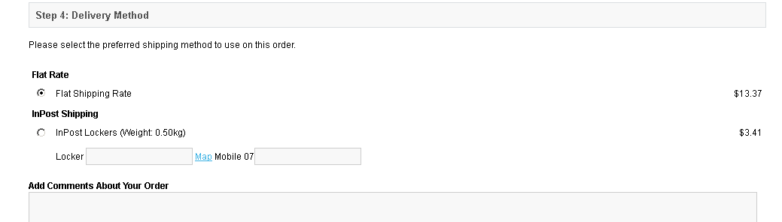
The user can then select the InPost delivery method and pick a locker that is where they want the parcel to be delivered. They also need to provide a mobile number so that they can receive a text with the PIN or password they need to get their parcel.
NB if the parcel is too large to fit any of the lockers then the InPost shipping method is not shown to the user. This check only works if the products in the store have all of their dimensions filled.

Administrative Facing
For the administrator of the site a new menu item is added to Main Menu -> Sales -> InPost Parcels. This then shows a list of the parcels that have been created which are to be delivered using the InPost shipping method.
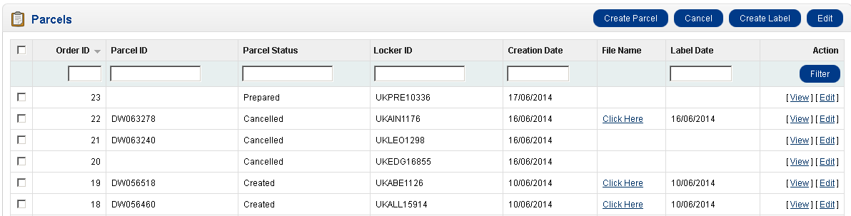
The normal procedure once an order has been paid for is as follows.
Select the parcels to be created. A new delivery starts with status Prepared. You will then select it using the checkbox and click on Create Parcel. The status of the line will change to be Created and the line will get a Parcel ID. You will then select the lines that you want to create labels for. If you select multiple lines then the labels generated will have ALL of the parcels on the same label. You will be able to print the lables individually if needed. Otherwise select each parcel singly and create the labels that way.
The line will be updated with a link that will open a new window with the PDF in it. The Label Date will also be filled with the date that the label was created on.

Cancelling A Parcel
Sometimes it will be necessary to cancel a parcel. To do so select the parcel that is to be cancelled and click on Cancel. The status of the line will be changed to cancelled.
NB once a parcel is cancelled it cannot be un-cancelled. If you mistakenly cancel a parcel the only way to recreate it is to log into the parcel manager and create a new parcel there.

Viewing / Editing A Parcel
It is possible to view the details of a parcel. Simply click on the view link on the line you would like to see and a view of the data is shown.

To edit a parcel simply click on the edit link and an edit window will open. You can then edit some of the data fields for the parcel. The locker machine, email address, mobile number and parcel size can all be modified.

Appendix I

Directory Structure
The following shows all of the directories containing files that need to be installed onto the web server.
\admin\controller\module\
\admin\controller\sale\
\admin\controller\sale\pdf_files\
\admin\controller\shipping\
\admin\language\english\module\
\admin\language\english\sale\
\admin\language\english\shipping
\admin\model\module\
\admin\view\template\module\
\admin\view\template\sale\
\admin\view\template\shipping\
\catalog\language\english\shipping\
\catalog\model\checkout\
\catalog\model\shipping\
\system\library\
\vqmod\xml\

