

Maksuturva/eMaksut
Payment Gateway Module
OpenCart 1.5.1-

Revision 120

Table of Contents
1 Changes 3
2 System requirements 4
3 Limitations and notes 4
4 Package contents 5
5 Installation 6
5.1 Package installation 6
5.2 Language customization 6
5.3 OpenCart setup 7
6 Configuration 7
6.1 Sandbox mode 9
6.2 eMaksut 9
6.3Communication encoding 9
6.4 Seller ID 9
6.5 Secret key 9
6.6 Secret key version 9
6.7Communication URL 9
6.8 Status for created order 10
6.9 Status for complete order 10
6.10 Status for cancelled order 10
6.11 Status for failed order 10
6.12 Status for delayed order 10
6.13 Module Status 10
6.14 Sort order 10
7 Administration 10
7.1 Delayed payments 10
7.2 Manually verifying payments 11
7.3 Taxes configuration 12
8 Testing the installation 13

Changes

Date | Module revision | Description
02.04.12 | 94 | Initial module version.
13.04.12 | 99 | Bug fix: Electronic product delivery address was missing and caused invalid data to be sent.
16.04.12 | 101 | Minor fix: Product name and model now sent as description.
25.05.12 | 105 | Bug fix: Confirmation e-mail is no longer sent too early.  Bug fix: Confirmation e-mail is no longer sent for cancelled order.  Bug fix: The module should now work with PHP 5.2 (not require 5.3)
16.07.12 | 110 | Bug fix:Hash calculation problems with HTML special characters fixed.
09.11.12 | 110b | Bug fix: Web store can now use other default currencies than Euro, but the buyer must choose Euro to confirm order.
15.03.13 | 120 | Fixes to handling product name and description (use other one if the other is blank). Fixed handling of unregistered customers. Also some changes in the common code. No effect on functionalities in this implementation.

System requirements
The Maksuturva Payment Gateway module for Open Cart was tested on and requires the following set of applications in order to fully work:
Requirement | Supported versions
OpenCart | - 1.5.0+
PHP | - 5.2.+
PHP cURL module | - Any
PHP mbstring module | - n/a

There is no guarantee that the module is fully functional in any other environment which hasn't such requirements.

Limitations and notes
The following limitations have been found in this revision of the payment module or in the web store software in question:
- Customer's postal code is not mandatory information in OpenCart by default, however it is required in Maksuturva payment service and results an error when missing. Postal code can be set mandatory in OpenCart's country specific settings (System → Localisation → Countries → {eg. Finland} )
- No quotation marks allowed in product names. Quotation marks in product names cause error in hash calculation.
- If a discount coupon in used in an order where shipping costs include tax, the values of the shipping costs and coupon will be forwarded incorrectly. Total sum of the order stays unchanged.
- Free shipping discount coupon is forwarded as a product row discount instead of setting shipping costs to zero. Does not affect into the total sum of the order, only the balance of pmt_amount and sellercosts.
- Shipping costs gross prices are are forwarded correctly, but the tax is claimed to be 0 %. Does not affect into shipping costs with no tax, product rows nor the total sum of the order.
- If in Maksuturva payment page the buyer chooses a payment method with additional billing fees, the additional fees will not be stored for the web store admin to see. Actual paid sum can be checked from the KauppiasExtranet. (The possibility of additional billing fees depends on your service contract with Maksuturva).
- Error or canceled payment responses from Maksuturva service are presented (to customer and/or to the admin) somewhat insufficiently or not at all. In unclear cases, you should confirm payments in KauppiasExtranet.

Package contents
This guide assumes that all the package files were correctly downloaded by the user. The following folder structure is presented by the module when uncompressed:
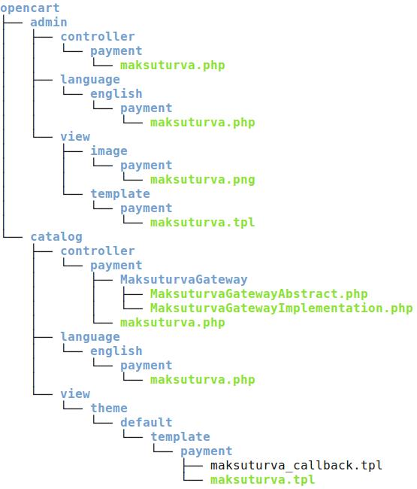Illustration 1: Tree structure of package contents
File | Description
opencart/admin/maksuturva.php | Administrative tool for configuring and verifying pending payments.
opencart/admin/languages/  english/payment/maksuturva.php | English language file for module, containing all admin messages.
opencart/admin/view/  image/payment/maksuturva.png | Maksuturva logo
opencart/admin/view/  template/payment/maksuturva.tpl | Administrative template
opencart/catalog/controller/payment/MaksuturvaGateway/ MaksuturvaGatewayAbstract.php | Base class used to wrap Maksuturva's features.
opencart/catalog/controller/payment/MaksuturvaGateway/  MaksuturvaGatewayImplementation.php | Implementation of base maksuturva's class based on OpenCart
opencart/catalog/controller/payment/  maksuturva.php | The main payment gateway file, called from checkout.
opencart/catalog/languages/  english/payment/maksuturva.php | English language file for module, containing all costumer messages.
opencart/catalog/view/theme/default/payment/  maksuturva_callback.tpl | Costumer's template for returning custom message
opencart/catalog/view/theme/default/payment/  maksuturva.tpl | Costumer's template for checkout an order.

Installation
Prior to any change in your environment, it is strongly recommended that a backup of the entire existing OpenCart installation is performed.

Package installation
The first step of installation involves to copy the package structure with its contents into a valid OpenCart installation directory. The simplest way of performing such operation is through copying both the admin and catalog folders from the maksuturva package into the OpenCart installation directory. In cases when the admin folder have been renamed the contents of the package's admin folder must be moved the correct admin folder of your installation. It is important to notice that a merge operation needs to be done, instead of replacing the entire directory.
Another option is to copy the package contents individually into their destination directories, creating such directories when they do not exist.

Language customization
It is possible to customize the language and messages used in the module. The customization takes effect by changing the text entries located in the files /opencart/admin/languages/english/payment/maksuturva.php and
/opencart/catalog/languages/english/payment/maksuturva.php.
To add support to an existing installed language, open the destination language directories (/opencart/ [admin , catalog] /languages/english/, where english is taken as example) and create the following tree structure, if it doesn't exist:
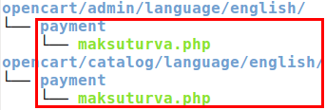
Then, copy the maksuturva.php file from the current language directory to the destination language directory. Finally, open both maksuturva.php files in edit mode and perform the translations and customizations.

OpenCart setup
When the files are copied into the destination directory, open the administrative panel of your OpenCart installation and go to Extensions → Payments section. The Illustration 2 shows the path to open the installation panel.
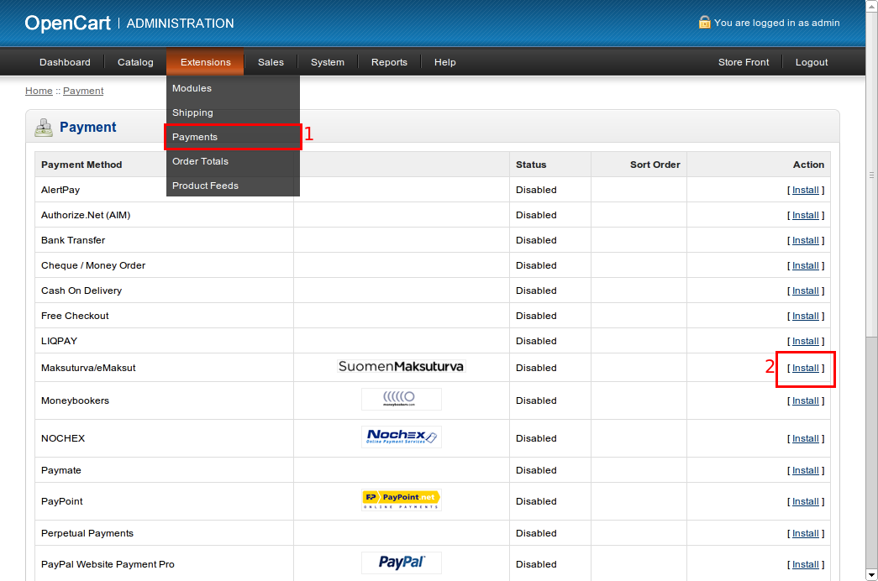Illustration 2: Open the payment section page, find the extension and click to install
In payment modules page, click “Install” in the Maksuturva line, as shown on step 2 of Illustration 2. The module is now shown as installed, and the configuration interface will be displayed (if not, click on edit link, shown on the same place of “install” link).

Configuration
The configuration section for Maksuturva's module is reached by accessing the installed payment modules, as shown in Illustration 2. The parameters and their possible configurations are presented in Illustration 3.

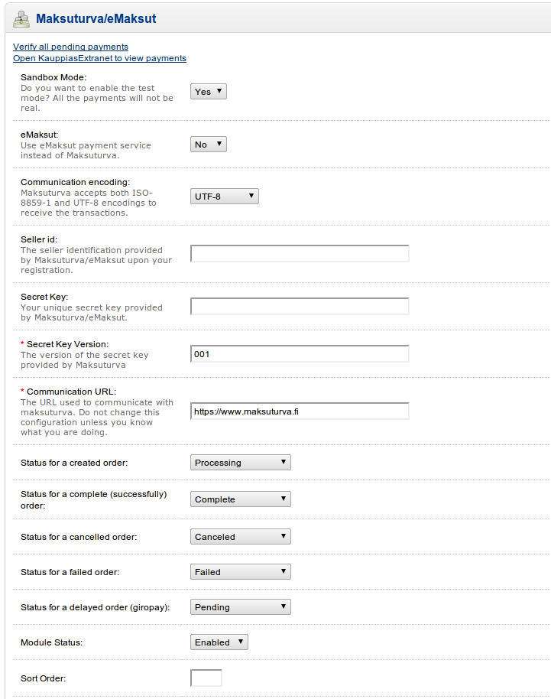
Illustration 3: Configuration parameters
All the configuration entries are detailed below. Remember to save the changes after your actions by clicking on “Save” button.

Sandbox mode
It is possible to set the module in test mode through turning the Sandbox mode to “True”. When this option is selected, default test parameters (Seller ID and Secret key) will be used in your store payments, meaning that no money will be spent when paying the orders. This is a great tool to test the operation of your store and training employees.
When set to “No”, the production mode will be used and real commercial transactions will be performed when payments are done.

eMaksut
This configuration option enables payments to be done using eMaksut's service, instead of using Maksuturva's one.

Communication encoding
There are two possible character encodings that are accepted by Maksuturva. Even if you are using a different encoding the module will attempt to convert the data from your OpenCart encoding to the encoding set on this configuration. You might need to test which of them works better for your encoding by using the sandbox mode. The possible values are 'ISO-8859-1' and 'UTF-8' and they are selected from the combobox. The default value for this setting is 'UTF-8'.

Seller ID
Open your Maksuturva account and check your seller ID in account details. The seller id is your identifier, used in every transaction inside your store. Copy the value and paste it in this field. When using sandbox mode, the value filled in this option will not be used, since the test account will be activated.

Secret key
Together with the Seller ID, the secret key is also provided by Maksuturva. Check your secret key and input this value into the configuration field. Please note that this key must not be shared with any person, since it allows many operations to be done in your Maksuturva account.

Secret key version
The version of Secret key, provided too by Maksuturva. Default value is 001.

Communication URL
This configures which URL the payment and query status operations will send the data to Maksuturva. The default value is 'https://www.maksuturva.fi'. The default value will be the address you need on 99,9% of the cases, so only change this parameter if you know exactly what you are doing.

Status for created order
Maps to OpenCart model what status should be the created orders. On every checkout, even unsuccessful, the Maksuturva module will change the order status to this one. A recommended value is “Processing”.

Status for complete order
Maps to OpenCart model what status should be the complete (successfully) orders. A recommended value is “Complete”.

Status for cancelled order
Maps to OpenCart model what status should be the cancelled orders, when user or maksuturva cancels for some reason. A recommended value is “Canceled”.

Status for failed order
Maps to OpenCart model what status should be the failed orders. Failed orders can happen for some user mistake or some communication problem between user and Maksuturva, or even from store's server and Maksuturva. A recommended value is “Failed”.

Status for delayed order
Maps to OpenCart model what status should be the delayed orders. A recommended value is “Pending”.

Module Status
This entry defines if the module should be activated for usage in payments for customers. When set to “True” it will be used. When set to “False”, it will not.

Sort order
Every payment gateway module has a classification which tells the order of listing to the store customers. Supposing you have more than one gateway installed, the lowest order will be printed on top of selections, giving the module more importance as a checkout option. The possible values are any integer equal or greater than zero.

Administration

Delayed payments
The Maksuturva Gateway Payment module allows customers to perform delayed payments, meaning that a constant verification of payment status is needed. For that purpose, an administrative tool is presented within the module summary, accessed in the administrative section in “Extensions” → “Payment” → “Maksuturva/edit” → “Verify all pending payments”. The link to verify the pending payments is highlighted in red in Illustration 4, in two places.
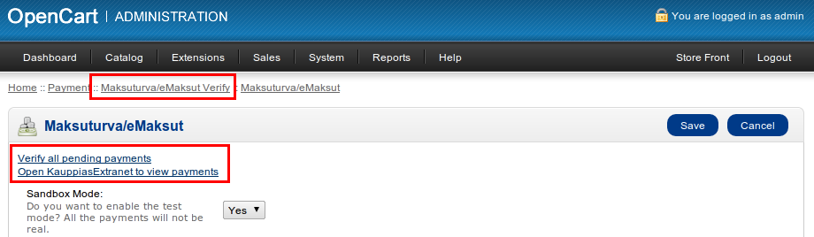Illustration 4: The verification tool
When clicked, a new window will open and the verification process will start. Depending on the number of pending payments, the verification can take a while to complete. When done, a summary of the status changes will be presented, with links to the orders on the left column and the message from Maksuturva on the right column. It is possible to change order status and communicate the customer using the links provided by this tool.

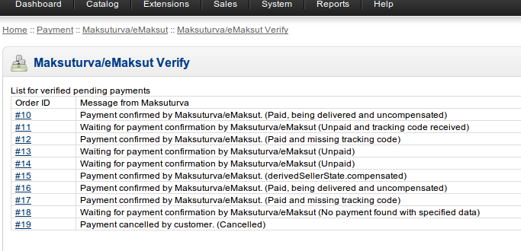Illustration 5: Pending payments verification result

Manually verifying payments
Besides the automatic pending status verification, another possibility is to open your Maksuturva account from within the OpenCart panel. The link “Open KauppiasExtranet to view payments” is highlighted in Illustration 6.

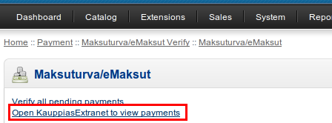Illustration 6: View payments in KauppiasExtranet

Taxes configuration
By default, OpenCart uses tax calculation disabled. If you want automatic tax include, check OpenCart forums and official site to enable and config this feature, and Maksuturva module will automatically sum the tax, considering the product's price as without taxes. This feature works only on OpenCart versions 1.5.1.x.

Testing the installation
In order to test the Maksuturva Payment Gateway module, open your configuration section, as shown in section 5 – Illustration 3, set the Sandbox mode to “True” and save your changes. Follow the steps below to test a purchase.
Step 1 - Log in as a customer and perform a purchase of a random item, selecting Maksuturva as the payment option during the checkout. Pay attention to some random address as Maksuturva validates some postal codes.
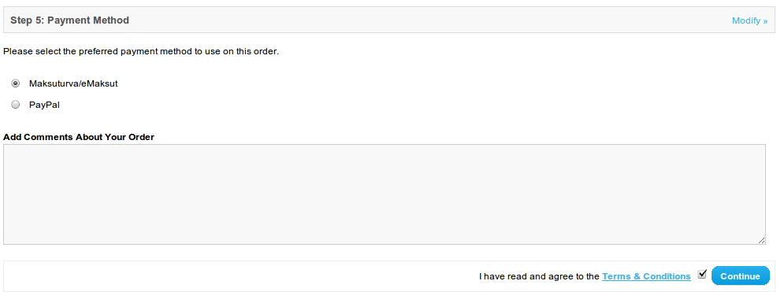Illustration 7: Step 1 - Select maksuturva
Step 2 – Confirm the order.
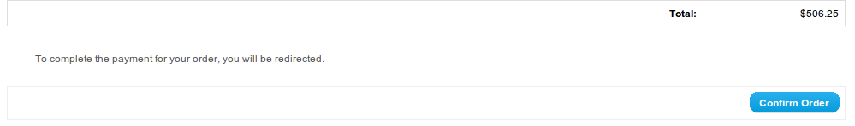Illustration 8: Step 2 - Confirm the order
Step 3 – In Maksuturva test environment, click “Ok return”, simulating a payment done successfully.
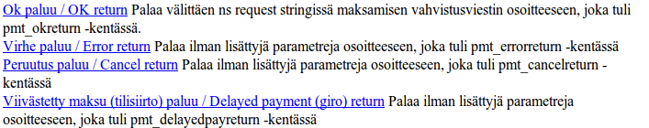Illustration 9: Step 3 - Select simulation action
Step 4 – Now the payment was confirmed and the store administrator will be able to check the update when viewing the order. The other actions in Step 3 can be selected (“Error return”, “Cancel return” and “Delay return”) for testing purposes.

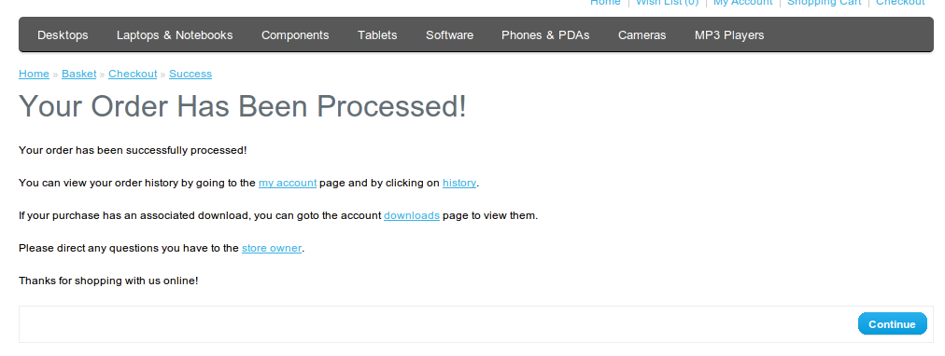Illustration 10: Step 4 - Simulation result

