Opencart Module for PayUmoney BOLT

for Opencart v3.0.2

Caution: Always keep backup of your existing Opencart installation including Mysql Database, before installing a new module.

Install via Opencart Extension Installer:-

1. Login to Opencart Admin panel and goto Extension Installer. Make sure Extension installer is already configured and working.

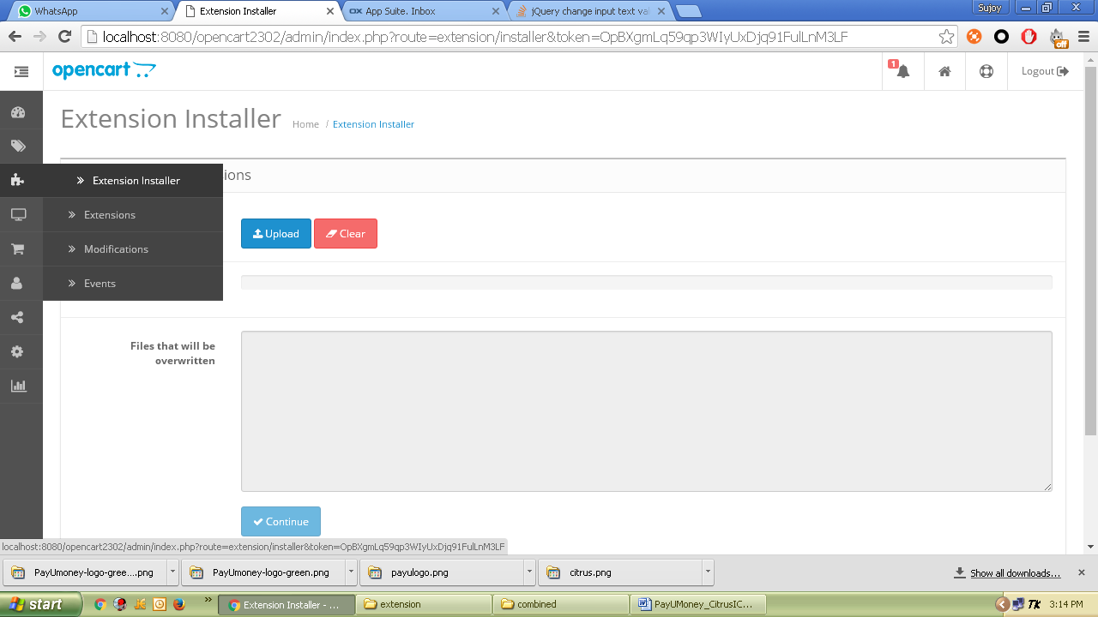

1. Click on Upload and select the downloaded module zip - *Opencart_v3.0.2_BOLT_PayUmoney_Module.ocmod.zip*
2. If you are installing the module for the first time then all files will be uploaded automatically to the appropriate locations, or else, a list of files will be shown to be overwritten and clicking on Continue button will perform the copy/installation.

Manual Installation:-

1. Unzip the content of the module zip in a folder. Upload the content of “upload” folder (admin, catalog) to your Opencart root folder.

Configure Module:-

1. Now in Opencart, login to your admin account and go to Extensions-> Payments option.

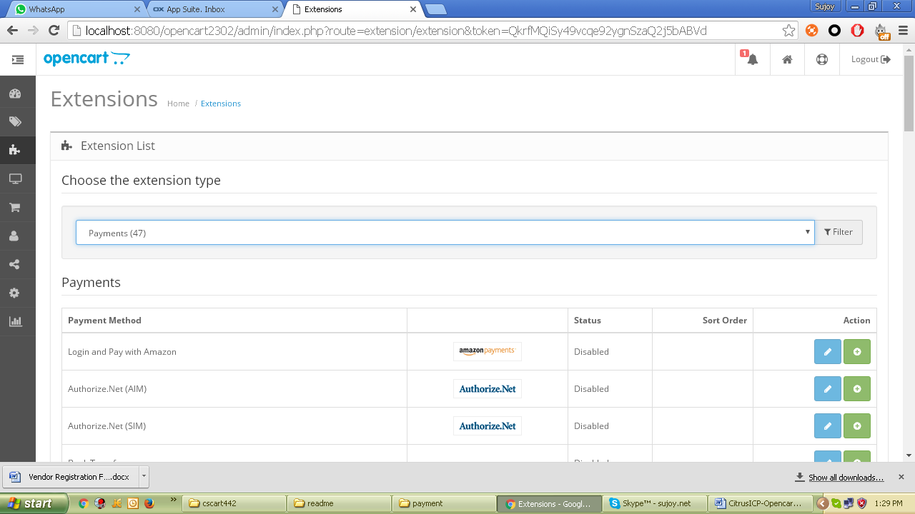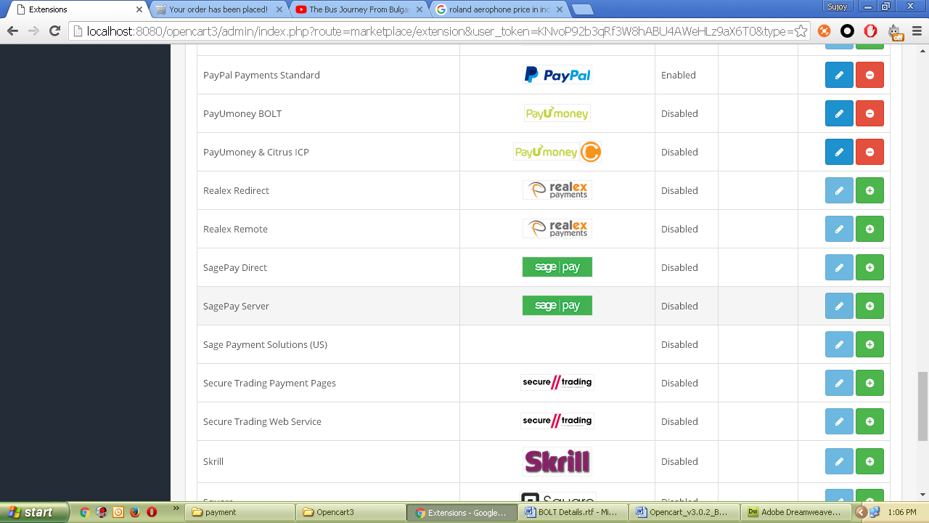

It will show you PayUmoney BOLT module as highlighted in the above image.

1. Click Install option in the right to install the module in Opencart engine.
2. After installation is over you will see Edit button. Click on Edit option to setup the options.

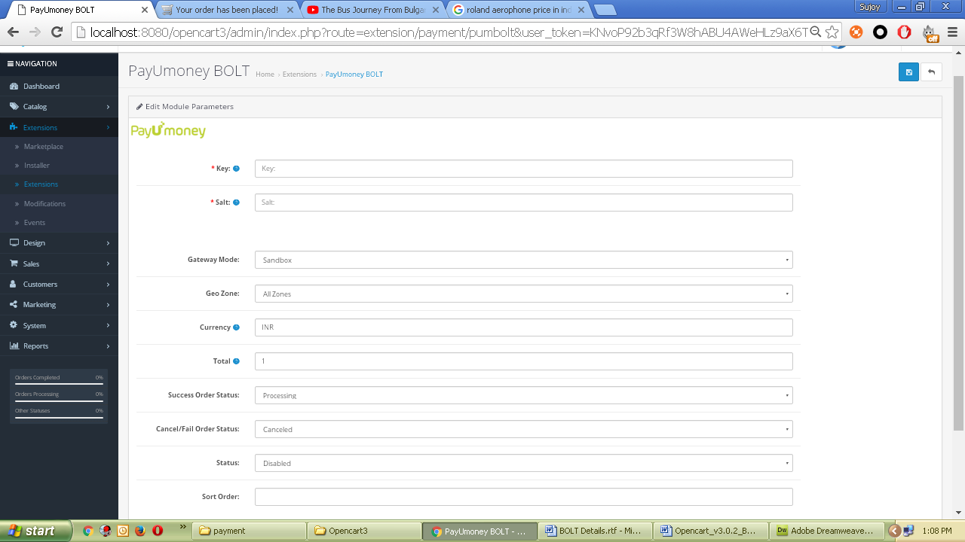

* + Enter Merchant Key and Salt.
  + Gateway Mode - “Sandbox” for sandbox/test operation and “Production” for live operation.
  + Geo Zone – Optional, select as per your configured Geo Zones.
  + Currency – Three letter, ISO-4217 currency code required. E.g. INR, USD, etc. For Indian currency use INR.
  + Total – Optional, if more than 0 then the payment option will be available only when order total is more than the Total value.
  + Success Order Status may be ‘Processing’ for successful payments and Cancel/Fail Order status may be ‘Pending’.
  + Status - Enable to enable the module.
  + Give Sort Order as appropriate or leave blank. This is useful when you are using multiple gateway modules and want to set an order of listing during checkout payment.

1. Now click save and customer will get PayUmoney BOLT option during checkout process.

