OpenCart 3 Extension for Plural XT by Pine Labs

CONTENTS

1 Installation 3

1.1 Installation via OpenCart Extension Installer 3

1.2 Manual Installation 5

2 Configuration……………………………………………………………………………………………………………………………………………..5

# Installation

**Caution:** Always keep backup of your existing OpenCart installation including MySQL Database, before installing a new module.

**OpenCart version:** 3.0.3.2

Extension can be installed by two ways:

* OpenCart Extension Installer
* Manual Installation

## **Installation via OpenCart Extension Installer**

* Login to OpenCart Admin panel.
* Click the **Extensions** Tab and then click **Installer** in the drop-down.

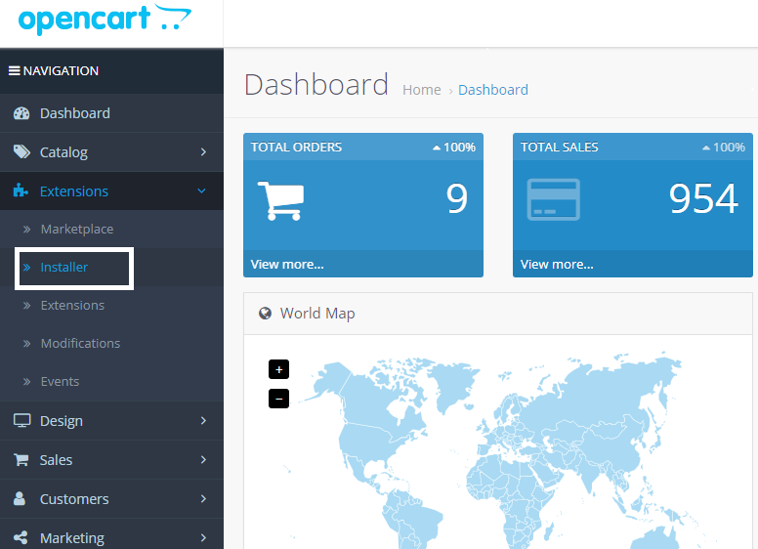

* Click the **Upload** button.

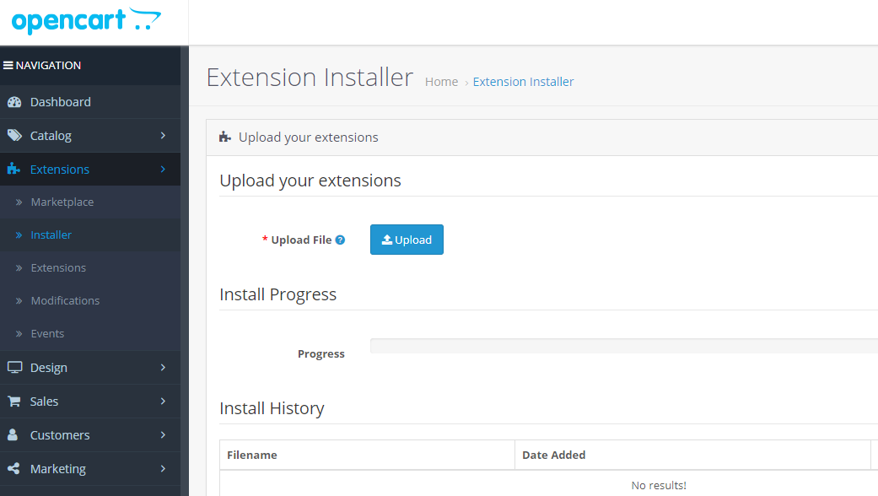

* Choose the downloaded **pluralxt-pinelabs-opencart3-v1.0.ocmod.zip** file.
* If you are installing the module for the first time then all files will be uploaded automatically to the appropriate locations, or else, a list of files will be shown to be overwritten and clicking on Continue button will perform the copy/installation.

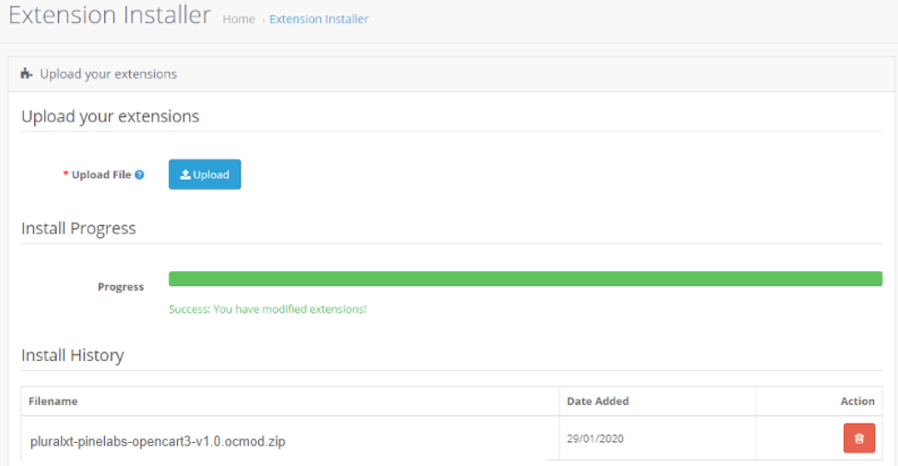

## **Manual** **Installation**

* Unzip the content of the downloaded **pluralxt-pinelabs-opencart3-v1.0.ocmod.zip** file in a folder. Upload the contents of **upload** folder (**admin**,  **catalog**) to your Opencart root folder.

# Configuration

* In the OpenCart Admin panel, click the **Extensions** Tab and then click **Extensions** in the drop-down.

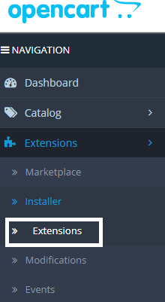

* Choose **Payments** from the extension type dropdown.

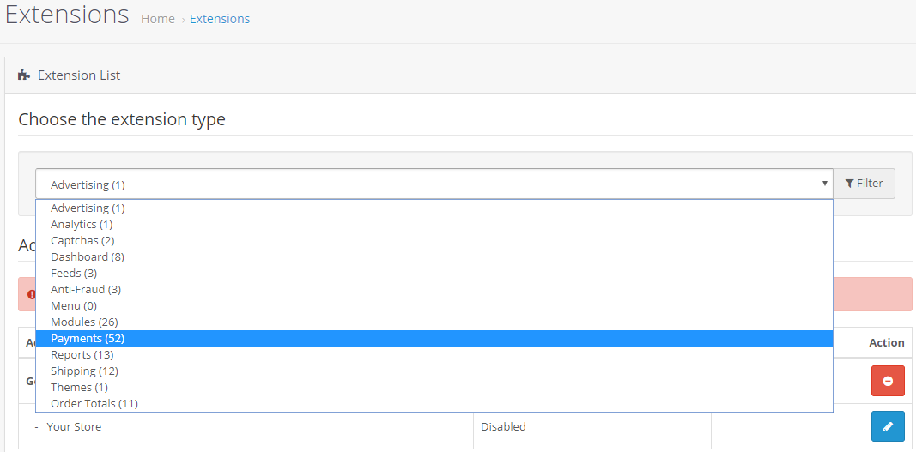

* Scroll down,if needed, to find the extension: **Plural XT by Pine Labs**.
* Click on **Install** button**.**

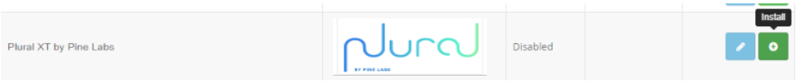

* After installation, click on the **Edit** button.



* The configuration options will appear:

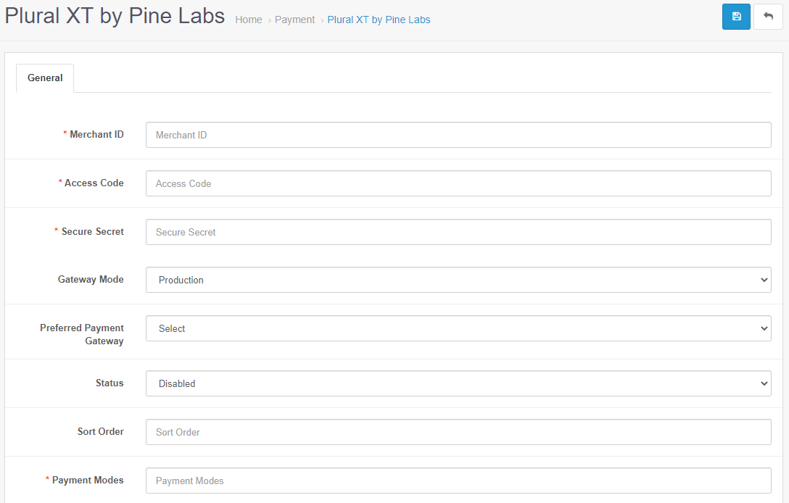

* + Merchant Id – Enter the Merchant Id provided by Pine Labs.
  + Access Code – Enter the Merchant Access Code provided by Pine Labs.
  + Secure Secret – Enter the Merchant Secure Secret Key provided by Pine Labs.
  + Gateway Mode - “Sandbox” for sandbox/test operation and “Production” for live operation.
  + Preferred Payment Gateway – Select one of the payment gateways according to your preference, if any.
  + Status – Select Enable to enable the extension.
  + Sort Order - Give Sort Order as appropriate or leave blank. This is useful when you are using multiple gateway modules and want to set an order of listing during checkout payment.
  + Payment Modes – Enter the Payment Modes as Comma Separated Values. These Payment Modes will be shown on the Payment Gateway transaction page.
* Fill the required credentials and then click **Save** button.



* Now, on the checkout page, customer can see the option for Plural XT by Pine Labs:

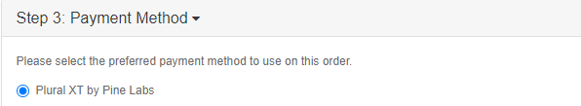

* On confirming the order, customer will be redirected to the payment gateway page.

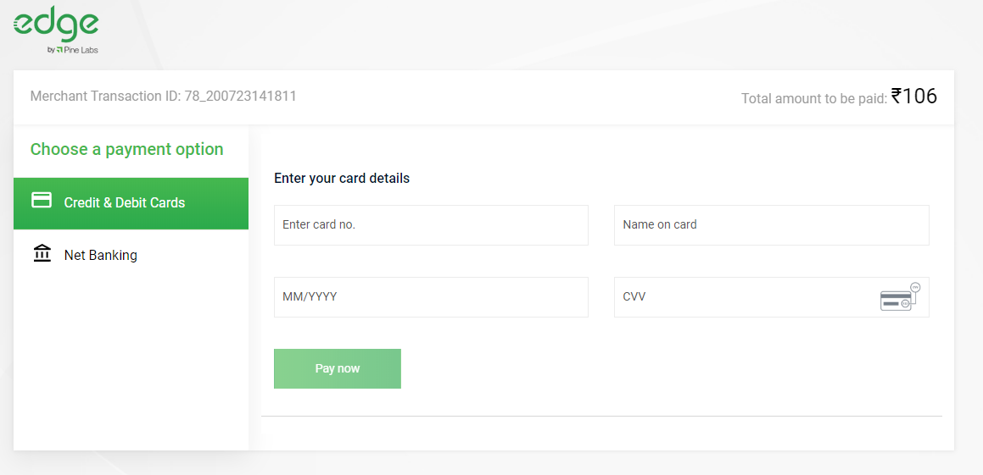

* After successful transaction, a message similar to the following will be displayed on the return page of your website.

