**Note: This module for Opencart 2.x only.**

**Install Zevioo module into Opencart**

1. Upload ‘admin’, ‘catalog’ folders to your Opencart root folder.
2. Login to Opencart admin, go to Extensions=>Modules:

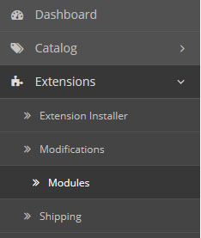

1. Scroll to the bottom of page, you will see ‘Zevioo’ module, click on ‘Install’ button on the right of this module:

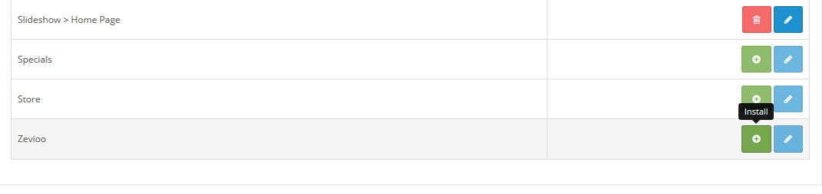

1. After clicking on ‘install’ button, module is installed into Opencart system. Scroll down again then click on ‘Edit’ button on the right of this module:



1. You will see Zevioo module setting:

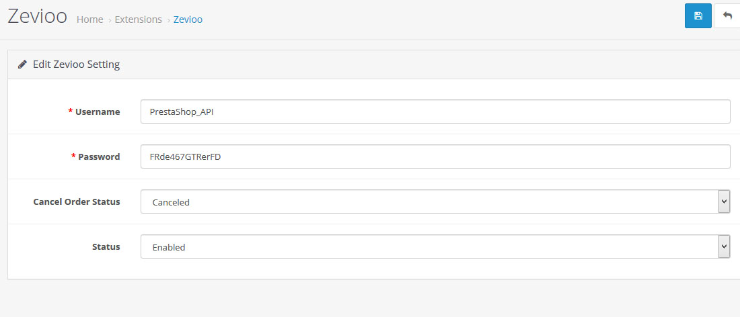

1. Insert Zevioo username and password, choose ‘Cancel Order Status’ = Cancelled, choose status = Enabled, then save the setting form.

That’s all, you have successful installed Zevioo into Opencart 2.x