## Lab 9-01: Azure Resource Locks

### Service Introduction

Acme Software, a rapidly growing software development company, embraced the cloud for its infrastructure. However, their agile development process resulted in concerns about accidental deletions or modifications of critical resources, potentially causing outages and data loss. They needed a way to prevent human error while still enabling agile development.

### Problem

The fast-paced environment led to accidental resource deletions or modifications by developers, causing service disruptions and costly downtime. Lack of control over resource configuration raised compliance concerns and made it difficult to enforce internal security policies consistently.

### Solution

Acme Software's success story showcases the power of Azure Resource Lock for cloud-based companies prioritizing both agility and security. By introducing preventive measures, granular control, and seamless integration, Acme achieved peace of mind knowing its infrastructure was protected from accidental disruptions while still empowering its developers to innovate.

|  |
| --- |
| 1. Log in to the **Azure Portal** using your credentials.  **Azure RBAC Role Assignment**  2. From the portal home page, search and open **Resource groups.**    3. A list of resource groups will appear; click on your **resource group.**    4. From the overview page of your resource group, click on **Access control (IAM).**    5. Inside the Role section, click on view to see the **Contributor role.**    6. Analyze the available permissions.    **Manage Resource Locks**  7. To understand the Lock feature provided by resource groups, go to your resource group from the main menu and open its overview pane.  8. After that, click on **Lock** present under the **Settings** section.    9. Specify the lock name, and to prevent the deletion of your resource group, you should set **Delete** lock. Click on **OK.**    **Note:** You need to specify the notes to enable it.  10. You will see that the lock has been successfully created.    11. To verify this lock, go to the overview page of your resource group and click on Delete resource group.    12. Try to delete the resource group and check whether the lock feature is working or not.    13. The following notice should appear. |

## Demo 9-01: Azure Monitor

1. Login to Azure Portal and go to “**Monitor.**”

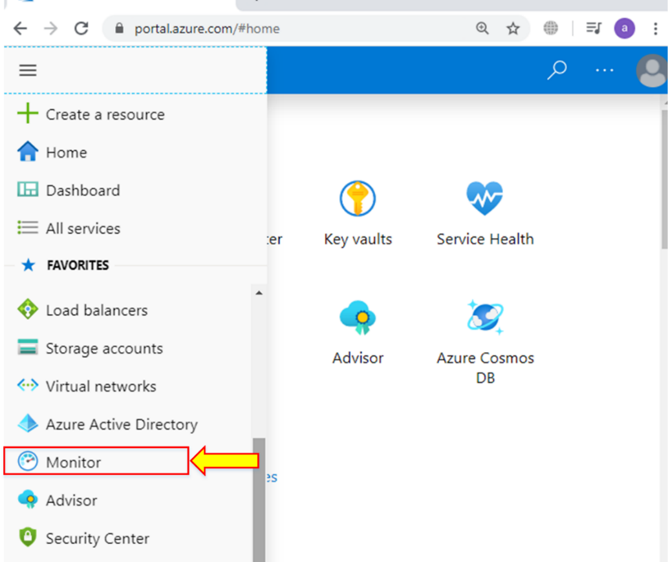

1. Here is an overview of the monitor.

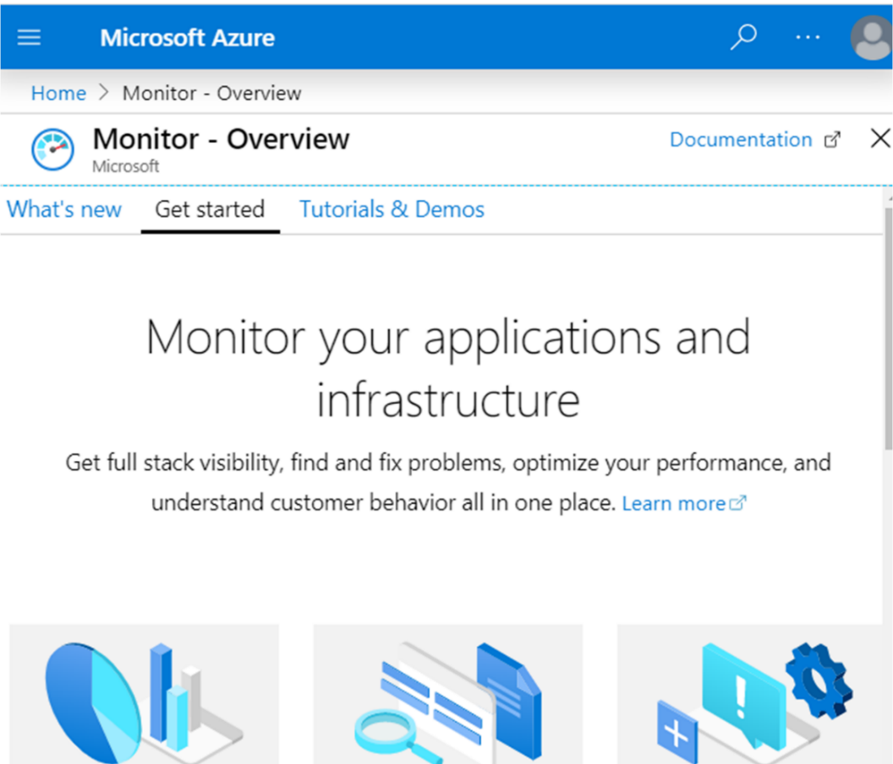

1. Now, go to “**Service Health**” from the left side of the window.

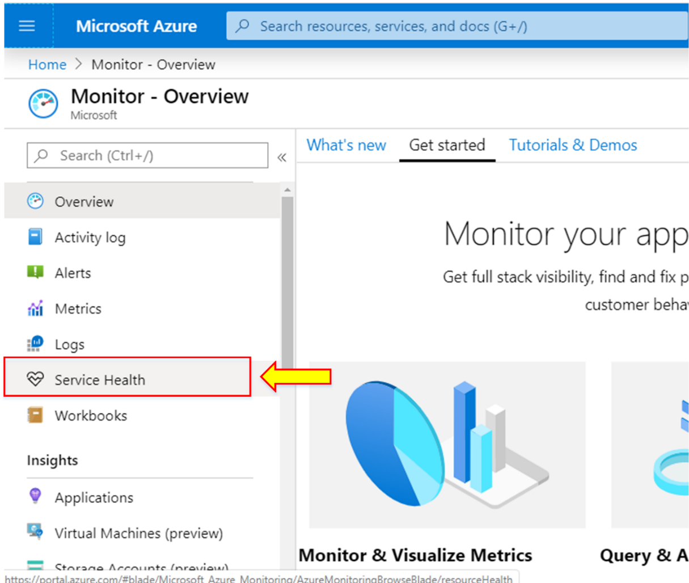

1. Currently, it shows that no issue has been found. It will alert you of any issue in the services if found.

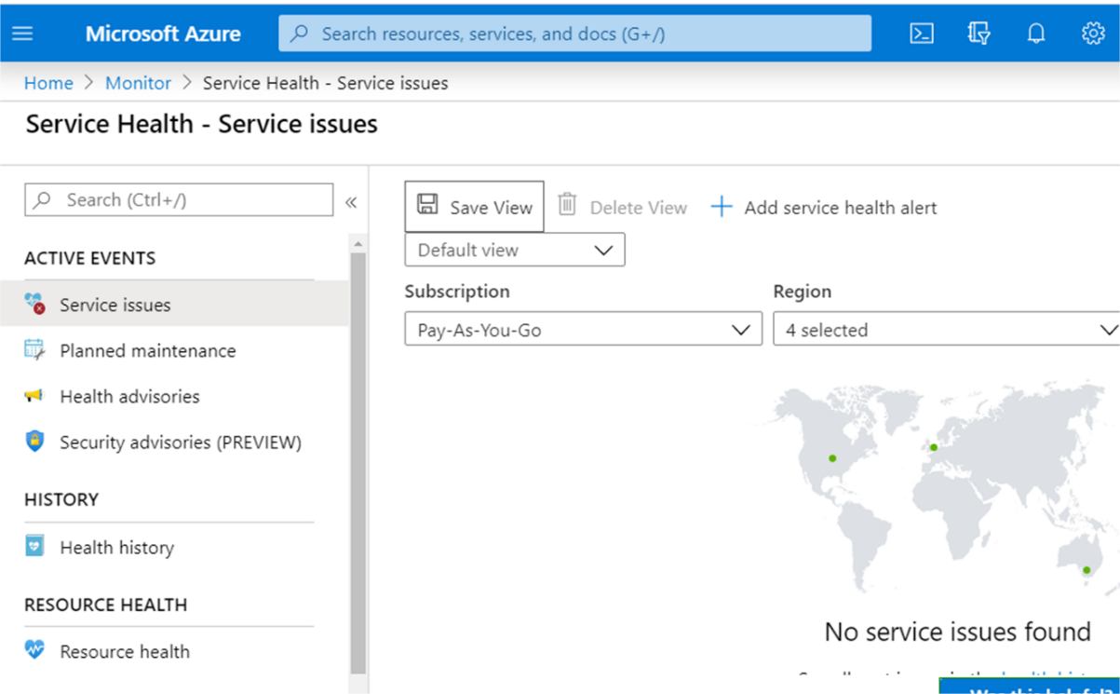

1. If you click “Planned maintenance,” it will show any upcoming or scheduled planned maintenance events.

