## Demo 12-01: Using Preview Services

1. Go to the following preview portal link: <https://preview.portal.azure.com/#home>. Here, you will see a preview option on top of the portal. It differs from the Azure portal as it contains all the services and products in the preview state.

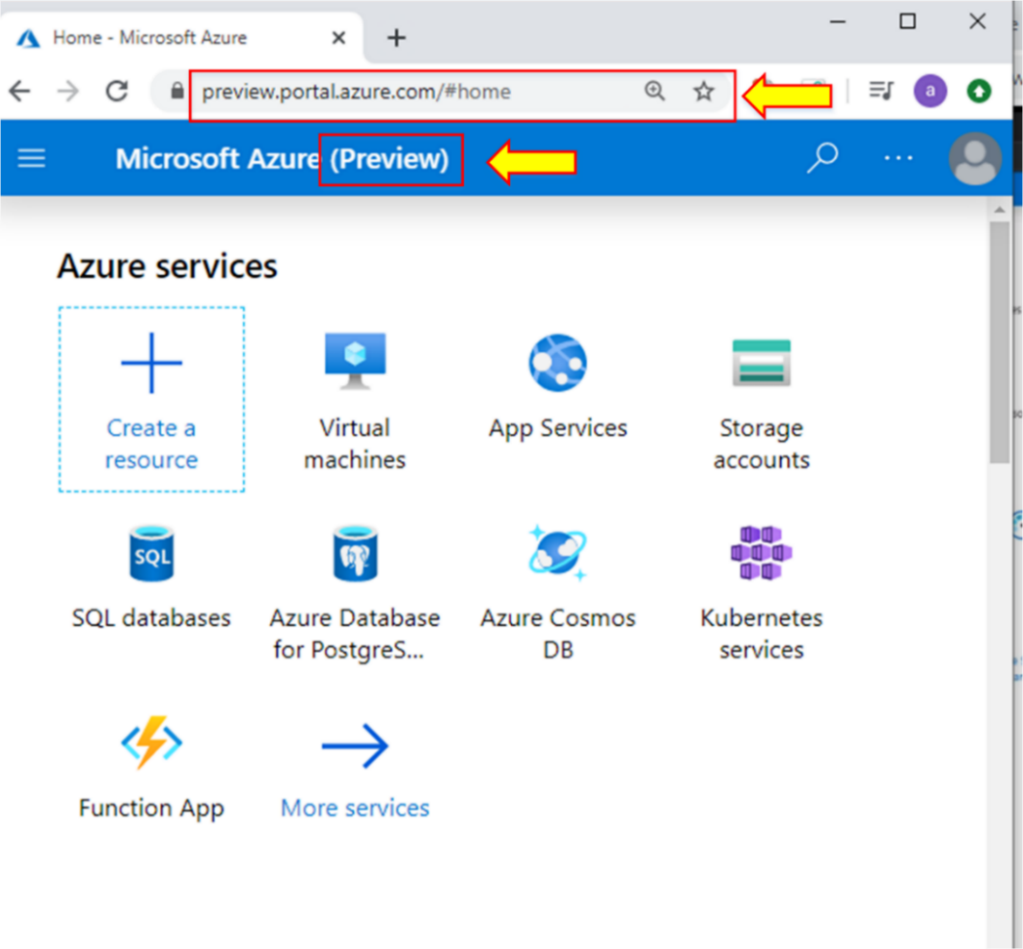

1. If you search the Virtual machine for “**Bastion hosts,”** you will see that option here.

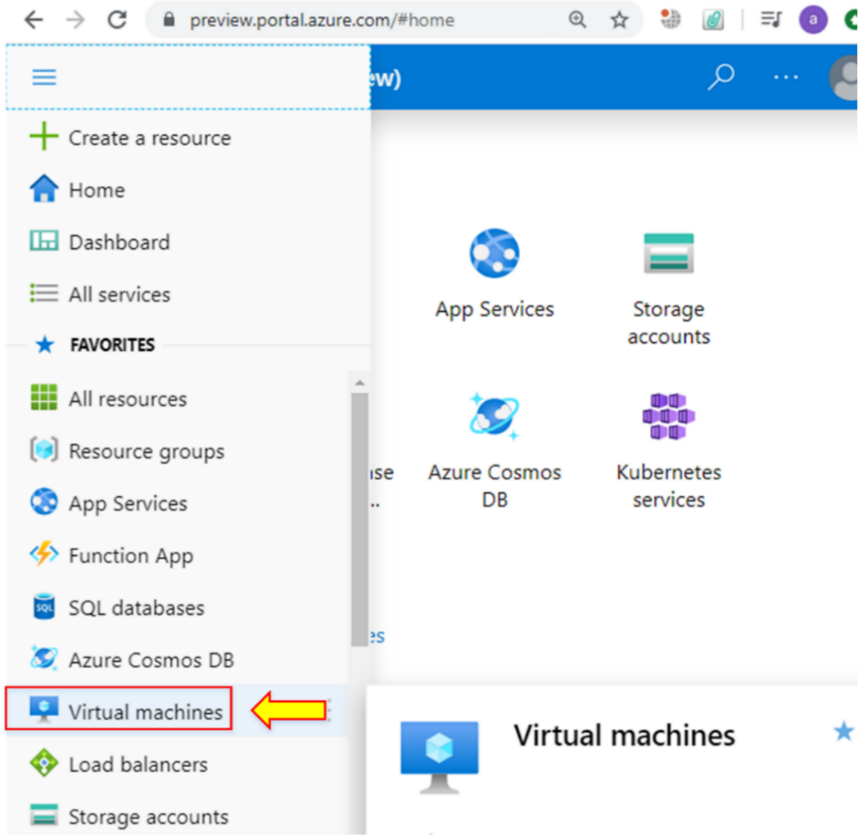

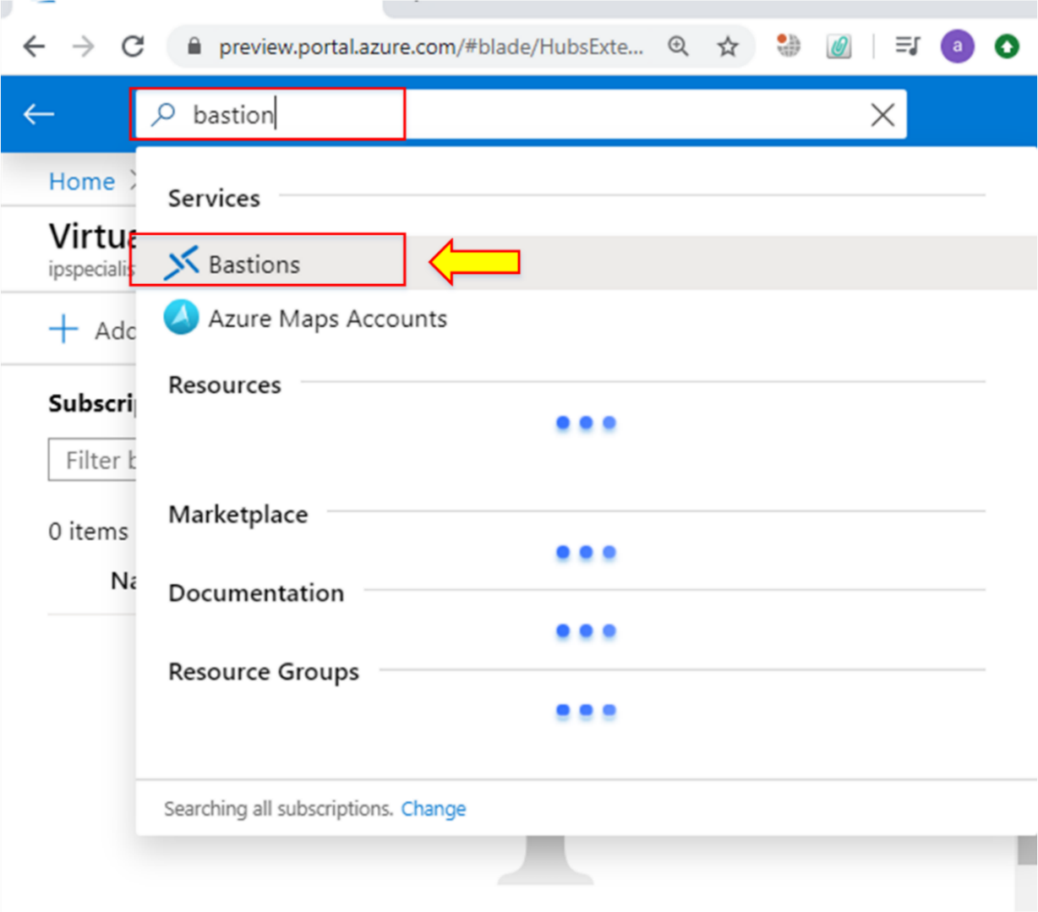

**Note:** Go into that service and create it if you want. From this preview portal, you can view all the currently unavailable products on the Azure portal.