## Lab 2-03: Quotas

### Lab Prerequisites

* Familiarity with basic Google Cloud Computing concepts and terminology.
* A Google account with an active subscription.

### Service Introduction

GCP quotas, or Google Cloud Platform quotas, are limits set on the usage of certain resources and services within the Google Cloud Platform. These quotas are in place to prevent abuse, ensure fair usage, and maintain the stability and reliability of the platform. Quotas are set on various metrics such as usage, requests, storage, and processing power and can be adjusted by project administrators as needed. By keeping track of quotas, users can ensure that their projects stay within budget and avoid any unexpected usage charges.

Case Study Wool manufacturers – YarnCo

Background

YarnCo, a wool manufacturing company, deals with large multinational clothing brands by providing raw materials for their products. Considering that they already have working contracts, they have almost neglected their website and social media presence.

The website is deployed on Google Cloud, but nobody manages it, and there is little to no traffic on it.

### Business Challenge

YarnCo’s neglect of their website had cost them financially due to an error. The GCP account was compromised, and the perpetrator used the already deployed VM instance to mine crypto.

The company filled the gaps in their GCP account but still needed a cap on the VM instance.

### Proposed Solution

You, as a Cloud Architect, propose the use of GCP quotas to limit the usage of the resources.

Lab Diagram

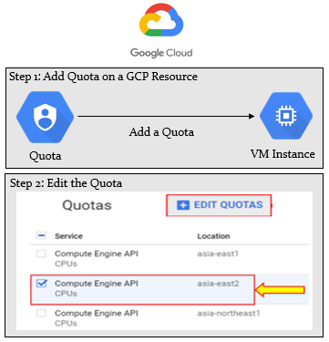

Figure 2-06: Lab diagram

Implementation Steps

1. Add a quota on a GCP resource.
2. Edit the quota.

Solution

|  |
| --- |
| 1. Sign in to GCP Console.      1. Go to “IAM” > “Quotas”.     Quotas represent everything that is currently in use.     1. As you can see, the location can be set as Global or Regional. There are limits on Global Quotas for the number of resources in the entire project, regardless of the region you are working with. Regional Quotas are limited to the number of resources in a given region.     You will have different menus in Quotas.     1. In Quota type, you can select the type of quotas.      1. In Services, you can see multiple services working on the project. You can select any one or all of them at the same time. 2. For this example, select the Compute Engine API. 3. First, you need to select “None” to deselect all, then select your desired service.        1. In the “Metric” section, select “CPUs”.      1. In “Location”, select “All locations”.      1. Now you can check the Compute Engine APIs working across all the regions with their CPU utilization. 2. You can also edit the quotas. 3. Select the quota and click on “EDIT QUOTAS”.      1. This will bring up the forum for quotas increase.          1. You can submit your quota increase request. |