NAME OF STUDENT : ........................................................... …………STUDENT NUMBER : ...........................................

SUBJECT  TECHNICAL PROGRAMMING 2 (3) | DATE  2nd November 2012 | TIME  2 HOURS


FACULTY OF INFORMATICS AND DESIGN

COURSE(S): ND: INFORMATION TECHNOLOGY

EXAMINER : MR B KABASO
INTERNAL MODERATOR : Mr K NAIDOO
EXTERNAL MODERATOR : Mr C KABUYA

SPECIAL INSTRUCTIONS/SPESIALE INSTRUKSIES

This Test is NOT an Open Book Exam
There are three sections in this paper and answer ALL sections
Write ALL YOUR answers in the GRID and ANSWER BOOK provided
Both question paper, answer grid and answer book should be handed back to the invigilator
ALL cell phones should be switched off. Even Silent mode is not allowed.

REQUIREMENTS
AnsWER BOOK AND ANSWER GRID

SECTION A
This section has 10 questions and each question carries 1 mark

- You are asked to interface with a class in an existing system, but the interface does not match the interface you need. Which design pattern would you use?
  - Decorator
  - Abstract Factory
  - Command
  - Adapter

- What does the acronym ACID when used in the context of Transactions stand for ?
  - Atomicity, Consistency, Isolation, Durability
  - Atomicity, Concurrency, Isolated, Durable
  - Authentication, Concurrency, Isolation, Duration
  - Attention, Consistency, Insolation, Dependability

- One of the variables that has impact on the service level requirement is Capacity. What does Capacity denote?
  - Workload that has been completed
  - Workload that is currently being undertaken
  - Workload that could be performed
  - Throughput of the workload

- Domain Driven Design is a set of:
  - Software Implementation Frameworks
  - Software Architecture Best Practices
  - Software Development APIs
  - Software Domain Technology

- Which of the statements is false:
  - There are various forms of testing and not all are done in code
  - Unit tests are relatively inexpensive
  - Sometimes testing involves extensive involvement of the end users
  - Code used for finding bugs will never have bugs

- Which of the following headings will you not find on a design pattern template?
  - Intent
  - Known Issues
  - Ontology
  - Consequences

- The Template Pattern is used to
  - Define the steps of an algorithm intended to be distributed via inheritance
  - Add functionality by wrapping objects
  - Decouple abstraction and implementation
  - Provide a single interface to a set of classes

- Which pattern would you use to create a complex object and have the assembly and parts independent?
  - Prototype
  - Singleton
  - Builder
  - Abstract Factory

- You have an Enterprise class that represents a customer's account. One of the methods that this class provides is deductCost(float amount) This method is used when a customer buys something from your company's website. This method must be executed as part of an existing transaction. What is the correct attribute setting on the method?
  - REQUIRED
  - REQUIRES NEW
  - SUPPORTS
  - MANDATORY

- You are designing an application that will need to use SSL to transmit data securely from one application to another. You know that you can easily get hold of existing implementations of SSL to use in your application but you'd like to learn more about SSL and have decided to implement your own version. You know that as part of the SSL handshake the client and server must agree a method of encryption. The problem is you don't know which method of encryption that will be. Which design pattern will help with this? Note: This is not a web-based application.
  - Decorator
  - Interpreter
  - Strategy
  - Composite
  - Template Method

--END OF SECITION A—

SECITION B (30 marks)
This section has 15 questions and each question carries 2 marks

- Object Orientation is defined by several major aspects, including inheritance and to a lesser degree abstraction. Name two other principles of Object Orientation.

- Name the two benefits that OO principle of Inheritance facilitates with your code

- What are the two benefits of using a Repository /Data-Mapper Pattern:

- Test Driven Development is usually broken up into three parts (as seen in the motto commonly associated with TDD). What are the first 2 phases called and what occurs in these phases?

- The GOF defined 3 categories of patterns. Name any 2 of these as well as the core focus of these categories.

- What are the 2 forms that an Adapter Pattern can take and explain the difference?

- What are the 2 types of duplication that can occur and how easy is each one to find?

- What are the two methods of scaling the performance of a system and how are they usually accomplished?

- Name and briefly explain any 2 of the ACID properties of a Transaction.

- List the two benefits of the Façade pattern?

- Good Software design should have high cohesion and low coupling. What is meant by high cohesion and low coupling in software design?

- Switch statements (or their equivalent, ifelseifelseif structures) are not inherently bad. They become bad only when they make your design more complicated or rigid than it needs to be. In that case, it is best to refactor away from switch statements to a more object-based or polymorphic solution. Which two design patterns can be used to address the issue above?

- In Domain-driven design (DDD), what is the difference between Entity Objects and Value Objects?

- Explain these Terms in Domain-driven design (DDD): Aggregates and Factories.

- The Dependency Inversion Principle (DIP) formalizes the concept of abstract coupling. What is abstract coupling and what is its significance in software design?

--END OF SECITION B—

SECTION C: (50 Marks)
This section has 5 questions and each question carries 10 marks

Question 1
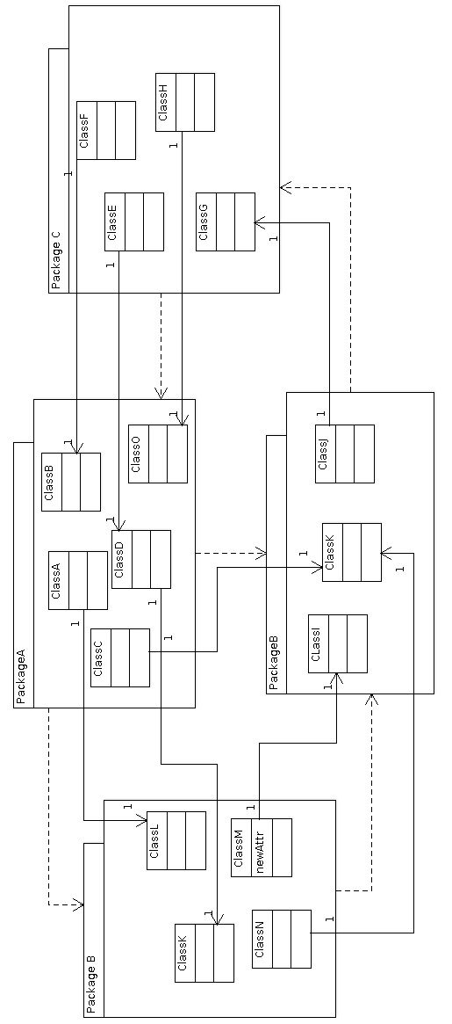

The diagram on the previous page shows the Domain Model of an application with entities housed in packages namely Package A , Package B package C and Package D. The Diagram also show package dependencies and the actual classes that the responsible for these dependencies.

- Name the Packages that are involved in the violation of the packaging principle called the Acyclic Dependencies Principle (ADP). (1 Mark)

- Calculate the Instability of of each of the four packages
(4 Marks)

- c) Explain the the instability value and list the packages in the order of increasing stability (2 Marks)

- d) Explain what you would do to fix the ADP violation mentioned in question a)
(3 Marks)
Question 2:

@Transactional(propagation= Propagation.REQUIRED)
public void transferMoney(BigDecimal amount){
withdrawFromAccountA(amount);
depositIntoAccountB(amount/3);
depositIntoAccountC(amount/3);
depositIntoAccountD(amount/3);

}

The code snipped above shows the method used to move money from one account A to three other account B, C, and D. The method distributes the amount withdrawn from A to the other accounts equally.

Given that Account A has R3 000.00 , Account B has R 1 000.00, Account C has R 1 500.00 and Account D has R 4 000.00 and that the underlying data store for all the accounts is a Relational Database that supports Transactions, answer the following questions that follow.

- If an application NOT in a Transaction calls the method transferMoney(1 500.00) and the method depositIntoAccountC(amount/3) throws an exception, forcing the transfer method to exit. What will be the balance in all the four accounts? (2 Marks)

- If the Transaction demarcation attribute of the method transferMoney is changed to NEVER, and the scenario described in question a is maintained, what will be the balance in all the four accounts. (2 Marks)
- Assuming that that the data the storage for Account B and D are in a NoSQL database called HBASE, which does not support transactions, what will be the balance in all four accounts if an outside applications NOT in a transaction calls the method transferMoney(3 000.00) and method depositIntoAccountC(amount/3) throws an exception forcing the transferMoney method to exit?

(2 Marks)
- Explain your results in a), b), c)
(3 Marks)

- What is the effect on Transactional Consistency by scenario described in c) (1 Marks)
Question 3

Consider the following Scenario where three people are accessing a table with the following records shown below . Assume that the underlying data store supports transactions and the clients are accessing this data by calling methods with a Transaction Demarcation attribute REQUIRED.

Accounts | Name | Balance
1 | Chanda Phiri | R 10 000. 00
2 | John Banda | R 12 000.00
3 | Peter Mathews | R 13 000 .00
4 | John Dole | R 14 000.00
5 | Bubu Chicken | R 20 000. 00

Consider the following steps and answer the questions that follow

- Paul opens a database transaction, T1, and SELECTs everything from the Accounts table.

- Brian initiates a separate transaction, T2, to DELETE an account record 2 belonging to John Banda from the Account table.

- Brian, still in his same T2 transaction, UPDATEs a record in the Account table, correcting a Bubu to Vuvu.

- Paul, still in his same T1 transaction, SELECTs all accounts of data in the Account table a second time.

- Brians transaction, T2, COMMITs.

- Mary initiates a new transaction, T3, and INSERTs a new account with balance R150 to the Accounts table table.

- Paul, still in his same T1 transaction, SELECTs all pieces of data in the Account table a third time.

- Mary's T3 transaction COMMITs.

- Paul, still in his same T1 transaction, SELECTs all pieces of data in the Accounts table a fourth time.

- Pauls transaction, T1, finally COMMITs.

- With the help of examples, explain what a dirty read and phantom reads are and state their key differences. (4 Marks)
- b) If the Transaction isolation level is set to READ UNCOMMITTED , what results will Paul see in each of his 3 SELECTS? (2 Marks)
- c) If the Transaction isolation level is set to READ COMMITTED , what results will Paul see in each of his 3 SELECTS? (2 Marks)
- d) If the Transaction isolation level is set to REPEATABLE READ , what results will Paul see in each of his 3 SELECTS? (2 Marks)

Question 4:
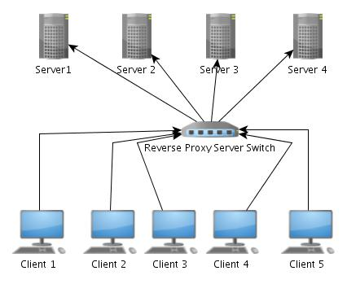

Over the years, software and system engineering practices have developed many best practices for improving systemic qualities. Many infrastructure-level practices for improving systemic qualities rely on using redundant components in the system . The diagram above shows an architecture that has three Servers, Server 1, Server 2, Server 3 and Server 4 to provide redundancy. The four servers are placed behind a Reverse Proxy Server as shown above.

The Reverse Proxy Server implements load balancing to address architectural concerns, such as throughput and scalability and receives requests from the clients shown in the diagram as Client 1, Client 2 , Client 3, Client 4 and Client 5.

- What is meant by Load balancing and name one advantage of using loading balancing in an architectural set-up? (2 Marks)
- Assuming that the load balancing strategy used by the reverse proxy is Round Robin, the Server 2 is down and that each client sequentially sends 1 request per second, (with Client 1 firing the requests first and Client 5 firing the request last) , which clients will report server not found? (2 Marks)
- c) If the client in b) send 2 requests per second, which clients will report 50% failure of the requests sent? (2 Marks)
- d) Name and explain two strategies that can be used to guarantee 100% server availability despite the failure of Server 2 (4 Marks)
Question 5:

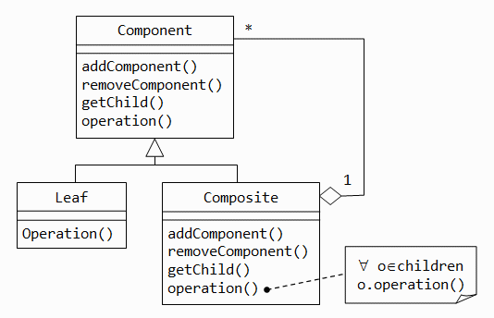

The above diagram shows the structure of a Composite Design pattern. Study the diagram and answer the questions that follow.

- Explain the Composite pattern and state the kind of problems it is used for. (3 Mark)
- What design Pattern has a simliar structure to the Composite Design Pattern. (1Mark)
- Draw the structure of the design pattern you have suggested in b) (2 Marks)

- Describe and explain how you would use the pattern you mentioned in c) to solve software design problems (2 Marks)
--END OF SECITION C—

------------------------END OF PAPER----------------

