SECTION A: (20 Marks)
This section has 20 questions and each question carries 1 mark
- In an interview between the senior management of Happy Standard Banking Corporation and the Enterprise Application Architect Joe Superman, the following points were discussed:
- The system needed to respond within 5 seconds
- The system is needed to have a 99.9% uptime
- HSBC was in the process of acquiring another bank which would add two hundred thousand customers to their already existing half million.
- Each phase of the SDLC was to have a clear sign off process.
- The development team was expected to provide a detailed unit test plan and user documentation.
- In order to ensure privacy, HTTPS was to be used.

What non-functional requirements were discussed?
- Scalability, Availability, Extensibility, Manageability and Security
- Performance, Reliability, Elaboration, Transition, Documentation and Security
- Specification, Elaboration, Construction, Transition, Use Cases and Security
- Performance, Availability, Scalability and Security
- Reliability, Availability, Scalability, Manageability and Security
- N-tier applications show better performance than 2-tier applications because they are modular in nature, which means that they can be scaled easily, by tuning components and containers individually. True/False ?
- True
- False
- Julia Banda Inc. is building a Web Enterprise application for Order Entry and management of their clients software. Once the order is taken, it is submitted to a relational database. A provisioning system then queries data and makes appropriate calls to various subsystems using a messaging API. What design pattern is the messaging API an example of here?
- Observer
- Mediator
- Adapter
- Bridge
- Visitor

- Compact Computers is a small computer assembly company. Their online application allows customers to pick and choose accessories to build their own PCs. The accessories are:
- Processor – 1Ghz, 2Ghz, 2.8Ghz
- HDD - 140 GB, 160 GB, 80 GB
- Memory - 512 MB, 1 GB, 2 GB
If a computer can have exactly 1 processor, 1 HDD and 1 memory stick, what pattern would be best used here?
- Factory Method
- Builder
- Prototype
- Abstract Factory
- Singleton

- You have had enough with all the Graphic tools on the market as none do exactly what you want them to. So you've decided to design your own. However when designing it you realise that certain parts will be really complicated for example you have a Diagram object that is made up of lots of other objects. This diagram object can be used for a variety of different diagrams including class and sequence diagrams. When you create it you only want to specify its type and content. What pattern should you use?

- Abstract Factory
- Factory Method
- Builder
- Decorator
- You need to interface with an existing application. You have full access to the source code and UML diagrams from the existing application. Part of the requirements implies that you will need to connect unrelated objects together. You want to know whether the Bridge pattern or the Adapter pattern will be suitable. Which of the following is true about the Bridge and Adapter patterns?
- The Adapter pattern implements an interface known to its clients and provides an instance of a class not known to its clients and the Bridge pattern creates a separation between abstractions and classes that implement those abstractions.
- The Bridge pattern implements an interface known to its clients and provides an instance of a class not known to its clients.
- The Adapter pattern creates a separation between abstractions and classes that implement those abstractions.
- The Adapter pattern creates a separation between abstractions and classes that implement those abstractions and the Bridge pattern creates a separation between abstractions and classes that implement those abstractions.
- As part of your new application you need to create a custom (your own) class loader so that you can implement with custom security. So you need to create objects without knowing the class of the objects or how to create them. What pattern should you use for this?
- Abstract factory
- Factory Method
- Builder
- Prototype
- Singleton

- You are creating a web application for an online product ordering system. You will be using data from several different databases and to reduce the load on the databases you have decided to use connection pooling in your data layer. You have a ConnectionPool class and you want one pool for each database however you will have to connect to a variable number of databases. What pattern should you use?
- Abstract factory
- Factory Method
- Builder
- Prototype
- Singleton

- You have a method that can execute in a transaction as part of that transaction but it doesn't matter if it doesn't. What is the correct demarcation attribute to use?
- Supports
- Not Supported
- Mandatory
- Required
- Leave is empty as this is the default setting

- What is the most important item in this list that should be considered when designing an application?
- Scalability
- Maintainability
- Reliability
- Meeting the needs of the customer
- Ensuring the application is produced on time and within budget
- That the application is technically the best possible solution
- You are designing an application to be used to edit photographs. The aim of the application is to provide effects such as converting a color picture to black and white, enlarging certain areas of the print, creating a watercolor effect etc. At the moment the application is structured so that the photographic image is represented by one object, other objects represent each effect and a control object is used to co-ordinate with these objects. When the user selects the color to black and white effect it changes the state of the Color object to Black and White. This then needs to co-ordinate with the control object and apply the effect. Basically as the state of the effects objects changes it need to co-ordinate with the photographic image object.Which design pattern do you use?
- Chain of Responsibility.
- Notifier
- Observer
- Mediator
- Command
- State

- You are designing an application that will need to use SSL to transmit data securely from one application to another. You know that you can easily get hold of existing implementations of SSL to use in your application but you'd like to learn more about SSL and have decided to implement your own version. You know that as part of the SSL handshake the client and server must agree a method of encryption. The problem is you don't know which method of encryption that will be. Which design pattern will help with this? Note: This is not a web-based application.
- Decorator
- Interpreter
- Strategy
- Composite
- Template Method

- You are an IT Lecturer at Cape Peninsula University of Technology. You are giving a presentation of a new piece of software you have written. Basically you have written the next generation spell checker, the reason yours is so good is that it can learn the common typing mistakes of an individual user. You have already sold licenses to many major software vendors and plan to retire. However before you go they all require slight changes in the logic to suit their individual needs. What design pattern will help you slightly change the logic in a class to be used in many applications?
- Strategy
- Adapter
- Mediator
- Interpreter
- Template Method
- In which of the following situations would you use the Observer pattern?
- When you need to co-ordinate state changes between other objects by using one object.
- You want one object to monitor when the state of another object but you don't want the object being monitored to need to send any messages regarding its state.
- When the instances of your class can be use interchangeable and you want to reduce the number of instances created in order to improve performance.
- You are building an online auction site to sell rare and collectable toys. You want customers to be notified of bids on items they are bidding for in as close to real time as possible. You would use the Observer pattern to notify the customer objects of changes in the auction object.

- You need to access a complex object in a recursive way…building the object from other objects. This is an example of which pattern?
- Abstract Factory
- Factory Method
- Builder
- Composite
- Recursive Builder

- You are currently designing your own Desktop Publishing application, as you have not found any that do exactly what you want with existing applications. As part of the design you are using a Controller to which you send all GUI requests. Not all objects can process the same commands. For example you can't select the spell check tool when an image has the focus. To stop any possible errors you would like to filter out some of the messages as they are passed from these objects to the Controller object. What pattern could you use?
- Firewall
- Proxy
- Adapter
- Observer
- Chain of Responsibility
- Filter

- When would you use the Visitor pattern?
- You need two unconnected objects to be able to send messages to each other.
- You need two connected objects to be able to send messages to each other.
- You need to create a new operation on an object and you will change the classes of elements on which it operates.
- You need to create a new operation on an object without changing the classes of elements on which it operates.

- Your have been contracted by a company to help them improve the performance of their sales application. You have suggested that the hardware the application is currently deployed on (2 web servers and a database server) be migrated to 3 web servers, an application server and a database server (all on different machines.) You assure them that all the software re-writes needed will be well worth it in the end. What are the characteristics of your suggested architecture?
- Fat Clients
- Thin Clients, Good separation of business logic, Good Scalability
- Poor separation of business logic
- Poor scalability
- There is no difference in the separation of business logic

- You have just bought a brand new dual processor server with over 3 Gigabytes of memory, the fastest server in its class. This server will host Apache Web server (shipped with the Oracle Database) and an Oracle 8i database. What are the most notable weaknesses of this architecture?
- Scalability
- Manageability
- Security
- Performance

- You have an Enterprise Bean that represents a customer's account. One of the methods that this bean provides is deductCost(float amount) This method is used when a customer buys something from your company's website. This method must be executed as part of an existing transaction. What is the correct attribute setting in the deployment descriptor?
- REQUIRED
- REQUIRES NEW
- SUPPORTS
- MANDATORY

--END OF SECITION A--

SECITION B (30 marks)
This section has 15 questions and each question carries 2 marks
- List two benefits of Test Driven Development.

Any of these
- The suite of unit tests provides constant feedback that each component is still working.
- The unit tests act as documentation that cannot go out-of-date, unlike separate documentation, which can and frequently does.
- When the test passes and the production code is refactored to remove duplication, it is clear that the code is finished, and the developer can move on to a new test.
- Test-driven development forces critical analysis and design because the developer cannot create the production code without truly understanding what the desired result should be and how to test it.
- The software tends to be better designed, that is, loosely coupled and easily maintainable, because the developer is free to make design decisions and refactor at any time with confidence that the software is still working. This confidence is gained by running the tests. The need for a design pattern may emerge, and the code can be changed at that time.
- The test suite acts as a regression safety net on bugs: If a bug is found, the developer should create a test to reveal the bug and then modify the production code so that the bug goes away and all other tests still pass. On each successive test run, all previous bug fixes are verified.
- Reduced debugging time!

- Give Two Characteristics of a Good Unit Test.

Any of these
- Runs fast, runs fast, runs fast. If the tests are slow, they will not be run often.
- Separates or simulates environmental dependencies such as databases, file systems, networks, queues, and so on. Tests that exercise these will not run fast, and a failure does not give meaningful feedback about what the problem actually is.
- Is very limited in scope. If the test fails, it's obvious where to look for the problem. Use few Assert calls so that the offending code is obvious. It's important to only test one thing in a single test.
- Runs and passes in isolation. If the tests require special environmental setup or fail unexpectedly, then they are not good unit tests. Change them for simplicity and reliability. Tests should run and pass on any machine. The "works on my box" excuse doesn't work.
- Often uses stubs and mock objects. If the code being tested typically calls out to a database or file system, these dependencies must be simulated, or mocked. These dependencies will ordinarily be abstracted away by using interfaces.
- Clearly reveals its intention. Another developer can look at the test and understand what is expected of the production code.

- What is subversion and why is it important in the management of a software group project
Subversion is a centralized system for sharing information. What makes the Subversion repository special is that it remembers every change ever written to it: every change to every file, and even changes to the directory tree itself, such as the addition, deletion, and rearrangement of files and directories.
- Name and explain the two types of file conflict methods used for managing source code sharing in Software applications such as Subversion and CVS
A lock-modify-unlock model- In such a system, the repository allows only one person to change a file at a time.
A copy-modify-merge model- a copy-modify-merge model

- Because HTTP is a request-response protocol, individual requests are treated independently. Consequently, Web-based enterprise applications need a mechanism for identifying a particular client and the state of any conversation it is having with that client. Name two common methods used to keep this conversation state?
Cookies and URL re-writing
- What class of design patterns ( creational, structural, etc) has the following characteristics
  - Deal with the details of assigning responsibilities between different objects
  - Describe the communication mechanism between objects
  - Define the mechanism for choosing different algorithms by different objects at runtime
Behavioral
- Explain the difference between FORM Authentication and BASIC Authentication
FORM uses a form and action method. Basic uses a pop up window and transmit text using no encrption
- Two of the ACID properties of transactions are ATOMICITY and DURABILTY. Explain what each of these terms mean.
Atomicity—Either all steps of a transaction succeed or none succeed.
Durability—Committed data is permanent and survives any system crashes.
- What is encapsulation and what design problem in software does this OO principle address

Encapsulation refers to the creation of self-contained modules that bind processing
functions to the data. Encapsulation enforces modularity.
- Explain how inheritance breaks encapsulation and name the alternative method to inheritance

Inheritance dictates that a child class (subclass) inherits all the attributes
and methods from a parent class (superclass).

Encapsulation dictates that one class must not have access to the (private)
data of another class.

Favour composition over inhereitance

- What is polymorphism and what benefits does it bring to software design
Polymorphism takes any shape. Object-oriented programming allows procedures about objects to be created whose exact type is not known until runtime.
- Good Software design should have high cohesion and low coupling. What is meant by high cohesion and low coupling in software design
High cohesion-objects or classes are highly specialized; Low coupling-There is little collaboration between classes to fulfill a task
- Which of the following is not a benefit of using Design Patterns?
  - They provide a common language for design discussions
  - They provide solutions to “real-world” problems
  - They communicate the insight already gained previously
  - They provide solutions to totally novel problems
D
- What other name is given to the Principle of Least Knowledge and explain what this principle mean.

The Principle of Least Knowledge (PLK) is also known as the Law of Demeter. The basic idea is to avoid calling any methods on an object where the reference to that object is obtained by calling a method on another object. Instead, this principle recommends we call methods on the containing object, not to obtain a reference to some other object, but instead to allow the containing object to forward the request to the object we would have formerly obtained a reference to. The primary benefit is that the calling method doesn’t need to understand the structural makeup of the object it’s invoking methods upon.
- What do the terms non-repudiation and authorization in software security?
non-repudiation-players cannot deny their identity or actions in the system. Authorization-players are give roles or rights as to what they can do in a system
--END OF SECITION B--

SECTION C: (50 Marks)
This section has 5 questions and each question carries 10 marks
Question 1:
- What is Unit Testing, Mock Testing and Integration Testing (1 marks)
A unit test is a piece of code written by a developer that exercises a very small, specific functionality of the code being tested. Mock testing is unit test on separated interfaces to test method calls through an Interface. Integration test is test conducted when two separate systems are joined together to check if they can work in a new system

- Define what a Test suite is and describe the advantage of using Test Suites (1 marks)
It is a test class can also invoke other test classes: individual classes, packages, or even the whole system. Saves time in running test as your project grow bigger

- List the four steps involved in building Test cases ( 1 marks)
- Setup all conditions needed for testing (create any required objects, allocate any needed resources, etc.)
- Call the method to be tested
- Verify that the method to be tested functioned as expected
- Clean up after itself

- What is the Test Driven Development Philosophy (1 mark)
Build Test cases based on the requirements and make them first fail and then make them pass
- The motto of Test-Driven Development is "RED, GREEN, REFACTOR.” Explain what each of the three terms-RED, GREEN and REFACTOR mean ( 6 marks)

RED: Create a test and make it fail.
GREEN: Make the test pass by any means necessary.
REFACTOR: Change the code to remove duplication in your project and to improve the design while ensuring that all tests still pass.

Question 2:
- Most web applications are based on the traditional design pattern called MVC pattern. Explain what the MVC pattern is and fully describe the roles played by each of the three components involved in the MVC pattern. (3 marks)

Model–view–controller (MVC)pattern is an architectural pattern used in software engineering. Successful use of the pattern isolates business logic from user interface considerations, resulting in an application where it is easier to modify either the visual appearance of the application or the underlying business rules without affecting the other. In MVC, the model represents the information (the data) of the application; the view corresponds to elements of the user interface such as text, checkbox items, and so forth; and the controller manages the communication of data and the business rules used to manipulate the data to and from the model.

- On the internet today there are two types of web applications, that is those based on the request response model an those based on the event based model
  - Describe the difference between the two models (3 marks )

In request/response frameworks MVC frameworks work in terms of whole requests and whole pages. In each request cycle, the incoming request is mapped to a method on a controller object, which then generates the outgoing response in its entirety, usually by pulling data out of a model to populate a view written in specialized template markup.

In Events based frameworks , on the other hand, the framework is closely patterned after stateful GUI frameworks such as Swing. Event based frameworks applications are trees of components, which use listener delegates to react to HTTP requests against links and forms in the same way that Swing components react to mouse and keystroke events.

  - With the aid of a diagram describe the life-cycle process of Request/Response model (4 marks)
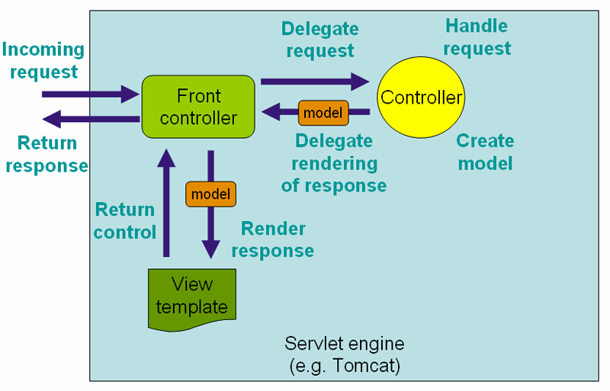

Question 3:
Isolation levels deal with concurrency issues that arise when two or more transactions are simultaneously operating on the same data. There are three problems that can occur with concurrent transactions: the dirty read, unrepeatable read, and phantom read problems. Explain, with the aid of an example, what each of the three problems men and suggest what isolation-levels address the issues named (10 marks)
The dirty read problem can be described by the following scenario:
An account entity initially has a balance of 100.
Transaction 1 updates the balance to 200.
Transaction 2 reads new balance of 200.
Transaction 1 rolls back restoring the balance to the original value of 100.
Transaction 2 now has an incorrect, or dirty, value of 200.
The unrepeatable read problem can be described by the following scenario:
Transaction 1 reads account id and balance for all accounts with balance less than 150.
Transaction 2 updates an account entity changing its balance from 100 to 200.
Transaction 1 reads the data again including detailed information such as account name
An account which appeared in the initial summary read is not present in the second detailed read.
This problem only occurs where there are multiple reads in same transaction. In many cases the reads will be in separate transactions so this problem is fairly rare.
The phantom read problem can be described by the following scenario:
Transaction 1 reads account ID and balance for all accounts with balance less than 150.
Transaction 2 adds a new account entity with a balance of 100.
Transaction 1 reads the data again including detailed information such as account name
A new account now appears in the second detailed read which was not present in the initial summary read.
A phantom read is similar to the unrepeatable read, except that data is inserted rather than updated by the second transaction.
There are four transaction isolation levels: Read Uncommitted, Read Committed, Repeatable Read, and Serializable.
The Read Uncommitted level will allow transactions to read uncommitted data written by a concurrent transaction and so allow dirty reads. Unrepeatable reads and phantom reads may also occur with this level.
The Read Committed level will prevent transactions from reading uncommitted data written by a concurrent transaction. Dirty reads are thus prevented, however unrepeatable reads and phantom reads may still occur.
The Repeatable Read level ensures that whenever committed data is read from the database, subsequent reads of the same data in the same transaction will always have the same values as the first read. So the unrepeatable read problem is prevented. Phantom reads can still occur.
The Serializable level is the strictest isolation level and prevents dirty reads, unrepeatable reads and phantom reads.

Question 4:
- State the meaning of each of the following Design Principals
  - Open Closed Principle (2 marks)
Classes should be open for extension but closed for modification.

  - Liskov Substitution Principle (2 marks)
Subclasses should be substitutable for their base classes.
  - Dependency Inversion Principle (2 marks)

Depend upon abstractions. Do not depend upon concretions.The Dependency Inversion Principle (DIP) formalizes the concept of abstract coupling and clearly states that we should couple at the abstract level, not at the concrete level.

- Acyclic Dependencies Principle states that dependencies between packages must form no cycles. With the help of a diagram, draw UML diagram that violets ADP and draw a second one that fixes the violation (4 marks)

ADP Violation

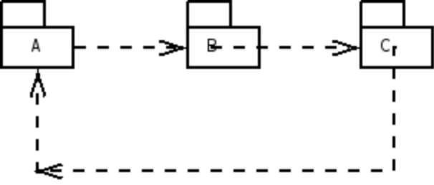

ADP Compliance

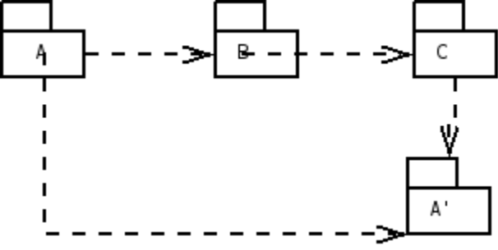

Question 5 :
- J2ME is the java technology for powering mobile devices.
  - Name two types of configurations and for each configuration list the requirements need on the device to run the configurations (2 marks)
CLDC
160 Kbytes to 512 Kbytes of total memory available
16-bit or 32-bit processor
Low power consumption and often operating with battery power
Connectivity with limited bandwidth.
CDC
2Mbytes or more memory for Java platform
32-bit processor
High bandwidth network connection, most often using TCP/IP

  - What is the difference between MIDP and MDLETS and (2 marks)

MIDP is a Profile and has a set of APIs that allow developers to control mobile device-specific problems
  - i.e. user interfaces, local storage and client application lifecycles etc. Midlet is part or subset of the MIDP profile and equivalent to Applets

  - List 4 minimum requirements are needed to run a MIDLET (2 marks)
96 x 54 pixels mono screen
two-way wireless network
input device (i.e. keypad)
128 KB for CLDC/MIDP class and another 32 KB for the KVM

  - With the aid of a diagram describe the lifecycle of a MIDLET(4 marks)

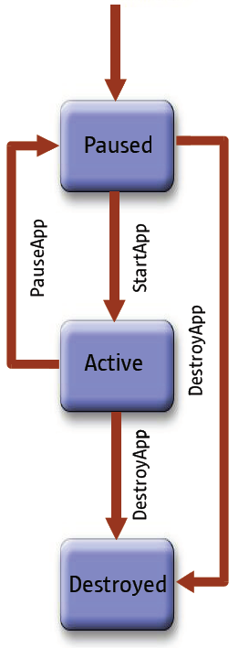

--END OF SECITION C—

------------------------END OF PAPER----------------

