**ANNEX 4**

**INDICATORS FOR CMS-LISTED AND MIGRATORY SPECIES.**

Compile by the Secretariat using information and analyses provided by BirdLife International - October 2019

1. **Introduction**

This annex has been compiled in this form by the Secretariat, using analysis provided by BirdLife International in the context of the assessment of progress in the implementation on the Strategic Plan for Migratory Species 2015-2023.

1. **Protected area coverage of Key Biodiversity Areas (KBAs)**

KBAs are 'sites contributing significantly to the global persistence of biodiversity’. The Global Standard for the Identification of Key Biodiversity Areas (IUCN 2016) defines the criteria by which KBAs are identified. The KBA dataset includes all Important Bird and Biodiversity Areas and Alliance for Zero Extinction sites. The KBAs are identified for particular species that meet one or more of the criteria for KBA identification.

These graphs show trends over time in the degree to which KBAs are covered by protected areas, based on overlaps between digital boundaries of KBAs from the World Database of KBAs and digital boundaries of protected areas from the World Database on Protected Areas. Methods are described at <https://unstats.un.org/sdgs/metadata/files/Metadata-15-01-02.pdf> (noting that the division into terrestrial and freshwater KBAs is not relevant in this context).

Each graph (Fig 1 to 7) shows the Mean percentage of each KBA covered by protected areas, and show trends for KBAs identified for migratory species (i.e. coded as ‘Full migrants’ on the IUCN Red List) and, separately, KBAs identified for species listed by the Convention on Migratory Species (CMS). KBAs triggered by congregations of ‘waterbirds’, ‘seabirds’ or ‘soaring birds’ exceeding 20,000 individuals (under IBA criterion A4) were included in the ‘migratory species’ indicator, given the majority of congregatory species in these groups are migratory. Confidence intervals are indicated in shading (see Methods above).

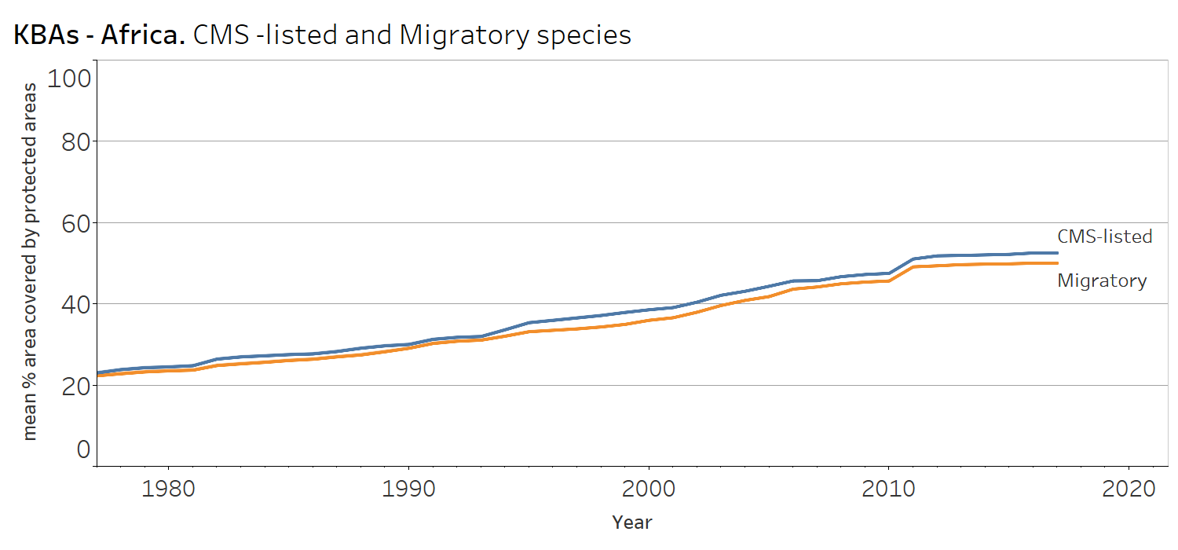

Fig1. Trends in protected area coverage of each Key Biodiversity Area identified for migratory and CMS-listed bird and mammal species in Africa. Shading shows confidence intervals.

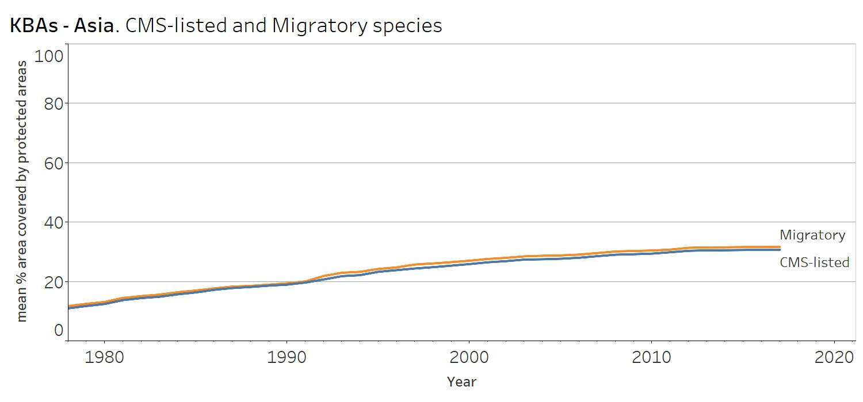

Fig2. Trends in protected area coverage of each Key Biodiversity Area identified for migratory and CMS-listed bird and mammal species in Asia. Shading shows confidence intervals.

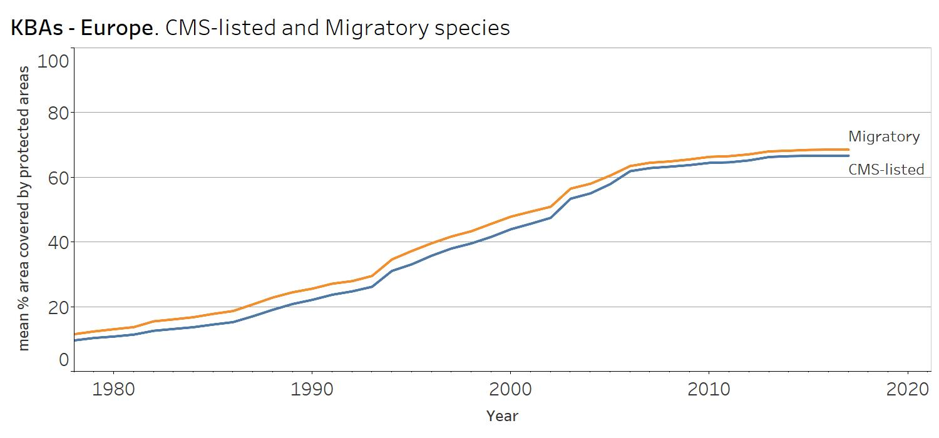

Fig3. Trends in protected area coverage of each Key Biodiversity Area identified for migratory and CMS-listed bird and mammal species in Europe. Shading shows confidence intervals.

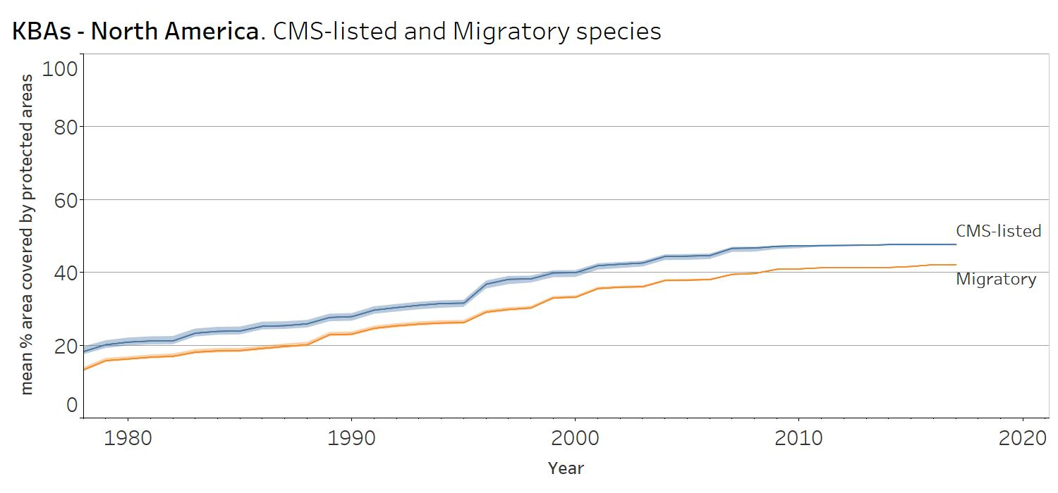

Fig 4. Trends in protected area coverage of each Key Biodiversity Area identified for migratory and CMS-listed bird and mammal species in North America. Shading shows confidence intervals.

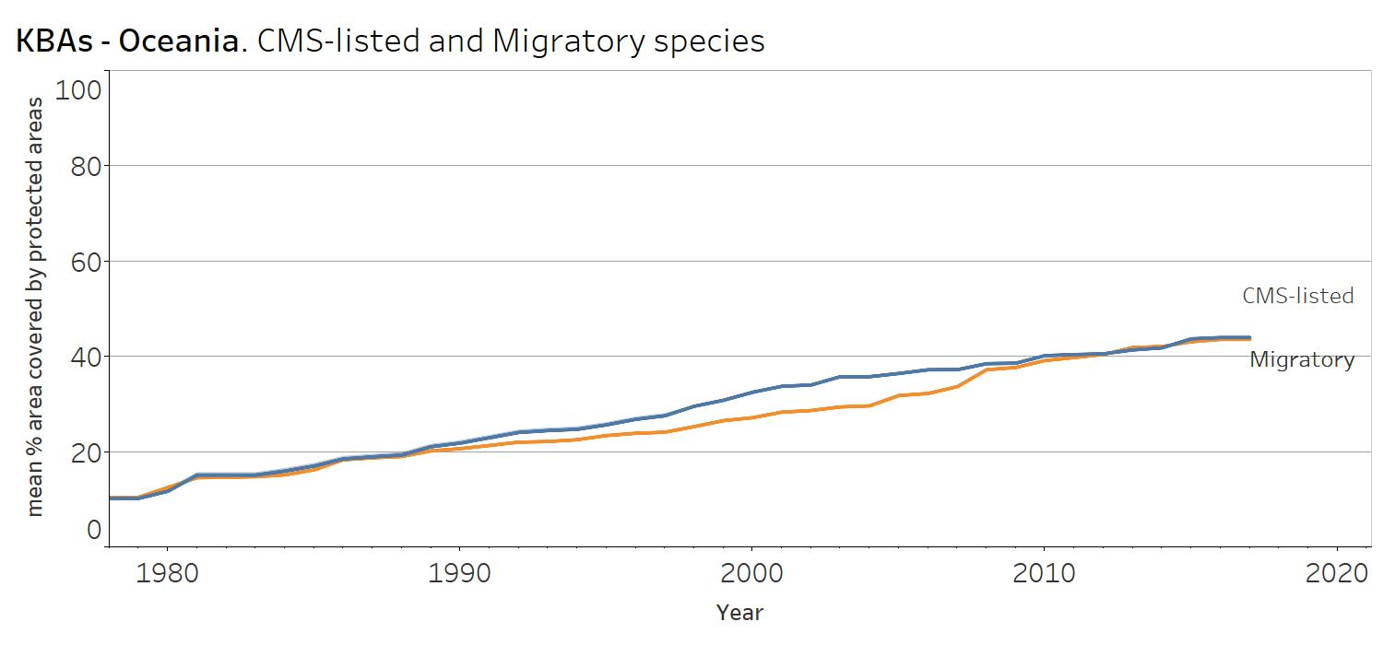

Fig 5. Trends in protected area coverage of each Key Biodiversity Area identified for migratory and CMS-listed bird and mammal species in Oceania.Shading shows confidence intervals.

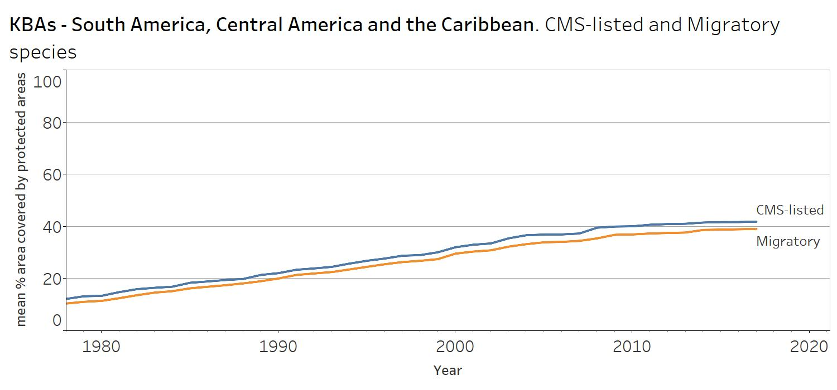

Fig 6. Trends in protected area coverage of each Key Biodiversity Area identified for migratory and CMS-listed bird and mammal species in South America, Central America and the Caribbean. Shading shows confidence intervals.

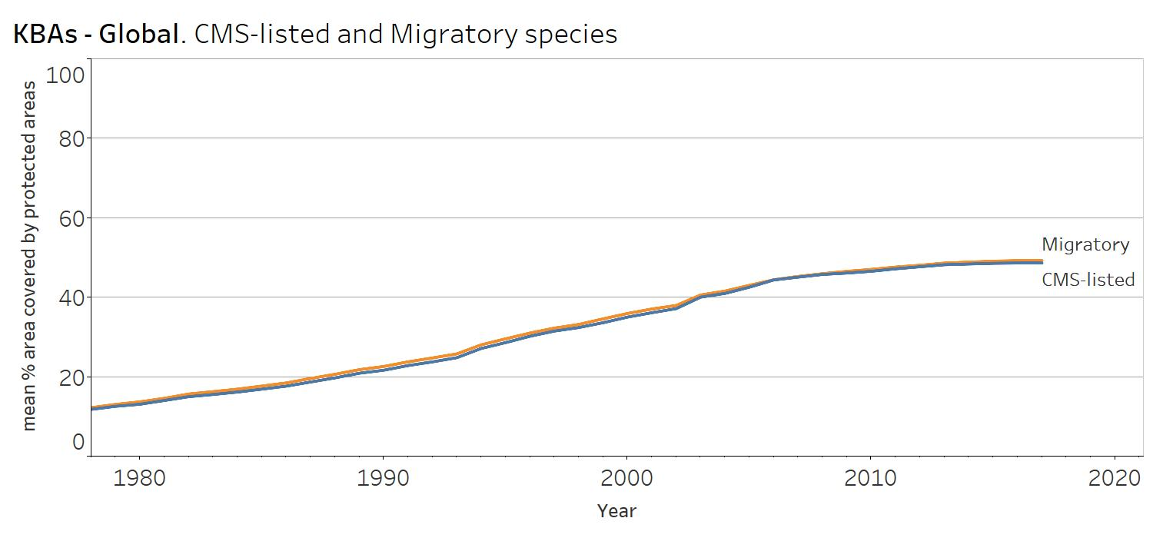

Fig 7. Trends in protected area coverage of each Key Biodiversity Area identified for migratory and CMS-listed bird and mammal species globally. Shading shows confidence intervals.

Data on High Seas and Antarctica are incorporated into the global graph, but these are not CMS regions, so specific graphs are not presented.

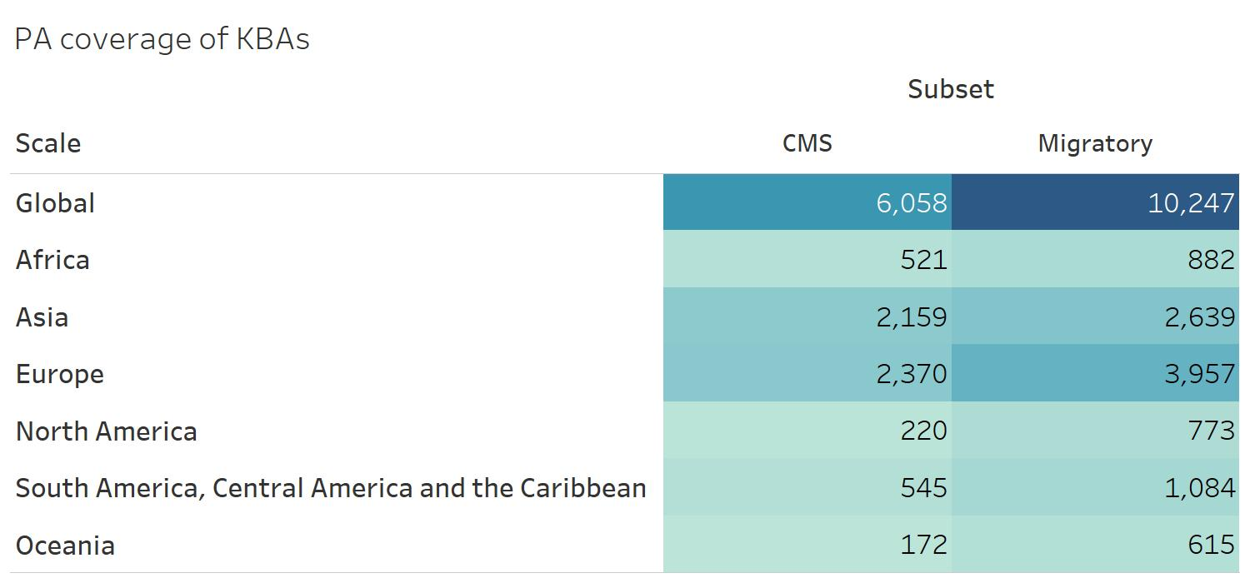

Fig. 8 Numbers of KBAs for each graphic.

**Results description**

Key Biodiversity Areas (KBAs) are 'sites contributing significantly to the global persistence of biodiversity’, and encompass Important Bird and Biodiversity Areas and Alliance for Zero Extinction sites. Many KBAs have been identified owing to their importance for congregations of migratory species, or for populations of threatened migratory species. The coverage of this subset of sites by formal protected areas has grown substantially over time, with the mean percentage of each KBA covered by protected areas reaching 49% by 2018. Coverage varies by region, being lowest in Asia (31%) and South/Central America and the Caribbean (39%), and highest in Africa (51%) and Europe (69%).

Protected area coverage of KBAs identified for species listed (Fig. 9) by the Convention on Migratory Species (CMS) averages 49% globally, and is lowest in Asia (31%) and South/Central America and the Caribbean (42%) and highest in Africa (53%) and Europe (67%)

Given evidence that higher levels of protected area coverage of key sites are associated with improved trends in extinction risk (Butchart et al. 2012; PloS ONE), increasing the coverage of these important sites for migratory species would contribute substantially to their conservation and help to achieve the aims of CMS.

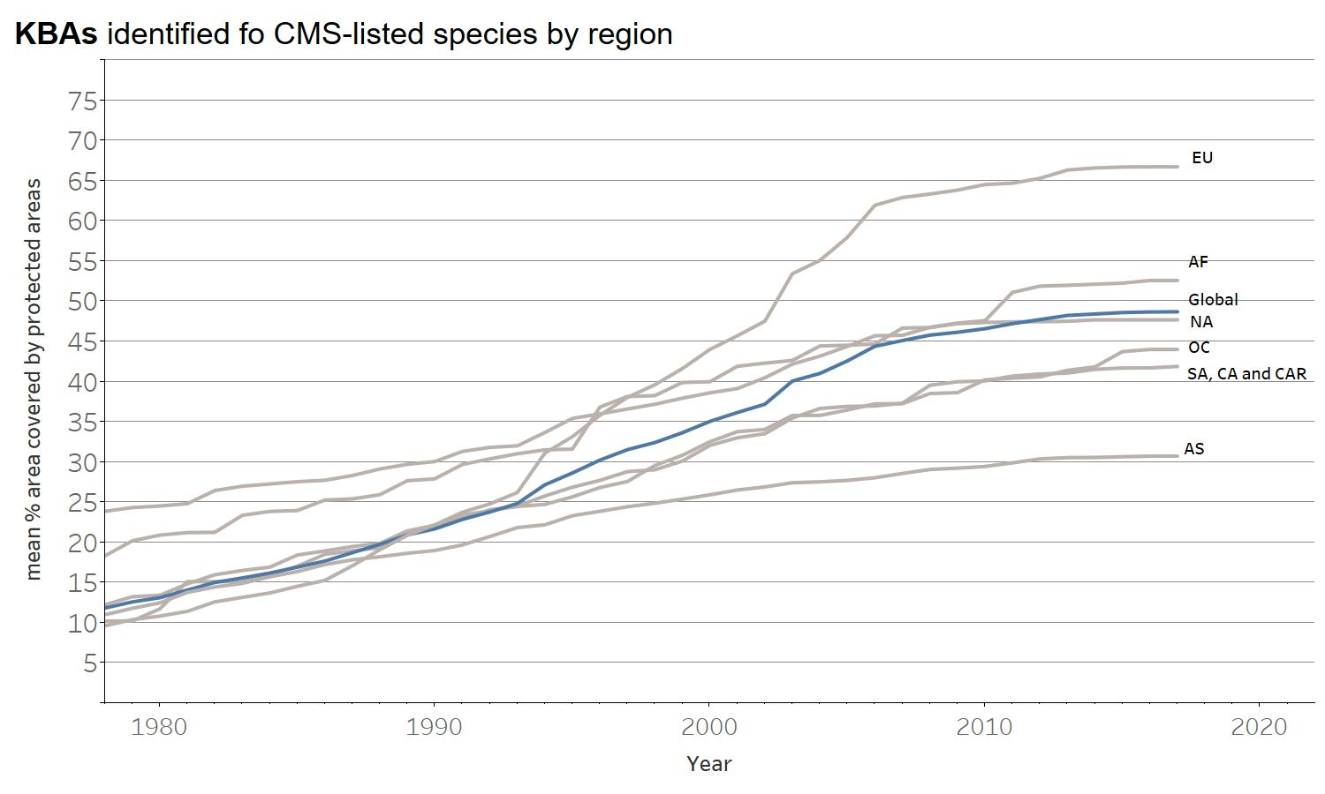

Fig. 9 Protected area coverage of KBAs identified for species listed by the Convention on Migratory Species (CMS). EU: Europe, AF: Africa, NA: North America, OC: Oceania, SA: South America, CA: Central America, CAR: Caribbean and AS: Asia.

1. **Red List Indices (RLIs)**

The RLI is an index of aggregate survival probability (the inverse of extinction risk) of sets of species. It is based on genuine changes in the number of species in each category of extinction risk on The IUCN Red List of Threatened Species, excluding any changes driven by improved knowledge or revised taxonomy. The index value ranges from 1 (all species are categorized as ‘Least Concern’) to 0 (all species are categorized as ‘Extinct’), and so indicates how far the set of species has moved overall towards extinction.

These graphs show Red List Indices of species survival for bird and mammal species that are migratory (i.e. coded as ‘Full migrant’ on the IUCN Red List) or (separately) listed by CMS. Methods are described at <https://unstats.un.org/sdgs/metadata/files/Metadata-15-05-01.pdf>.

Regional Red List Indices (Fig. 10 to 15) are weighted by the fraction of each species’ distribution occurring within the region. These show how well species are conserved in each region relative to its potential contribution to global species conservation. They vary from 1 if the region has contributed the minimum it can to the global RLI (i.e., because all species in the region are Least Concern) to 0 if the region has contributed the maximum it can to the global RLI (i.e., if all species in the region are extinct).

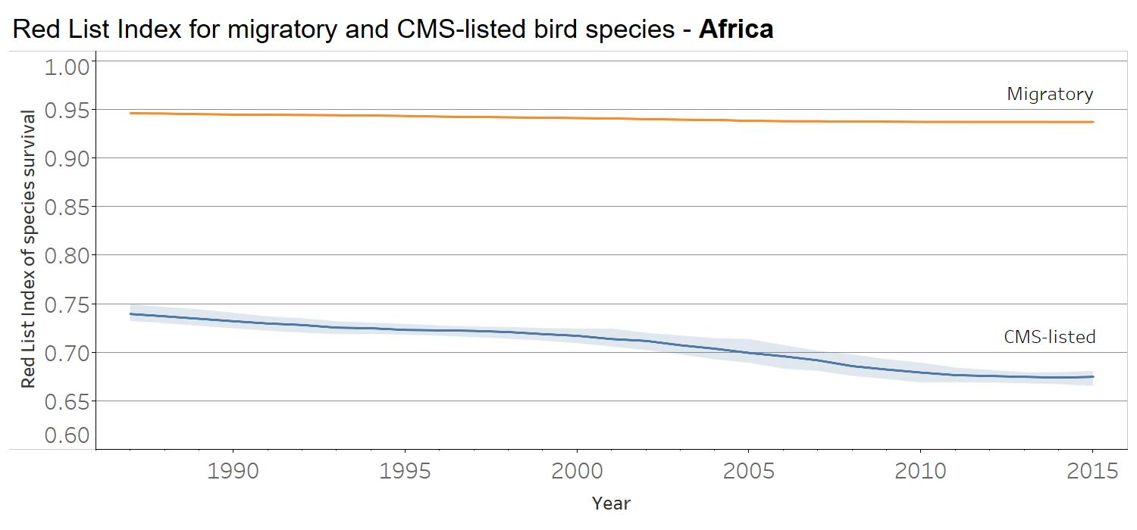

Fig 10. Red List Index of species survival for migratory and CMS-listed bird species in Africa, with each species weighted by the proportion of its global distribution occurring in the region. Shading shows confidence intervals. An index value 1 equates to all species in the region being Least Concern; an index value of 0 equates to all species in the region being extinct.

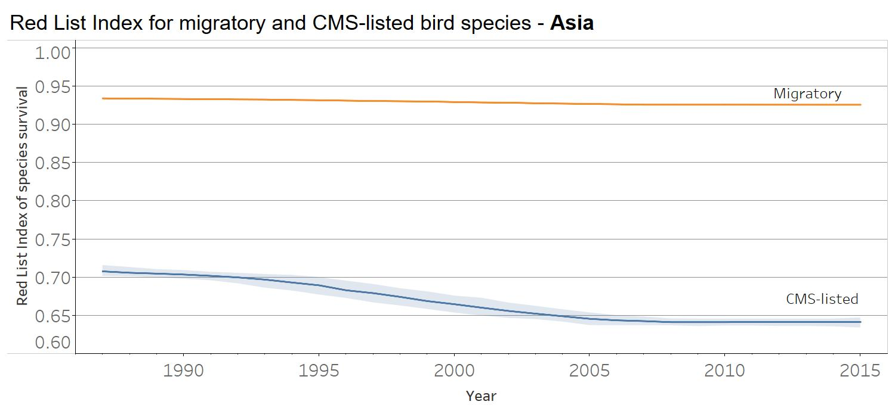

Fig 11. Red List Index of species survival for migratory and CMS-listed bird species in Asia, with each species weighted by the proportion of its global distribution occurring in the region. Shading shows confidence intervals. An index value 1 equates to all species in the region being Least Concern; an index value of 0 equates to all species in the region being extinct.

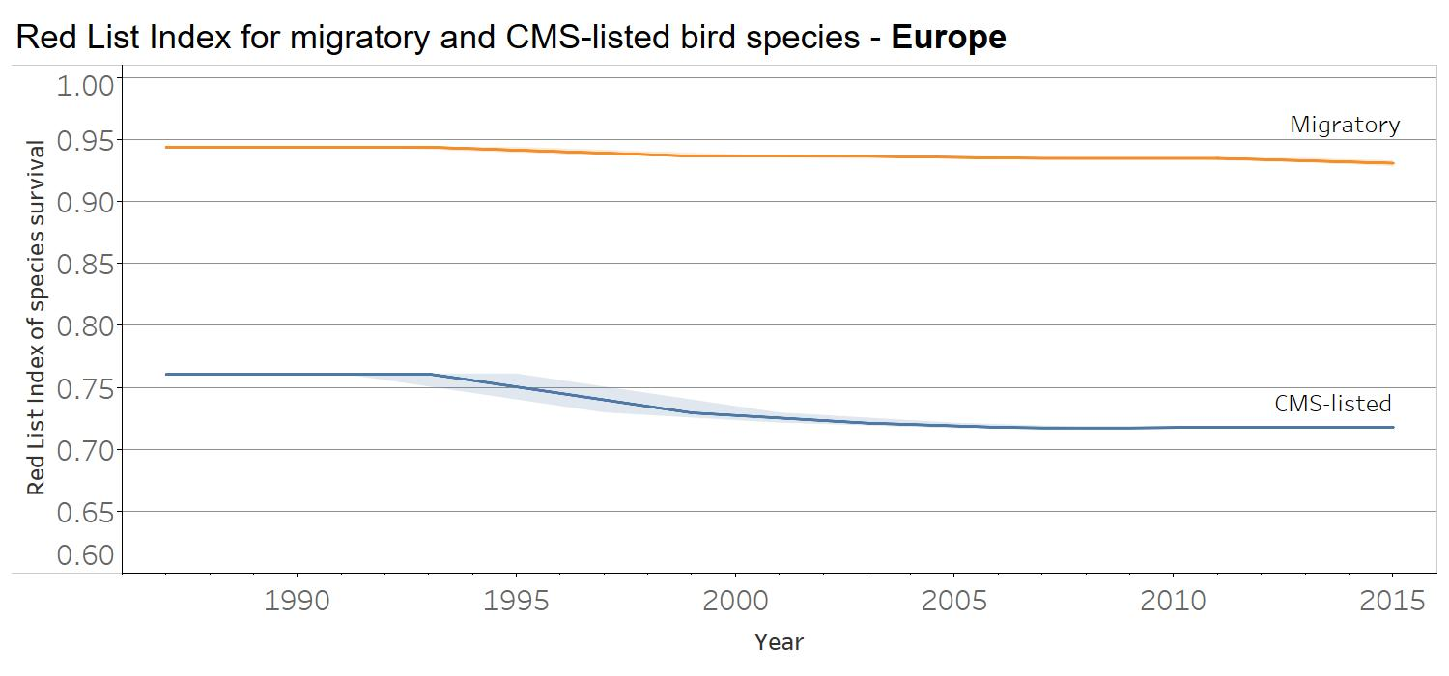

Fig 12. Red List Index of species survival for migratory and CMS-listed bird species in Europe, with each species weighted by the proportion of its global distribution occurring in the region. Shading shows confidence intervals. An index value 1 equates to all species in the region being Least Concern; an index value of 0 equates to all species in the region being extinct.

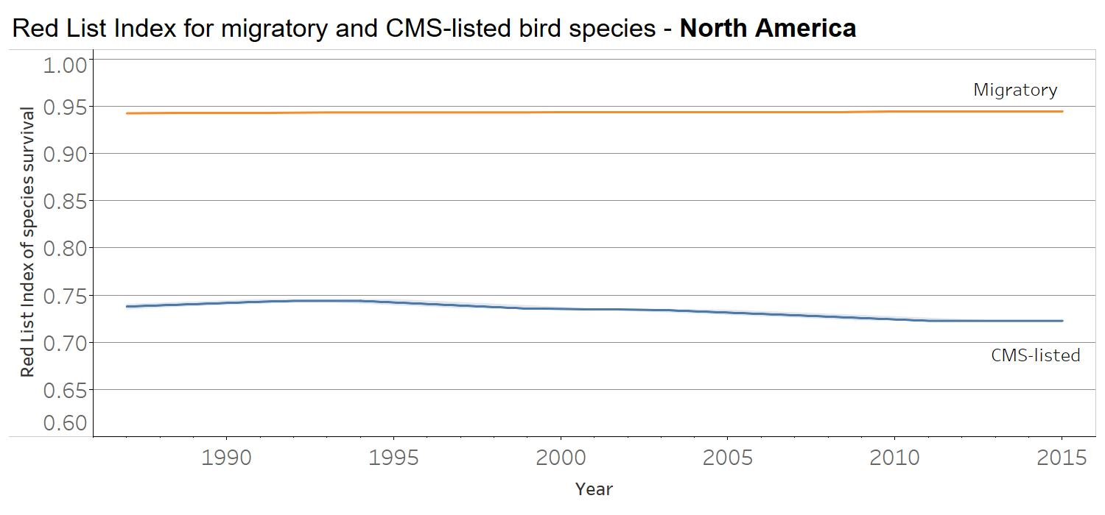

Fig 13. Red List Index of species survival for migratory and CMS-listed bird species in North America, with each species weighted by the proportion of its global distribution occurring in the region. Shading shows confidence intervals. An index value 1 equates to all species in the region being Least Concern; an index value of 0 equates to all species in the region being extinct.

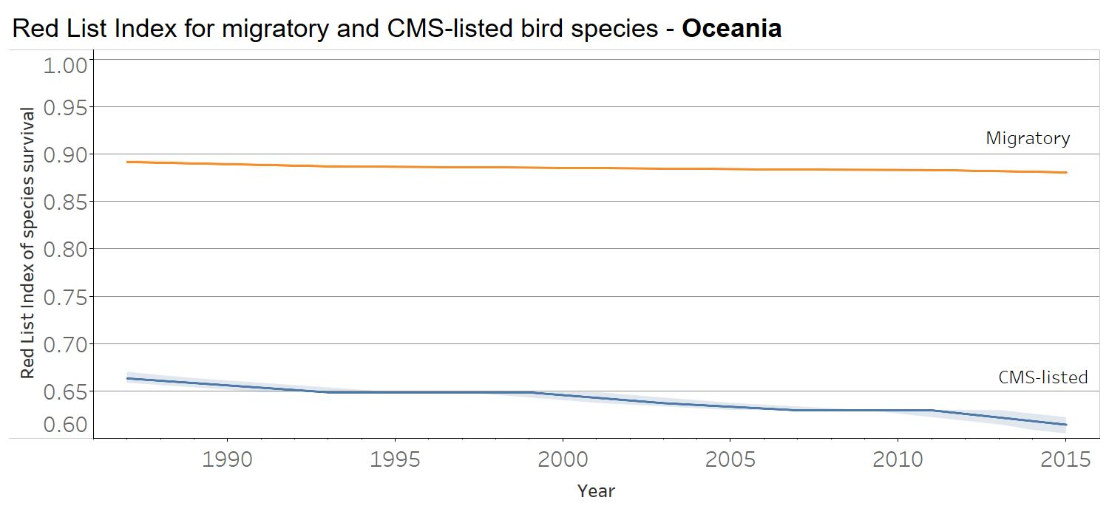

Fig 14. Red List Index of species survival for migratory and CMS-listed bird species in Oceania, with each species weighted by the proportion of its global distribution occurring in the region. Shading shows confidence intervals. An index value 1 equates to all species in the region being Least Concern; an index value of 0 equates to all species in the region being extinct.

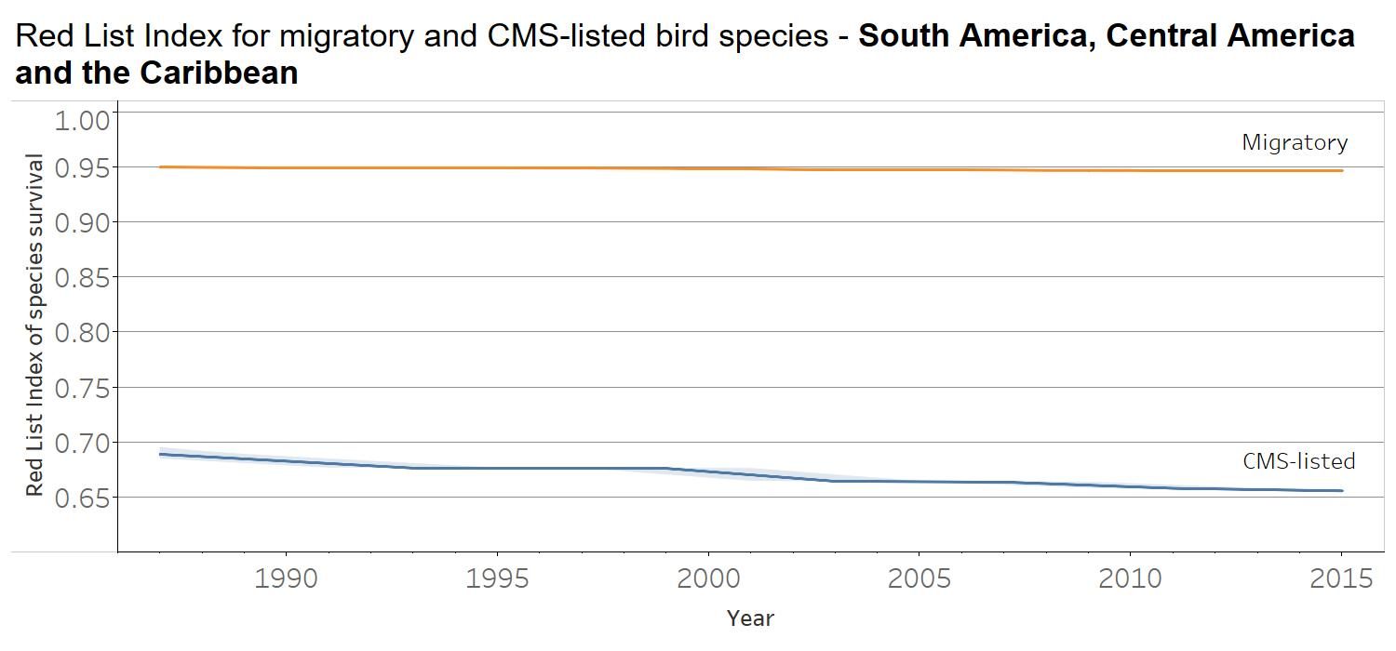

Fig 15. Red List Index of species survival for migratory and CMS-listed bird species in South America, Central America and the Caribbean, with each species weighted by the proportion of its global distribution occurring in the region. Shading shows confidence intervals. An index value 1 equates to all species in the region being Least Concern; an index value of 0 equates to all species in the region being extinct.

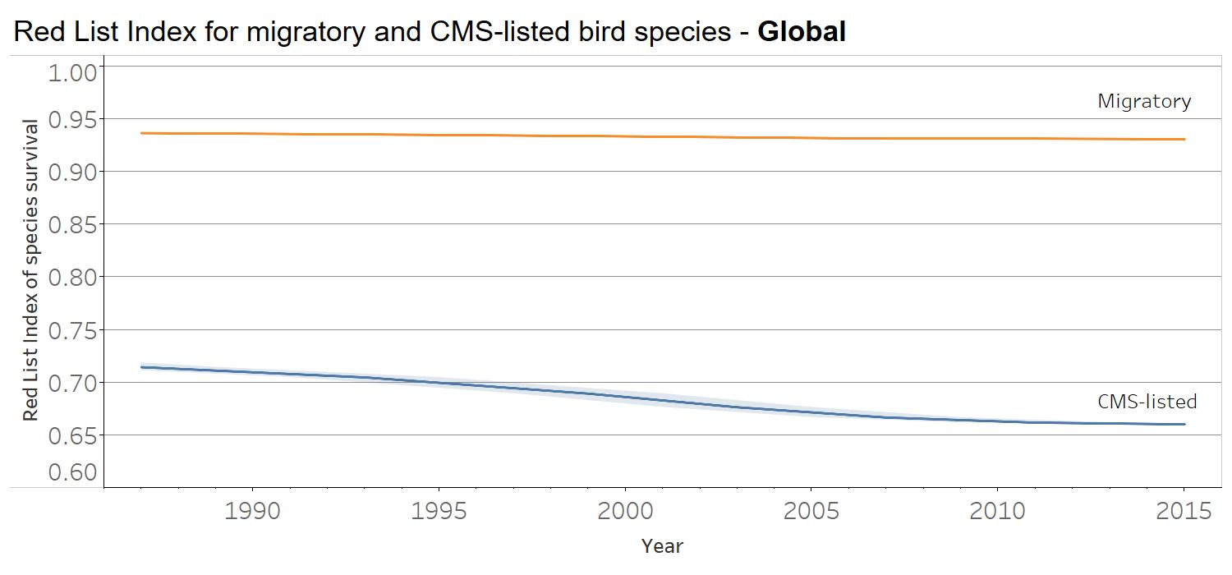

Fig 16. Red List Index of species survival for migratory and CMS-listed bird species Globally, with each species weighted by the proportion of its global distribution occurring in the region. Shading shows confidence intervals. An index value 1 equates to all species in the region being Least Concern; an index value of 0 equates to all species in the region being extinct.

A disaggregation of the global RLI showing trends driven by utilisation (Fig. 17) and (separately) fisheries was elaborated. Both were based on data for all migratory/CMS-listed bird and mammal species. But trends in the former (utilisation) were based only on changes in extinction risk (Red List category) driven by any of: hunting and trapping of terrestrial animals (whether the species is the target or not), gathering terrestrial plants, logging and wood-harvesting, and fishing and harvesting aquatic resources (whether the species is the target or not) [i.e. all threats within ‘Biological resource use’ in the IUCN Threats Classification Scheme].

Trends in the latter (trends driven by fisheries) were based only on changes in extinction risk (Red List category) driven by fishing and harvesting aquatic resources (whether the species is the target or not). In both cases, drivers coded as primary (causing >50% of the change in status, or most important secondary [causing <50% of the change in status], were included); all other changes in extinction risk (Red List Category) are excluded.The disaggregation of the RLI for fisheries were based on a limited number of species to be reliable and therefore not presented in the present report. Aggregated Red List Indices (shown in red) were calculated as the arithmetic mean of the indices for birds and mammals. Grey shading shows confidence intervals (see methods).

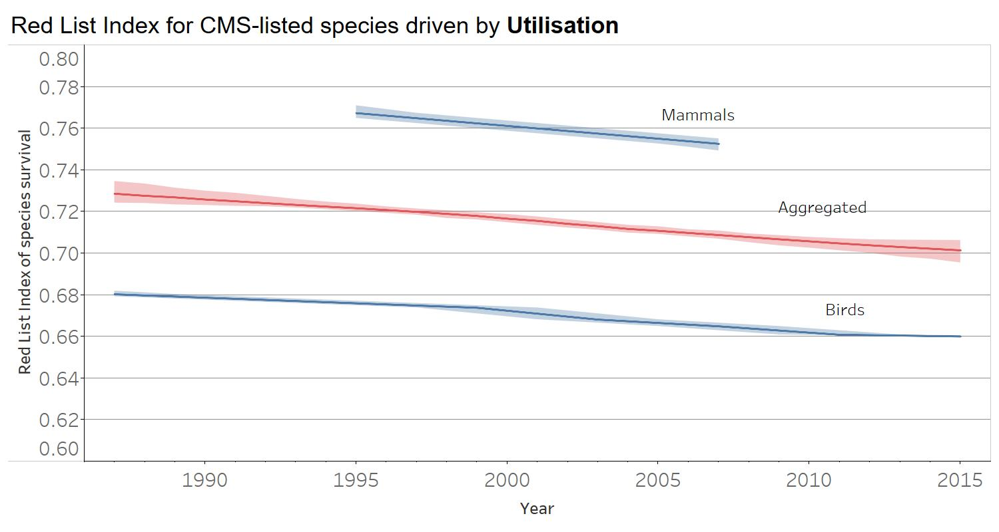

Fig. 17 Red List Index of species survival for CMS-listed bird and mammal species, showing trends driven by utilisation, including hunting/trapping, fisheries, logging and wood harvesting. Shading shows confidence intervals. An index value of 1 equates to all species being categorized as ‘Least Concern’; an index value of 0 equates to all species being categorized as ‘Extinct’.

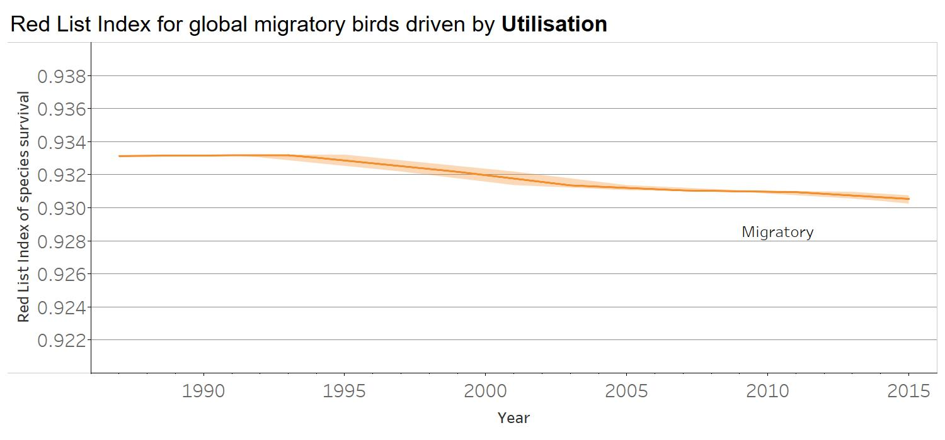

Fig 18. Red List Index of species survival for Global birds showing trends driven by utilisation, including hunting/trapping, fisheries, logging and wood harvesting. Shading shows confidence intervals. An index value of 1 equates to all species being categorized as ‘Least Concern’; an index value of 0 equates to all species being categorized as ‘Extinct’.

Also note that there are striking differences between the sets of species listed on CMS versus listed as Full Migrants on the IUCN Red List. For example, many CMS-listed mammals are omitted from the ‘migratory’ indicators above because they are coded as Nomadic (e.g. *Addax nasomaculatus, Ursus maritimus* etc), not a migrant (e.g. *Vicugna vicugna, Lontra provocax*) or because their migratory status is not coded on the Red List (e.g. *Balaenoptera musculus*).

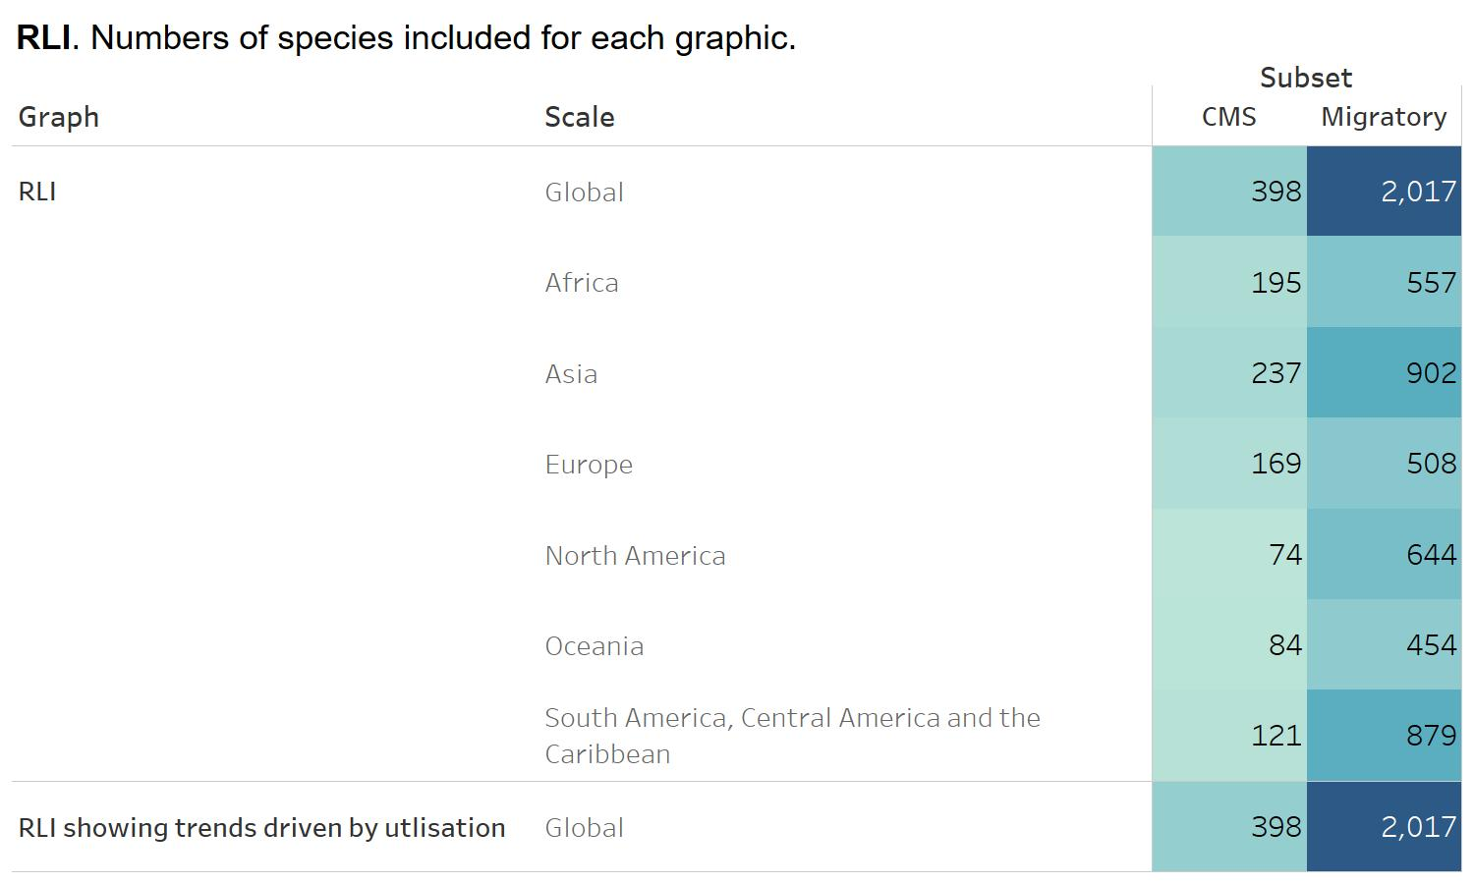

Fig 19. Number of species for each graphic of RLI.

**Results description**

Red List Indices (RLIs) show trends in the survival probability of sets of species. The following bullet points summarise the results for those disaggregations for which there are sufficient data to calculate meaningful RLIs (e.g. too few data are available to calculate meaningful RLIs for CMS-listed or migratory mammals by region, or a global RLI for migratory mammals).

For CMS-listed species:

* RLI trends for birds, mammals and the aggregate of both groups show declines, indicating that these species are moving towards extinction ever faster. CMS-listed birds are more threatened overall than CMS-listed mammals (i.e. lower RLI values) and are declining at a faster rate (i.e. steeper RLI slope).
* RLIs for CMS-listed birds show negative trends in each region (Fig. 20). CMS-listed birds are most threatened overall (i.e lowest RLI values) in Oceania and Asia, and least threatened overall in Europe and North America. Declines show a similar pattern (steepest in Oceania and Asia, but also Africa) and slowest in Europe and North America.
* A version of the RLI for CMS-listed species showing trends driven only by utilisation or its management (and factoring out trends driven by other factors such as agriculture and invasive alien species) is declining. This shows that overall, use of CMS-listed species (eg through hunting for food and sport, and capture for pets) remains unsustainable, with the number of species being uplisted to higher categories of threat owing to intensifying threats from use outweighing the number of species being downlisted to lower categories of threat owing to successful control or management of use.

For migratory species (birds only):

* The RLI for migratory birds is declining, indicating that these species are moving towards extinction ever faster.
* RLIs for migratory birds show negative trends in nearly all regions; trends are marginally positive in North America. Migratory birds are most threatened overall (i.e lowest RLI values) in Oceania, and least threatened in North America, and South/Central America and the Caribbean. Declines have been fastest in Europe.
* A version of the RLI for migratory birds showing trends driven only by utilisation or its management (and factoring out trends driven by other factors such as agriculture and invasive alien species) is declining. This shows that overall, use of migratory species (eg through hunting for food and sport, and capture for pets) remains unsustainable, with the number of species being uplisted to higher categories of threat owing to intensifying threats from use outweighing the number of species being downlisted to lower categories of threat owing to successful control or management of use.

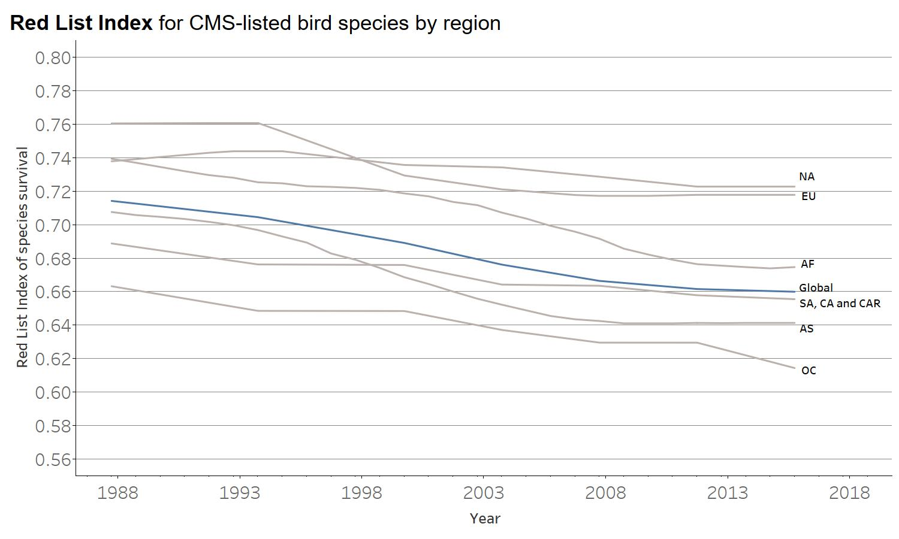

Fig 20. Red List Index of species survival for CMS-listed bird species by region. EU: Europe, AF: Africa, NA: North America, OC: Oceania, SA: South America, CA: Central America, CAR: Caribbean and AS: Asia