OpenAlex as the Literature Database of Choice of IPBES
White Paper
Rainer M Krug
2023-11-10
Abstract
The short abstract goes here and can go over multiple lines. …
Reviewed by:
For any inquires please contact aidin.niamir@senckenberg.de

Introduction
In IPBES assessments, the main sources for scholary literature search are Web of Science and Scopus. These are mainly used via the web interface due to licensing limitations and complexities in the API. The use of the web interface poses a huge problem regarding the transparency and the reproducibility of the search. In addition, neither the data used of these scholary data sources nor the code which is used to conduct the search or the API implementation is openly availabe. As the literature search forms the foundation of many aspects in IPBES assessments, this lack of transparency filters through to the final product.
The Data and Knowledge Management Policy aims at improving this transparency. One alternative to these proprietary scholary data sources is OpenAlex. In comparison to the proprietoryh and non open scholary data sources, OpenAlex is open and free to use and the data and code used is openly available, licensed under the CC0 license.
We data tsu therefore decided to assess the suitability of OpenAlex as a replacement for the proprietary scholary data sources. Based on this initial assessment and the initial usage in assessments, we recommend the usage of OpenAlex instead of proprietary scholary data sources.
This document will detail differences between the sholary data sources and outline the advantages of OpenAlex over WoS and Scopus.

Advantges OpenAlex in comparison to other databases
The comparison needs to be done in several aspects which are:
- Available works and number of OpenAccess works
- Coverage (e.g Global South, academic, grey literature, etc)
- Openness of data and code used
- Web and API Access
- costs
We will go throuh these points in more detail now.

Available Works and Number of OpenAccess works
OpenAlex was seeded with data from Microsoft Academic when it was retired in 2021. The data was then enriched with data from Crossref and is continuously updated from several sources (See here).
As can be seen in this table, OpenAlex has more works than any other scholary data source with the exception of google scholar.
Most works in OpenAlex are ingested via Crossref, but a large proportion are from other sources.
 | Number of works | Open Access Works | Citations | Price | Data Openness | Org Structure
OpenAlex | 243M | 48M | 1.9B | Freemium | Fully open, CC0 license | Non-profit
Scopus | 87M | 20.5M (ref) | 1.8B | Subscription | Closed | For Profit
Web of Science (core) | 87M (ref) | 12M (ref) | 1.8B | Subscription | Closed | For Profit
Dimensions | 135M | 29M (ref) | 1.7B | Freemium | Partly open, personal use | For Profit
Google Scholar | 389M (estimated) | ? | ? | Free | Closed | For Profit
Crossref | 145M | 20M | 1.45B | Free | Fully open, CC0 license | Non-profit
(From: OpenAlex)

Coverage (e.g Global South, academic, grey literature, etc)
OpenAlex has a broad coverage from the Global South. It also has a large proportion of non-academic works as well as works without DOIs.
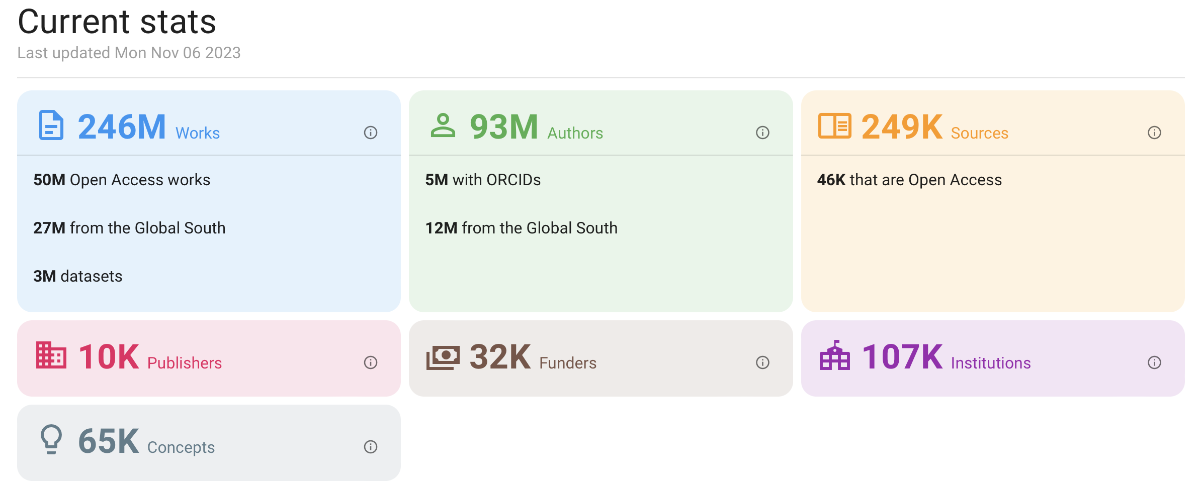
From: OpenAlex
A more detailed analysis of these aspects is conducted at the moment by OpenAlex.

Openness of Data and Code used
OpenAlex is free and open, i.e. it is free to use for everybody without any subscription or registration, by design. The data is freely available (database dumps (i.e. download of the whole dataset) are possible and easy to do). The datasets can therefore be analysed in regards to aspects which are not implemented in the API.

Web and API Access
API access is important for accessing the database programmatically. An example is a search for all articles covering a specific topic. Usually, this is an iterative provess which needs refinement of the search terms. The traditional way is to type the search term in the search box and at least write down the number of hits, change the search term and repeat the process. Especially when other comparisons should also be done (e.g. assessment of certain key-papers are in the search results), is this a very tedious and error prone process.
This process can be automated by using the API. In this case, the search is defined e.g. in R or any other programming language and the search is done programmatically. The results can then be analysed and the search terms can be refined in a reproducible way with transparent criteria. The results can be shown in a clear, concise and reproducible automatically generated report.
Nevertheless, web acces to conduct manual searches is a valuable tool to conduct initial testing of search terms.
OpenAlex has, as all of the other other scholary data sources, a web interface. It is still in beta phase, but it is already very usable and based on personal experiences easier to use than WoS or Scopus.
In addition to the web interface, most scholary sources, with the notable exception of google scholar, have an API which can be used to access the data programmatically.
In contrast to the APIs assessed, (WoS, Scopus), the OpenAlex API] is relatively simple but provides all the neccessary functionality needed for all IPBES related tasks. For more complex searches or analysis, the data dump can be used and data can be stored and analysed locally.
To simplify the API usage even more, the excellent R package openalexR is available to access the API from R.

Costs
OpenAlex is free to use, which is not the case for most other databases. If the limit for free usage (100k API calls per day with a maximum of 10 per second) is not enaough, a Premium subscription is can be obtained (the tsu has obtained a Premium license key free of charge due to extensive feed back and extensive discussions with OpenAlex). The pricing is determined on a case by case basis.
For about 95% cases of IPBES, the free tier is more than enough, and the remaining 5% simply are still possible but require longer running times of the search.
In contrast, the API costs for WoS can easily go intu 10s of thousands per dollars per year, if a data dump is required even in the millions. In addition, none of the offered smaller API licenses covers the needs of IPBES, i.e. doewnload of diverse metadata as well as download of a large nuber of works.

Conclusion
We therefore conclude, that OpenAlex is a suitable replacement for WoS and Scopus and recommend the usage of OpenAlex in IPBES assessments.
To facilitate the switch, technical guidelines are in preparation to help the authors to use OpenAlex programmatically in their assessments.

