**Stock trade and analyst system**

Developed by Quan Xing, Guofeng Wu

**Project summary**

The project offers the live trade system for the different investors, including individuals and financial companies. It offers the functions including paper trading, daily charts, watch list, portfolio, stock news etc.

The project is the desktop platform version based on Windows OS 7/8/10, there is another web version available in the near future.

**Key points:**

* Daily stock charts
* Paper trading
* Get data from API
* Investment performance chart

**Technical skills:**

* Windows 7/8/10, Visual studio 2013
* .Net framework 4.5, C#, WPF
* SQL server 2014, asp.net

**System frame:**

* Main window: the main window for trading
* Stock chart: subform of main, the stock chart data, such as price, trading amount, time line etc.
* Trading form: subform of main, the trading form, such as living open, close, bid price, and other transaction detail.
* Portfolio form: subform of main, the detail of client account, such as balance, stock owned, transaction history etc.

**GUI:**

It will open the main windows, there is main menu and shortcut on the top, it will restore the layout of previous login information, so the client can check the watch list related to the stock chart if he/she wants to buy, or checks his/her account and stocks if the client wants to sell.

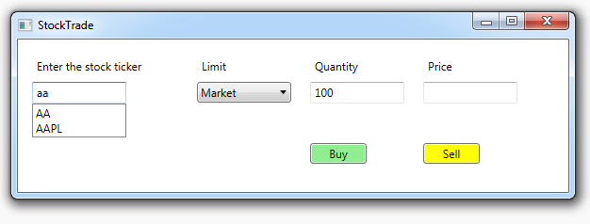

**TradeStock Database:**

Tables

* Stock: ticker, name, category, share
* Portfolio: stock list
* Transaction: Id, ticker, quantity, price, buy/sell
* StockPriceByDay: ticker, date, open/close/high/low price, transaction amount
* TrendLine: Id, position x/y, length,color,etc

