Survey Analysis Report

# Survey Question

What additional products or services would you like to see in the future at the campus bookstore?

# Overall Sentiment Score

0.40

# Top 20 Collocations

would like (6), like see (6), see variety (6), variety textbooks (3), textbooks stationery (3), stationery would (3), would great (19), great coffee (3), coffee shop (3), shop inside (3), inside bookstore (6), bookstore options (3), options products (3), products would (6), would appreciated (17), appreciated would (6), would love (3), love see (3), see section (3), section dedicated (3)

# Top 20 Bigrams

would like (6), like see (6), see variety (6), variety textbooks (3), textbooks stationery (3), stationery would (3), would great (19), great coffee (3), coffee shop (3), shop inside (3), inside bookstore (6), bookstore options (3), options products (3), products would (6), would appreciated (17), appreciated would (6), would love (3), love see (3), see section (3), section dedicated (3)

# Top 10 Trigrams

would like see (6), like see variety (6), see variety textbooks (3), variety textbooks stationery (3), textbooks stationery would (3), stationery would great (3), would great coffee (3), great coffee shop (3), coffee shop inside (3), shop inside bookstore (3)

# Wordcloud

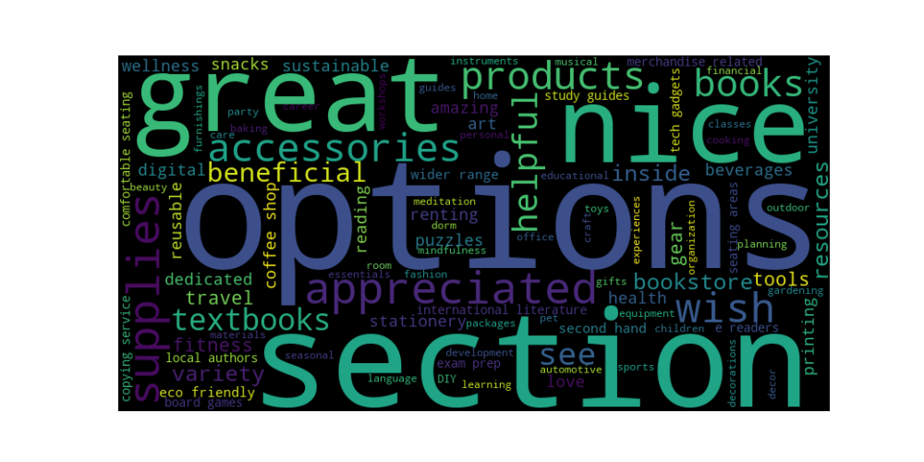

# Sample Comments

Comment: A section for renting textbooks would be beneficial.

Age: 58, Gender: M, Residency Campus: N, Indigenous: 1, Faculty: Faculty of Arts, Program: Bachelor of Science

Comment: I wish there were more options for health and wellness products.

Age: 44, Gender: M, Residency Campus: R, Indigenous: 1, Faculty: Faculty of Engineering, Program: Bachelor of Engineering

Comment: It would be nice to have a section for pet supplies and accessories.

Age: 50, Gender: O, Residency Campus: N, Indigenous: 1, Faculty: Faculty of Medicine, Program: Doctor of Medicine

Comment: Having a section for career development books and resources would be helpful.

Age: 32, Gender: M, Residency Campus: R, Indigenous: 0, Faculty: Faculty of Medicine, Program: Bachelor of Arts

Comment: Having a section for DIY and craft supplies would be beneficial.

Age: 46, Gender: M, Residency Campus: R, Indigenous: 1, Faculty: Faculty of Engineering, Program: Bachelor of Engineering