Remote Resources

**User Manual**

Instituto de Pesquisas Eldorado

Version: 1.1

January/2014

Summary

Summary 2

Objective 3

Introduction 3

Functionalities 3

Home Screen 4

Main Screen 4

This chapter describes the Remote Resources features. 5

How to add a remote device? 5

How to start/stop a device view? 6

How to change the device settings? 6

How to interact with an active device? 7

How to interact with physical device keys? 7

How to remove a device from device list? 7

How to extract logs? 8

How to take screenshots? 8

How to insert texts quickly? 8

Objective

The main goal of this document is to show an overview of the tool proposed by Instituto Eldorado in order to remotely manipulate Android devices.

The use of this tool is focused on people who want to verify the device behavior when it’s not possible to reproduce the used scenario in the real environment. This tool also permits the device information extraction in an easy way, as the automation of routines. All the functionalities are described on the following sections.

However, this version is a concept proof that shows some of the possible use scenarios, and it is a prototype developed for discussion of further extensions and improvements.

Introduction

The mobile market has grown tremendously in recent years. The Android operating system (OS) has been an ongoing prominence as one of the most used platforms in this niche. As their features are numerous, we can think of many applications that benefit from the power offered by this OS, or in many other life that would help developers and analysts who work in the testing platform.

Our proposal is to provide a tool which facilitates remote interaction with Android devices, using a computer with Internet access. The idea itself is not original, since there are applications available that perform part of the objectives proposed by our tool, however the "Remote Resources" stands out because it does not require installing applications directly on the device. Moreover, the range of available resources is increased and may even be extended, as future demands.

Functionalities

The main functionalities of Remote Resources are (now):

* Add and maintain remote servers that have devices connected to them;
* Add and maintain remote and local devices;
* Perform any action on a remote device like a local device;
* Extract logs from devices;
* Get screenshots anytime using the device;
* Create scripts of device usage;
* Execute scripts sequentially
* Execute script step by step (similar to debug).

# Home Screen

When running the "Remote Resources", the first interface with the tool is presented in Figure 1 below. It prompts you to choose the language used by the application on the next screens. We currently have a version in Portuguese and English (default).

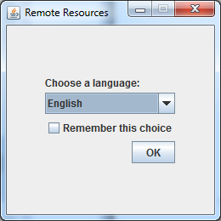

*Figure 1 – Home screen of Remote Resources*

# Main Screen

When you select a language and click [OK] on the home screen, the system displays its main screen, which is depicted in Figure 2.

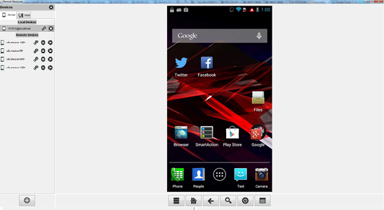

*Figure 2 – Remore Resources’ Main Screen*

The main screen has 4 parts:

1. Change language;
2. Devices list;
3. Device screen area;
4. Device control Keys and functionalities main menu

**Using the tool**

## This chapter describes the Remote Resources features.

## How to add a remote device?

1. In the device list, click the [+] button in the upper right corner;
2. The system will display a registration screen similar to Figure 3. Choose whether you want to register a new host or choose another already registered earlier. When registering a host, enter its address (name or IP), port (54321 is the default number), and name (for purposes of easy location). Then click [Next>].

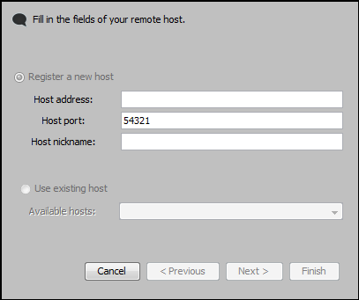

Figure 3 – Adding remote devices I

1. On the next screen, select a device from the existing list, enter a name for it (for the purpose of easy location), and then click [Finish].

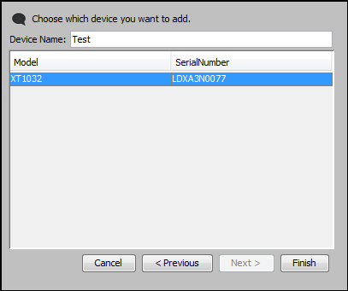

Figure 4 – Adding remote devices II

**Note**: Remote Resources also works with local devices, but these are recognized automatically by the tool and appear already listed in area "2" in *Figure 2*.

## How to start/stop a device view?

1. Each device is displayed in a row in the list of available devices. To enable the viewing, just click the button []of the desired device;
2. Once on display, the device line is highlighted and the button changes to [].Click it to close the connection from the active device.

## How to change the device settings?

1. To change device settings, click the [] button;
2. The system shows *Figure 5* screen where is possible to:
   1. Change the display name of the device;
   2. Change the time to capture the images of the device screen (when active);
   3. Change the image quality of the device;

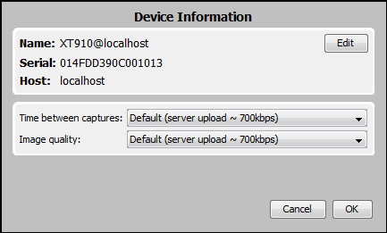

Figure 5 – Device information and settings screen

## How to interact with an active device?

The interaction with an active device in the Remote Resources is done in a similar way as with a real device: to simulate touches, click the mouse in the desired area of the image. To simulate slides, click the image with your mouse in the desired location, press and hold the mouse and drag to where you want.

## How to interact with physical device keys?

All real device has at least one physical button. Remote Resources also allows the simulation of these buttons. This is done using the buttons of the area number 4 of *Figure 2*. Hovering the mouse over them, a tooltip indicates the functionality of each button. The external buttons are shown in *Table 1* below:

|  |  |
| --- | --- |
|  | Activate the associated menu |
|  | Go to device home screen |
|  | Go back to previous screen |
|  | Activate the device’s search tool |
|  | Simulate device’s power button |

*Table 1 – Extern buttons*

## How to remove a device from device list?

If you don’t want a device to appear on available devices list, click the [] button associated to the device you want to remove.

## How to extract logs?

1. Click the main menu button, of the area number 1 of *Figure 2*.
2. Click [] button;
3. The previous action will open a screen (Figure 6) where is possible to choose where the file will be saved, change the file name and choose the preferred filter to extract the log. Just to remember, the filters are ordered from left side to right side, from less restricted to more restricted.

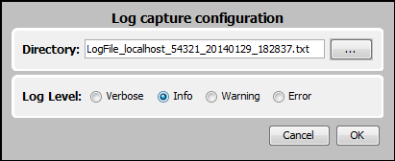

Figure 6 – Extracting logs - configuration screen

## How to take screenshots?

1. Click the main menu button, of the area number 1 of *Figure 2*.
2. Click [] button;
3. The previous action will open a screen where is possible to choose where the JPG file will be saved.

## How to insert texts quickly?

1. Click the main menu button, of the area number 1 of *Figure 2*.
2. Click [] button;
3. The previous actiobn will open a screen (Figure 7) where is possible to type a text directly on the computer keyboard. After typing, click [OK] button to send it to device.

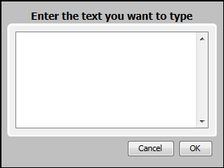

Figure 7 – Input text screen