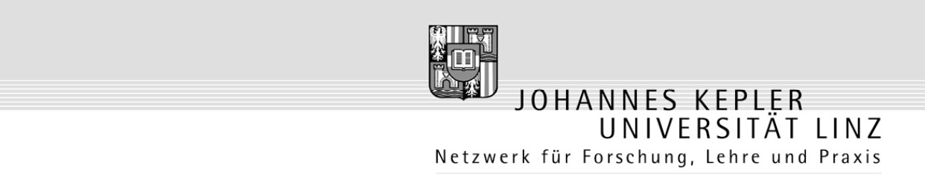

Questionnaire “Patriotism”

Course: Sprache, Land, Leute Englisch / 228.53E
Prof. Mag. Roland Fischer
SS’ 2008

Research carried out by:

Stefan Obermüller
Elena Pchelova
Elisabeth Steinkellner

Thank you for participating!

- What does patriotism mean to you?

- How is your attitude towards patriotism?

extremely  positive | very positive | positive | neutral | negative

- Are you proud to be Austrian / Russian?

yes | rather yes | rather no | no

- How patriotic are you?

extremely  patriotic | very patriotic | patriotic | to some extent | non patriotic

- How patriotic do you think people of your country are?

extremely  patriotic | very patriotic | patriotic | to some extent | non patriotic

- How important do you think the following issues are for a person to be Austrian / Russian?

 | very  important | important | less  important | not important at all | I don’t know
be born in the country

citizenship

living in the country

speaking the language

having family

religion

respect for law and politics

Other ideas:

- Does patriotism in your country show in the following aspects?

 | yes | no
flags
patriotism in education
sports
national day
politics
TV / newspaper / radio

- If patriotism is showing in another way, please tell us:

- Do you think that any measures in order to increase patriotism in your country should be undertaken?

yes | neutral | no

- Do you …

 | yes | no
support immigration in your country
know any immigrants
have friends who immigrated
like living in Austria / Russia
consider emigrating to another country

- At last please give us some information about yourself:

Sex
male | female

Date of birth
19

