ABDM V3 — HIP Service API Documentation
Milestone 1 (M1): ABHA Creation, Verification and Profile
Service: hip-service (In.ProjectEKA.HipService)
Starting commit: 83ddacfe4fa59b044b23309114d505e4b7b82c07 — “abdm V3”
Scope of this section: M1 only. M2 (linking) and M3 (data flow) will be added after recap.
References: ABDM Sandbox V3 documentation, User-initiated linking swagger, HIP-initiated linking.

1. How to read this document
This file documents the ABDM V3 work in hip-service from commit 83ddacfe (“abdm V3”) and the follow-on fixes on the trialsv3 line. M1, M2 and M3 are written in that order. This first delivery is M1 only, so the frontend and HIP contract can be recapped before linking (M2) and health-information exchange (M3).
- HIP path is what Bahmni / the hospital UI calls on hip-service.
- ABHA path is what hip-service calls on ABDM after it obtains a gateway session token.
- Sensitive values (Aadhaar, mobile, OTP) leave the hospital UI in plain text and are RSA-encrypted inside HIP before they are sent to ABDM.
- txnId and user tokens are stored in HIP memory against the Bahmni session. The UI usually does not need to round-trip txnId, except on the search-by-mobile login APIs.

2. ABDM milestones in this service
Milestone | ABDM capability | HIP modules | Status in this file
M1 | ABHA number & ABHA address: create, search, login, profile, card | CreationController, VerificationController, EncryptionService, GatewayClient | Documented now
M2 | User-initiated linking and HIP-initiated linking of care contexts; SMS notify; scan-and-share | Discovery, Link, CareContext, UserAuth, SmsNotification, Patient share | Next, after M1 recap
M3 | Consent notify and encrypted FHIR health-information transfer (HIP as data provider) | Consent, DataFlow | After M2

3. Common ABDM call pattern
Every M1 ABHA call from HIP follows the same outer pattern. The hospital UI never talks to ABDM directly. HIP is the adapter: it authenticates the Bahmni user, fetches a short-lived ABDM gateway token, encrypts PII, calls ABHA, and keeps transaction state in memory for that Bahmni session.
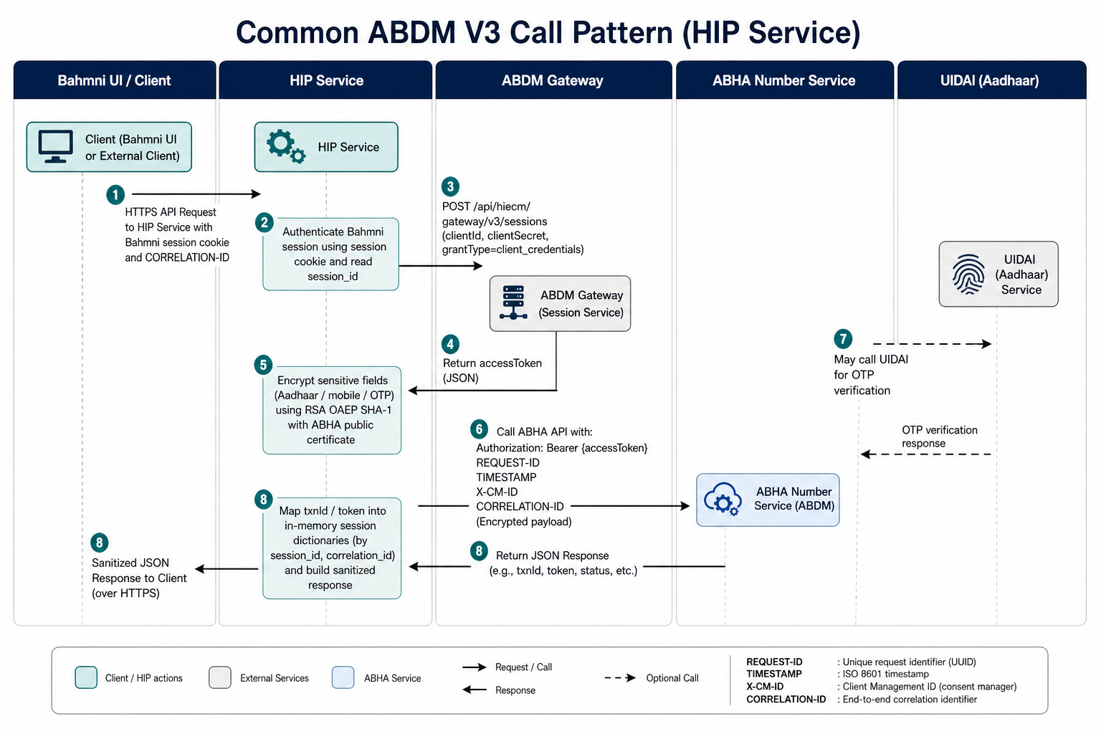
Figure 1. Common ABDM V3 call pattern used by all M1 APIs.

3.1 Actors and base URLs
Actor | Role | Configured as
Bahmni UI / HIP client | Calls HIP /v3/hip/* APIs with Bahmni session cookie | OpenMRS session
hip-service | Encrypts PII, maps payloads, stores txnId/token per session | This service
ABDM Gateway | Issues accessToken for subsequent ABHA and HIECM calls | Gateway.url + /api/hiecm/gateway/v3/sessions
ABHA Number service | Enrollment, login, profile, ABHA card (M1 core) | Gateway.abhaNumberServiceUrl (sandbox: https://abhasbx.abdm.gov.in/abha/api)
ABHA Address / PHR service | ABHA-address search, login, phr-card, legacy phr flows | Gateway.abhaAddressServiceUrl (sandbox: https://phrsbx.abdm.gov.in/api)
UIDAI | Aadhaar OTP and e-KYC. HIP never calls UIDAI directly. | Reached only by ABHA

3.2 Step-by-step for one ABHA call
1. Client authentication to HIP
CreationController and VerificationController are decorated with [Authorize(AuthenticationSchemes = bahmni)]. CustomAuthenticationHandler accepts reporting_session or OpenMRS JSESSIONID, validates it against OpenMRS whoami, and stores session_id on HttpContext.Items. That session_id is the key for all in-memory ABHA state.
2. Gateway session token
GatewayClient.Authenticate POSTs clientId, clientSecret and grantType=client_credentials to {Gateway.url}/api/hiecm/gateway/v3/sessions with headers REQUEST-ID, TIMESTAMP, X-CM-ID and optional CORRELATION-ID. The accessToken is sent as Authorization on the ABHA call. HIP does this on every ABHA request.
POST {Gateway.url}/api/hiecm/gateway/v3/sessions
{
"clientId": "<clientId>",
"clientSecret": "<clientSecret>",
"grantType": "client_credentials"
}
3. Encryption of Aadhaar / mobile / OTP
On startup, EncryptionService loads the ABHA RSA public key from GET {AbhaNumberServiceUrl}/v3/profile/public/certificate. HIP encrypts plain text with RSA OAEP SHA-1 (RSA/ECB/OAEPWithSHA-1AndMGF1Padding) and Base64-encodes the result. The hospital UI must send plaintext; HIP encrypts before the ABHA request.
4. Downstream ABHA HTTP call
HttpRequestHelper always adds REQUEST-ID (UUID), TIMESTAMP (yyyy-MM-dd'T'HH:mm:ss.fff'Z'), Authorization, and X-CM-ID. Optional headers used in M1: CORRELATION-ID, X-Token (user token after login/enrol), T-token (legacy mobile-login token), Transaction_Id (used by profile login verify).
5. Session dictionaries (CreationMap)
Dictionary | Key | Value stored | Used by
TxnDictionary | Bahmni session_id | Latest ABDM txnId | Almost every OTP step
HealthIdNumberTokenDictionary | session_id | User X-token after enrol / login | getAbhaProfile, getAbhaCard, verifyAbhaAccount
HealthIdLoginScopeDictionary | session_id | Scope list used on requestOtp | verifyOtp / abhaAddress verifyOtp
HealthIdTokenDictionary | session_id | PHR Bearer token | Legacy LinkPhrController (v1 phr)
VerifiedMobileTokenDictionary | session_id | T-token from v2 mobile login | Legacy GET_AUTHORIZED_TOKEN

These maps are ConcurrentDictionary instances (thread-safe). They are in-process memory, not the database. A HIP restart or a different HIP replica will lose txnId/token for that session.

3.3 Common request headers (HIP → ABDM)
Header | Required | Source in HIP
Authorization | Yes | Bearer accessToken from gateway sessions
REQUEST-ID | Yes | New GUID per call
TIMESTAMP | Yes | UTC, format yyyy-MM-dd'T'HH:mm:ss.fff'Z'
X-CM-ID | Yes | Gateway.cmSuffix (sbx in sandbox)
CORRELATION-ID | When UI sent it | Copied from incoming HIP header
X-Token | After user login/enrol | Bearer {user token} from HealthIdNumberTokenDictionary
Transaction_Id | profileLoginVerify | txnId from search/OTP step

4. M1 functionality overview
Milestone 1 is ABHA identity. A patient at the hospital can create a new ABHA number with Aadhaar OTP, optionally verify a communication mobile that is not the Aadhaar-linked mobile, pick an ABHA address, and download the ABHA card. An existing patient can search and log in with ABHA number, Aadhaar, mobile, or ABHA address, then fetch profile and card. HIP does not persist Aadhaar numbers.
Implemented M1 flows in this codebase:
- Flow A — Create ABHA number via Aadhaar OTP, optional mobile verify, ABHA address, ABHA card.
- Flow B — Login / verify an existing ABHA (ABHA number, Aadhaar, or mobile identifier).
- Flow C — Search ABHA by mobile, then OTP login for a selected index (V3 search-abha APIs).
- Flow D — Search and login with ABHA address (PHR address service).
Not implemented as first-class V3 HIP APIs (ABDM supports them, this service does not expose them on /v3/hip): driving-licence enrolment, biometric enrol/login, demo-auth V3 body, email verification, delete/deactivate/re-KYC. A V1 demo-auth route still exists at /v1/hid/benefit/createHealthId/demo/auth.

5. Flow A — Create ABHA via Aadhaar OTP
Official ABDM V3 sequence: request Aadhaar OTP → enrol by Aadhaar (creates 14-digit ABHA) → if communication mobile is different, request mobile OTP and auth/byAbdm → get address suggestions → create ABHA address → download ABHA card. Consent code abha-enrollment version 1.4 is added by HIP on enrol.
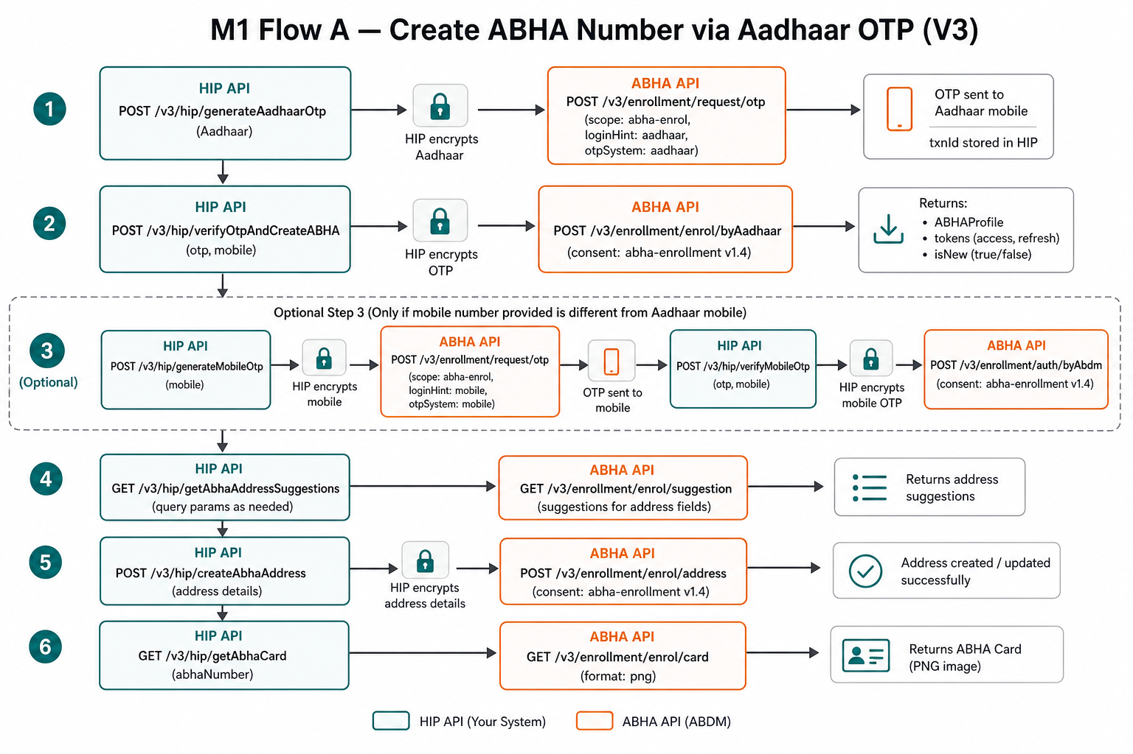
Figure 2. M1 Flow A — Create ABHA number via Aadhaar OTP, then address and card.

5.1 Generate Aadhaar OTP
Item | Value
HIP method & path | POST /v3/hip/generateAadhaarOtp
Auth to HIP | Bahmni session (reporting_session / JSESSIONID)
Downstream ABHA API | POST {AbhaNumberServiceUrl}/v3/enrollment/request/otp
Purpose | Send OTP to the mobile linked with Aadhaar. Stores txnId in TxnDictionary. Returns only the ABDM message to the UI (txnId is not returned).

HIP request body
{
"aadhaar": "123412341234" // 12-digit Aadhaar, plaintext; HIP encrypts
}
HIP → ABHA body (after encryption)
{
"txnId": "",
"scope": ["abha-enrol"],
"loginHint": "aadhaar",
"loginId": "<RSA-encrypted Aadhaar>",
"otpSystem": "aadhaar"
}
HIP response (202 Accepted on success)
{
"message": "OTP sent to Aadhaar registered mobile ending xx001"
}
Resend OTP: call the same HIP API again. ABDM allows resend; the sandbox guidance is to enable resend at least twice after 60 seconds. HIP currently starts a new enrolment OTP (empty txnId) rather than passing the previous txnId for resend.

5.2 Verify Aadhaar OTP and create ABHA
Item | Value
HIP method & path | POST /v3/hip/verifyOtpAndCreateABHA
Auth to HIP | Bahmni session (reporting_session / JSESSIONID)
Downstream ABHA API | POST {AbhaNumberServiceUrl}/v3/enrollment/enrol/byAadhaar
Purpose | Verifies Aadhaar OTP, creates or returns the ABHA profile, stores user token for card/profile.

HIP request body
{
"otp": "123456",
"mobile": "98xxxxxxxx" // communication mobile; sent unencrypted to ABHA in current code
}
HIP → ABHA body
{
"authData": {
"authMethods": ["otp"],
"otp": {
"txnId": "<from session>",
"otpValue": "<RSA-encrypted OTP>",
"mobile": "98xxxxxxxx",
"timestamp": "2026-08-22T06:25:00.000Z"
}
},
"consent": {
"code": "abha-enrollment",
"version": "1.4"
}
}
HIP response (200 OK)
{
"message": "Account created successfully",
"isNew": true,
"abhaProfile": {
"firstName": "First",
"middleName": "",
"lastName": "Last",
"dob": "01-01-1990",
"gender": "F",
"mobile": "98xxxxxxxx",
"phrAddress": ["first.last@sbx"],
"address": "...",
"stateName": "...",
"districtName": "...",
"pinCode": "400001",
"abhaNumber": "91-xxxx-xxxx-xxxx",
"abhaStatus": "ACTIVE"
}
}
HIP stores enroll tokens.token in HealthIdNumberTokenDictionary and the new txnId in TxnDictionary. isNew=false means this Aadhaar already had an ABHA; the same profile is returned.

5.3 Generate mobile OTP (only if communication mobile ≠ Aadhaar mobile)
Item | Value
HIP method & path | POST /v3/hip/generateMobileOtp
Auth to HIP | Bahmni session (reporting_session / JSESSIONID)
Downstream ABHA API | POST {AbhaNumberServiceUrl}/v3/enrollment/request/otp
Purpose | OTP to the communication mobile. Uses existing txnId from session. Scopes abha-enrol + mobile-verify.

HIP request body
{
"mobile": "98xxxxxxxx"
}
HIP → ABHA body
{
"txnId": "<session txnId>",
"scope": ["abha-enrol", "mobile-verify"],
"loginHint": "mobile",
"loginId": "<RSA-encrypted mobile>",
"otpSystem": "abdm"
}
HIP response (202 Accepted)
{
"message": "OTP sent to mobile ending xx89"
}

5.4 Verify mobile OTP and link mobile
Item | Value
HIP method & path | POST /v3/hip/verifyMobileOtp
Auth to HIP | Bahmni session (reporting_session / JSESSIONID)
Downstream ABHA API | POST {AbhaNumberServiceUrl}/v3/enrollment/auth/byAbdm
Purpose | Links the verified communication mobile to the ABHA enrolment transaction.

HIP request body
{
"otp": "123456"
}
HIP → ABHA body
{
"scope": ["abha-enrol", "mobile-verify"],
"authData": {
"authMethods": ["otp"],
"otp": {
"txnId": "<session txnId>",
"otpValue": "<RSA-encrypted OTP>",
"timestamp": "2026-08-22T06:26:00.000Z"
}
}
}
HIP response (200 OK) — EnrollmentAuthByAbdmResponse
{
"txnId": "...",
"authResult": "success",
"message": "Mobile verified successfully"
}

5.5 Get ABHA address suggestions
Item | Value
HIP method & path | GET /v3/hip/getAbhaAddressSuggestions
Auth to HIP | Bahmni session (reporting_session / JSESSIONID)
Downstream ABHA API | GET {AbhaNumberServiceUrl}/v3/enrollment/enrol/suggestion
Purpose | Returns suggested ABHA addresses for the current enrolment txnId (sent as Transaction_Id header).

HIP request: no body. txnId is taken from session.
HIP response (200 OK) — txnId is stripped; UI only receives the list
{
"abhaAddressList": [
"first.last",
"firstlast90",
"first.l90"
]
}

5.6 Create ABHA address
Item | Value
HIP method & path | POST /v3/hip/createAbhaAddress
Auth to HIP | Bahmni session (reporting_session / JSESSIONID)
Downstream ABHA API | POST {AbhaNumberServiceUrl}/v3/enrollment/enrol/abha-address
Purpose | Creates the preferred ABHA address for the enrolment transaction.

HIP request body
{
"abhaAddress": "first.last"
}
HIP → ABHA body
{
"txnId": "<session txnId>",
"abhaAddress": "first.last",
"preferred": 1
}
HIP response: 200 OK with empty body on success. Error body is forwarded from ABDM.

5.7 Download ABHA card
Item | Value
HIP method & path | GET /v3/hip/getAbhaCard
Auth to HIP | Bahmni session (reporting_session / JSESSIONID)
Downstream ABHA API | GET {AbhaNumberServiceUrl}/v3/profile/account/abha-card
Purpose | Returns PNG of the official ABHA card. Requires X-Token from enrol/login stored in session.

HIP response: image/png stream. The UI should treat this as a file download. If the session has no token, this call fails with HTTP 500 in the current implementation.

6. Flow B — Verify / login existing ABHA
Use this when the patient already has an ABHA. HIP maps identifierType + authMethod to ABDM scope, loginHint and otpSystem. After OTP success, HIP stores the user token. If several accounts are returned, the UI must call verifyAbhaAccount with the chosen ABHA number.
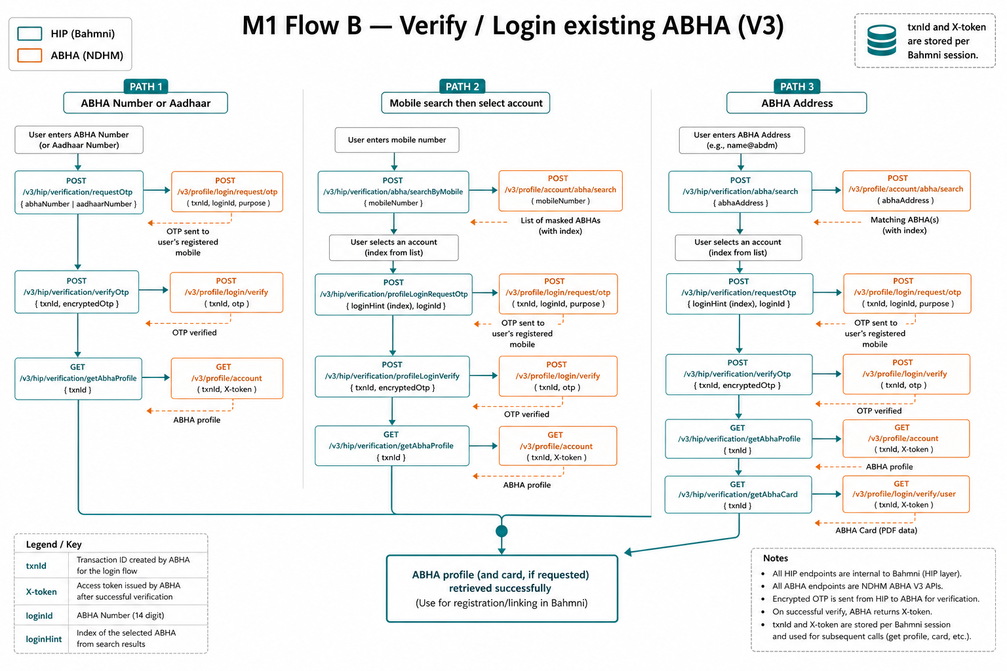
Figure 3. M1 Flows B, C and D — login by ABHA/Aadhaar, search-by-mobile, and ABHA address.

6.1 Identifier and auth mapping (requestOtp)
identifierType | authMethod | ABDM scope | loginHint | otpSystem
ABHA_NUMBER | AADHAAR_OTP | abha-login, aadhaar-verify | abha-number | aadhaar
ABHA_NUMBER | MOBILE_OTP | abha-login, mobile-verify | abha-number | abdm
AADHAAR_NUMBER | (any / Aadhaar) | abha-login, aadhaar-verify | aadhaar | aadhaar
MOBILE_NUMBER | (mapped) | abha-login, mobile-verify, search-abha | index | abdm

MOBILE_NUMBER on /verification/requestOtp uses loginHint=index. That path expects the identifier to be an ABHA list index, not a raw mobile number. For “find ABHA by mobile number”, use Flow C (searchByMobile) instead.

6.2 Request OTP
Item | Value
HIP method & path | POST /v3/hip/verification/requestOtp
Auth to HIP | Bahmni session (reporting_session / JSESSIONID)
Downstream ABHA API | POST {AbhaNumberServiceUrl}/v3/profile/login/request/otp
Purpose | Starts ABHA login. Stores txnId and scope against the Bahmni session.

HIP request body
{
"identifier": "91-xxxx-xxxx-xxxx",
"identifierType": "ABHA_NUMBER",
"authMethod": "AADHAAR_OTP"
}
Allowed identifierType: ABHA_NUMBER | MOBILE_NUMBER | AADHAAR_NUMBER. Allowed authMethod: MOBILE_OTP | AADHAAR_OTP.
HIP → ABHA body example (ABHA number + Aadhaar OTP)
{
"scope": ["abha-login", "aadhaar-verify"],
"loginHint": "abha-number",
"loginId": "<RSA-encrypted ABHA number>",
"otpSystem": "aadhaar"
}
HIP response (202 Accepted)
{
"message": "OTP sent to Aadhaar registered mobile ending xx001"
}
Invalid identifierType or authMethod returns 400 with the exception message.

6.3 Verify OTP
Item | Value
HIP method & path | POST /v3/hip/verification/verifyOtp
Auth to HIP | Bahmni session (reporting_session / JSESSIONID)
Downstream ABHA API | POST {AbhaNumberServiceUrl}/v3/profile/login/verify
Purpose | Completes login. Stores user token. Returns auth result and linked accounts (token itself is not returned to UI).

HIP request body
{
"otp": "123456"
}
HIP → ABHA body
{
"scope": ["abha-login", "aadhaar-verify"],
"authData": {
"authMethods": ["otp"],
"otp": {
"txnId": "<session txnId>",
"otpValue": "<RSA-encrypted OTP>"
}
}
}
HIP response (200 OK) — VerificationVerifyOtpResponse
{
"txnId": "...",
"authResult": "success",
"message": "OTP verified",
"accounts": [
{
"abhaNumber": "91-xxxx-xxxx-xxxx",
"preferredAbhaAddress": "first.last@sbx",
"name": "First Last",
"gender": "F",
"dob": "01-01-1990",
"status": "ACTIVE",
"kycVerified": true
}
]
}

6.4 Verify / select ABHA account (when multiple accounts)
Item | Value
HIP method & path | POST /v3/hip/verification/verifyAbhaAccount
Auth to HIP | Bahmni session (reporting_session / JSESSIONID)
Downstream ABHA API | POST {AbhaNumberServiceUrl}/v3/profile/login/verify/user
Purpose | Selects one ABHA from the list returned by verify OTP. Replaces session user token.

HIP request body
{
"abhaNumber": "91-xxxx-xxxx-xxxx"
}
HIP adds session txnId and sends X-Token from the previous verify step. Success is 200 OK with empty body. Subsequent getAbhaProfile / getAbhaCard use the new token.

6.5 Get ABHA profile
Item | Value
HIP method & path | GET /v3/hip/verification/getAbhaProfile
Auth to HIP | Bahmni session (reporting_session / JSESSIONID)
Downstream ABHA API | GET {AbhaNumberServiceUrl}/v3/profile/account
Purpose | Full ABHA profile for the logged-in user. Requires session token from verify OTP or enrol.

If the session has no token, HIP returns 401 with message: Session token not found. Please complete OTP verification first.
HIP response (200 OK) — selected fields
{
"abhaNumber": "91-xxxx-xxxx-xxxx",
"preferredAbhaAddress": "first.last@sbx",
"mobile": "98xxxxxxxx",
"firstName": "First",
"lastName": "Last",
"name": "First Last",
"yearOfBirth": "1990",
"monthOfBirth": "01",
"dayOfBirth": "01",
"gender": "F",
"address": "...",
"stateName": "...",
"districtName": "...",
"pincode": "400001",
"kycVerified": "true",
"authMethods": ["AADHAAR_OTP", "MOBILE_OTP"]
}

7. Flow C — Search ABHA by mobile (V3)
This is the dedicated V3 “find ABHA using mobile” path added in the M1 search-by-mobile commits. It is the correct flow when the patient knows the mobile number but not the ABHA number. HIP encrypts mobile and loginId, stores txnId, and returns a simplified list (index, masked ABHA, name, gender).

7.1 Search ABHA by mobile
Item | Value
HIP method & path | POST /v3/hip/verification/abha/searchByMobile
Auth to HIP | Bahmni session (reporting_session / JSESSIONID)
Downstream ABHA API | POST {AbhaNumberServiceUrl}/v3/profile/account/abha/search
Purpose | Returns masked ABHA numbers linked to the mobile. Stores txnId in session.

HIP request body
{
"scope": ["search-abha"],
"mobile": "98xxxxxxxx" // plaintext; HIP encrypts before ABHA call
}
Validation: scope and mobile are required; otherwise 400 “scope and mobile are required.”
ABDM raw response (array) is mapped by HIP to:
{
"txnId": "uuid-from-abdm",
"abhaList": [
{
"index": 1,
"abhaNumber": "xx-xxxx-xxxx-6514",
"name": "First Last",
"gender": "F"
}
]
}
UI should display abhaList and let the patient pick an index for the next call.

7.2 Request OTP for selected ABHA index
Item | Value
HIP method & path | POST /v3/hip/verification/abha/profileLoginRequestOtp
Auth to HIP | Bahmni session (reporting_session / JSESSIONID)
Downstream ABHA API | POST {AbhaNumberServiceUrl}/v3/profile/login/request/otp
Purpose | Requests OTP for the ABHA chosen from search. loginId is encrypted. Returns txnId + message.

HIP request body
{
"scope": ["abha-login", "search-abha"],
"loginHint": "index",
"loginId": "1",
"otpSystem": "abdm",
"txnId": "<txnId from searchByMobile>"
}
Required fields: scope, loginHint, loginId, txnId. HIP encrypts loginId (the index). Unlike most M1 OTP APIs, this one returns txnId to the UI.
HIP response (202 Accepted)
{
"txnId": "uuid-from-abdm",
"message": "OTP sent to mobile ending xx89"
}

7.3 Profile login verify OTP
Item | Value
HIP method & path | POST /v3/hip/verification/abha/profileLoginVerify
Auth to HIP | Bahmni session (reporting_session / JSESSIONID)
Downstream ABHA API | POST {AbhaNumberServiceUrl}/v3/profile/login/verify
Purpose | Verifies OTP for the selected ABHA. Stores user token. Returns ABDM auth payload including token.

HIP request body
{
"scope": ["abha-login", "search-abha"],
"authData": {
"authMethods": ["otp"],
"otp": {
"txnId": "<txnId from previous step>",
"otpValue": "123456"
}
}
}
HIP encrypts otpValue and also sends Transaction_Id header = txnId.
HIP response (202 Accepted) — ABHALoginVerifyOTPResponse when authResult is not failed
{
"txnId": "...",
"authResult": "success",
"message": "OTP verified successfully",
"token": "<user-token>",
"expiresIn": 1800,
"refreshToken": "...",
"refreshExpiresIn": 1296000,
"accounts": [ { "abhaNumber": "91-xxxx-xxxx-xxxx", "preferredAbhaAddress": "...", "name": "..." } ]
}
After success, GET /v3/hip/verification/getAbhaProfile and GET /v3/hip/getAbhaCard work with the stored session token. If authResult is failed, HIP forwards the ABDM status and body.

8. Flow D — ABHA address (PHR) login
These APIs talk to AbhaAddressServiceUrl (PHR), not the ABHA number enrolment APIs. Use them when the patient has an ABHA address such as name@sbx.

8.1 Search ABHA address
Item | Value
HIP method & path | POST /v3/hip/verification/abhaAddress/search
Auth to HIP | Bahmni session (reporting_session / JSESSIONID)
Downstream ABHA API | POST {AbhaNumberServiceUrl}/login/abha/search
Purpose | Looks up an ABHA address and returns available auth methods.

HIP request body
{
"abhaAddress": "first.last@sbx"
}
HIP response (202 Accepted) — SearchAbhaAddressResponse
{
"healthIdNumber": "91-xxxx-xxxx-xxxx",
"abhaAddress": "first.last@sbx",
"authMethods": ["AADHAAR_OTP", "MOBILE_OTP"],
"blockedAuthMethods": [],
"status": "ACTIVE",
"fullName": "First Last",
"mobile": "xxxxxx7890"
}

8.2 Request OTP for ABHA address
Item | Value
HIP method & path | POST /v3/hip/verification/abhaAddress/requestOtp
Auth to HIP | Bahmni session (reporting_session / JSESSIONID)
Downstream ABHA API | POST {AbhaNumberServiceUrl}/login/abha/request/otp
Purpose | Sends OTP for ABHA-address login. Scope is abha-address-login + aadhaar-verify or mobile-verify.

HIP request body
{
"abhaAddress": "first.last@sbx",
"authMethod": "MOBILE_OTP"
}
HIP response (202 Accepted): { "message": "..." }. txnId stored in session.

8.3 Verify OTP for ABHA address
Item | Value
HIP method & path | POST /v3/hip/verification/abhaAddress/verifyOtp
Auth to HIP | Bahmni session (reporting_session / JSESSIONID)
Downstream ABHA API | POST {AbhaNumberServiceUrl}/login/abha/verify
Purpose | Verifies OTP and stores PHR user token. Returns users list without the raw token.

HIP request body
{
"otp": "123456"
}
HIP response (200 OK)
{
"authResult": "success",
"message": "OTP verified",
"users": [
{
"abhaAddress": "first.last@sbx",
"fullName": "First Last",
"abhaNumber": "91-xxxx-xxxx-xxxx",
"status": "ACTIVE",
"kycStatus": "VERIFIED"
}
]
}

8.4 Get ABHA address profile
Item | Value
HIP method & path | GET /v3/hip/verification/abhaAddress/getProfile
Auth to HIP | Bahmni session (reporting_session / JSESSIONID)
Downstream ABHA API | GET {AbhaNumberServiceUrl}/login/profile/abha-profile
Purpose | Profile for the logged-in ABHA address. Uses X-Token from verify step.

HIP response (200 OK) includes abhaAddress, abhaNumber, demographics, kycStatus, mobileVerified.

8.5 Get ABHA address / PHR card
Item | Value
HIP method & path | GET /v3/hip/verification/abhaAddress/getCard
Auth to HIP | Bahmni session (reporting_session / JSESSIONID)
Downstream ABHA API | GET {AbhaNumberServiceUrl}/login/profile/abha/phr-card
Purpose | PNG PHR card for the logged-in ABHA address.

HIP response: image/png stream.

9. M1 API catalogue (HIP facing)
# | HIP API | ABDM API | Flow
A1 | POST /v3/hip/generateAadhaarOtp | POST /v3/enrollment/request/otp | Create
A2 | POST /v3/hip/verifyOtpAndCreateABHA | POST /v3/enrollment/enrol/byAadhaar | Create
A3 | POST /v3/hip/generateMobileOtp | POST /v3/enrollment/request/otp | Create (optional mobile)
A4 | POST /v3/hip/verifyMobileOtp | POST /v3/enrollment/auth/byAbdm | Create (optional mobile)
A5 | GET /v3/hip/getAbhaAddressSuggestions | GET /v3/enrollment/enrol/suggestion | Create
A6 | POST /v3/hip/createAbhaAddress | POST /v3/enrollment/enrol/abha-address | Create
A7 | GET /v3/hip/getAbhaCard | GET /v3/profile/account/abha-card | Create / after login
B1 | POST /v3/hip/verification/requestOtp | POST /v3/profile/login/request/otp | Login
B2 | POST /v3/hip/verification/verifyOtp | POST /v3/profile/login/verify | Login
B3 | POST /v3/hip/verification/verifyAbhaAccount | POST /v3/profile/login/verify/user | Login (multi-account)
B4 | GET /v3/hip/verification/getAbhaProfile | GET /v3/profile/account | Login
C1 | POST /v3/hip/verification/abha/searchByMobile | POST /v3/profile/account/abha/search | Search by mobile
C2 | POST /v3/hip/verification/abha/profileLoginRequestOtp | POST /v3/profile/login/request/otp | Search by mobile
C3 | POST /v3/hip/verification/abha/profileLoginVerify | POST /v3/profile/login/verify | Search by mobile
D1 | POST /v3/hip/verification/abhaAddress/search | POST /login/abha/search | ABHA address
D2 | POST /v3/hip/verification/abhaAddress/requestOtp | POST /login/abha/request/otp | ABHA address
D3 | POST /v3/hip/verification/abhaAddress/verifyOtp | POST /login/abha/verify | ABHA address
D4 | GET /v3/hip/verification/abhaAddress/getProfile | GET /login/profile/abha-profile | ABHA address
D5 | GET /v3/hip/verification/abhaAddress/getCard | GET /login/profile/abha/phr-card | ABHA address

10. Typical UI call order

10.1 New patient — create ABHA
1. Collect consent (ABDM enrolment consent, version 1.4 is sent by HIP on enrol).
2. POST /v3/hip/generateAadhaarOtp with aadhaar.
3. Patient enters Aadhaar OTP and communication mobile → POST /v3/hip/verifyOtpAndCreateABHA.
4. Show ABHA number from abhaProfile. If communication mobile must be verified separately → generateMobileOtp then verifyMobileOtp.
5. GET /v3/hip/getAbhaAddressSuggestions → patient picks or types an address → POST /v3/hip/createAbhaAddress.
6. GET /v3/hip/getAbhaCard to display / download PNG.
7. Continue hospital registration using abhaNumber and preferred ABHA address (M2 linking is a later step).

10.2 Existing patient — knows ABHA number
1. POST /v3/hip/verification/requestOtp with identifierType=ABHA_NUMBER and AADHAAR_OTP or MOBILE_OTP.
2. POST /v3/hip/verification/verifyOtp.
3. If accounts.length > 1, POST /v3/hip/verification/verifyAbhaAccount with the chosen abhaNumber.
4. GET /v3/hip/verification/getAbhaProfile and optionally GET /v3/hip/getAbhaCard.

10.3 Existing patient — knows only mobile
1. POST /v3/hip/verification/abha/searchByMobile with scope ["search-abha"] and mobile.
2. Patient selects an index from abhaList.
3. POST /v3/hip/verification/abha/profileLoginRequestOtp with loginHint=index, loginId=<index>, txnId from step 1.
4. POST /v3/hip/verification/abha/profileLoginVerify with the OTP and txnId from step 3.
5. GET /v3/hip/verification/getAbhaProfile.

10.4 Existing patient — knows ABHA address
1. POST /v3/hip/verification/abhaAddress/search.
2. POST /v3/hip/verification/abhaAddress/requestOtp with the authMethod returned by search.
3. POST /v3/hip/verification/abhaAddress/verifyOtp.
4. GET /v3/hip/verification/abhaAddress/getProfile and optionally getCard.

11. Error handling and operational notes
- ABDM non-success status codes and response bodies are forwarded as-is (HIP uses StatusCode((int)response.StatusCode, responseContent)).
- Unhandled exceptions in HIP return HTTP 500 with no body.
- Always send CORRELATION-ID from the UI; HIP copies it to gateway and ABHA calls for tracing.
- Do not store Aadhaar in HMIS. HIP also does not persist Aadhaar; only encrypted transit to ABDM.
- Session maps are in-memory. Keep create/login steps on the same HIP instance and the same Bahmni session cookie.
- Public certificate is loaded once at HIP startup. ABDM rotates it periodically (order of months); restart HIP after rotation if encryption starts failing.
- Legacy V1/V2 routes still exist (auth/init, mobile generateOtp, phr/login/mobileEmail/*, demo auth). Prefer the /v3/hip APIs above for new UI work.

12. Code map (M1)
Area | Primary types
Create APIs | Creation/CreationController.cs
Verify / search / address APIs | Verification/VerificationController.cs
Identifier → ABDM mapping | Verification/VerificationRequestMapper.cs
Session maps | Creation/CreationMap.cs
RSA encrypt | Common/EncryptionService.cs
Gateway token + ABHA HTTP | Gateway/GatewayClient.cs, Common/HttpRequestHelper.cs
Paths | Common/Constants.cs (APP_PATH_* and ABHA_*)
Auth to HIP | Common/Model/CustomAuthenticationHandler.cs

13. What comes next (not in this section)
M2 will document user-initiated linking (discover → link init → link confirm), HIP-initiated linking (generate-token, carecontext, context notify, SMS notify2), scan-and-share (patient/share), and HFR id per care context. M3 will document consent/hip/notify and health-information request / encrypted FHIR push.
Please recap M1 (API list, call order, and whether the UI should keep using session-hidden txnId versus the search-by-mobile APIs that return txnId). After that, M2 will be appended to this same file.

14. External references
- ABDM Sandbox V3 documentation: https://sandbox.abdm.gov.in/sandbox/v3/new-documentation
- User-initiated linking swagger (M2): sandbox v3 swagger with integration_label abdm_user_initiated_linking_phr
- HIP-initiated linking (M2): https://sandbox.abdm.gov.in/sandbox/v3/new-documentation?doc=HIPInitiatedlinking
- ABHA number sandbox base: https://abhasbx.abdm.gov.in/abha/api
- Gateway sessions: POST {Gateway.url}/api/hiecm/gateway/v3/sessions
End of Milestone 1. M2 and M3 sections will follow in this document after recap.

