ABDM HIP communication flow
M1, M2 and M3 for the Bahmni HIP setup
hip-service · openmrs-module-hip · abdm-callback-proxy · ABDM gateway
How a patient is created or verified, linked to a visit, and how the PHR app later shows that consultation.
What this document is based on
The paths, headers and callbacks below are the ones implemented in this workspace: hip-service (In.ProjectEKA.HipService), openmrs-module-hip, the ABHA-Verification Bahmni screen, otp_service, and abdm-callback-proxy. Gateway calls that start at the HIP go directly to the ABDM gateway. Calls that start at the gateway come back through the callback proxy, which chooses the facility from the X-HIP-ID header.

1. The four systems
Four systems carry one patient journey. Each one has a single job.
System | Role in this setup
Bahmni UI (ABHA-Verification) | Registration screen inside Bahmni. Creates or verifies ABHA, saves demographics on the HIP, and later asks the HIP to link a visit or send the deep-link SMS. Calls are made to /hiprovider on the same clinic host.
openmrs-module-hip | OpenMRS module. Does not call ABDM. Answers the HIP when it needs a patient match, the list of care contexts, or the FHIR document for a saved visit (consultation, prescription, lab report and the other HI types).
hip-service | The HIP. Speaks ABDM on behalf of the facility. Holds link tokens, consent artefacts and the discovery transaction. Encrypts FHIR and pushes it to the PHR app.
abdm-callback-proxy | Sits on the public callback URL registered with ABDM. Reads X-HIP-ID (or X-HIU-ID) and forwards the callback to that facility’s /hiprovider path.
ABDM gateway and ABHA APIs | Gateway is the HIE-CM: tokens, linking, consent, data-flow. ABHA APIs create and verify the ABHA number and ABHA address. The gateway also sends several of the OTPs.
otp_service | Local SMS sender used for one case only: the OTP the patient types in the PHR app while linking care contexts that the HIP discovered.
PHR app | The patient’s app. It discovers the facility, links records, grants consent, and receives the encrypted FHIR that it then shows.

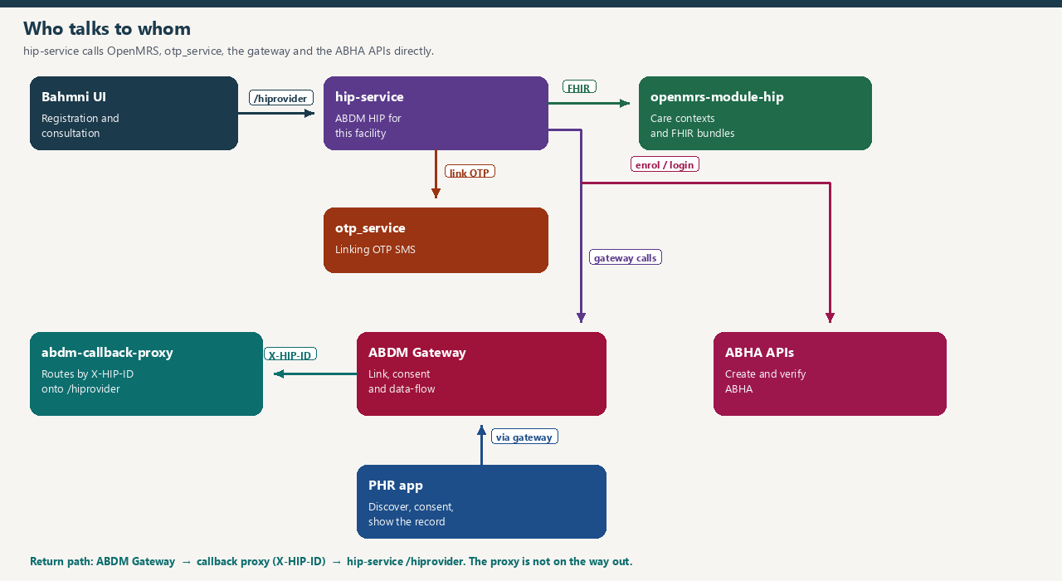
Figure 1. Bahmni and OpenMRS stay inside the facility. The proxy is only on the gateway’s callback path.

2. How the callback proxy chooses a HIP
ABDM is given one callback host for many clinics. Every callback URL begins with /callback. The proxy never looks at the body. It looks at the header.
- Read the incoming headers. Header names are compared in upper case, so X-HIP-ID and x-hip-id both match.
- If X-HIU-ID is present and is a known id, route with that. Otherwise if X-HIP-ID is a known id, route with that.
- The id is a facility id (an HFR id such as IN2710015434, or a configured HIP name). The proxy maps it to that clinic’s host, for example shreeclinic.bahmnilite.in.
- The path is rewritten by replacing the word callback with hiprovider. /callback/api/v3/hip/token/on-generate-token becomes /hiprovider/api/v3/hip/token/on-generate-token on that clinic host.
- The proxy then makes an HTTPS call to that host and returns the HIP’s status to ABDM.
- If the header is missing or the id is not in the map, the proxy does not forward the call. It answers 200 with a plain-text summary of the request. The HIP never sees that callback.
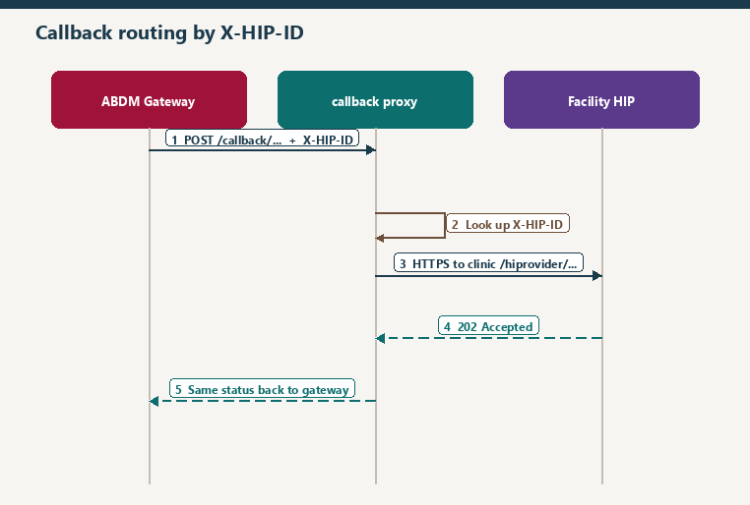
Figure 2. One public callback URL, many facilities. X-HIP-ID picks the host. The word callback in the path becomes hiprovider.
Which calls use the proxy
Only traffic from the gateway (or ABHA share) toward a HIP or HIU. When hip-service calls the gateway or the ABHA APIs, it calls them directly and puts X-HIP-ID on the request so the gateway can echo it on the callback. Bahmni calling /hiprovider on its own clinic also does not go through the proxy.

The HIP puts X-HIP-ID on outbound gateway calls from the facility resolved for that visit (HipFacilityResolver, falling back to the default HFR id). On discovery, if the care context belongs to a different HFR id than the X-HIP-ID on the request, the HIP refuses the discovery with a care-context HIP mismatch and does not return the records.

3. The journey in one pass
This is the path from the registration desk to a consultation visible in the PHR app. The later sections open each step.
- At registration the clerk either creates a new ABHA or verifies one the patient already has. ABDM sends the OTP SMS. hip-service only relays the encrypted OTP and keeps the transaction id against the Bahmni session.
- The ABHA profile comes back to the screen. The clerk saves the Bahmni patient, which stores the ABHA number and ABHA address on the OpenMRS patient. The screen also posts demographics to the HIP (name, gender, year of birth, mobile, ABHA address). Those demographics are what the HIP later sends when it asks for a link token, and what it uses to find the facility when sending the deep-link SMS.
- The consultation is saved in Bahmni as a visit and encounters. That save is ordinary OpenMRS data. Nothing is sent to ABDM at the moment of the clinical save itself.
- Bahmni then calls the HIP with the new care context for that visit. The reference is patientId:visitUuid. The HIP asks ABDM for a link token (generate-token). ABDM calls back on-generate-token through the proxy. With that token the HIP links the visit (link/carecontext). ABDM confirms with on_carecontext, again through the proxy. Later on visit for a patient who is already linked uses context notify instead of a fresh link, and the callback is on-notify.
- Bahmni can then ask the HIP to send the deep-link SMS. The HIP calls the gateway sms/notify2 API. ABDM texts the patient a link into the PHR app for this facility. The gateway confirms with sms/on-notify through the proxy.
- In the PHR app the patient discovers the facility. The gateway calls discover on the HIP (through the proxy). The HIP reads care contexts from openmrs-module-hip and answers on-discover. The patient selects visits. The HIP sends its own linking OTP SMS through otp_service and answers on-init. The patient types the OTP. The HIP checks it, writes the ABHA identifier onto the OpenMRS patient, and answers on-confirm.
- If the HIP already linked the visit in step 4, the PHR app can already see that context and the patient does not have to discover it. Discovery returns only contexts that are not linked yet.
- The patient grants consent in the PHR app to pull those records (the PHR app is the HIU). The gateway notifies the HIP. The HIP stores the consent artefact and answers consent on-notify.
- The gateway sends a health-information request with a dataPushUrl and the HIU’s encryption key. The HIP answers on-request, loads FHIR bundles for that visit from openmrs-module-hip, encrypts them, and POSTs them to the dataPushUrl. It then tells the gateway the transfer finished. The PHR app decrypts the bundles and shows the consultation.

4. M1 — create an ABHA
M1 here is ABHA creation and the demographics the rest of the flow depends on. The Bahmni screen calls hip-service. hip-service calls the ABHA number service. These calls are synchronous, so the callback proxy is not involved. Before each ABHA call the HIP logs in to the gateway (POST api/hiecm/gateway/v3/sessions with the facility client id and secret) and sends that bearer token.
Aadhaar and OTP values are encrypted with the ABHA public certificate before they leave the HIP. The transaction id returned by ABHA is stored against the Bahmni session id, so the next click on the same screen continues the same enrolment.
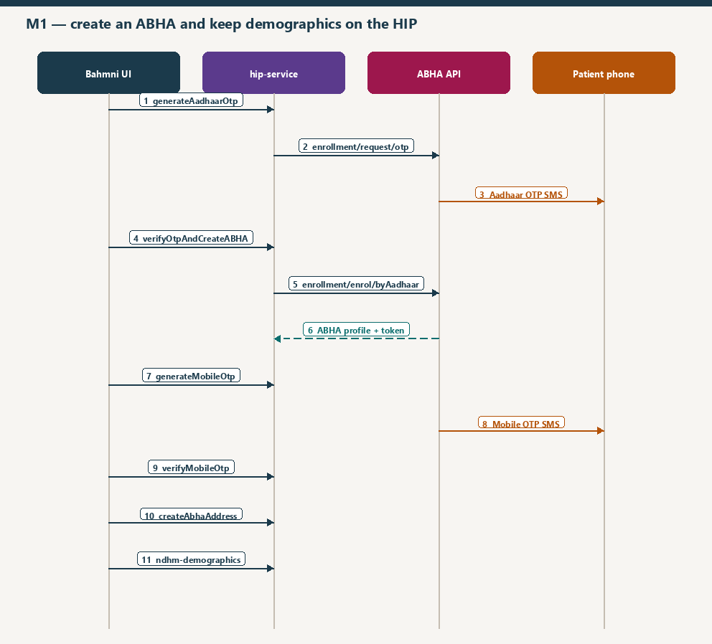
Figure 3. Create ABHA. The two SMS messages are sent by ABDM / UIDAI, not by the clinic SMS gateway.
Step | Bahmni calls | HIP calls on ABHA | SMS
1 | POST /hiprovider/v3/hip/generateAadhaarOtp | POST /v3/enrollment/request/otp with login hint AADHAAR and scope abha-enrol | Aadhaar OTP to the mobile registered with Aadhaar
2 | POST /hiprovider/v3/hip/verifyOtpAndCreateABHA with OTP and mobile | POST /v3/enrollment/enrol/byAadhaar | None. Response carries the ABHA profile, whether it is new, and a user token
3 | POST /hiprovider/v3/hip/generateMobileOtp when that mobile still has to be verified | POST /v3/enrollment/request/otp with login hint MOBILE and scope mobile-verify | ABDM OTP to the mobile number just entered
4 | POST /hiprovider/v3/hip/verifyMobileOtp | POST /v3/enrollment/auth/byAbdm | None
5 | GET /hiprovider/v3/hip/getAbhaAddressSuggestions | GET /v3/enrollment/enrol/suggestion | None
6 | POST /hiprovider/v3/hip/createAbhaAddress | POST /v3/enrollment/enrol/abha-address | None
7 | GET /hiprovider/v3/hip/getAbhaCard | GET /v3/profile/account/abha-card with the user token in X-Token | None. PNG card is returned to the screen
8 | POST /hiprovider/v0.5/hip/ndhm-demographics | Stored in the HIP database. No gateway call | None

Demographics saved in step 8 are the ABHA address, name, gender, date of birth and phone number. Without this row, generate-token later has nothing to send, and the deep-link SMS cannot resolve which facility the phone number belongs to.

5. M1 — verify an existing ABHA and attach it
Verification is the same shape: the screen talks to the HIP, the HIP talks to ABHA, ABDM sends the OTP. After a successful profile, the clerk saves the Bahmni patient. That save is what attaches the ABHA to the clinical record. There is a second attach later, during PHR linking, where the HIP itself writes the ABHA identifiers onto the OpenMRS patient.
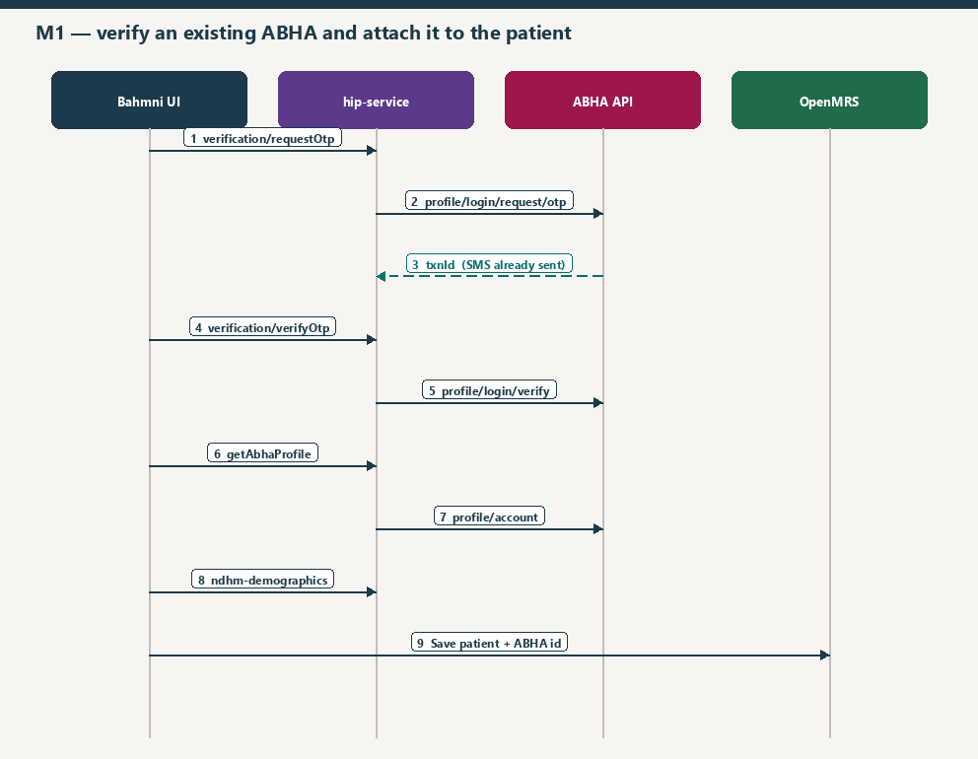
Figure 4. Verify by ABHA number. ABHA-address verification and mobile search follow the same screen-to-HIP-to-ABHA shape.

5.1 Verify with an ABHA number
Bahmni calls | HIP calls | What comes back
POST /v3/hip/verification/requestOtp | POST /v3/profile/login/request/otp | ABDM sends the OTP (Aadhaar OTP or mobile OTP, depending on the login hint). HIP keeps txnId.
POST /v3/hip/verification/verifyOtp | POST /v3/profile/login/verify | Accounts linked to that login. If several ABHA numbers share the mobile, the screen asks the clerk to pick one.
POST /v3/hip/verification/verifyAbhaAccount | POST /v3/profile/login/verify/user | Confirms the chosen ABHA number and returns the user token.
GET /v3/hip/verification/getAbhaProfile | GET /v3/profile/account with X-Token | Name, gender, mobile, ABHA number and ABHA address for the registration form.

5.2 Verify with an ABHA address
Bahmni calls | HIP calls on the ABHA-address service | SMS
POST /v3/hip/verification/abhaAddress/search | POST /login/abha/search | None
POST /v3/hip/verification/abhaAddress/requestOtp | POST /login/abha/request/otp | ABDM sends the OTP
POST /v3/hip/verification/abhaAddress/verifyOtp | POST /login/abha/verify | None
GET /v3/hip/verification/abhaAddress/getProfile | GET /login/profile/abha-profile | None
GET /v3/hip/verification/abhaAddress/getCard | GET /login/profile/abha/phr-card | None

5.3 Find an ABHA from a mobile number
POST /v3/hip/verification/abha/searchByMobile calls ABHA POST /v3/profile/account/abha/search and lists the ABHA numbers on that mobile. The clerk picks one. POST /v3/hip/verification/abha/profileLoginRequestOtp then POST profileLoginVerify repeat the login OTP (ABDM sends the SMS) and return the profile.

5.4 Attaching the ABHA to the Bahmni patient
- The registration screen fills the Bahmni patient from the profile (name, gender, phone, ABHA number, ABHA address). Saving the patient in Bahmni writes those identifiers in OpenMRS. That is the attach the clerk sees.
- The same screen posts /v0.5/hip/ndhm-demographics so the HIP can mint a link token and send SMS later, even before any care context exists.
- A second write happens only on user-initiated link confirm. The HIP POSTs to OpenMRS ws/rest/v1/hip/existingPatients/update/{patientUuid} with the ABHA number and ABHA address, and stores the same demographics again. This covers a patient who was matched from the PHR app rather than typed in at the desk.
- openmrs-module-hip also exposes GET /ws/rest/v1/hip/existingPatients and GET by health id, which the screen uses to warn if this ABHA is already on a Bahmni patient.

6. Scan and share, and the older user-auth callbacks
Two more M1-style entry points exist. Scan-and-share is how a patient who already has a PHR app skips typing an ABHA at the desk. The older user-auth APIs are still in hip-service and still travel through the proxy; the registration screen can still call them.

6.1 Profile share (facility QR)
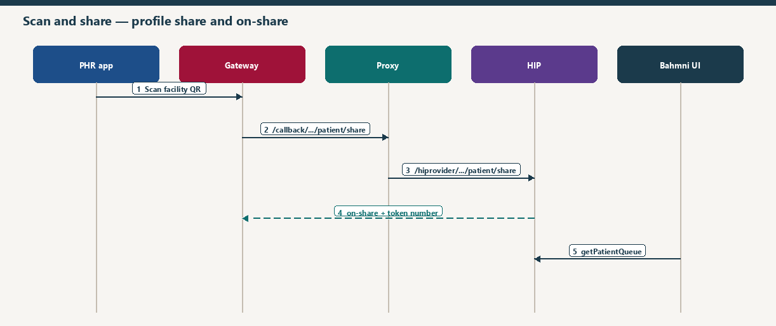
Figure 5. The only callback in this flow is on-share, and it is an outbound call from the HIP back to the gateway, not a second inbound callback.
- The patient scans the facility QR in the PHR app. The gateway POSTs /api/v3/hip/patient/share to the callback host.
- The proxy forwards it to /hiprovider/api/v3/hip/patient/share.
- The HIP checks the payload, stores the shared profile on the patient queue, and returns 202. It then calls the gateway at /api/hiecm/patient-share/v3/on-share with a counter token and a context, and an expiry of 1800 seconds.
- The registration screen polls GET /hiprovider/v3/hip/getPatientQueue and opens that patient. No SMS is sent on this path.

6.2 Legacy gateway user authentication
This is the older way for the facility to authenticate an ABHA through the gateway instead of the ABHA profile APIs. The HIP calls the gateway and then waits, polling an in-memory map, until the matching on-* callback arrives through the proxy. If it never arrives, the HIP returns 504 gateway timeout. The wait is the configured timeout (default 3 seconds) repeated for the configured counter (default 7). Auth confirm waits a little longer on each pass.
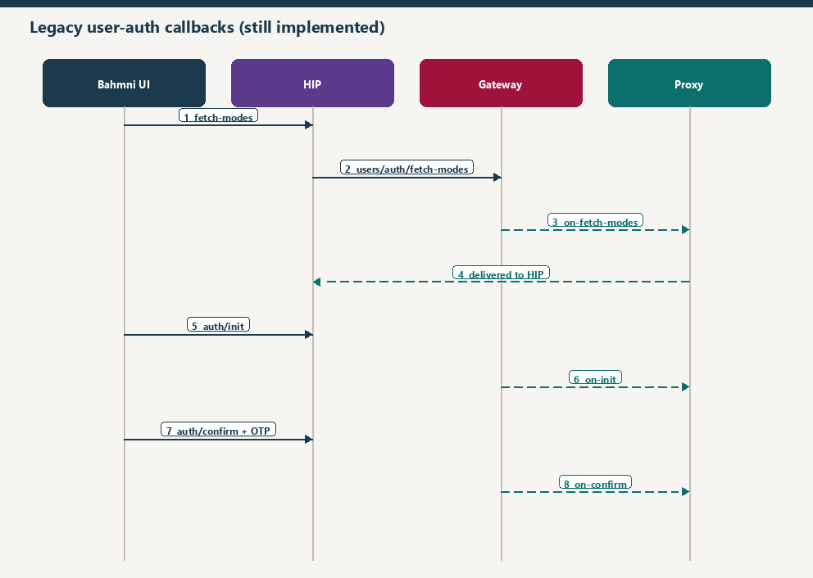
Figure 6. Every on-* in this picture is gateway to proxy to HIP. The HIP does not answer those callbacks with another on-* call.
Bahmni calls HIP | HIP calls gateway | Callback into HIP via proxy | What the HIP does with it
/v0.5/hip/fetch-modes | /v0.5/users/auth/fetch-modes | POST /v0.5/users/auth/on-fetch-modes | Stores the auth modes for that request id and adds DIRECT. Returns the list to the screen.
/v0.5/hip/auth/init | /v0.5/users/auth/init | POST /v0.5/users/auth/on-init | Stores the transaction id. ABDM has sent the OTP SMS as part of init.
/v0.5/hip/auth/confirm with the OTP base64-encoded | /v0.5/users/auth/confirm | POST /v0.5/users/auth/on-confirm | Stores the access token and the patient demographics, and returns the patient to the screen.
/v0.5/hip/auth/direct (DIRECT mode) | No extra call. The HIP waits. | POST /v0.5/users/auth/notify | Patient approved or denied inside the PHR app. HIP stores GRANTED or DENIED, then calls gateway /v0.5/users/auth/on-notify with status OK.

There is also POST /v0.5/patients/status/notify into the HIP. After it runs the notification locally it calls the gateway at /v0.5/patients/status/on-notify. This is a status acknowledgement, not part of ABHA creation.

7. M2 — link the consultation as a care context
M2 is linking. A care context is one visit (or one program enrolment). The reference the HIP uses for a visit is patientId:visitUuid. The display text is the visit label. Each context carries the HI types that visit can produce, such as OPConsultation and Prescription. openmrs-module-hip is the source of that list (GET /ws/rest/v1/hip/careContext). The HIP does not invent contexts.
Linking can be started by the facility (HIP-initiated, using a link token) or by the patient (user-initiated discovery from the PHR app). Both are implemented. A visit the facility has already linked does not need to be discovered again.

7.1 After the consultation is saved — HIP-initiated link
Saving the consultation writes encounters in OpenMRS. The ABDM link is a separate call Bahmni makes to the HIP: POST /hiprovider/v0.5/hip/new-carecontext with the ABHA address, the patient reference, the patient name, and the care contexts for that visit. The HIP loads the contexts it has already linked for that patient.
- A context that is not linked yet is sent with link/carecontext (add). The HIP does this once for the new set.
- A context that is already linked is sent with link/context/notify, so the PHR app is told the visit was updated. The callback for that path is on-notify and the HIP only logs the acknowledgement.
Both paths need a link token for that ABHA address and that HIP id. The HIP reuses a token it already holds if the token’s expiry is still in the future. Otherwise it asks the gateway to mint one.
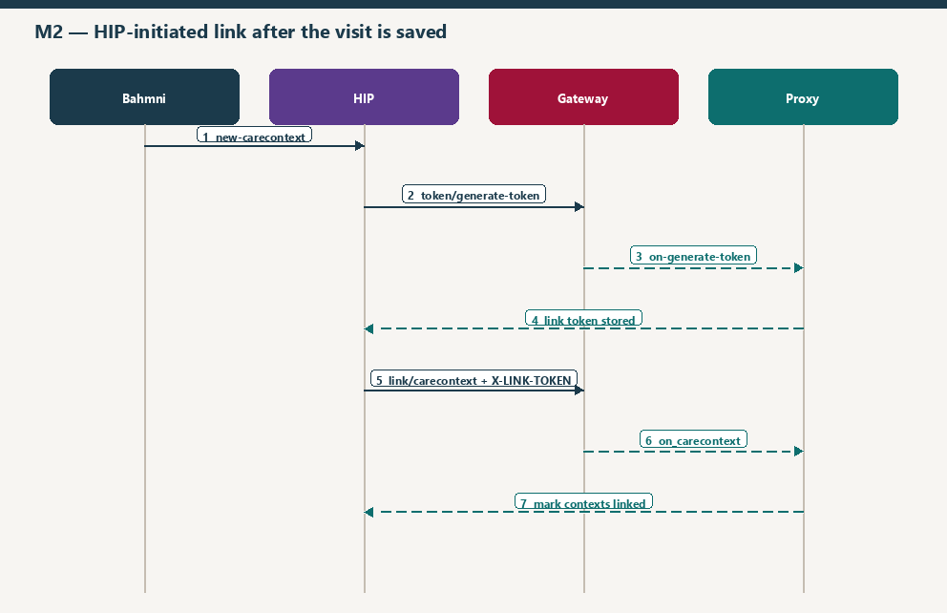
Figure 7. First link of a visit. on-generate-token and on_carecontext both travel gateway, proxy, HIP.

7.2 on-generate-token
- The HIP builds the token request from stored demographics: ABHA address, name, gender, and the year of birth. If demographics were never saved, it stops and the visit is not linked.
- It POSTs /api/hiecm/v3/token/generate-token to the gateway with X-HIP-ID set to the facility for this visit, plus REQUEST-ID, TIMESTAMP, X-CM-ID and the gateway bearer token.
- The HIP waits. Each wait is the gateway timeout plus 8 seconds, repeated up to the configured counter.
- The gateway calls POST /api/v3/hip/token/on-generate-token on the callback host, with the same X-HIP-ID. The proxy rewrites that to /hiprovider/api/v3/hip/token/on-generate-token on the clinic.
- The body carries either an error or a linkToken. The HIP reads the JWT, checks that it has an abhaAddress claim and that exp is still in the future, and reads hipId from the token. It stores the token in memory and in the HIP database under the key ABHA address + HIP id.
- The waiting add-context call then continues. The token is sent on the next gateway call as the header X-LINK-TOKEN.
If the callback is an error, or it never arrives, the HIP does not call link/carecontext. The visit stays only in Bahmni until a later attempt.

7.3 Add care context and on_carecontext
POST /api/hiecm/hip/v3/link/carecontext sends the ABHA address and the care contexts grouped by HI type, with X-LINK-TOKEN and X-HIP-ID. The HIP has already stored an initiated-link row under its own request id, so it can finish the link when the acknowledgement comes back.
The gateway calls POST /api/v3/link/on_carecontext. Through the proxy that is POST /hiprovider/api/v3/link/on_carecontext. The HIP reads the echoed request id, finds the link reference it stored, marks the link successful, and saves the linked account: ABHA address, patient reference, and the care-context reference numbers. It does not call the gateway again. The callback is the acknowledgement.

7.4 Notify an already linked context, and on-notify
POST /api/hiecm/hip/v3/link/context/notify tells the gateway that an already linked visit has new data (a new consultation on a known context, or an update). The body names the patient, the care-context reference, the HI types, the time, and the HIP id. The same link token and X-HIP-ID are required.
The gateway calls POST /api/v3/links/context/on-notify. The HIP logs the acknowledgement status or the error and returns 202. Linking state was already saved when the context was first added, so this callback does not write the link again.

7.5 The deep-link SMS
This SMS is not sent automatically when the care context is saved. Bahmni calls the HIP, and the HIP asks ABDM to send it. The call is useful after demographics exist and a visit has been linked or at least remembered, because the HIP finds the facility from the phone number.
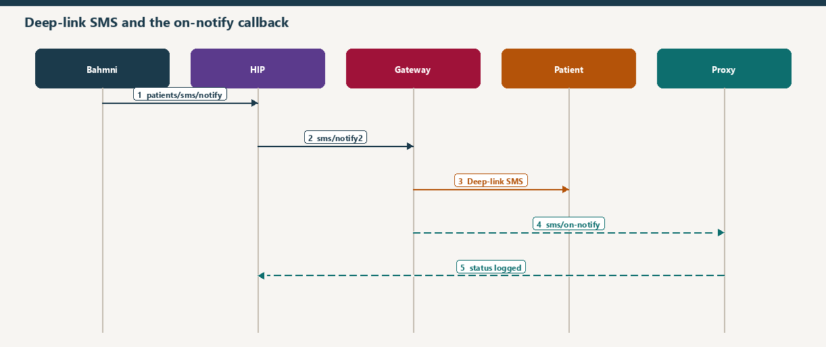
Figure 8. ABDM sends the SMS. sms/on-notify only reports whether that request was accepted.
- Bahmni POSTs /hiprovider/v0.5/hip/patients/sms/notify with the patient’s phone number.
- The HIP resolves the ABHA address from that phone (memory first, then the demographics table written at registration).
- It reads the latest visit id remembered for that ABHA address during add or notify, resolves the HFR id and facility name, and refuses the call if it cannot.
- It POSTs /api/hiecm/hip/v3/link/patient/links/sms/notify2 with the phone number and the HIP id and name.
- ABDM sends the patient an SMS with a link that opens the PHR app on this facility’s records.
- The gateway calls POST /api/v3/patients/sms/on-notify. The proxy delivers it to the HIP, which logs the status or the error and returns 202.

7.6 Patient links from the PHR app
This is the path the deep-link SMS opens, and also the path a patient starts by searching for the facility. Three inbound calls from the gateway, three outbound on-* answers, and one OTP SMS from the clinic.
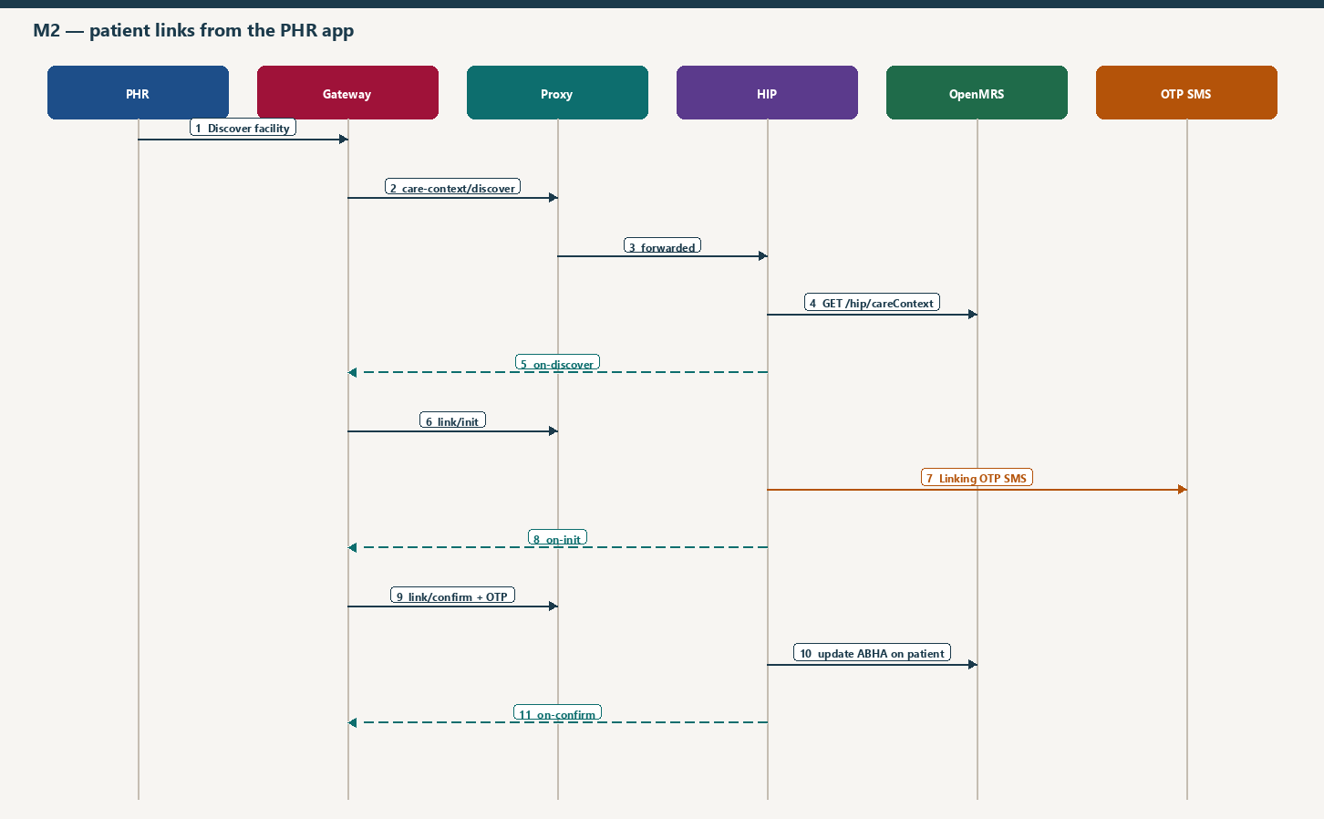
Figure 9. Discover, link init and link confirm. The linking OTP is the only SMS sent by otp_service in this journey.
Discover. The gateway POSTs /api/v3/hip/patient/care-context/discover with X-HIP-ID. The HIP returns 202 immediately and does the work on a background job.
- If this ABHA address already has linked accounts, the HIP loads that OpenMRS patient and returns only the care contexts that are not linked yet.
- Otherwise it searches OpenMRS, first by the verified health id, then by name, gender, year of birth and mobile.
- It asks openmrs-module-hip for care contexts: GET /ws/rest/v1/hip/careContext?patientUuid=.
- It checks that the visit’s HFR id matches the X-HIP-ID on the request. A mismatch is answered as an error on on-discover and no records are returned.
- It POSTs /api/hiecm/user-initiated-linking/v3/patient/care-context/on-discover with the patient, the care contexts, the transaction id, and matchedBy (for example MOBILE or ABHA_ADDRESS).
Link init. The patient selects contexts. The gateway POSTs /api/v3/hip/link/care-context/init. The HIP checks that this transaction id was discovered for this ABHA address and that every selected reference exists. It then asks otp_service (POST /otp) to text the patient’s mobile. The message is: “The OTP is {otp} to link your care context.” followed by the clinic name. The HIP then POSTs /api/hiecm/user-initiated-linking/v3/link/care-context/on-init with a link reference, authentication type MEDIATED, and meta that says MOBILE, plus the phone and the OTP expiry.
Link confirm. The patient types the OTP in the PHR app. The gateway POSTs /api/v3/hip/link/care-context/confirm with the token and the link reference. The HIP asks otp_service to verify it (POST /otp/{linkRef}/verify). On success it marks the link, saves the linked account, POSTs the ABHA number and ABHA address to OpenMRS ws/rest/v1/hip/existingPatients/update/{patientUuid}, stores demographics, and POSTs /api/hiecm/user-initiated-linking/v3/link/care-context/on-confirm with the linked patient and contexts grouped by HI type.
From this moment the visit is linked in both places that matter: the HIP’s link table (so a later data request can find the OpenMRS patient) and the OpenMRS patient identifiers.

8. M3 — the PHR app pulls the consultation
M3 starts only after at least one care context is linked. The PHR app is acting as a HIU: it asks for the records, the gateway tells the HIP, and the HIP pushes encrypted FHIR to a URL the gateway supplied. The HIP never sends the clinical document to the gateway. The gateway only coordinates.
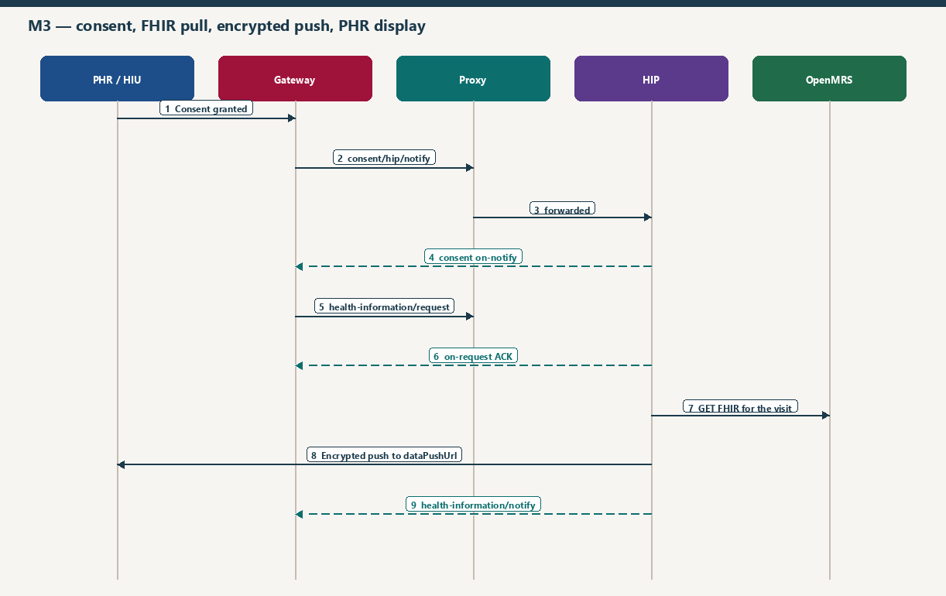
Figure 10. Consent, then the data request, then the encrypted push that the PHR app displays.

8.1 Consent notify and consent on-notify
- The patient grants consent in the PHR app for this HIP, these care contexts, these HI types and this date range.
- The gateway POSTs /api/v3/consent/request/hip/notify. The proxy delivers it to the HIP. The HIP returns 202 and continues in the background.
- When the status is GRANTED, the HIP stores the consent artefact: consent id, care contexts, HI types, permission, date range, consent manager id and the signature.
- The HIP POSTs /api/hiecm/consent/v3/request/hip/on-notify with status OK.
- When the status is REVOKED, the HIP updates the stored consent and, if it still has the artefact, sends the same on-notify with status OK. A revoked consent is not used for a later data push.
The patient already acted inside the PHR app, so this HIP does not send a consent SMS of its own for M3.

8.2 Health-information request and on-request
- The gateway POSTs /api/v3/hip/health-information/request with a transaction id, the consent id, the date range, the dataPushUrl and the HIU key material.
- The HIP returns 202. In the background it loads the consent. If the patient link has not been written yet it waits 5 seconds and reads again. No consent, or an expired HIU key, becomes an error.
- It saves the request and publishes it to RabbitMQ (exchange hiservice.exchange.dataflowrequest) so collection and encryption do not block the callback.
- It POSTs /api/hiecm/data-flow/v3/health-information/hip/on-request with the transaction id and status ACKNOWLEDGED, or ERRORED with the reason.

8.3 Reading the saved consultation from openmrs-module-hip
A listener takes the data request off the queue. For each granted care context and each granted HI type it calls OpenMRS. A visit reference patientId:visitUuid is split into the patient id and the visit id. The date range is widened by one day on each side so a consultation saved on the boundary day is still included.
HI type on the consent | OpenMRS API the HIP calls
OPConsultation | GET /ws/rest/v1/hip/opConsults/visit
Prescription | GET /ws/rest/v1/hip/prescriptions/visit
DiagnosticReport | GET /ws/rest/v1/hip/diagnosticReports/visit
DischargeSummary | GET /ws/rest/v1/hip/dischargeSummary/visit
ImmunizationRecord | GET /ws/rest/v1/hip/immunizationRecord/visit
HealthDocumentRecord | GET /ws/rest/v1/hip/healthDocumentRecord/visit
WellnessRecord | GET /ws/rest/v1/hip/wellnessRecord/visit
Invoice | GET /ws/rest/v1/hip/invoice/visit

Each response contains FHIR R4 bundles built by openmrs-module-hip from the encounters, observations, orders and documents saved for that visit. Program enrolments use the matching /program endpoint instead of /visit. An empty bundle is simply omitted. This is the moment the consultation becomes a document the PHR app can show.

8.4 Encrypt, push, notify, and what the PHR app shows
- The HIP generates its own key pair and encrypts each bundle with ECDH and AES-GCM, using the HIU public key from the data request. The clinical JSON does not travel in clear text.
- It POSTs the encrypted entries to dataPushUrl (the PHR app’s HIU endpoint), with the gateway bearer token, X-CM-ID, X-HIP-ID and the transaction id.
- It then POSTs /api/hiecm/data-flow/v3/health-information/notify. On success the session status is TRANSFERRED and each care context is DELIVERED. If authentication or the push fails, the session is FAILED and the contexts are ERRORED, with the message “Failed to deliver health information”.
- The PHR app decrypts the bundles with its private key and shows the consultation, prescription and the other documents the patient consented to.
Why the PHR app can show the visit
The visit was linked in M2, so the consent names a care-context reference the HIP understands. The consent was stored in M3, so the data request is accepted. openmrs-module-hip still has the encounter from the Bahmni save, so the FHIR bundle is not empty. The push goes to the PHR app, and the notify tells the gateway the transfer completed.

9. Every on-* callback
There are two directions. Inbound callbacks are sent by the gateway to the HIP and therefore pass through abdm-callback-proxy. Outbound on-* calls are sent by the HIP to the gateway and do not pass through the proxy. Names are the paths in hip-service Constants.

9.1 Inbound — gateway to proxy to HIP
Callback on the HIP (after /hiprovider) | When it arrives | What the HIP does
POST /api/v3/hip/token/on-generate-token | Reply to generate-token, during HIP-initiated linking | Validates the link-token JWT and stores it for that ABHA address and HIP id. An error is stored against the request id so the waiting link call can stop.
POST /api/v3/link/on_carecontext | Reply to link/carecontext | Marks the initiated link successful and saves the linked care contexts. No further gateway call.
POST /api/v3/links/context/on-notify | Reply to link/context/notify | Logs the acknowledgement or the error. Returns 202.
POST /api/v3/patients/sms/on-notify | Reply to sms/notify2 | Logs status or error. Returns 202. This is not the SMS itself.
POST /v0.5/users/auth/on-fetch-modes | Reply to fetch-modes | Stores auth modes for the request id. The screen is waiting.
POST /v0.5/users/auth/on-init | Reply to auth/init | Stores the transaction id. The screen is waiting. The OTP SMS was sent by ABDM.
POST /v0.5/users/auth/on-confirm | Reply to auth/confirm | Stores access token and patient details. The screen is waiting.
POST /v0.5/users/auth/notify | DIRECT auth: patient approved or denied in the PHR app | Stores GRANTED or DENIED. HIP then calls gateway users/auth/on-notify. This incoming path is notify, and the HIP’s answer is the on-notify.

These inbound calls are not on-* names, but they are the gateway calls that cause the HIP to send an on-* answer. They also arrive through the proxy, using X-HIP-ID.
Inbound request | HIP answers with
POST /api/v3/hip/patient/care-context/discover | on-discover
POST /api/v3/hip/link/care-context/init | on-init (and the linking OTP SMS)
POST /api/v3/hip/link/care-context/confirm | on-confirm
POST /api/v3/consent/request/hip/notify | consent on-notify
POST /api/v3/hip/health-information/request | health-information on-request, then later health-information/notify
POST /api/v3/hip/patient/share | patient-share on-share
POST /v0.5/patients/status/notify | patients/status/on-notify

9.2 Outbound — HIP directly to the gateway
HIP calls | After which inbound event | Payload in short
/api/hiecm/user-initiated-linking/v3/patient/care-context/on-discover | Discover | Matched patient and care contexts, or an error such as no patient, no care context, or HIP id mismatch. Includes transaction id and matchedBy.
/api/hiecm/user-initiated-linking/v3/link/care-context/on-init | Link init, after the OTP SMS is handed to otp_service | Link reference, authentication type MEDIATED, mobile meta and expiry.
/api/hiecm/user-initiated-linking/v3/link/care-context/on-confirm | Link confirm, after the OTP is verified and OpenMRS is updated | Linked patient and care contexts grouped by HI type.
/api/hiecm/consent/v3/request/hip/on-notify | Consent granted or revoked | Status OK and the consent id.
/api/hiecm/data-flow/v3/health-information/hip/on-request | Health-information request accepted onto the queue, or rejected | Transaction id and ACKNOWLEDGED, or ERRORED.
/api/hiecm/data-flow/v3/health-information/notify | After the encrypted push to the PHR app is attempted | TRANSFERRED and DELIVERED, or FAILED and ERRORED, per care context. This one is not named on-*.
/api/hiecm/patient-share/v3/on-share | Profile share stored on the queue | Acknowledgement, ABHA address, counter token, context, expiry 1800 seconds.
/v0.5/users/auth/on-notify | DIRECT auth notify | Acknowledgement OK.
/v0.5/patients/status/on-notify | Patient status notify | Acknowledgement SUCCESS.

10. When an SMS is sent
Three different senders appear in this setup. The clinic does not send the ABHA OTPs. ABDM does. The clinic SMS gateway is used for the care-context linking OTP only.
Moment | Who sends it | What starts it | Purpose
Create ABHA, Aadhaar step | ABDM / UIDAI | generateAadhaarOtp | Prove the Aadhaar before an ABHA is created.
Create ABHA, mobile step | ABDM | generateMobileOtp | Bind the ABHA to the mobile number on the registration form.
Verify ABHA number | ABDM | verification/requestOtp | Log in to an existing ABHA number.
Verify ABHA address | ABDM | abhaAddress/requestOtp | Log in to an existing ABHA address.
ABHA found by mobile, then login | ABDM | profileLoginRequestOtp | Confirm the person holds that mobile.
Legacy auth/init | ABDM | users/auth/init | Older registration authentication. The HIP waits for on-init.
Patient links contexts in the PHR app | otp_service, through the clinic SMS gateway | link/care-context/init | “The OTP is … to link your care context.” The patient types it in the PHR app. The HIP checks it on link confirm.
Facility wants the patient to open the PHR app | ABDM | Bahmni calls patients/sms/notify, HIP calls sms/notify2 | Deep link to this facility’s records. Confirmed later by sms/on-notify. Not sent by the care-context save itself.
Consent and data pull | Nobody in this HIP | Patient acts inside the PHR app | No SMS is triggered by consent notify, on-request, or the FHIR push.
Scan and share | Nobody | patient/share | The counter token is returned on on-share. No SMS.

Order that makes the deep-link SMS succeed: save demographics first, then link or notify a care context (that remembers the visit id for the ABHA address), then call patients/sms/notify. If the phone number was never stored, or the visit was never seen, the HIP rejects the SMS call because it cannot name the facility.

11. Headers that keep the conversation together
Header | Where it matters
Authorization | Gateway access token from POST api/hiecm/gateway/v3/sessions. Sent on every HIP-to-gateway call and on the data push.
X-CM-ID | Consent-manager suffix configured for the gateway (the part after @ in an ABHA address, for example sbx).
X-HIP-ID | Facility HFR id. The HIP sends it so the gateway can echo it. The proxy uses it to pick the clinic. Discovery also checks it against the visit’s facility.
X-LINK-TOKEN | Link-token JWT from on-generate-token. Required on link/carecontext and on link/context/notify.
X-Token | ABHA user token. Used for the ABHA profile and the ABHA card, not for gateway linking.
REQUEST-ID and TIMESTAMP | On gateway calls. Callbacks echo the request id in the body so the HIP can match a waiting call, especially on-generate-token, on-fetch-modes, on-init and on-confirm.
CORRELATION-ID | Taken from the Bahmni cookie reporting_session by the registration screen and forwarded by the HIP, so one registration can be traced across ABHA calls.
X-HIU-ID | Same proxy mechanism when the callback is for a HIU rather than a HIP. This document’s clinic path is the HIP id.

12. What is stored, and what a failure looks like
- HIP database: ABHA demographics, link token per ABHA address and HIP id, discovery requests, initiated and completed links, consent artefacts, and the health-information request.
- OpenMRS: the patient, the ABHA identifiers, the visit and the consultation. openmrs-module-hip only reads these when the HIP asks.
- In memory, for the life of the process: request id to auth mode, transaction id, or link token, so a callback can unblock the Bahmni call that is still waiting. A recycled process loses a wait that has not been saved yet. The link token itself is also written to the database.
- A waiting call (fetch-modes, auth init, auth confirm, generate-token) ends as gateway timeout when the callback does not arrive in time.
- A callback for an unknown X-HIP-ID stops at the proxy. The gateway sees HTTP 200 and a text summary, and the HIP never runs. That is the usual reason an on-generate-token or on-discover “succeeds” at the gateway and still does nothing in the clinic.
- User-initiated link confirm will not attach the ABHA if the OTP is wrong or expired, or if the discovery transaction does not match the ABHA address.
- A data push is reported as FAILED when the HIP cannot obtain a gateway token or the POST to dataPushUrl throws. The PHR app then has nothing new to show for that consent.

13. Short map of milestones to APIs
Milestone | What the user sees | Systems that talk
M1 create | New ABHA, card, patient on the registration form | Bahmni UI → hip-service → ABHA APIs. SMS from ABDM. Demographics stored on the HIP.
M1 verify | Existing ABHA pulled onto the Bahmni patient | Bahmni UI → hip-service → ABHA APIs. SMS from ABDM. Patient save in OpenMRS.
M1 share / legacy auth | QR queue token, or older OTP login | PHR → gateway → proxy → HIP → gateway on-share. Legacy on-fetch-modes, on-init, on-confirm, notify.
M2 facility link | Visit becomes a care context after the consultation is saved | Bahmni → HIP → gateway generate-token → proxy on-generate-token → gateway link/carecontext → proxy on_carecontext. Later visits: notify and on-notify.
M2 deep-link SMS | Patient receives a link to the PHR app | Bahmni → HIP → gateway sms/notify2 → ABDM SMS → proxy sms/on-notify.
M2 patient link | Patient selects visits and types an OTP in the PHR app | Gateway discover / init / confirm through the proxy. HIP reads openmrs-module-hip. otp_service sends the OTP. HIP writes the ABHA onto the patient. Answers on-discover, on-init, on-confirm.
M3 show in the PHR app | Consultation appears in the app | Consent notify and on-notify. Health-information request and on-request. FHIR from openmrs-module-hip. Encrypted push to the PHR app. health-information/notify.

The clinical record and the ABDM record stay separate until a care context is linked. Creation and verification make an ABHA and attach it to the Bahmni patient. Linking names a visit. Consent authorises a pull. The encrypted push is the consultation the PHR app shows.

