No Idea

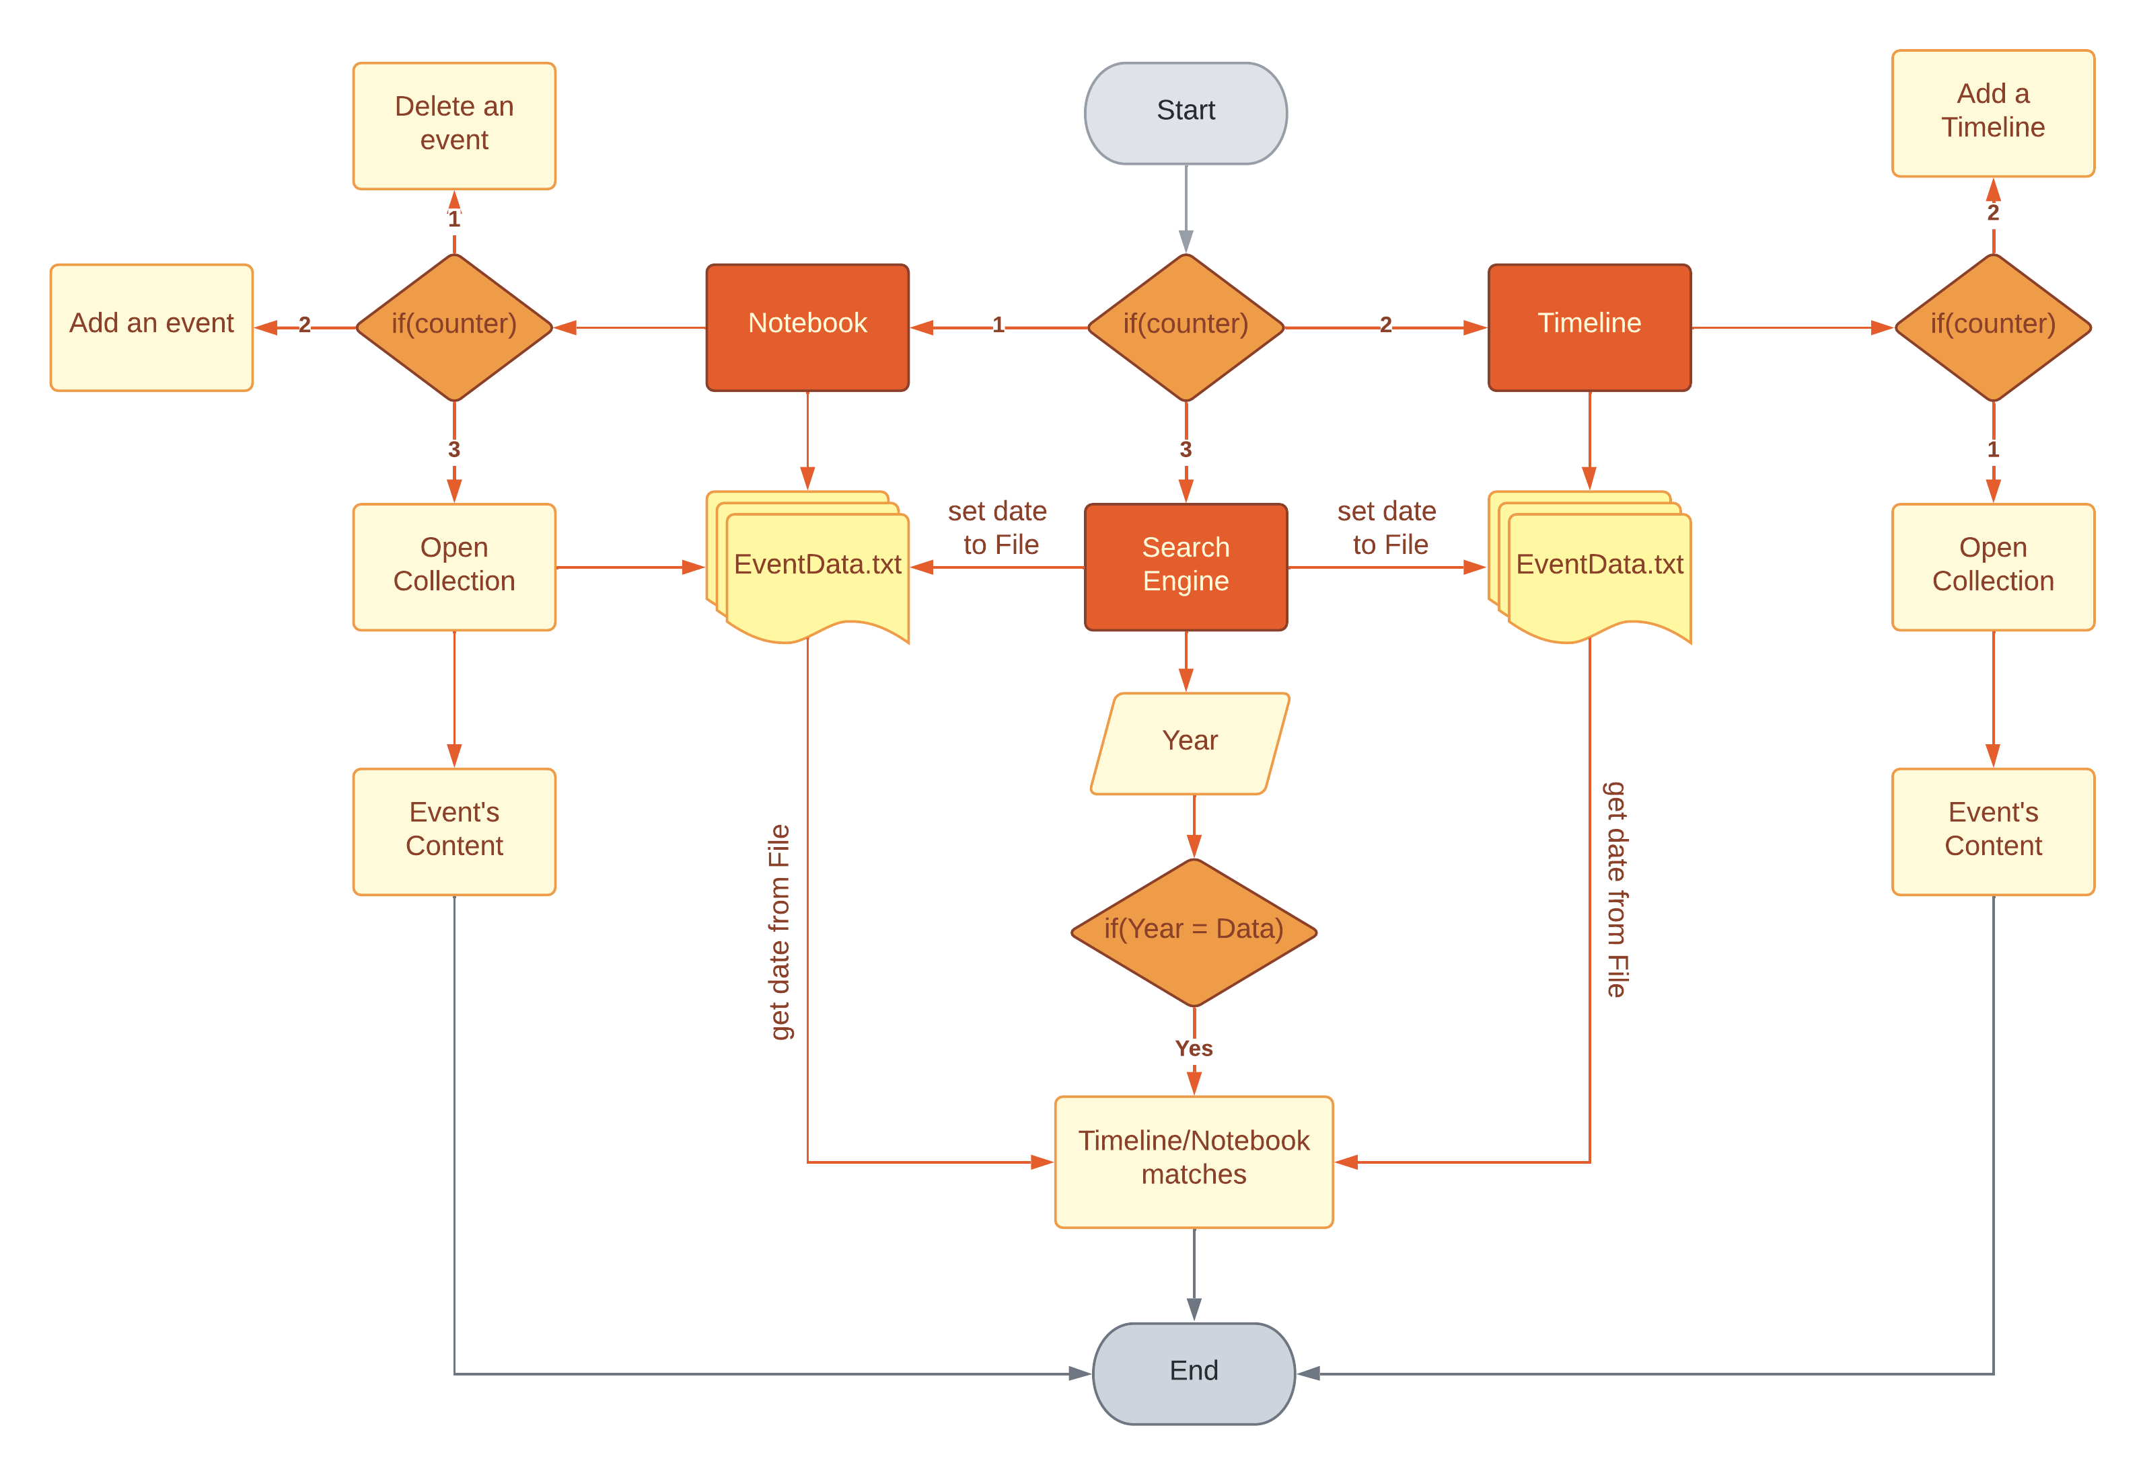

**PRESENTED BY**

No Idea

**WORK WITH**

GitHub

**REPOSITORY**

Biology_project

Content

Information and Development of a plan 2

Team roles 2

Introduction 2

Milestones in realization 3

Code plan 3

Plan testing 4

All tasks to perform 4

Purpose of each section 4

**P**

## Information and Development of a plan

**PRESENTATION OF THE PROJECT**

Our project is a C++ application for Biology, which you can download from our repository.

Link - [https://github.com/INMihaylov19/Greys-Warriors.git](https://github.com/IPMarkov19/Biology_Project)

### Team roles

|  |  |
| --- | --- |
| № | Roles in the team |
|  | Ivaylo Markov (IPMarkov19) – Scrum Trainer |
|  | Teodor Osmanliev (TPOsmanliev19) – Back-end Developer |
|  | Ivelin Vasilev (IGVasilev19) – Front-end Developer |
|  | Georgi Milev (GNMilev19) – QA Engineer |

### Introduction

|  |  |
| --- | --- |
| № | Introduction |
|  | What is the product?  The product is a C++ application. We have a game in which you learn about Biology. |
|  | Where is it available?  Our collaborative work took place in **GitHub** and in order for the files to be accessible to everyone they were uploaded in the GitHub Repository of our project.  **Link** - <https://github.com/IPMarkov19/Biology_Project> |
|  | Communication?  Communication is realized through **Teams**. Thanks to all the features and the provided visualization - on-screen communication and feedback are sufficiently complete. |
|  | What technologies are used?  The technologies used are **Visual Studio** as IDE for creating the C++ application, **C++** as a programming language, **Git** and **GitHub** for collaborative work. **Teams** - connection and communication, **MS** **PowerPoint** - preparing a Presentation, **MS** **Word** - preparing Documentation, **MS Excel –** preparing a QA Documentation . |

### Milestones in realization

|  |  |
| --- | --- |
| № | Milestones in realization |
| 1 | Form the team  Our team is formed by 4 students and everyone has a unique role. That role is determined according to his skills and knowledge. |
| 2 | Do research on the topic  To achieve our goals, we had to spend some of our time in researching. Research is an essential part of the project. |
| 3 | Discuss ideas  After doing some research on the topic, everyone suggested their idea, we discussed the ideas and assigned everyone some tasks. |
| 4 | Sort and separate tasks  Each of us had a unique role and the tasks he receives are determined according to it. The tasks are sorted in the Projects section in GitHub and are well described, so that everyone can understand what they are supposed to do. |
| 5 | Work on the project  After everyone received their tasks, we started working on the project. With hard work and a lot of effort, together we managed to create the final product. |

## Code plan

|  |  |
| --- | --- |
| № | Plan for realization |
|  | Main Menu  We made a main menu with login and register section which had to work properly.  You could also exit from it or view your password. |
|  | Design of different sections  Our task was to create different sections. Those sections are Start (Main Game), Info about the game and Exit. Our Front-end developer was assigned the task to make design for those sections. |
|  | Functionality of each section  Our Back-end developer had the task to make those tabs functioning. |

## Plan testing

### All tasks to perform

|  |  |
| --- | --- |
| № | Completed tasks |
| 1 | Main Menu The design and functionality of the Main Menu was created by the Front-end developer. |
| 2 | Start  The start section was separated to different sections which were the different subjects of Biology you could learn from. |
| 3 | Info  This section gives you brief explanation and information about our team. You can also exit from it using the escape button. |
| 4 | Exit  The exit section was a fairly simple task. It gets you back to the main menu and thanks you for using the app. |
| 5 | Create a Documentation  Our Scrum trainer had the task to create a Documentation where the essence of our project is described in the best possible way. |
| 6 | Create Presentation  Our Scrum trainer was assigned the task to create a proper presentation which represents our team and our work. |

### Purpose of each section

|  |  |
| --- | --- |
| № | Sections |
| 1 | Start The first section of the start is genetics. It gives you explanation of them and asks you if you want to do a test. The test is made out of question about the thing you read in the previous section. The cells section is the basically the same thing, however there are questions where you have to order your choice of answer. The other two sections – Biosphere and Homeostasis are basically the same thing. |
| 2 | Info  The info section is very simple. Here you can understand who we are, where do we study and in which grade are we. Also, you can see everyone’s role in the project. |
| 3 | Exit  The exit section is basically explained in the name – when you want you can exit the program and also you are thanked for using the app. |