Pagatpatan, Jhed Micheal O.
C334_IT

STEP 2:
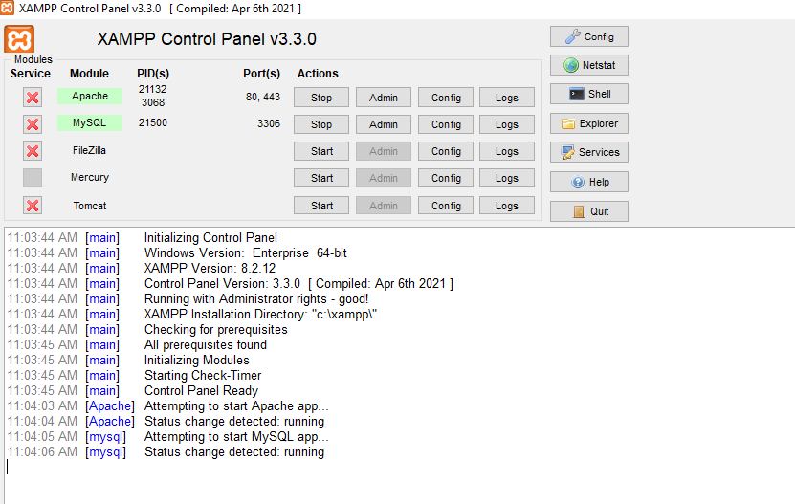

STEP 3:
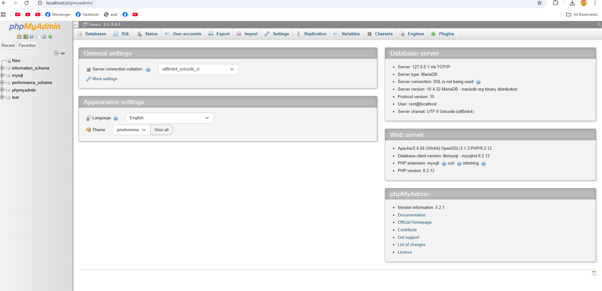
STEP 4 : 