Steven Cannon

Kyndryl/IBM Contractor

Identity Provisioning Teams – L3 Engineer

Abstract

Daily Domino eReg Infrastructure Monitoring Processes & Procedures

Domino eReg Infrastructure

Monitoring Cookbook

Table of Contents

**Kyndryl eReg Domino Environment 2**

Databases to Monitor 2

Checking eReg CPC Machines for Request Processing2

Checking Restore Agent for Processing3

Checking Reconcile Processes 4

Checking Ocean Reconciles in ISIM 5

Restarting Recon Process in eReg 6

Checking Pending Requests in eReg 7

Checking AdminP Requests in eReg 7

**IBM eReg Domino Environment8**

Databases to Monitor8

Checking eReg Machines for Request Processing8

Checking Restore Agent for Processing 9

Checking Reconcile Processes10

Looking Up Specific Reconcile on ISIM11

Restarting Recon Process in eReg 12

Finding Which eReg Machine Recon is on 13

Checking Pending Requests in eReg 14

Checking AdminP Requests in eReg 14

**Kyndryl eReg Domino Environment**

Databases to Monitor

LN eReg Log Ocean – IDPData2/IDP – File Name – Ocean\eRegLog.nsf

NCO UAR Database Ocean – IDPData2/IDP – File Name – Ocean\ncouar3.nsf

LN eReg Tool 6 – IDPData1/IDP – File Name – e_dir\eregtoo6.nsf

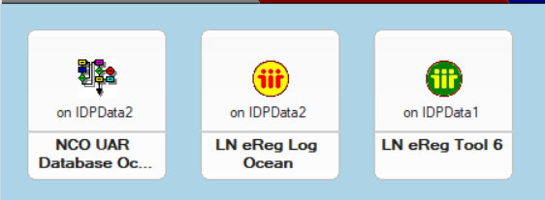

Checking eReg CPC Machines for request processing

* Open LN eReg Log Ocean to main view
* Navigate to section & view Last Actions by Machine.
  + Collapse the view.
  + Then open each machine 1 at a time and look for the most recent entry. You are looking to verify that at least the agent manager or some eReg process ran recently, usually within last 15-20 minutes.

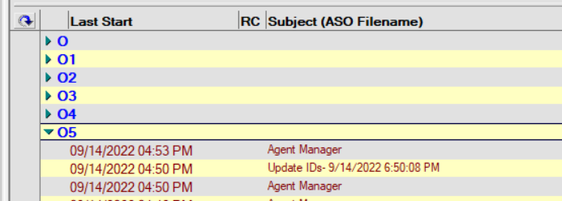

* If all 6 machines show recently ran agent managers or eReg processes, then the machines are processing normally as expected.
* If any 1 or more than 1 of the machines shows nothing recently running agent manager or a eReg process you need to report to the L3 CIO team which Ocean eReg machine is not processing.

Checking Restore Agent for Processing

* If Kyndryl is still using Domino for Identity Provisioning, then the UpdateIDs agent (ASO Restores) needs to be run from a Kyndryl CPC Machine (05) and it must be signed by the EMEA eReg/Germany/IBM. If Kyndryl is no longer using Domino for Identity Provisioning, then this checking the Restore Agent process is no longer relevant.
* To check the Restore agent.
  + Open LN eReg Log Ocean to main view
  + Navigate to section & view Last Actions by Agent.
    - Collapse the view.
    - Expand the UpdateIDs category.
    - Verify that most recent process run is within last 15-30 minutes.
    - Select most recent process run right click the record and choose document properties
    - 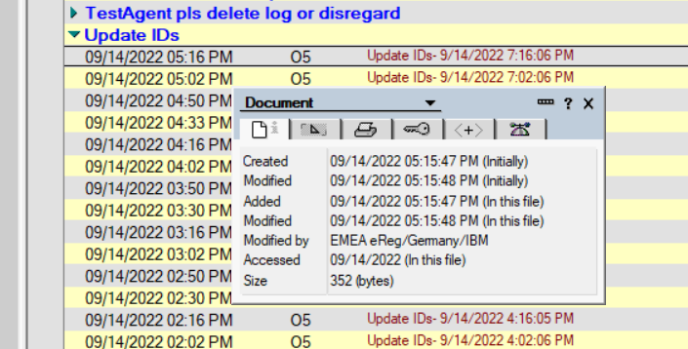
    - You are looking for Modified by: EMEA eReg/Germany/IBM
  + If you see it modified by correctly as listed above, then Restores are successfully running.

Checking Reconcile Processes

* Open LN eReg Log Ocean to main view
* Navigate to section & view Last Actions by Agent.
  + Collapse the view.
  + Expand the ITIM_Recon > Reconcile_Java category and subcategory.

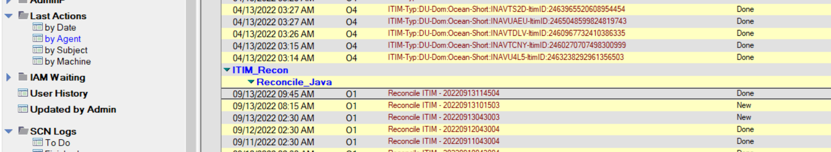

* + Look for most recent entry by date and look to far right column for done.
    - Open Log file and scroll to bottom.
    - Look for line for System Service ===OCN:OCNFT then look below it a few lines and look for the Recon submitted. Request number is 4359606714191744308 and then look a few lines below that for the Recon started successfully line.
    - Next look for the line for System Service ===OCN:Ocean then look below it a few lines and look for the Recon Submitted. Request number is 4363933207108923627 and then look a few lines below that for the Recon started successfully line.
    - If both items are found and showing started successfully then can proceed to checking Ocean Recons in ISIM section below.
    - If you see on one or both item that “Recon failed to start in alotted time” this means that either the Recon did not start in ISIM or that the waiting period set by Kurt to get a response from ISIM back to eReg. You can determine if the Recon started in ISIM by checking Ocean Recons in ISIM section below. If it did start proceeding as normal, if it is in failed/cancelled status get with L3 to restart the process in ISIM. If it is pending, wait a bit and check again in ISIM.
  + If far right column shows new
    - Open Log file and scroll to bottom.
    - You are looking to see if there is an error message at the bottom. Typically the error message is this – “09/14/2022 05:25:13 AM >>>> *****Error****** while position to entry2022/09/14 05:25:13:pool-1-thread-4-Ncouar from : 137217 - 138241 Error Notes error: Network operation did not complete in a reasonable amount of time; please retry ((ITIMExport))-Notes error: Network operation did not complete in a reasonable amount of time; please retry ((ITIMExport))”
    - If there is an error message related to Network Time Out, then you can wait until the process runs again the next day or restart the recon process via the LN eReg Tool 6 section below
    - If there is no error message most likely the process is still running, or it has been significant time since last log entry the machine could have stopped running.

Checking Ocean Recons in ISIM

* Log into ISIM and go to View All Requests
* Request Type = Reconciliation; Time Interval = Specified Date Range
* Start Date/Time = (Use Yesterday’s date and 10:00 PM time)
* End Date/Time = (Use Today’s date and 11:59 PM time)
* Click Search Requests

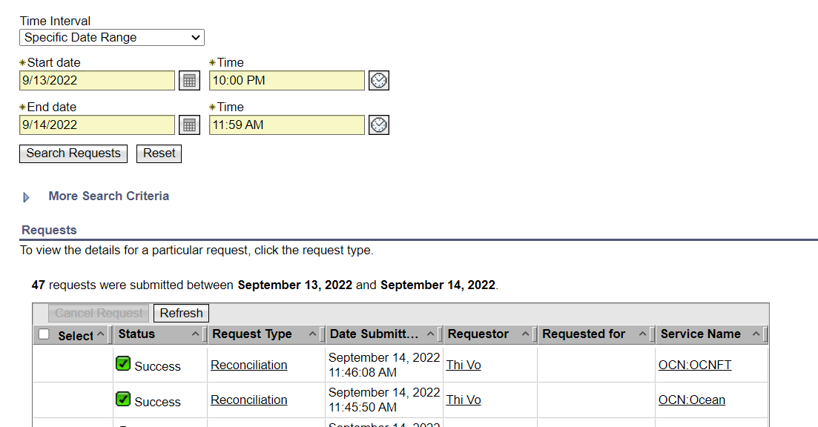

* Scroll through the list and to verify the 2 Ocean Recons ran with Success.
* If they are listed with status of pending, check back later.
* If they are listed with status of Failed/Canceled. Report it to L3 Team to have it restarted.

Restarting Recon Process in eReg

* Open the LN eReg Tool 6
* Click on Scheduled Agent View
* Scroll to bottom of list, you are looking for (agITIMReconcile) that is active in column 2 (has a 1 in it) for the CPC machine that is running the Ocean eReg Recon (Usually O1).

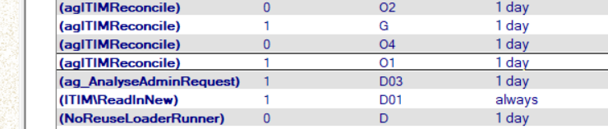

* Double click to open the reconcile record.
* Double click or use CTRL-E to put the document in edit mode.
* Look for Next Start entry. The date you should see is tomorrow mornings date.
* Edit the date back to yesterday’s date and then save & close the document.
* 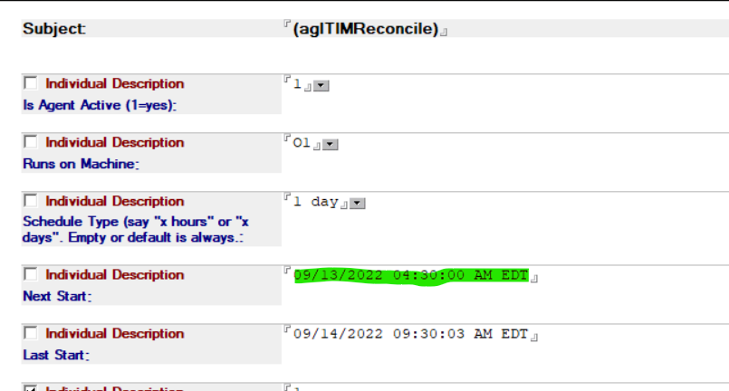
* The eReg Reconcile process will start approximately 15-20 minutes later automatically.
* To check this restarted process, you can simple go back to the original monitoring process above.

Checking Pending Requests in eReg

* Open LN eReg Log Ocean to main view
* Navigate to section & view Pending by Type.
  + Collapse the view.
  + Expand each section. You are looking for items where First State date is over 60 days old or stopped.
  + If over 60 days old, check with management but most requests can be moved to stopped/done as they are no longer active in ISIM and most types of requests if they have been stuck in pending for over 60 days they are no longer needed or have been resolved outside eReg in another way or via a another eReg request. Example if you see a pending AU look at user history in eReg for that short name and see if there is an AU that has already been completed etc.
  + If the request is stopped, you can try restarting it if it has been stopped for a few days to see if it will process now. Or you can look at the error message and try and get with L3 to resolve it.

Checking AdminP Requests in eReg

* Open LN eReg Log Ocean to main view
* Navigate to section & view AdminP by Type or AdminP by Errors.
  + Collapse the view
  + You can look at the types if you are looking for some specific issue. Normally I look at the errors to see if anything stands out such as LSX error or Server related errors. Then again look at the error message and try and get with L3 to resolve it.

**IBM eReg Domino Environment**

Databases to Monitor

LN eReg Log 6 – IDPData1/IDP – File Name – e_dir\eRegLog6.nsf

NCO UAR Database 2 – IDPData1/IDP – File Name – e_dir\ncouar2.nsf

NCO UAR Database – IDPData1/IDP – File Name – e_dir\ncouaruk.nsf

LN eReg Tool 6 – IDPData1/IDP – File Name – e_dir\eregtoo6.nsf

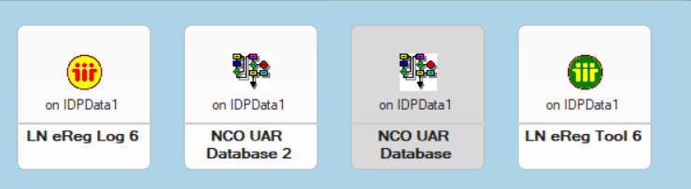

Checking eReg Machines for Request Processing

* Open LN eReg Log 6 to main view
* Navigate to section & view Last Actions by Machine.
  + Collapse the view. Focus on Machines D01-D05 & W01-W05
  + Then open each machine 1 at a time and look for the most recent entry. You are looking to verify that at least the agent manager or some eReg process ran recently, usually within last 15-20 minutes.

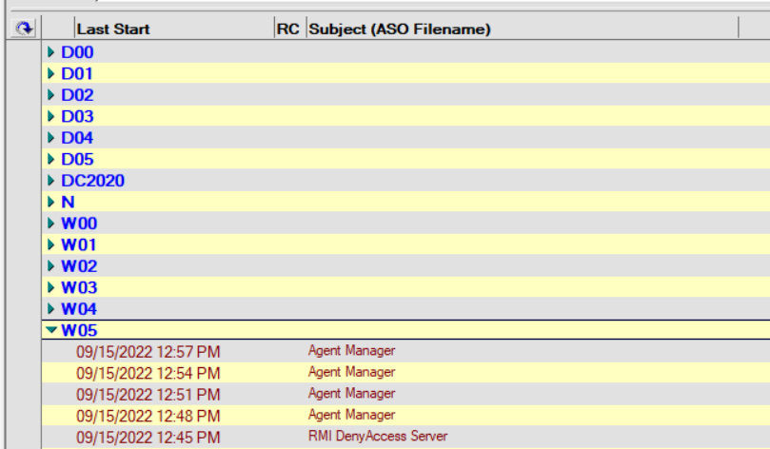

* If all 10 machines show recently ran agent managers or eReg processes, then the machines are processing normally as expected.
* If any 1 or more than 1 of the machines shows nothing recently running agent manager or an eReg process you need to report to the L3 CIO team which eReg machine is not processing.

Checking Restore Agent for Processing

* As of Today (09-15-22) log into Kyndryl eReg DB as listed in the Kyndryl eReg Domino Environment.
* To check the Restore agent.
  + Open LN eReg Log Ocean to main view
  + Navigate to section & view Last Actions by Agent.
    - Collapse the view.
    - Expand the UpdateIDs category.
    - Verify that most recent process run is within last 15-30 minutes.
    - Select most recent process run right click the record and choose document properties
    - 
    - You are looking for Modified by: EMEA eReg/Germany/IBM
  + If you see it modified by correctly as listed above, then Restores are successfully running.
* To Move Restore agent back to IBM Side of eReg Domino Environment
  + Open LN eReg Tool 6 Database
  + Open By Schedule Agent View
  + You are looking for the Update IDs agent. 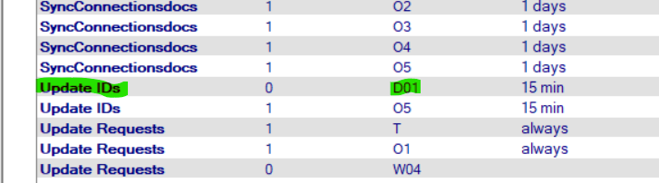
  + Column 2 is for Active/Inactive (0 or 1) and Column 3 is the eReg Machine (IBM or Kyndryl side)

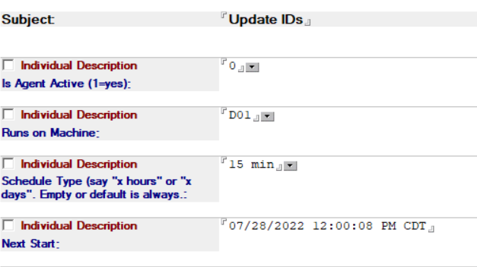

* + Make sure that only 1 instance of the agent is active and that it is assigned to an IBM eReg machine.
  + Make sure any desired changes and save the document(s) accordingly.

Checking Reconcile Processes

* Open LN eReg Log 6 to main view
* Navigate to section & view Last Actions by Agent.
  + Collapse the view.
  + Expand the ITIM_Recon > Reconcile_Java category and subcategory.

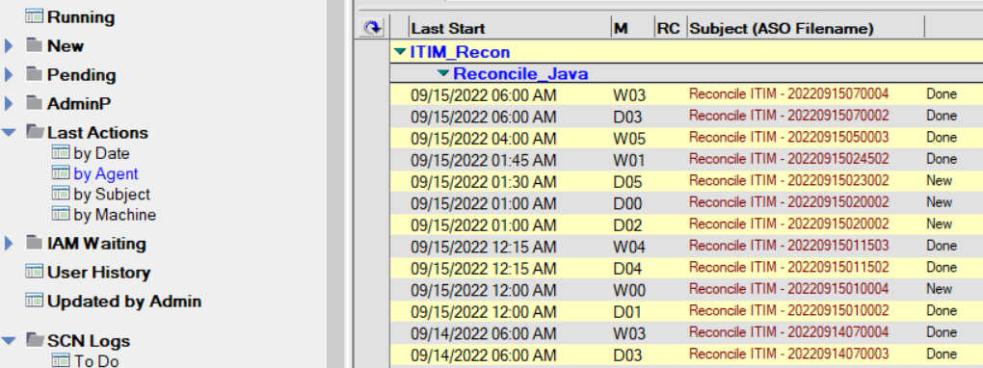

* + Look for most recent entry by date and look to far right column for Done.
  + As you can see there are multiple Recons that run daily. If you are looking for a specific reconcile you will have to look up to see what recons are run on what machines. See section below on Looking Up Specific IBM Reconcile.
  + To check to see if a specific Reconcile was completed in eReg and run in ISIM.
    - Open Log file and look for the domain for the reconcile. Example IBMEE, you are looking for the line that says, “try to start reconcile in ISIM for domain IBMEE” and the next line should read, “Extracted IBMEE”
    - It is possible for a Reconcile to have succeeded in eReg even if the document is still in a new state. You will have to look through the log to determine that. There is no single response that comes back from eReg for a failed Reconcile. It could time out, there could be a Config Document not found, it could have just kept running but never shows an error or time out at the bottom of the log. There could be a listing saying it failed to start in allotted time.
    - You will also have to investigate ISIM to see if the reconcile for the domain got kicked off or if it failed in eReg and never made it to starting in ISIM.

Looking up Specific Reconcile in ISIM

* Log into ISIM and go to View All Requests
* Request Type = Reconciliation; Time Interval = Specified Date Range
* Start Date/Time = (Use Yesterday’s date and 10:00 PM time)
* End Date/Time = (Use Today’s date and 11:59 PM time)
* Click Search Requests

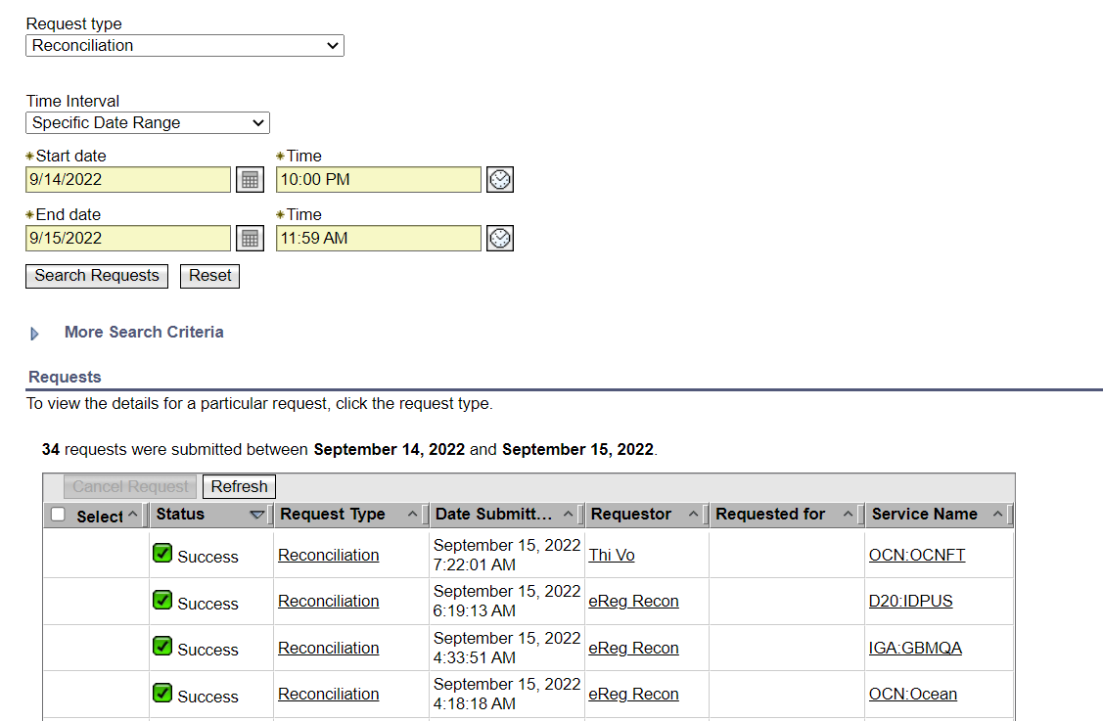

* Scroll through the list to find the domain you are looking for based on eReg Log.
* If they are listed with status of pending, check back later.
* If they are listed with status of Failed/Canceled. Report it to L3 Team to have it restarted.

Restarting Recon Process in eReg

* Open the LN eReg Tool 6
* Click on Scheduled Agent View
* Scroll to bottom of list, you are looking for (agITIMReconcile) that is active in column 2 (has a 1 in it) for the eReg machine that is running the eReg Recon (D00-D05 & W00-W05).

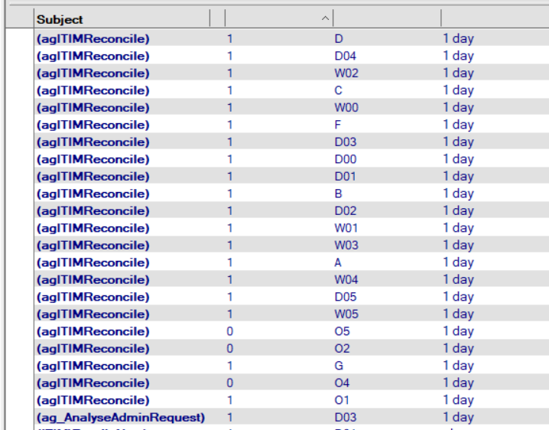

* Double click to open the reconcile record.
* Double click or use CTRL-E to put the document in edit mode.
* Look for Next Start entry. The date you should see is tomorrow mornings date.
* Edit the date back to yesterday’s date and then save & close the document.

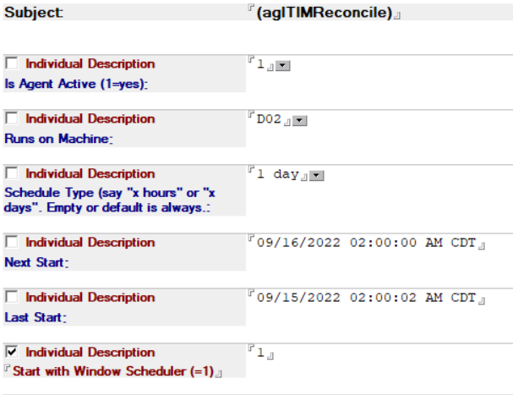

* The eReg Reconcile process will start approximately 15-20 minutes later automatically.
* To check this restarted process, you can simple go back to the original monitoring process above.

Finding Which eReg Machine Recon is on

* Open LN eReg Tool 6 Database
* Click on the All Setting Documents view – Scroll down to the ReconcileParameterITIM->XXXX entries.

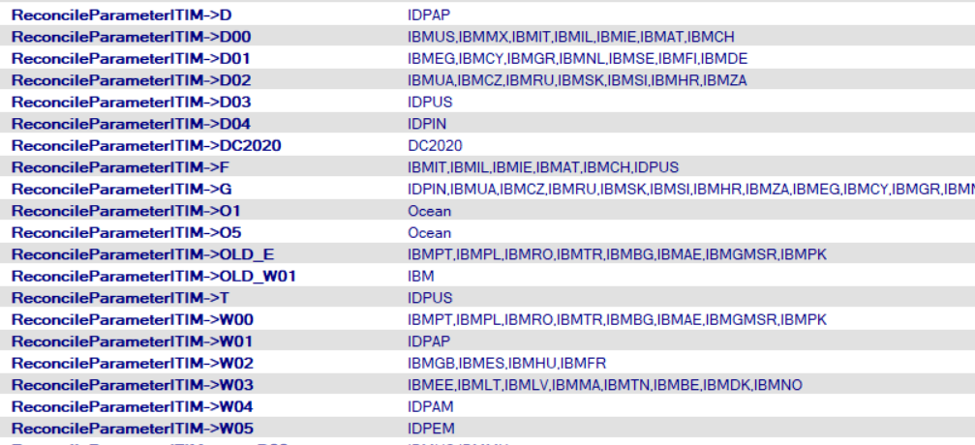

* Open the document for the eReg Machine you are looking for. Example D02.

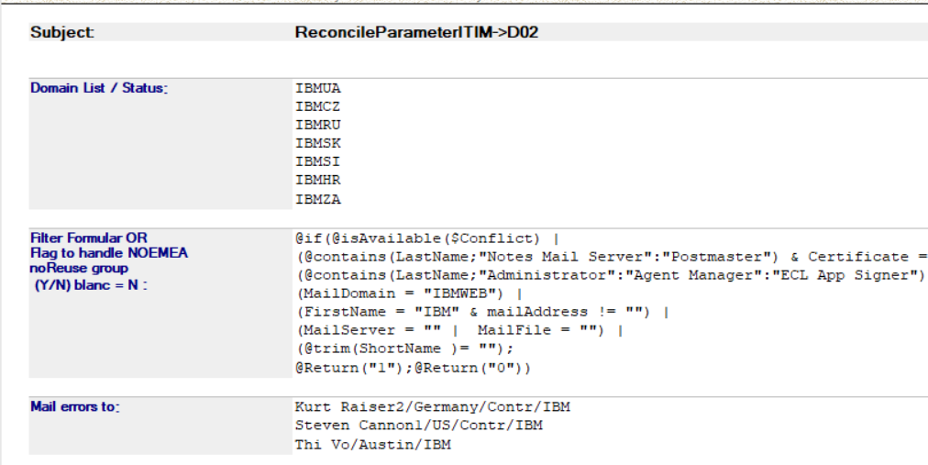

* Look through the Domain List to see what domains part of the Recon for that record should be.
* You should be able to find the reconcile for each of those domains in the eReg Log file for the Reconcile for the eReg machine you are looking for.

Checking Pending Requests in eReg

* Open LN eReg Log 6 to main view
* Navigate to section & view Pending by Type.
  + Collapse the view.
  + Expand each section. You are looking for items where First State date is over 60 days old or stopped.
  + If over 60 days old, check with management but most requests can be moved to stopped/done as they are no longer active in ISIM and most types of requests if they have been stuck in pending for over 60 days they are no longer needed or have been resolved outside eReg in another way or via a another eReg request. Example if you see a pending AU look at user history in eReg for that short name and see if there is an AU that has already been completed etc.
  + If the request is stopped, you can try restarting it if it has been stopped for a few days to see if it will process now. Or you can look at the error message and try and get with L3 to resolve it.

Checking AdminP Requests in eReg

* Open LN eReg Log 6 to main view
* Navigate to section & view AdminP by Type or AdminP by Errors.
  + Collapse the view
  + You can look at the types if you are looking for some specific issue. Normally I look at the errors to see if anything stands out such as LSX error or Server related errors. Then again look at the error message and try and get with L3 to resolve it.