**Banino configuration:**

Banino Version : 1.21

Path for Banino driver: \\bdcspiec010.gar.corp.intel.com\os_image

File name: banino.zip

Copy to C folder and extract the zip file. Open banino\code\BaninoControlCenter->BaninoControlCenter.exe

copy Ladybird2 : Serial number (s/n:119814145) highlighted below.

(Serial number will always change in each system)

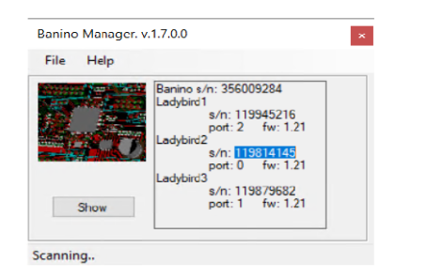

Paste to config.xml(LadyBirdSerialNumber) file which is available below folder:

C:\Banino\banino\code\Banino_SXState

File name : config.xml

