1. Download and install “Windows Assessment and Deployment Kit” from below link

<https://support.microsoft.com/zh-cn/windows/adk-download-for-windows-10-2a0b7ff2-79b7-b989-f727-43ae506e36ad>

1. Search for “Windows System Image Manager”, open as administrator
2. Unzip the original windows 2019 RS5 iso file by 7zip-64bit
3. Find the “install.wim” under /sources
4. Right click “Select a Windows image or catalog file” and import “install.wim” to “Windows System Image Manager”. Choose “Windows Server 2019 SERVERSTANDARD”. You will see “Components” and “Packages”

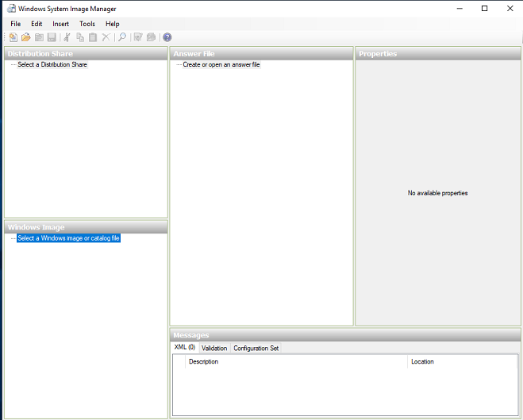

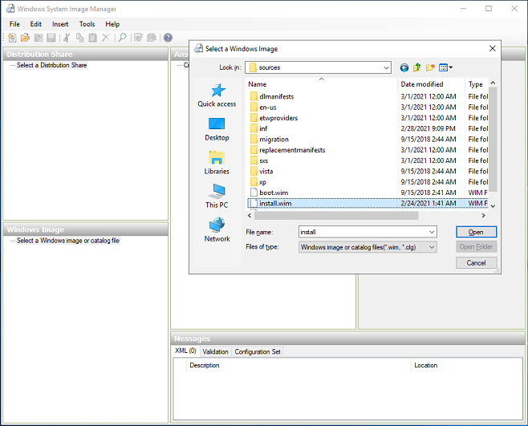

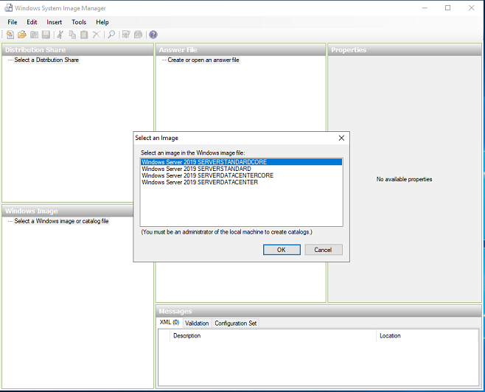

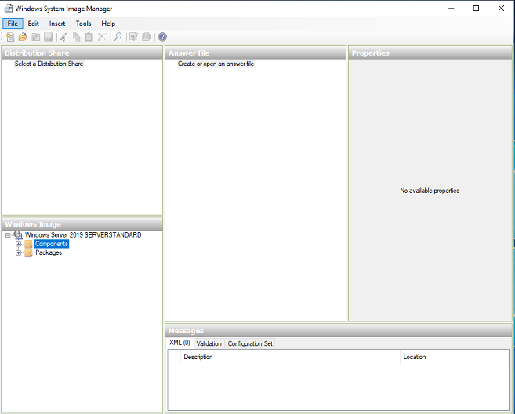

1. Right click “Create or open an answer File” in “Answer File” option and choose “New Answer File”.

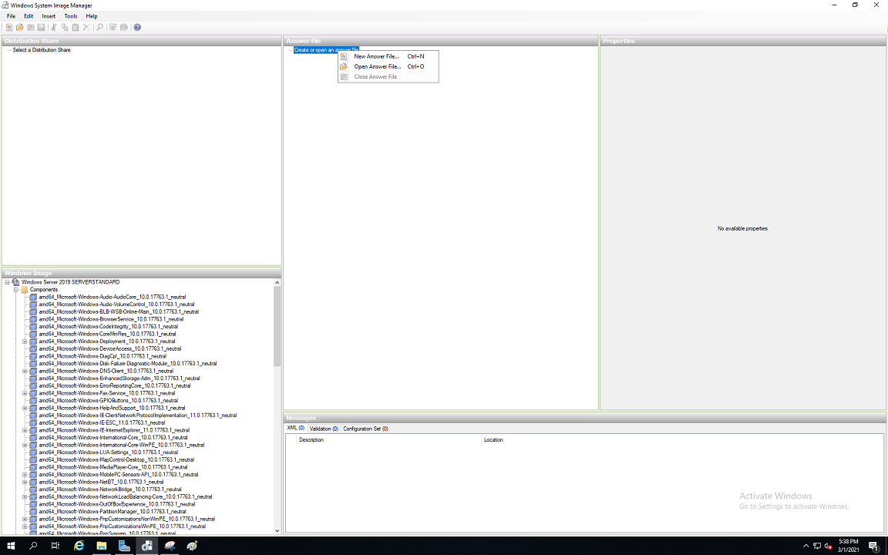

1. In the *Windows Image* pane, select the component *amd64_Microsoft-Windows-International-Core-WinPE_10.0.17763.1_neutral*. Right-click and choose *Add Setting to Pass 1 windowsPE*.

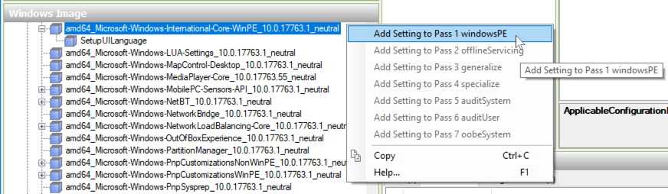

Using the Answer File Properties and Settings panes, configure the following:

| **Setting** | **Value** |
| --- | --- |
| InputLocale | en-US |
| SystemLocale | en-US |
| UILanguage | en-US |
| UserLocale | en-US |

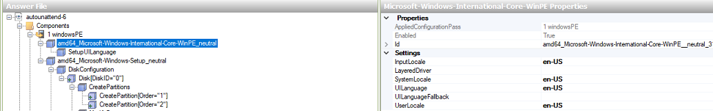

Choose the “+” icon , select “SetupUILanguage” , set “UILanguage” to “en-US”

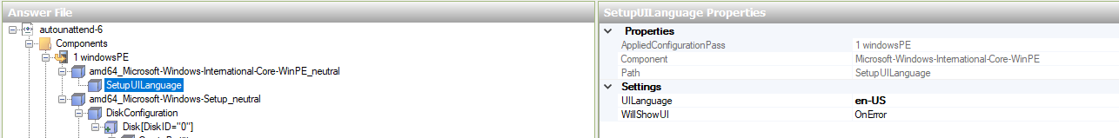

1. In the *Windows Image* pane, select the component *amd64_Microsoft-Windows-Setup_10.0.17763.1_neutral*. Right-click on DiskConfiguration, *UserData/ProductKey*, ImageInstall/OSImage/InstallFrom/MetaData and ImageInstall/OSImage/InstallTo . Then choose *Add Setting to Pass 1 windowsPE*.

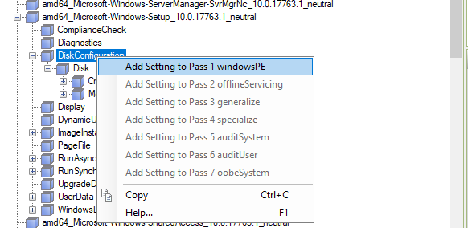

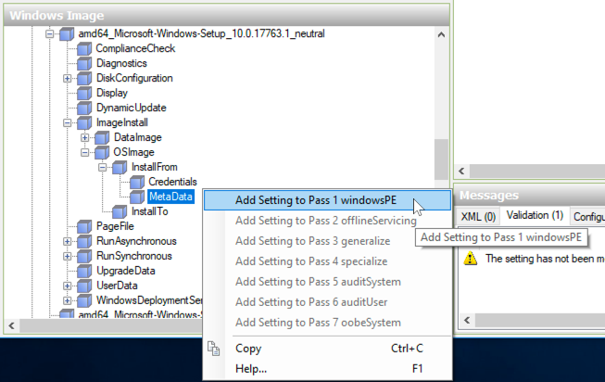

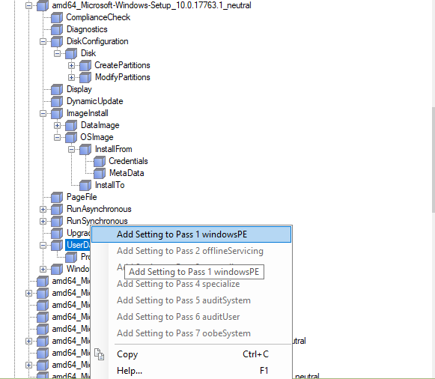

1. Settings for Disk Configuration

Using the Answer File Properties and Settings panes, configure the following:

| Setting | Value |
| --- | --- |
| DiskID | 0 |
| WillWipeDisk | true |

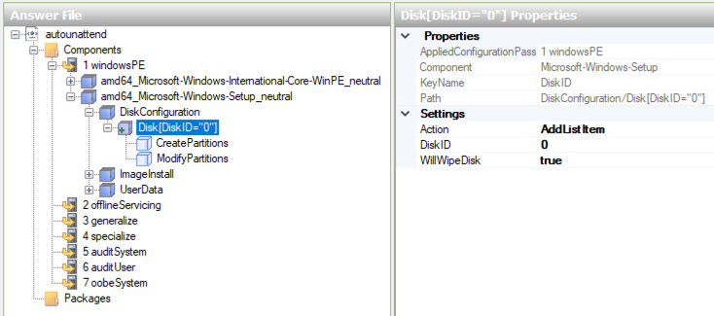

In the Answer File pane, right-click on DiskConfiguration/Disk/CreatePartition and choose Insert New CreatePartition from the menu to create a new System Reserved Partition.  This is used to store Boot Configuration Data and BitLocker Drive Encryption files. On Windows 2019 the recommended System Reserved Partition size is 500MB. You aren't required to create System Reserved Partition, but either way the boot files take space on your hard drive and most people would expect them to be on a separate partition.

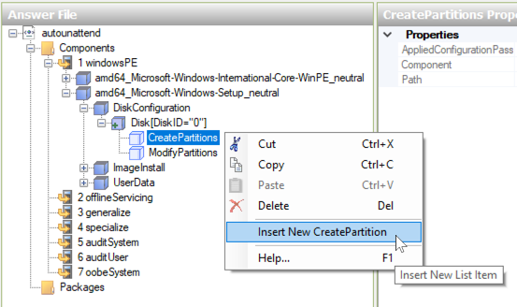

Using the Answer File Properties and Settings panes, configure the following settings for the System Reserved Partition:

| Setting | Value |
| --- | --- |
| Extend | false |
| Order | 1 |
| Size | 500 |
| Type | Primary |

Then create at least one partition for your Windows OS install.

In the Answer File pane, right-click on DiskConfiguration/Disk/CreatePartition and choose Insert New CreatePartition from the menu to create a new operating system partition.

Using the Answer File Properties and Settings panes, configure the following settings:

| Setting | Value |
| --- | --- |
| Extend | false |
| Order | 2 |
| Size |  |
| Type | Primary |

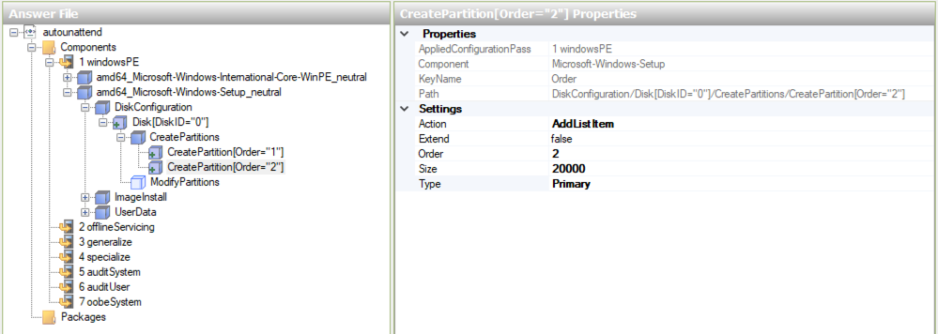

In the Answer File pane, right-click on DiskConfiguration/Disk [DiskID="0"]/ModifyPartitions and choose Insert New ModifyPartition from the menu:

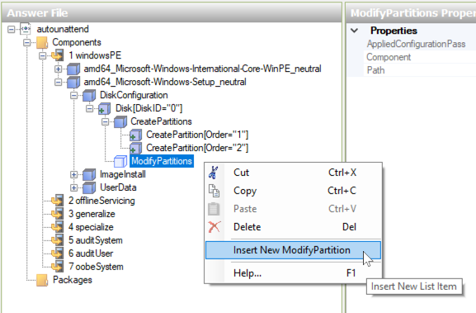

Using the Answer File Properties and Settings panes, configure the following settings for the System Reserved partition:

| Setting | Value |
| --- | --- |
| Active | true |
| Format | NTFS |
| Label | System Reserved |
| Order | 1 |
| PartitionID | 1 |

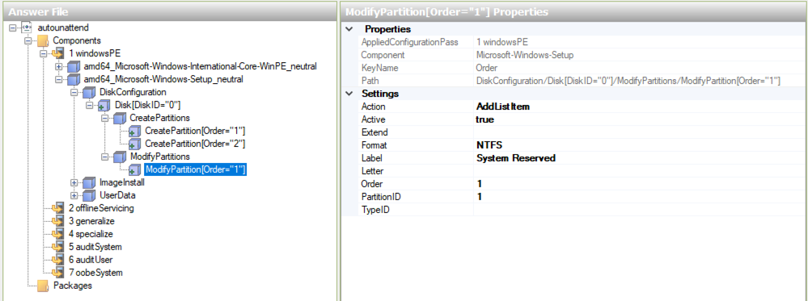

In the Answer File pane, right-click on DiskConfiguration/Disk [DiskID="0"]/ModifyPartitions and choose Insert New ModifyPartition from the menu for the OS partition:

| Setting | Value |
| --- | --- |
| Extend | true |
| Format | NTFS |
| Letter | C |
| Order | 2 |
| PartitionID | 2 |

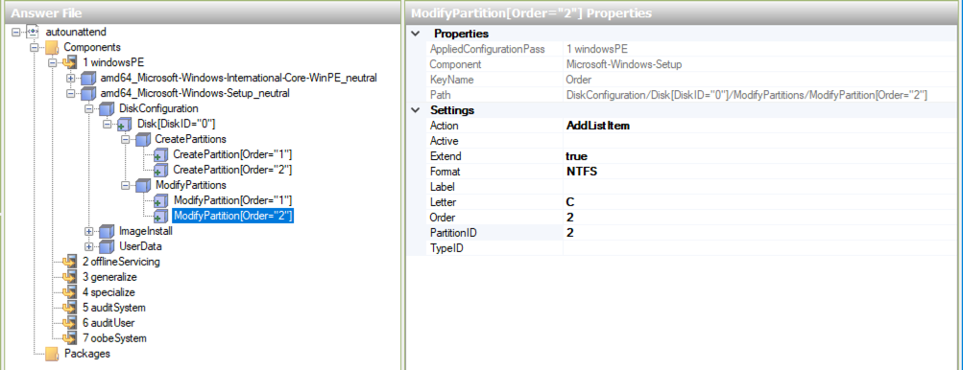

1. Settings for ImageInstall/OSImage/InstallTo

Using the Answer File Properties and Settings panes, configure the following:

| Setting | Value |
| --- | --- |
| DiskID | 0 |
| PartitionID | 2 |

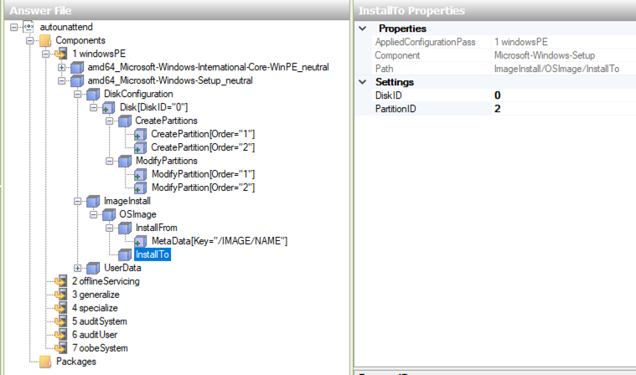

1. Settings for ImageInstall/OSImage/InstallFrom/MetaData

Using the Answer File Properties and Settings panes, configure the following:

| Setting | Value |
| --- | --- |
| Key | /IMAGE/NAME |
| Value | Windows Server 2019 SERVERDATACENTER |

NOTE: Make sure the /IMAGE/NAME value matches the Windows Server 2019 image flavour you selected. Possible values are:

* Windows Server 2019 SERVERDATACENTER
* Windows Server 2019 SERVERDATACENTERCORE
* Windows Server 2019 SERVERSTANDARD
* Windows Server 2019 SERVERSTANDARDCORE

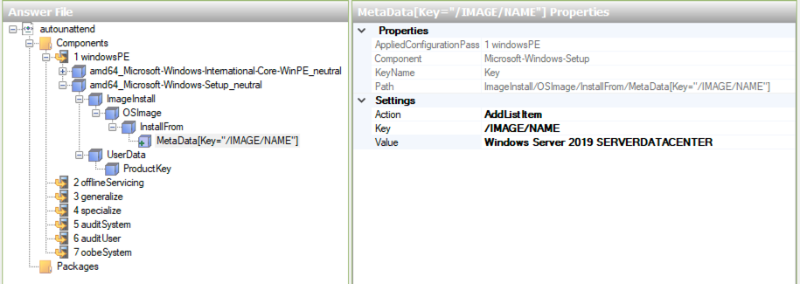

1. Settings for UserData and *UserData/ProductKey*

Using the Answer File Properties and Settings panes, configure the following:

| Setting | Value |
| --- | --- |
| AcceptEula | true |

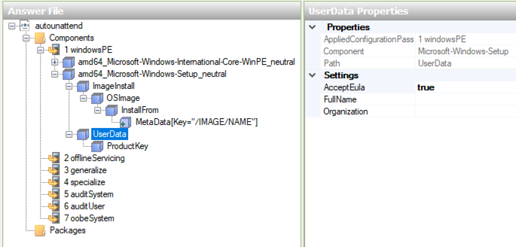

| Setting | Value |
| --- | --- |
| ProductKey | N69G4-B89J2-4G8F4-WWYCC-J464C |

If you are using volume licensed edition of Windows, you can use one of the KMS Client Setup Keys listed here: <https://docs.microsoft.com/en-us/windows-server/get-started/kmsclientkeys> Using a KMS key is also a great way to test your automation.

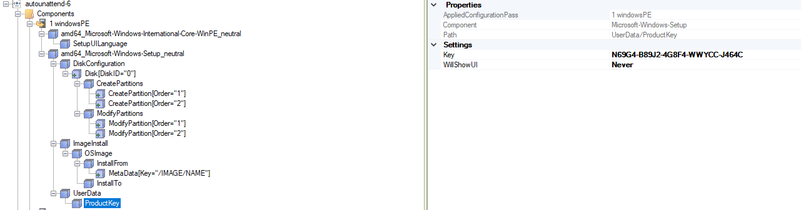

1. In the *Windows Image* pane, select the component *amd64_Microsoft-Windows-Security-SPP-UX_10.0.1.17763.1_neutral*. Right-click and choose *Add Setting to Pass 4 specialize*.

Setting SkipAutoActivation to true

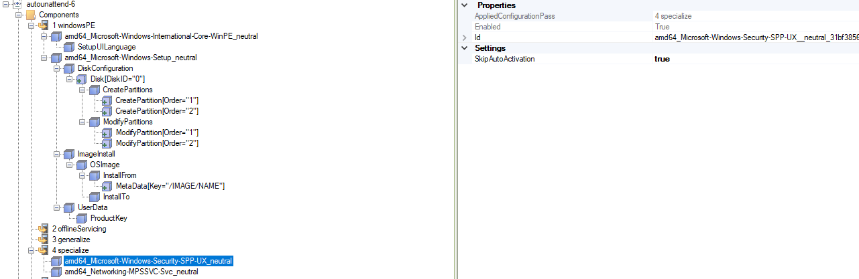

1. In the *Windows Image* pane, select the component *amd64_Networking-MPSSVC-Svc_neutral*. Right-click and choose *Add Setting to Pass 4 specialize*.

Using the Answer File Properties and Settings panes, configure the following:

| Setting | Value |
| --- | --- |
| DomainProfile_EnableFirewall | false |
| PrivateProfile_EnableFirewall | false |
| PublicProfile_EnableFirewall | false |

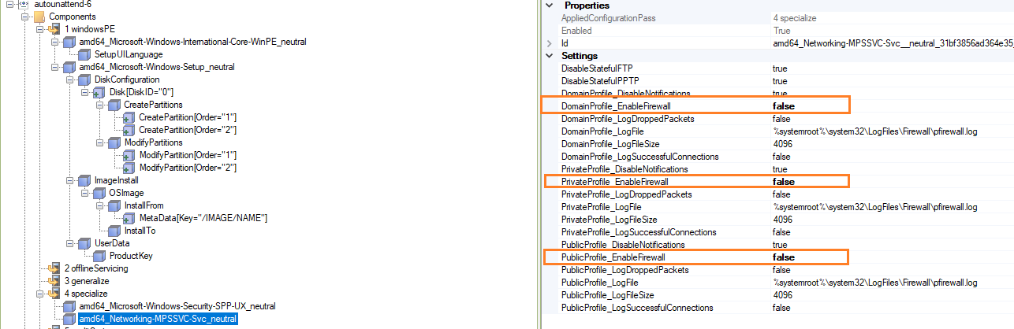

1. In the *Windows Image* pane, select the component *amd64_Microsoft-Windows-International-Core_10.0.17763.1_neutral*. Right-click and choose *Add Setting to Pass 7 oobeSystem*.

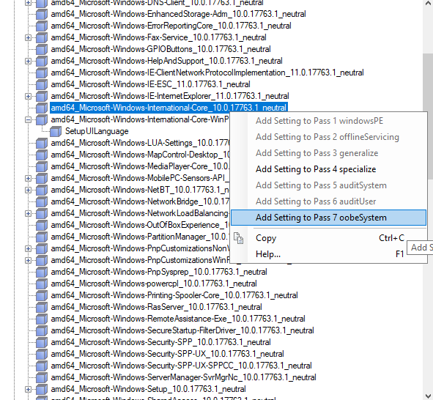

Using the Answer File Properties and Settings panes, configure the following:

| Setting | Value |
| --- | --- |
| InputLocale | en-US |
| SystemLocale | en-US |
| UILanguage | en-US |
| UserLocale | en-US |

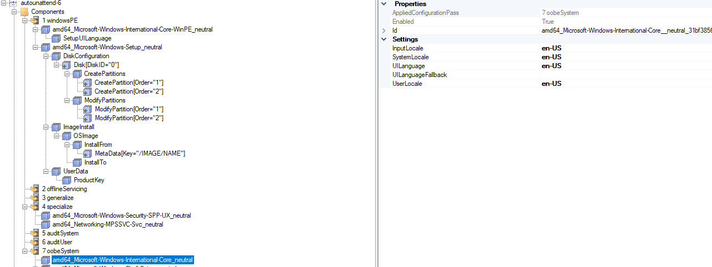

1. In the *Windows Image* pane, select the component amd64_Microsoft-Windows-Shell-Setup_10.0.17763.1_neutral. Right-click on AutoLogon/Password, OOBE and UserAccounts/AdministratorPassword. Then choose Add Setting to Pass 7 oobeSystem.

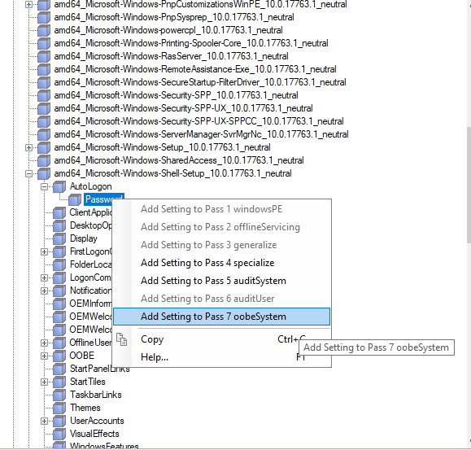

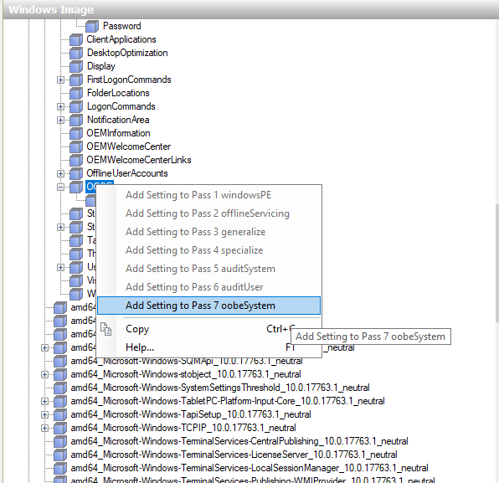

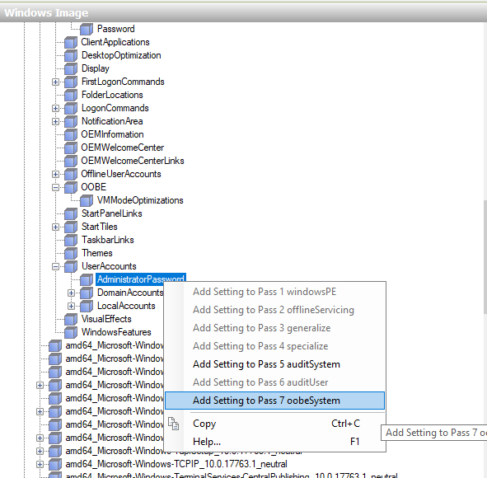

1. Settings for AutoLogon and AutoLogon/Password

Using the Answer File Properties and Settings panes, configure the following:

| Setting | Value |
| --- | --- |
| Enabled | true |
| LogonCount | 1 |
| Username | Administrator |

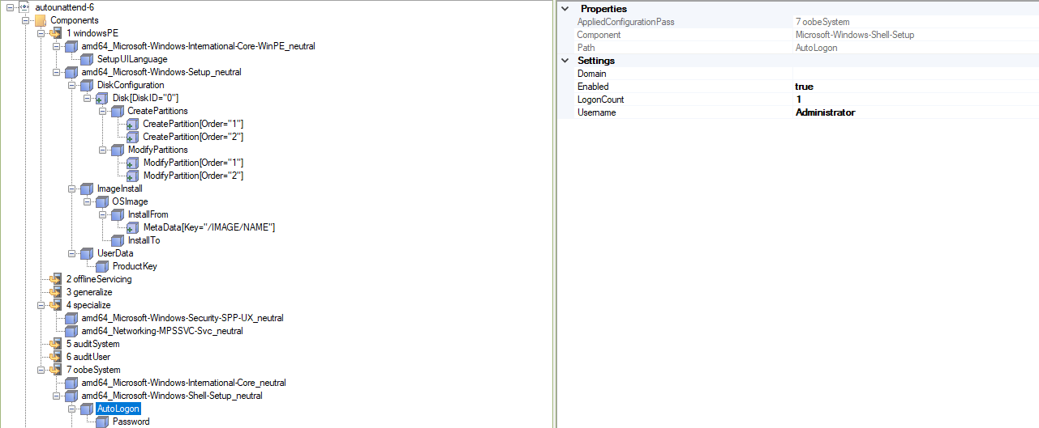

| Setting | Value |
| --- | --- |
| Value | Intel@123 |

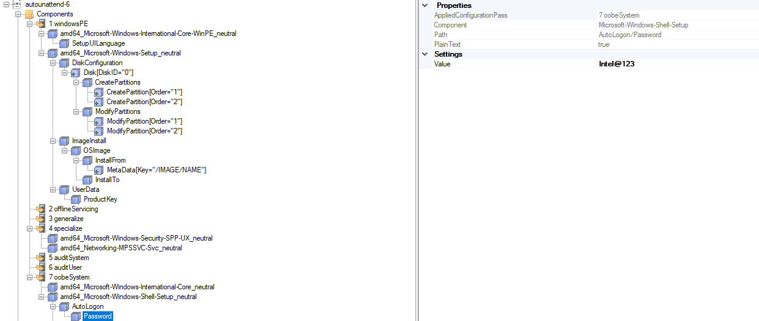

1. Setting for OOBE

Using the Answer File Properties and Settings panes, configure the following:

| Setting | Value |
| --- | --- |
| HideEULAPage | true |
| HideLocalAccountScreen | true |
| HideOEMRegistrationScreen | true |
| HideOnlinAccountScreens | true |
| HideWirelessSetupInOOBE | true |
| UnattendEnableRetailDemo | false |

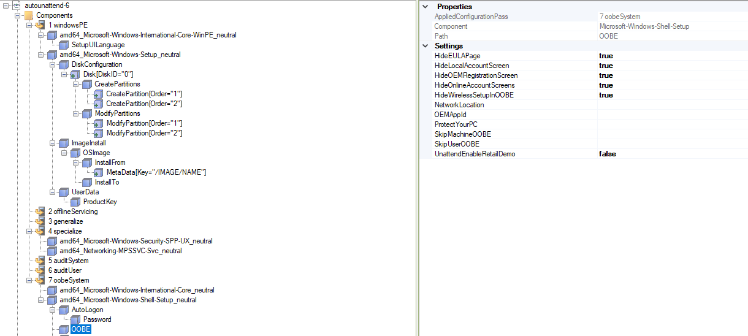

1. UserAccounts/AdministratorPassword

Using the Answer File Properties and Settings panes, configure the following:

| Setting | Value |
| --- | --- |
| Value | Intel@123 |

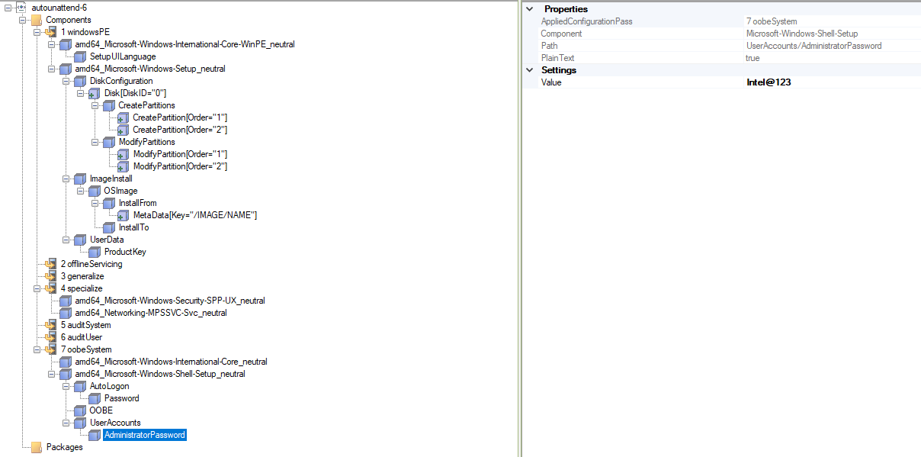

1. After finish these config for answer file. Click Tools/Validate Answer File

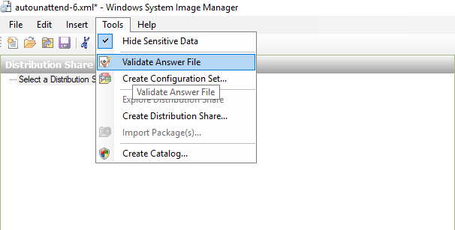

Check messages in “Messages” window. If show “No warnings or errors”, save the answer file as “Autounattend.xml”. If show some warnings or errors, please delete the option. And then save the file as “Autounattend.xml”.

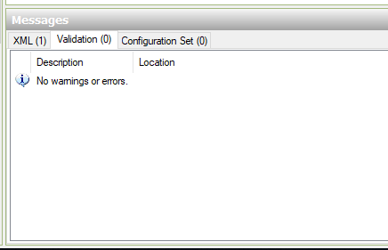

1. Put the “Autounattend.xml” to root path of iso file

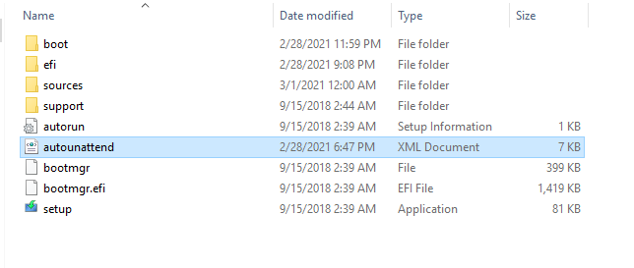

1. Use ISO encapsulation tool(UltraISO/ dism++) to zip the folder of iso to .iso file.