<div id="content"> <div class="breadcrumb">

<a href="http://livedemo00.template-help.com/opencart_43219/index.php?route=common/home">Home</a>

» <a href="http://livedemo00.template-help.com/opencart_43219/index.php?route=account/account">Account</a>

» <a class="last" href="http://livedemo00.template-help.com/opencart_43219/index.php?route=account/success">Success</a>

</div>

<h1>Your Account Has Been Created!</h1>

<div class="box-container">

<p>Congratulations! Your new account has been successfully created!</p> <p>You can now take advantage of member privileges to enhance your online shopping experience with us.</p> <p>If you have ANY questions about the operation of this online shop, please email the store owner.</p> <p>A confirmation has been sent to the provided email address. If you have not received it within the hour, please <a href="http://livedemo00.template-help.com/opencart_43219/index.php?route=information/contact">contact us</a>.</p> <div class="buttons">

<div class="right"><a class="button" href="http://livedemo00.template-help.com/opencart_43219/index.php?route=account/account"><span>Continue</span></a></div>

</div>

</div>

</div>

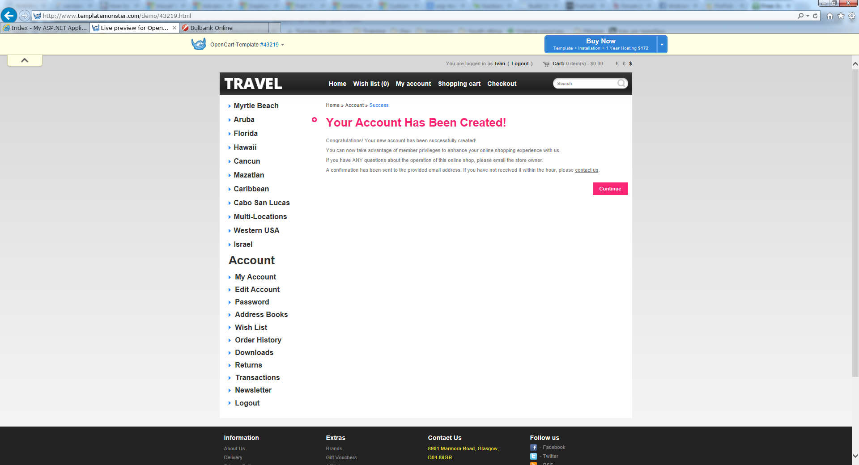

Top Line – Log Details and Language

Start with <div class= “outer”

<form action="http://livedemo00.template-help.com/opencart_43219/index.php?route=module/currency" method="post" enctype="multipart/form-data">

<div id="currency"><span>

Currency</span>

<a title="Euro" onclick="$('input[name=\'currency_code\']').attr('value', 'EUR').submit(); $(this).parent().parent().submit();"><span>€</span></a>

<a title="Pound Sterling" onclick="$('input[name=\'currency_code\']').attr('value', 'GBP').submit(); $(this).parent().parent().submit();"><span>£</span></a>

<a title="US Dollar"><span class="act">$</span></a>

<input type="hidden" name="currency_code" value="">

<input type="hidden" name="redirect" value="http://livedemo00.template-help.com/opencart_43219/index.php?route=account/success">

</div>

</form>

__________________

<div class="cart-position">

<div class="cart-inner"><div id="cart">

<div class="heading">

<a>

<b>Cart: </b>

<span class="sc-button"></span>

<span id="cart-total">0 item(s) - <strong>$0.00</strong></span>

<span class="clear"></span>

</a>

</div>

<div class="content">

<div class="empty">Your shopping cart is empty!</div>

</div>

</div>

</div>

</div>

_______________________________________

<div id="welcome">

You are logged in as <a href="http://livedemo00.template-help.com/opencart_43219/index.php?route=account/account">I</a> <b>(</b> <a href="http://livedemo00.template-help.com/opencart_43219/index.php?route=account/logout">Logout</a> <b>)</b> </div>

My Account Information:

<div id="content"> <div class="breadcrumb">

<a href="http://livedemo00.template-help.com/opencart_43219/index.php?route=common/home">Home</a>

» <a href="http://livedemo00.template-help.com/opencart_43219/index.php?route=account/account" class="last">Account</a>

</div>

<h1>My Account</h1>

<div class="box-container">

<h2>My Account</h2>

<div class="content">

<ul>

<li><a href="http://livedemo00.template-help.com/opencart_43219/index.php?route=account/edit">Edit your account information</a></li>

<li><a href="http://livedemo00.template-help.com/opencart_43219/index.php?route=account/password">Change your password</a></li>

<li><a href="http://livedemo00.template-help.com/opencart_43219/index.php?route=account/address">Modify your address book entries</a></li>

<li><a href="http://livedemo00.template-help.com/opencart_43219/index.php?route=account/wishlist">Modify your wish list</a></li>

</ul>

</div>

<h2>My Orders</h2>

<div class="content">

<ul>

<li><a href="http://livedemo00.template-help.com/opencart_43219/index.php?route=account/order">View your order history</a></li>

<li><a href="http://livedemo00.template-help.com/opencart_43219/index.php?route=account/download">Downloads</a></li>

<li><a href="http://livedemo00.template-help.com/opencart_43219/index.php?route=account/reward">Your Reward Points</a></li>

<li><a href="http://livedemo00.template-help.com/opencart_43219/index.php?route=account/return">View your return requests</a></li>

<li><a href="http://livedemo00.template-help.com/opencart_43219/index.php?route=account/transaction">Your Transactions</a></li>

</ul>

</div>

<h2>Newsletter</h2>

<div class="content">

<ul>

<li><a href="http://livedemo00.template-help.com/opencart_43219/index.php?route=account/newsletter">Subscribe / unsubscribe to newsletter</a></li>

</ul>

</div>

</div>

</div>

Edit Account Information

<div id="content"> <div class="breadcrumb">

<a href="http://livedemo00.template-help.com/opencart_43219/index.php?route=common/home">Home</a>

» <a href="http://livedemo00.template-help.com/opencart_43219/index.php?route=account/account">Account</a>

» <a href="http://livedemo00.template-help.com/opencart_43219/index.php?route=account/edit" class="last">Edit Information</a>

</div>

<h1>My Account Information</h1>

<div class="box-container">

<form action="http://livedemo00.template-help.com/opencart_43219/index.php?route=account/edit" method="post" enctype="multipart/form-data" id="edit">

<h2>Your Personal Details</h2>

<div class="content">

<table class="form">

<tbody><tr>

<td><span class="required">*</span> First Name:</td>

<td><input type="text" name="firstname" value="I">

</td>

</tr>

<tr>

<td><span class="required">*</span> Last Name:</td>

<td><input type="text" name="lastname" value="P">

</td>

</tr>

<tr>

<td><span class="required">*</span> E-Mail:</td>

<td><input type="text" name="email" value="ivan_email@mail.bg">

</td>

</tr>

<tr>

<td><span class="required">*</span> Telephone:</td>

<td><input type="text" name="telephone" value="12345">

</td>

</tr>

<tr>

<td>Fax:</td>

<td><input type="text" name="fax" value=""></td>

</tr>

</tbody></table>

</div>

<div class="buttons">

<div class="left"><a href="http://livedemo00.template-help.com/opencart_43219/index.php?route=account/account" class="button-back-left"><span>Back</span></a></div>

<div class="right">

<a onclick="$('#edit').submit();" class="button-cont-right"><span>Continue</span></a>

</div>

</div>

</form>

</div>

</div>

1. **Account Edit**

<div class="box-container">

<form action="http://livedemo00.template-help.com/opencart_43219/index.php?route=account/edit" method="post" enctype="multipart/form-data" id="edit">

<h2>Your Personal Details</h2>

<div class="content">

<table class="form">

<tbody><tr>

<td><span class="required">*</span> First Name:</td>

<td><input type="text" name="firstname" value="I">

</td>

</tr>

<tr>

<td><span class="required">*</span> Last Name:</td>

<td><input type="text" name="lastname" value="P">

</td>

</tr>

<tr>

<td><span class="required">*</span> E-Mail:</td>

<td><input type="text" name="email" value="ivan_email@mail.bg">

</td>

</tr>

<tr>

<td><span class="required">*</span> Telephone:</td>

<td><input type="text" name="telephone" value="12345">

</td>

</tr>

<tr>

<td>Fax:</td>

<td><input type="text" name="fax" value=""></td>

</tr>

</tbody></table>

</div>

<div class="buttons">

<div class="left"><a href="http://livedemo00.template-help.com/opencart_43219/index.php?route=account/account" class="button-back-left"><span>Back</span></a></div>

<div class="right">

<a onclick="$('#edit').submit();" class="button-cont-right"><span>Continue</span></a>

</div>

</div>

</form>

</div>