<p>Your current balance is:<b> $0.00</b>.</p>

<table class="list">

<thead>

<tr>

<td class="left">Date Added</td>

<td class="left">Description</td>

<td class="right">Amount (USD)</td>

</tr>

</thead>

<tbody>

<tr>

<td class="center" colspan="5">You do not have any transactions!</td>

</tr>

</tbody>

</table>

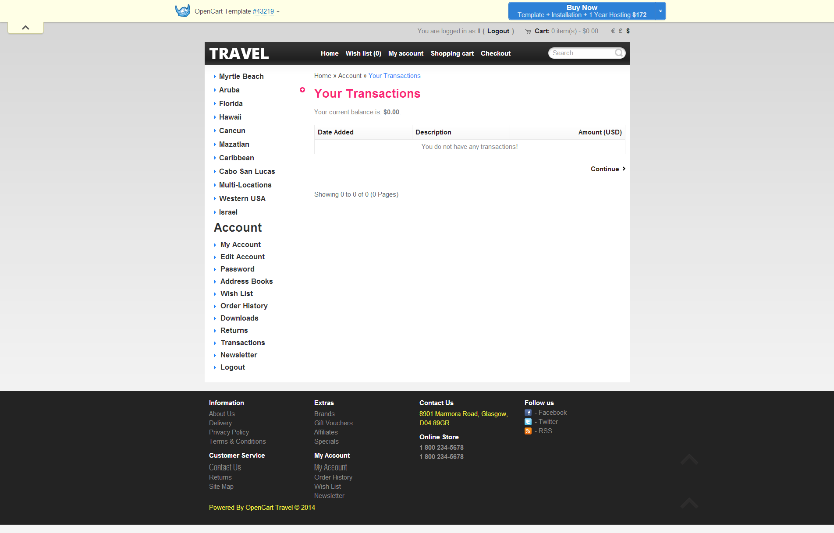

<table>

<thead>

<tr>

<td class="image">Image</td>

<td class="name">Product Name</td>

<td class="model">Model</td>

<td class="quantity">Quantity</td>

<td class="price">Unit Price</td>

<td class="total" style="border-right:none;">Total</td>

</tr>

</thead>

<tbody>

<tr>

<td class="image"> <a href="http://livedemo00.template-help.com/opencart_43219/index.php?route=product/product&amp;product_id=43"><img src="http://livedemo00.template-help.com/opencart_43219/image/cache/data/COZUMEL TOURS FROM CANCUN 1-47x37.jpg" alt="Acicte magna ipsum dolor tation ullamcorper" title="Acicte magna ipsum dolor tation ullamcorper"></a>

</td>

<td class="name"><a href="http://livedemo00.template-help.com/opencart_43219/index.php?route=product/product&amp;product_id=43">Acicte magna ipsum dolor tation ullamcorper</a>

<div>

</div>

<small>Reward Points: 600</small>

</td>

<td class="model">Product 16</td>

<td class="quantity"><input type="text" name="quantity[43]" value="1" size="1">

<div class="wrapper mt5">

<input type="image" src="catalog/view/theme/theme179/image/update.png" alt="Update" title="Update">

&nbsp;<a href="http://livedemo00.template-help.com/opencart_43219/index.php?route=checkout/cart&amp;remove=43"><img src="catalog/view/theme/theme179/image/remove.png" alt="Remove" title="Remove"></a>

</div>

</td>

<td class="price">$588.33</td>

<td class="total" style="border-right:0;">$588.33</td>

</tr>

</tbody>

</table>

