**Computer Networking, BSAIF23 Blue**

**Task 04**

**1-What is the name of the website?**

**Answer:**  
The name of the website is [**testphp.vulnweb.com**](testphp.vulnweb.com)

**2-Find the packet that contains the first GET request for the website you have accessed.**

**Answer:**  
Apply the Wireshark display filter:

**http.request.method == "GET"**

The first packet listed after applying this filter is the initial GET request for the site.

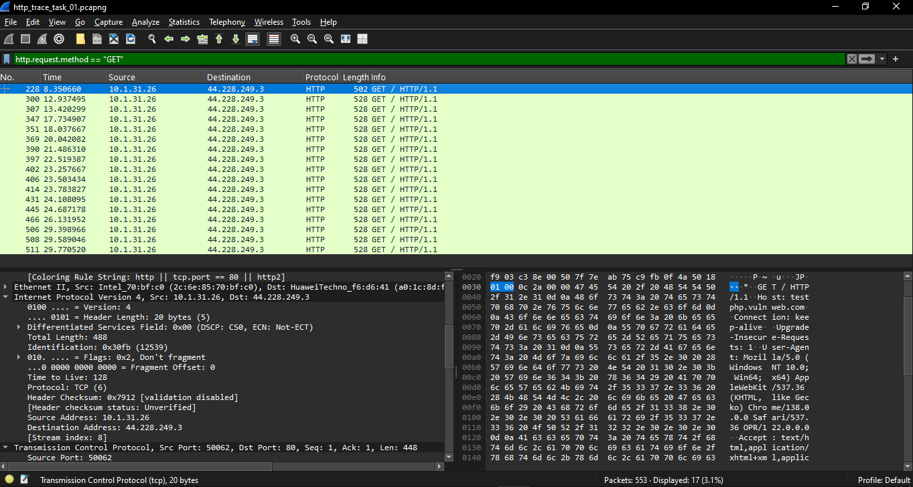

**3- Describe all headers and their values in this GET request message.**

**4- Identify the status code in the first server response.**

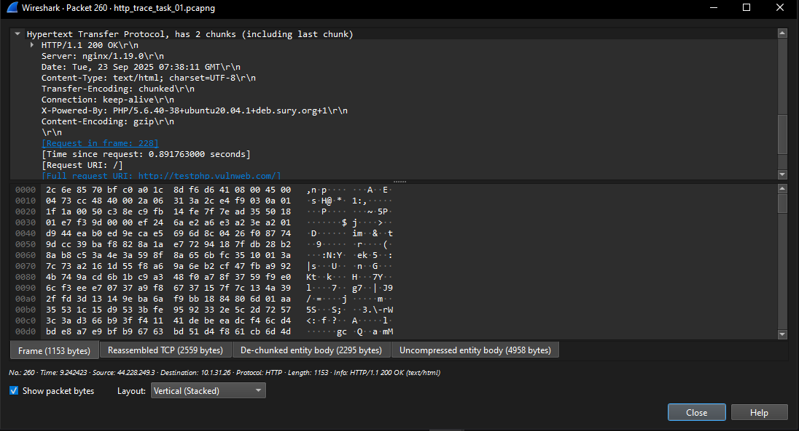

**5- How many HTTP response messages are exchanged in total?**

There were total of 16 responses throughout the trace.

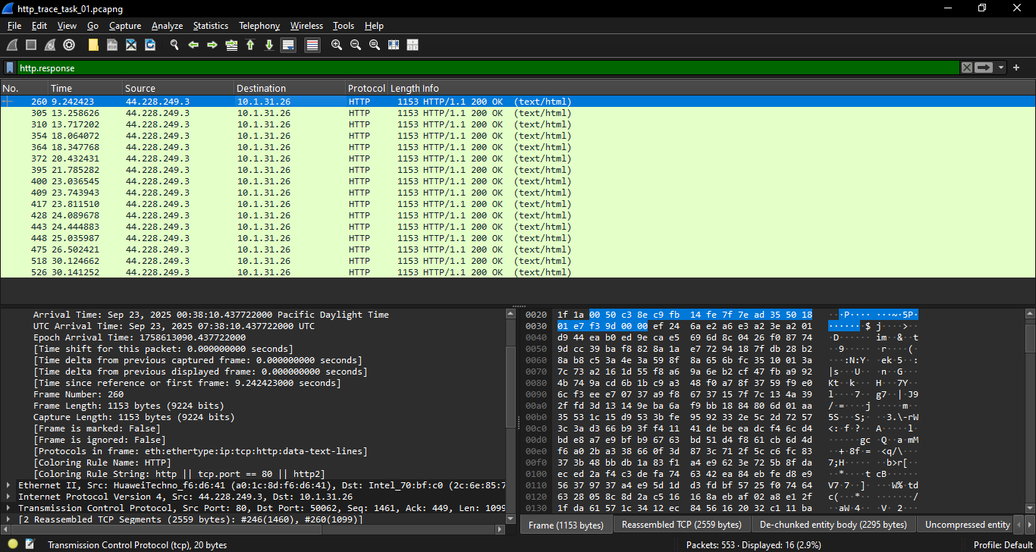

**6- Determine whether the connection is persistent or not. Justify with evidence from packet captures.**

**Answer:**

The connection is persistent. The “Connection” represents: keep-alive

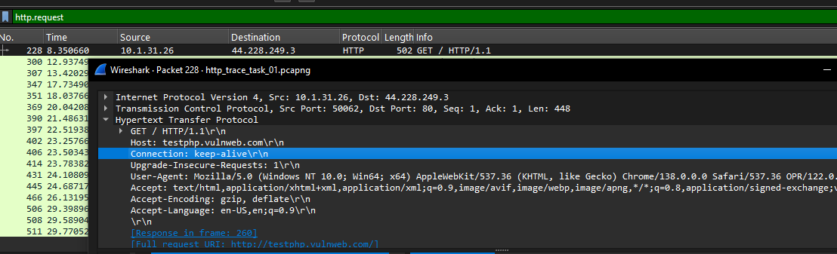

By opening the captured GET packet from the trace of http site, and following it to the hypertext Transfer Protocol noticing that the connection is persistent, as evidenced by the "Connection: keep-alive" header present in both the GET request and the server response within the packet captures. This indicates that the client (browser) and server (testphp.vulnweb.com) have agreed to reuse the same TCP connection for multiple HTTP requests.