Email Spam Detection with Machine Learning
Natural Language Processing · Binary Text Classification
Iqra Solangi github.com/IQRASOLANGI linkedin.com/in/iqra-solangi-a65945334
98.2%  Accuracy | 93.1%  Precision (spam) | 92.4%  Recall (spam) | 0.927  F1-score (spam)
Linear SVM, evaluated on 1,034 held-out messages

Overview
This project builds a classifier that separates spam from legitimate messages using natural language processing. The goal was a filter that catches most spam while rarely blocking genuine messages, with an evaluation that reflects that trade-off instead of relying on accuracy alone.

Project Snapshot
Problem | Binary classification: spam versus legitimate (ham) messages
Data | UCI Machine Learning Repository spam collection: 5,572 labelled text messages, 5,169 after removing duplicates
Class balance | 87.4% ham, 12.6% spam (imbalanced)
Features | TF-IDF vectors using unigrams and bigrams, 5,202-term vocabulary
Models | Multinomial Naive Bayes, Logistic Regression, Linear SVM
Evaluation | Stratified 80/20 split (4,135 train, 1,034 test); accuracy, precision, recall, F1-score, confusion matrices
Tools | Python, pandas, scikit-learn, matplotlib, seaborn, WordCloud

Approach
- Data preparation. Removed duplicate records and standardised the text: lowercasing, removing HTML codes, URLs, digits and punctuation, and dropping English stopwords.
- Feature extraction. Converted each message into TF-IDF vectors (unigrams and bigrams). The vectorizer was fitted on training data only, which prevents information leaking from the test set.
- Handling class imbalance. A stratified split keeps the 87/13 class ratio in both sets, and class weighting is applied to Logistic Regression and Linear SVM.
- Modelling. Trained Multinomial Naive Bayes, Logistic Regression and Linear SVM on the same features.
- Evaluation. Compared models on held-out data using precision, recall and F1-score for the spam class, alongside accuracy. A model that labels every message as ham would still score about 87% accuracy, so accuracy alone is not a reliable measure here.

Results
All three models perform strongly. Linear SVM gives the best balance between catching spam and protecting genuine messages.
Model | Accuracy | Precision | Recall | F1-score | Spam missed | False alarms
Multinomial Naive Bayes | 0.9816 | 0.9590 | 0.8931 | 0.9249 | 14 | 5
Logistic Regression | 0.9739 | 0.8824 | 0.9160 | 0.8989 | 11 | 16
Linear SVM | 0.9816 | 0.9308 | 0.9237 | 0.9272 | 10 | 9
Test set of 1,034 messages (131 spam, 903 legitimate). Spam missed = spam delivered as ham; false alarms = legitimate messages flagged as spam.
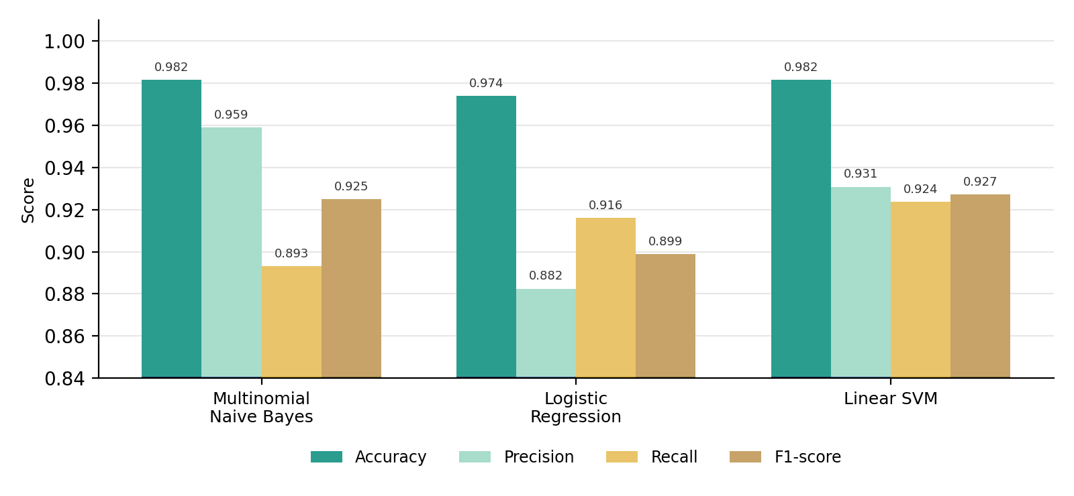
Model comparison on the held-out test set
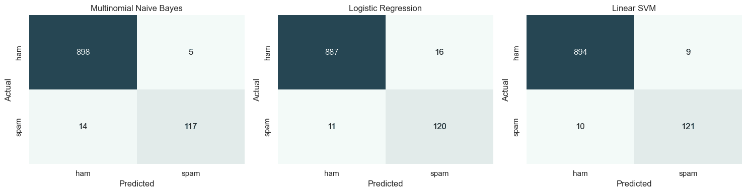
Confusion matrices for each model

Key Findings
- Linear SVM: best overall, with the highest F1-score (0.927). It caught 121 of 131 spam messages and wrongly flagged 9 of 903 legitimate ones.
- Multinomial Naive Bayes: the most cautious model. It has the highest precision (0.959) and flagged only 5 legitimate messages, but it missed 14 spam messages, the lowest recall (0.893).
- Logistic Regression: flagged the most legitimate messages (16), giving the lowest precision (0.882).
- Choosing a model: the right choice depends on which error costs more. Where blocking a genuine message is the bigger risk, Naive Bayes is the safer option. Where missed spam is the bigger risk, Linear SVM is preferable.

Why Recall Matters in Spam Detection
Recall is the share of real spam that the filter catches. Low recall lets phishing and scam messages reach the inbox, which defeats the purpose of the filter. Precision protects the opposite side: genuine messages that should not be hidden. The F1-score summarises both. Because spam is the minority class, recall on the spam class gives a more honest picture of filter quality than overall accuracy.

What the Data Shows
Spam messages are dominated by promotional and call-to-action vocabulary such as free, win, claim, prize, stop and reply. Legitimate messages use everyday conversational language. This clear difference in vocabulary is what the TF-IDF features capture.
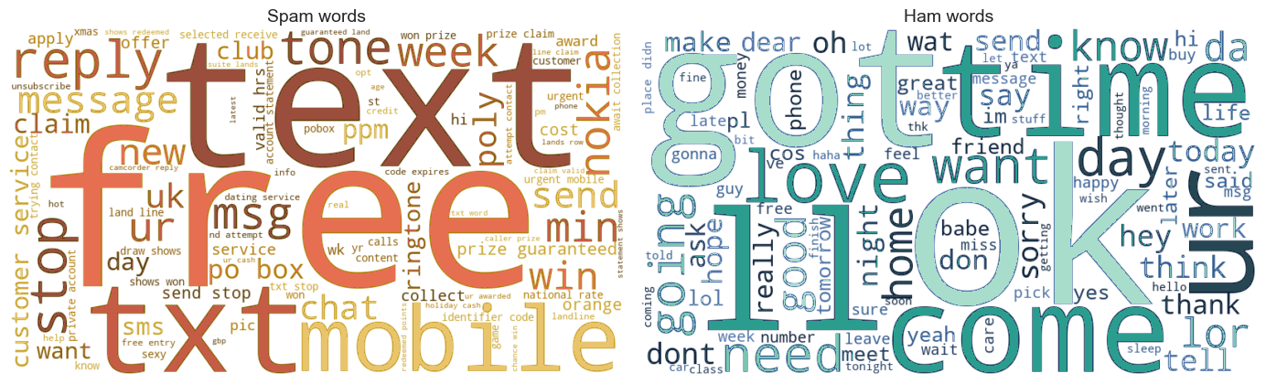
Most frequent words after cleaning: spam (left) and legitimate messages (right)

Skills Demonstrated
- Text preprocessing and NLP feature engineering with TF-IDF
- Handling imbalanced classification with stratified splitting and class weighting
- Model comparison using precision, recall, F1-score and confusion matrices
- Data visualisation and clear communication of technical results
- Reproducible workflow: documented notebook, dataset, requirements file and README

Limitations and Next Steps
- Results come from a single train/test split. Cross-validation would give a more stable estimate.
- The dataset contains short text messages. For production email filtering, the approach should be validated on a full-length email corpus.
- Hyperparameter tuning and lemmatisation are natural next improvements.

