Unemployment Analysis in India
Regional Trends and the Impact of COVID-19
Iqra Solangi | Data Analysis Project | github.com/IQRASOLANGI

Summary
This project analyses monthly unemployment data for 28 regions of India between May 2019 and June 2020, focusing on regional differences and the effect of the national COVID-19 lockdown. The average unemployment rate rose from 9.51% before the lockdown to 17.77% afterwards, and the increase varied sharply from one region to another.
Key metric | Result
Average rate before lockdown | 9.51%
Average rate after lockdown | 17.77%
Change | +8.26 percentage points (+86.9%)
Peak monthly average | 24.88% (May 2020)
Highest regional average | Tripura (28.35%)
Lowest regional average | Meghalaya (4.80%)

1. Objective
To examine how unemployment varied across regions and over time, and to quantify the change in unemployment following the national lockdown announced on 25 March 2020.

2. Dataset
The analysis uses the Unemployment in India dataset from Kaggle. The raw file contains 768 rows. After removing 28 empty rows, 740 observations remain, covering 28 regions from 31 May 2019 to 30 June 2020.
Each record contains:
- Region, Date and Frequency
- Estimated Unemployment Rate (%)
- Estimated Employed
- Estimated Labour Participation Rate (%)
- Area

3. Methodology
- Cleaning: removed empty rows, trimmed stray whitespace from column names and text values, and standardised column names.
- Type conversion: parsed dates (day-first format) and converted the numeric measures to numeric types.
- Exploration: computed regional and monthly averages, tracked selected states over time and built a correlation matrix.
- COVID-19 comparison: records dated before 25 March 2020 were classed as pre-lockdown and later records as post-lockdown. Mean unemployment was compared overall and by region.
- Tools: Python, pandas, NumPy, Matplotlib, Seaborn and Jupyter Notebook.

4. Findings

4.1 Regional differences
Average unemployment differed widely across regions. Tripura (28.35%), Haryana (26.28%) and Jharkhand (20.58%) recorded the highest averages over the period, while Meghalaya had the lowest at 4.80%.
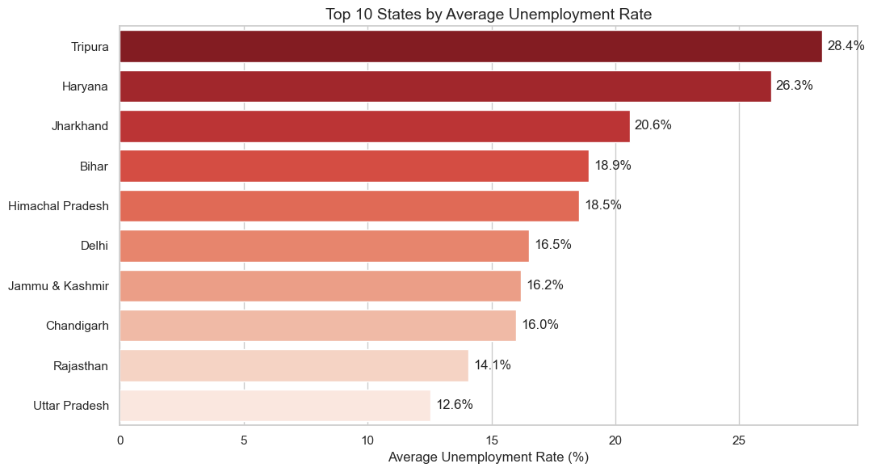
Figure 1. Ten regions with the highest average unemployment rate

4.2 Trend over time
The average rate climbed sharply after the lockdown began and peaked at 24.88% in May 2020, compared with a low of 8.87% in May 2019.
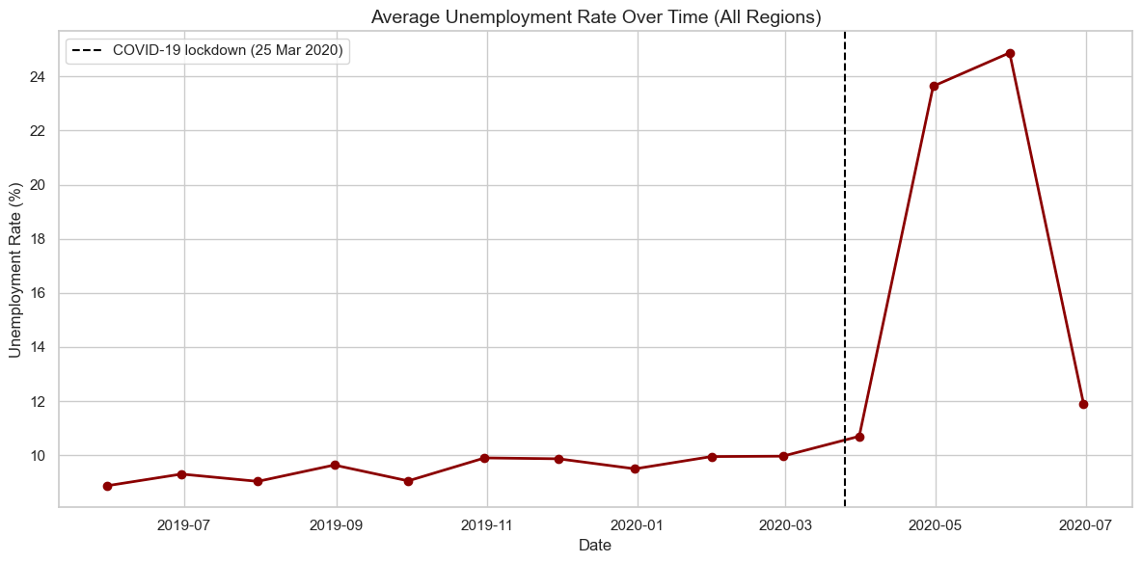
Figure 2. Average unemployment rate across regions, with the lockdown date marked

4.3 Selected states
The five states below all reached their highest recorded rates in April or May 2020.
State | Peak rate | Month
Maharashtra | 25.3% | April 2020
Delhi | 45.8% | May 2020
Tamil Nadu | 53.2% | April 2020
Uttar Pradesh | 32.1% | May 2020
Bihar | 58.8% | April 2020
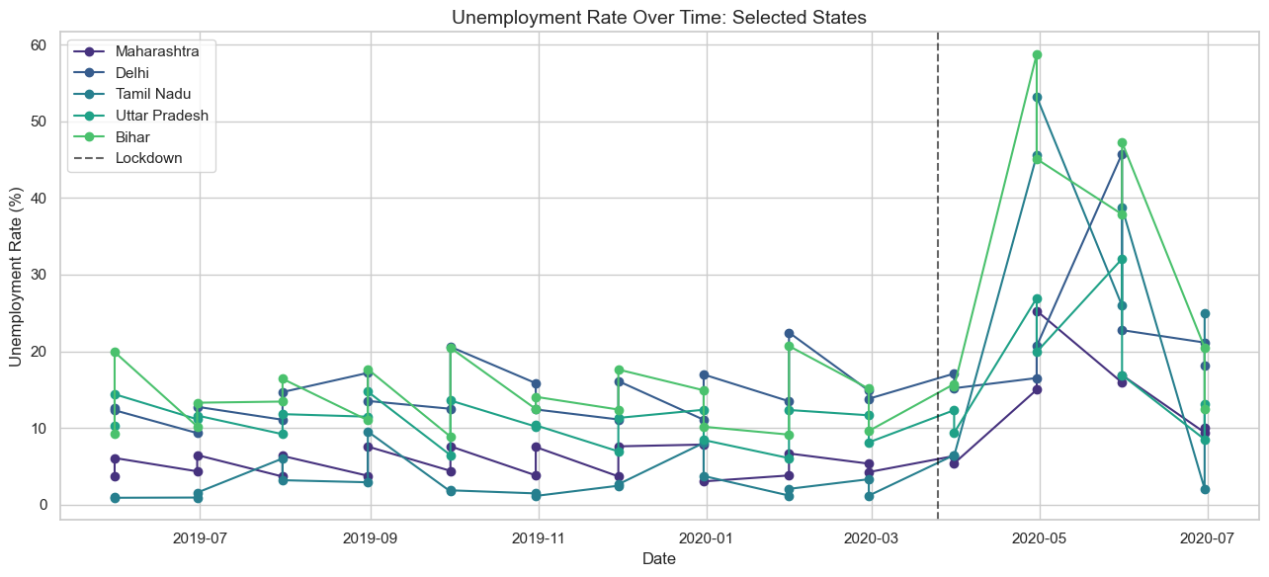
Figure 3. Unemployment rate over time in selected states

4.4 Relationships between measures
Unemployment shows no linear relationship with labour participation (correlation 0.00) and a weak negative relationship with the estimated number employed (correlation -0.22).
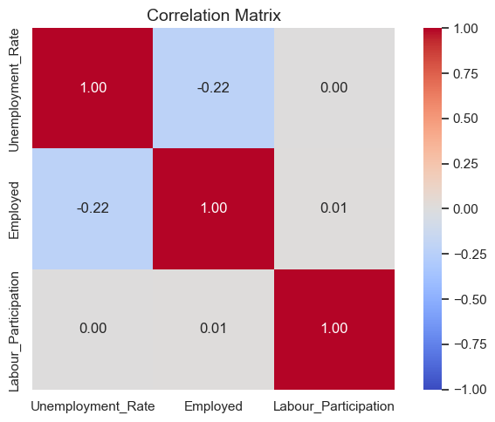
Figure 4. Correlation matrix of the three measures

4.5 Impact of the lockdown
The mean unemployment rate rose from 9.51% before the lockdown to 17.77% afterwards, an increase of 8.26 percentage points. The rise was uneven: Puducherry (+37.4 percentage points), Tamil Nadu (+22.6) and Jharkhand (+22.1) recorded the largest increases.
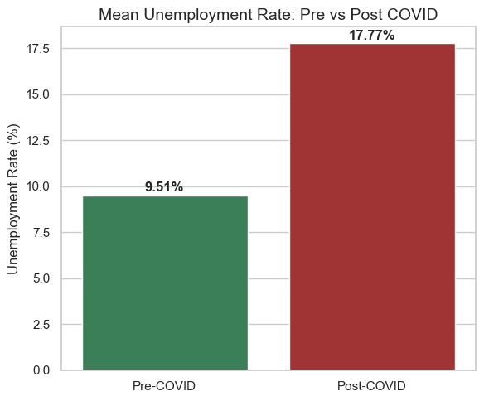
Figure 5. Mean unemployment rate before and after the lockdown
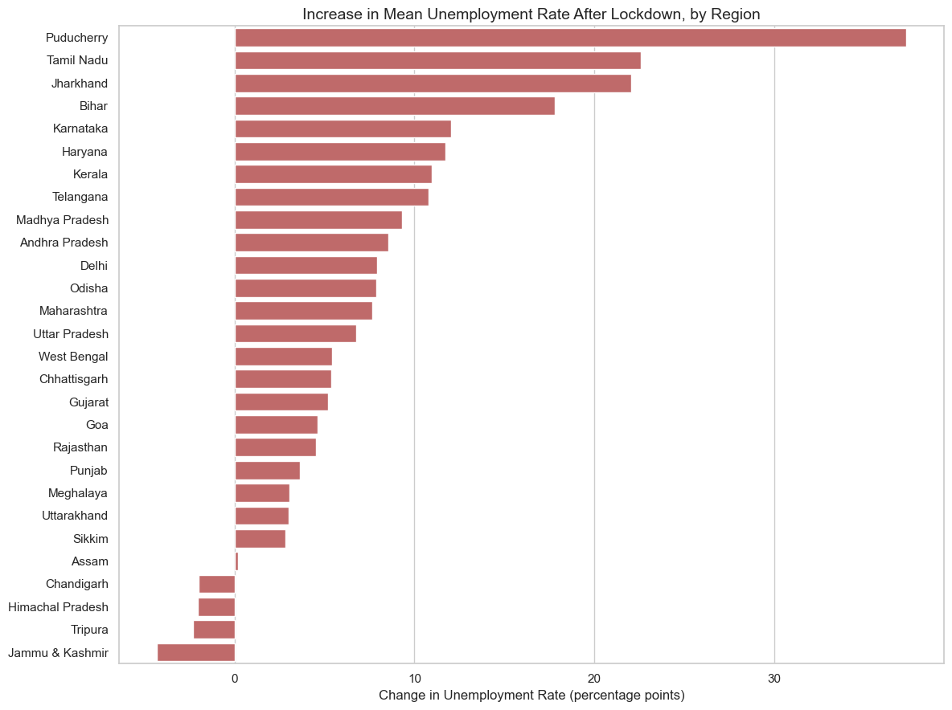
Figure 6. Change in mean unemployment rate after the lockdown, by region

5. Conclusion
- The lockdown marks a clear break in the data, with the average unemployment rate almost doubling.
- Regional gaps were large both before and after the lockdown.
- Jharkhand combines a high average rate with one of the largest post-lockdown increases, making it a clear priority for targeted employment support.
- Unemployment is only weakly related to the other two measures in the dataset.

6. Limitations
- National figures are unweighted averages of regional rates, so they differ from a labour-force-weighted national rate.
- The dataset ends in June 2020, so the post-lockdown period covers three months, against eleven months before it.

