1) sudo apt-get update

2) sudo apt-get upgrade

3) sudo raspi-config

Select update

Sudo shutdown –r now

4) sudo apt-get update

sudo apt-get install apache2

5) sudo apt-get install hostapd

Configuring the HOSTAPD

6) sudo nano/ etc/hostapd/hostapd.conf

Make sure you have the following code in the file

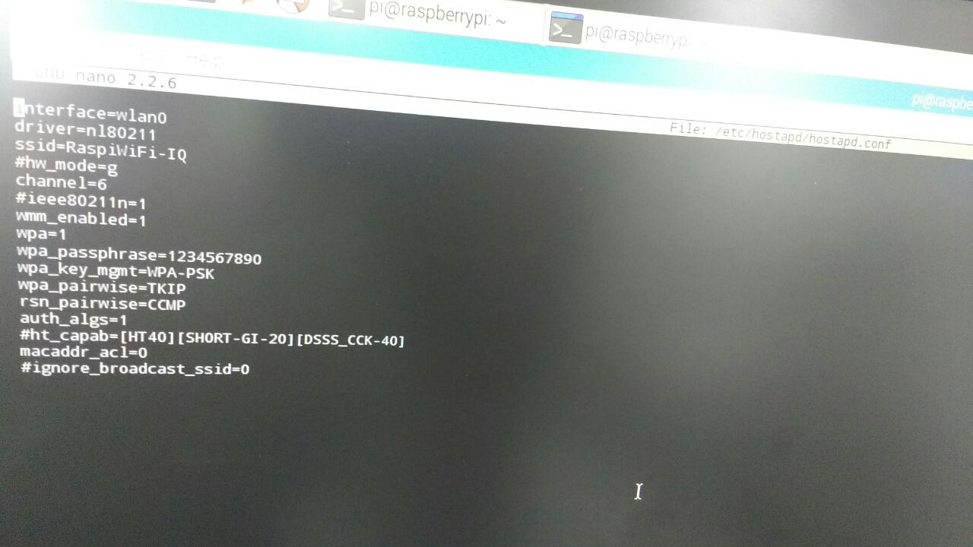

7) sudo nano /etc/network/interfaces

Make sure you have the following code in file

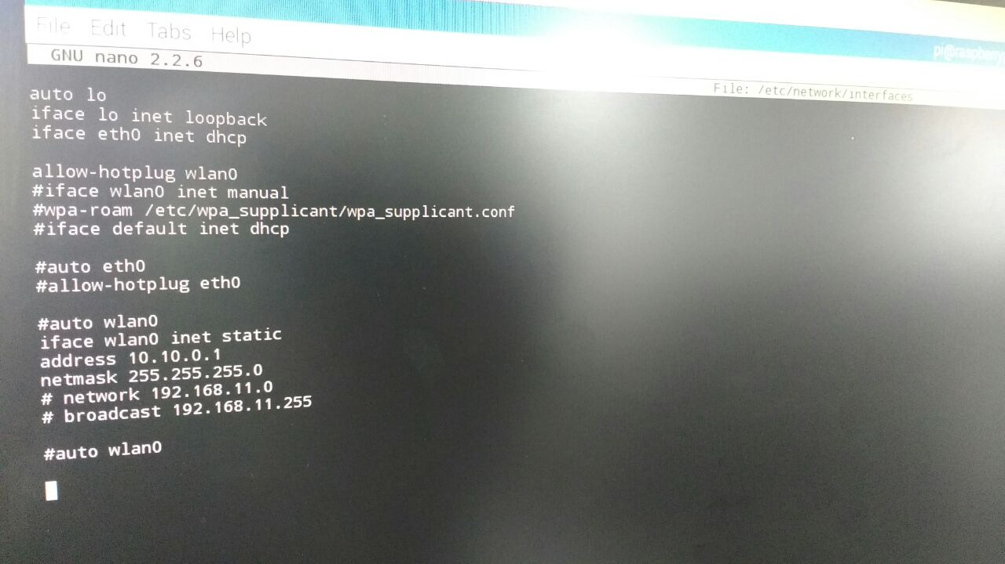

8) sudo apt-get install isc-dhcp-server

9) sudo nano /etc/dhcp/dhcpd.conf

*authoritative; #be careful with this setting  
ddns-update-style none;  
default-lease-time 600;  
max-lease-time 7200;  
log-facility local7;*

*#for the wireless network on wlan0  
subnet 10.10.0.0 netmask 255.255.255.0 {  
range 10.10.0.25 10.10.0.50;  
option domain-name-servers 8.8.8.8, 8.8.4.4;  
option routers 10.10.0.1;  
interface wlan0;  
}*

10) sudo reboot

11) sudo hostapd –B /etc/hostapd/hostapd.conf

THIS WILL ENABLE THE RPi- ACCESS POINT

LINK : https://www.daveconroy.com/using-your-raspberry-pi-as-a-wireless-router-and-web-server/