VDC 2.0 – Affiliate Login Support – Design Draft

Date | Changes | By
March 01, 2007 | Document Creation | Wendy Bossons
March 01, 2007 | Per feedback from MC: Removed supporting text from the design and also added a dropdown list for the affiliation login. | Wendy Bossons
March 09, 2007 | Added screenshots and testing scenarios, outstanding question | Wendy Bossons
March 28, 2007 | Added testing scenarios | Wendy Bossons

Table of Contents

VDC 2.0 – Affiliate Login Support – Design Draft 1
Table of Contents 1
1. Objective 1
2. Terminology 1
3. Needs and Content Analysis 2
4. Requirements 2
5. Design 2
6. Examples 5
7. Outstanding Questions 5
8. Testing 5

1. Objective

Provide the user with an option to login to a DVN via an affiliated login service.

2. Terminology
EZproxy – Software that sits on a Harvard Univerity Library server that provides authentication for campus users. This design draft uses EZproxy interchangeably with the term affiliate login service.

HUL – Harvard University Libraries

DVN – Dataverse Network. Refers to the archival software.

3. Needs and Content Analysis
There may be a predefined community of users that require access to a DVN. This community of users is accustomed to accessing institutional resources through an established login procedure (ex. Harvard’s Pin Service). A set of privileges may be defined for those users after they have logged into the resource. The DVN should supply a means of integrating with the established login procedure. At Harvard, this login procedure takes advantage of software that behaves as a proxy which facilitates this authentication and then manages the traffic between the client and the resource (EZproxy).

4. Requirements

4.1 Add frontend components of a configurable affiliate login service to the login page.

4.2 Add administrative ui to support configurable affiliate login service.

4.3 Add middleend components to support configurable affiliate login service.

4.4 Add any backend properties to support configurable affiliate login service.

4.5 Integrate with the IP Group functionality so that users coming in through the configured proxy will be recognized as members of a group. Any corresponding privileges assigned to that group will then apply to the user.

4.6 Document required steps for configuring the affiliate login service.

5. Design
5.1 Add front-end components of a configurable affiliate login service to the login page: This refers to the jsp and the constituent components that allow a user to choose affiliate login. This will be a visible button link with a label and a dropdown list where the configured affiliates will appear. The affiliate login service will request the same page which would be the result of an ordinary end-user login. An example of this is that a user may request a page that requires a certain privilege level. If the user has not been authenticated, a redirect to the login page takes place. After the user is logged in, the page is redirected to that page, which was originally requested.

See figure 1 for the layout.

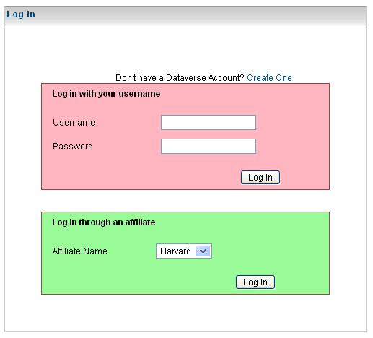
Figure 1. The login page when a user is a member of an ip group.

5.2 Add administrative ui to support configurable affiliate login service: This refers to the jsp and the constituent components that allow a privileged user to setup affiliate login. For the purposes of this document, the constituent components will be identified with the Harvard setup in mind. This page would accept inputs of a label and an url that points to the EZproxy.

This input key/value pairs would then be:
Label: Login as an Harvard Affiliate
URL: http://vdc-build.hmdc.harvard.edu:8080.ezp1.harvard.edu/VDCNet-web/[dataverse]/[aliased vdc name]/faces/HomePage.jsp
Affiliated IP Groups.

This will be added to the IP User Group page.

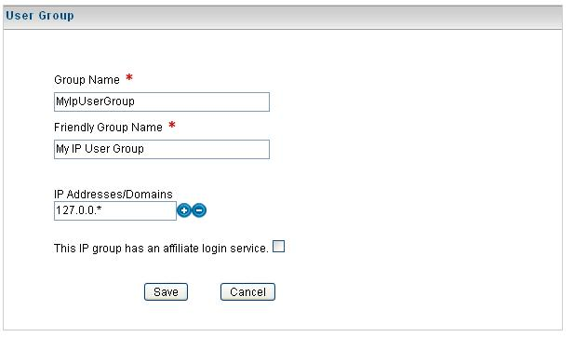
Figure 2. The EditUserGroup page for an IP Address/Domain group.

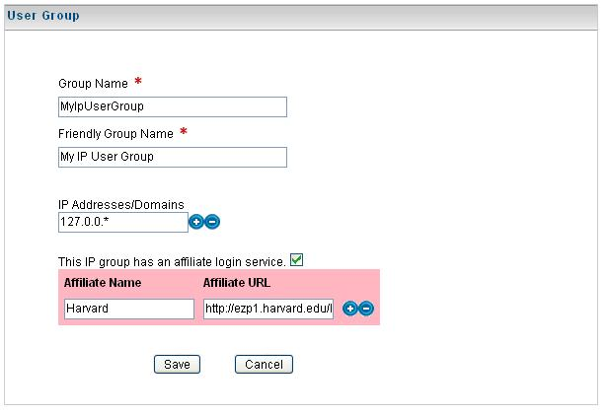
Figure 3. The EditUserGroup page for an IP Address/
Domain group with the login service selected.

5.3 Add middle-end components to support configurable affiliate login service: This refers to the backing beans that support the end-user and privileged end-user interfaces. For this design, that means adding code to the existing login page backing bean which will support the end user data needs. If the privileged user page will be a new jsp, then this will be a backing bean which follows the naming convention of the jsp. (Example: the frontend jsp may be LoginPageConfiguration.jsp. The backing bean source code will reside in LoginPageConfiguration.java.

5.4 Add any backend properties to support configurable login feature: This refers to the EJB side of the design where properties will have to be added to the database which support the configurable elements of this design, label, url and supporting text.

The existing usergroup table will have two new columns, proxy name and proxy url. These properties will remain empty for username groups and IP groups that are not associated with an affiliate login service.

5.5 Integrate with the IP Group functionality so that users coming in through the configured proxy will be recognized as members of a group. Any corresponding privileges assigned to that group will then apply to the user. This is primarily a documentation step so that the privileged user tasked with configuring an affiliate will know how to do so.

6. Examples
1. IP addresses for domain groups can be static or wildcarded.
Example 192.168.2.1 acknowledges the user at 192.168.2.1
192.168.2.* acknowledges any user with an ip address starting with 192.168.2, so 192.168.2.1, 192.168.2.2 ….

2. Domain addresses for domain groups can be static or wildcarded.
Example my.domain.com acknowledges a user identified only as my.domain.com.
*.my.domain.com acknowledges abcd.my.domain.com, efgh.my.domain.com, …

7. Outstanding Questions
Is additional work required on Log out – e.g. should the user also be logged out of the EZProxy?

8. Testing

- On the EditUserGroup page, create an ip group with the following ip address or domain name of the EZproxy. At this writing, the correct ip address for Harvard’s EZproxy should be 128.103.60.*. (Wildcard acceptable).
- Verify that the option to add affiliates appears below the ip address/domain field(s).
- Check the affiliate option. Verify that the affiliate options input table appears with two fields, name and url.
- Enter the affiliate name and affiliate url. Save.
- Go to the login page. The affiliate name will appear on the login page in the dropdown in the affiliate login section.
- Select Harvard. Click login. Verify that the Harvard pin service login appears. Login using a valid Harvard pin. Verify that you are redirected.
- Test referers. Log out. Close the browser. Click on the SiteMap link. Click on the Log in link. Verify that the SiteMap appears after logging into the Harvard pin service.
- Test referrers. Log out. Select Log in. Choose the Harvard affiliate login and click login. Verify that the home page appears after logging into the Harvard pin service. Do this same test for an url from a network admin page. Verify that the user is returned to the home page.

Additional Affiliates Admin Testing:
1. Add a new ip group. Check add affiliate. Do not enter any data.
Uncheck and submit. Expected result -- no new affiliate blank.
2. Add a new ip group. Check add affiliate, enter the data. Then add
another row by checking on the plus image. Submit. Expected result -- 1
new affiliate and no affiliate blank.
3. Add a new ip group. Check add affiliate. Submit. Expected result --
1 new affiliate and no affiliate blank.
4. Add a new ip group. Check add affiliate, enter the data. Uncheck and
submit. Expected result no new affiliate and no blank.
Additional state maintenance testing:
1. Create a new ip group, the default checkbox state for affiliates is off.
2. After creating an ip group with an affiliate (just one), choose the
ip group from the UserGroup page and verify that the checkbox is checked.

