DataVerse Developer’s Guide

Date | Changes | By
November 14, 2006 | Document Creation – start accumulating various installation instructions. | Wendy Bossons
December 12, 2006 | Add the Ingest and JavaMail instructions  TODO: add Tiles instructions | Wendy Bossons
January 02, 2006 | Added tiles instructions | Wendy Bossons
January 30, 2007 | Added jaxb jar for DDI/Study creation | Wendy Bossons
March 2007 | General updates for message service | Wendy Bossons
April 11, 2007 | Updated jars and also jvm settings | Wendy Bossons

These are setup instructions collected during the development of Dataverse 1.0 from various developer emails. Feel free to add and update these instructions.

Components required:
- Glassfish Application Server
- NetBeans 5.5
- NetBeans Enterprise Pack for 5.5
- NetBeans WebPack (optional)
- PostgresQL

All of the above can be downloaded from the web.

Installation Instructions

Glassfish*
- Download Glassfish v.2 b22 from the Glassfish project site (https://glassfish.dev.java.net/downloads/v2-b22.html). Place it in the root of your c: drive.
- From a command line prompt, type: java -Xmx256m -jar <filename>.jar where <filename>.jar is the name of the glassfish jar file.¹
- Change to the glassfish\bin\ant\bin directory.
- From the command line, type: ant -f setup.xml (Use the ant that is installed in the glassfish\bin\ant\bin folder.
* Additional instructions for setting up Glassfish and PostgreSql follow the installation of PostgreSql later in this document.

¹ When you get to the step of running ant -f setup.xml, a few thing to note:
- You need to copy tools.jar from the jdk1.5.0_06/lib directory to the jre1.5.0_06/lib directory
- You need to set up the environment variable (from control panel/system/advanced) for java_home
to your local jdk installation (eg C:\Program Files\Java\jdk1.5.0_06)

NetBeans 5.5
- Download the most recent release of NetBeans 5.5 from the NetBeans project web site. Be sure to install the IDE only, not the version packaged with the Sun Application Server.
- Run the install on your machine. (After a few dialogs, NetBeans will prompt you for information on the application server to use. Browse to or fill in the path to the Glassfish root location and continue with the installation.)

NetBeans 5.5 Enterprise Pack
- Download the NetBeans 5.5 Enterprise Pack from the NetBeans project web site.
- Run the installation. (After a few dialogs, the Enterprise Pack prompts you with a list of compatible NetBeans installations. If there is more than one, choose the one that you installed in the step above and continue with the installation.)

NetBeans 5.5 Web Pack
- Download the NetBeans 5.5 Web Pack from the NetBeans project web site.
- Run the installation. (After a few dialogs, the Enterprise Pack prompts you with a list of compatible NetBeans installations. If there is more than one, choose the one that you installed in the step above and continue with the installation.)

<Add steps to make the Web Pack work in our environment if needed.>

PostgresQL

- Download and install PostgresQL
- Open the pgAdmin tool.
- Connect to the postGresSql database server.
- Right click on the postGresSql and choose new object|create new login role (user is vdcApp, password is secret)
- Right click on the database node and create a new database. Here’s a picture: 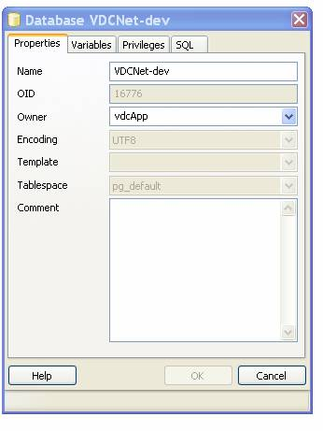
Figure 1. The PGAdmin con
Run the sql scripts from the EJB project.
Go to Tools on the menubar. Open the query tool.
- Go to Tools on the menubar. Open the query tool.
- Run the sql scripts from the EJB project, referenceData.sql and testdata.sql.

Additional Configuration Instructions for Glassfish

1. Jar files needed. Unless otherwise noted, these should be stored wherever you set up your lib folder. In NetBeans, right click on the VDCNet-web project | Properties. Add these libraries to the project and check to be packaged. If they do not make it to your server, then you must add them in the packaging panel and type in the correct path, (WEB-INF\lib).
1.1 postgresql-8.2dev-503.jdbc3 (Add to the glassfish lib folder.)
1.2 harvester2
1.3 xalan.jar
1.4 commons-digester
1.5 commons-el
1.6 commons-logging
1.7 commons-bean
1.8 shale-tiles-1.0.4.jar * (See Tiles setup for additional information.)
1.9 tiles-core-2.0-SNAPSHOT.jar
1.10 vdc-jaxb (EJB project)
1.11 commons-httpclient (EJB and web project)
1.12 oaicat.jar
1.13 vdcnet-ejb.jar
1.14 log4j.jar
1.15 lucene-core-2.0.0.jar (EJB project)

1.16 Theme-default library. Required change.
The theme-default library has been modified to use our own transparent images in place of a set of default tree images that are used in our user interface. You must modify this library in order to see the tree as it is intended.
Go to NetBeans | Tools | Library Manager.
Locate the theme-default library in the left-hand panel.
The library classpath points to the default location for default-theme.jar. Check out our version of the default-theme.jar (dvn-default-theme.jar). Change the classpath pointer to the new dvn-…jar and remove the default-theme.jar.
1.17 Web-ui library. Required change.
The tree component that’s shipped in the web ui library has been changed so that the tree now wraps correctly. You must use the modified library to see the tree as it is intended. Follow the steps in 1.16 above to replace the webui.jar with the dvn-webui.jar.

** An easy way to maintain the libraries is to check them out to the CVS lib folder on your hard drive. Then create a dvnlibs library, adding all of the jars to this library’s classpath. You can then add the dvnlibs to in your libraries property windows, and verify that this library and the correct classpath (WEB-INF\lib) is configured (also from the properties window).

** Please note that development time needs Java EE5 and jsfimpl jars requires also that the Java EE5 and jsfimpl jars be added as libraries. These can be found in the glassfish lib folder. They should appear at the top of the library list, and should *not* be packaged with the project.

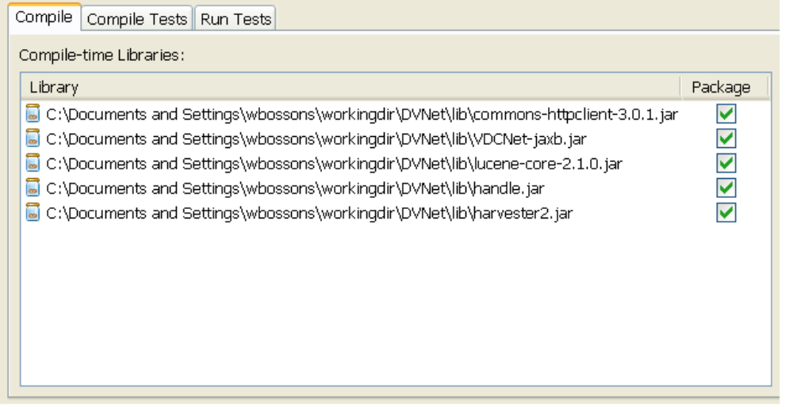
Figure 2. The DVN-ejb libraries configuration

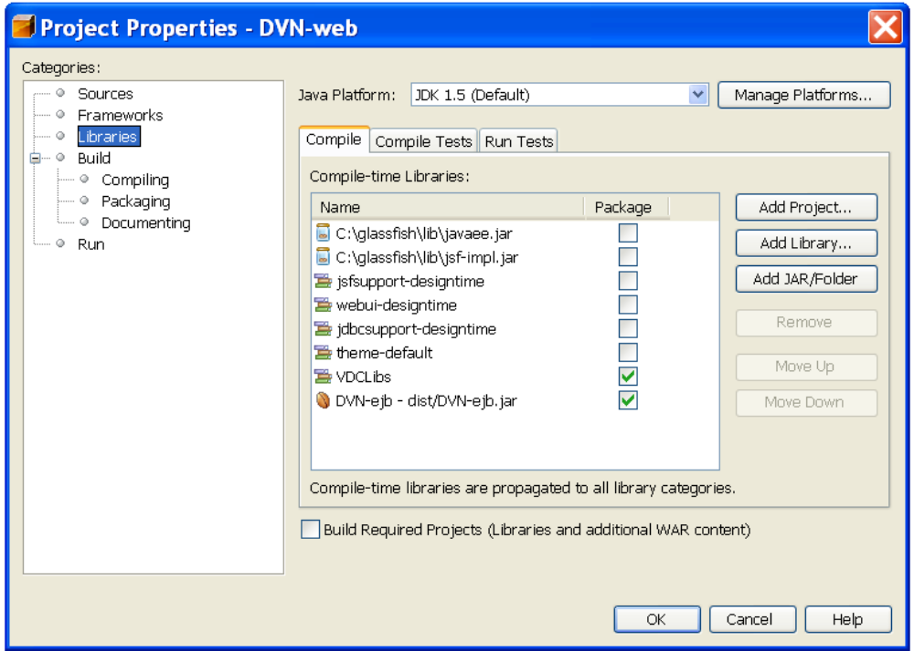

Figure 3. The DVN-web libraries configuration

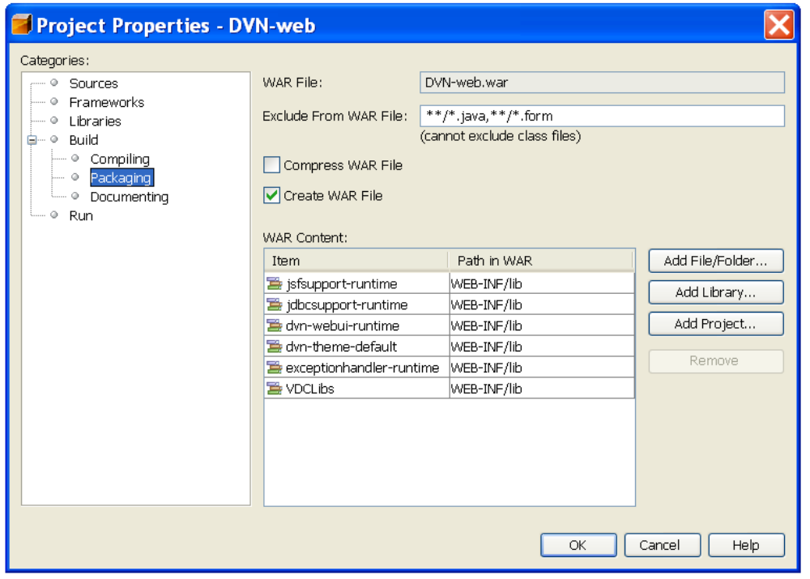

Figure 4. The DVN-web Packaging Configuration

1. Open up the admin console (localhost:4848)

2. Go to Resources/JDBC/Connection Pools. Add new:

Name: VDCNet-devpool
ResourceType: javax.sql.DataSource
Database Vendor: PostGreSQL

Select Next and Edit/Add the following parameters:
DataSource ClassName: org.postgresql.jdbc3.Jdbc3PoolingDataSource
ResourceType: javax.sql.DataSource

Properties:
connectionAttributes: ;create=true
user: vdcApp
port: 5432
password: secret
databaseName: VDCNet-dev
serverName: localhost
Save

3. Go to Resources/JDBC/JDBC Resources. Add new:
JNDIName: jdbc/VDCNetDS
PoolName: VDCNet-devpool
SAVE

4. JVM Options
Change these options in the admin console through the path, Application Server | JVM Settings | JVM Options. Here is an example. Please note that the vdc.dsb.url corresponds to the dsb server host. This value should reflect whichever dsb host you are using.

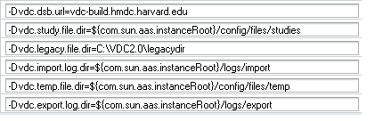

Configuring JMS for DSB Ingest

1. Login to localhost:4848
2. Go to: Resources / JMSResources
3. Add a new ConnectionFactory:
JNDIName: jms/DSBQueueConnectionFactory
Type: javax.jms.QueueConnectionFactory
4. Add a new DestinationResource
JNDIName: jms/DSBIngest
Type: javax.jms.Queue
Name (this is under additional properties): DSBIngest

IndexMessage
1. Add a new Connection Factory:
JNDI Name: jms/IndexMessageFactory
Type: javax.jms.QueueConnectionFactory
2.Add a new Destination Resource
JNDI Name: jms/IndexMessage
Type: javax.jms.Queue
Name( Under Additional Properties) : IndexMessage

Configuring JavaMail
1. Go to the Server Admin console (http://localhost:4848)
2. Go to Resources->JavaMail Sessions Click the New button to create a new JavaMail Session
3. Set JNDI Name : mail/notifyMailSession
4. Set Mail Host : vdc-build.hmdc.harvard.edu
5. Set Default User : dataversenotify
6. Set Default Return Address: do-not-reply@vdc-build.hmdc.harvard.edu

The rest of the fields should be ok with the defaults.

Configuring Tiles
- Add these libraries to the project and include to be packaged: commons-digester, commons-el, commons-logging, commons-bean(?), shale-tiles-1.0.4.jar *, and tiles-core-2.0-SNAPSHOT.jar.

* These jars can be downloaded from the VDCNet\lib folder in CVS. It is important to use these versions of the jars. The Shale-tiles-1.0.4.jar in the project is a modified version of the Shale standalone tiles effort. The one that is currently under development is not JSF 1.2 compatible. The one in our project contains the needed modifications.

- Add these libraries to the project and uncheck the packaging option: javaee.jar, jsf-impl.jar. Move these libraries to the top of the list of packages.
This is not needed for the runtime package. However, for the NetBeans 5.5 beta2 ide, they enable ide support for specific JEE 5 features.

- Add the StudioCreator libs to the NetBeans IDE. This is not specifically a tiles requirement, so you may already have done this. After unzipping the creator libs to the NetBeans C:\Documents and Settings\wbossons\.netbeans\5.5beta2\config\org-netbeans-api-project-libraries\Libraries folder, be sure to remove the jsf-impl and jsf-api jars, as well as any commons… jars. These are JSF 1.1 related jars and will prevent your application from recognizing important JSF 1.2 components.

- The project otherwise is configured to use tiles. See the document, tiles_guidelines.doc in the vdcnet doc folder for more detailed information on the usage.

ENABLING CREATION OF A STUDY FROM A DDI.
You must add the VDCNet-jaxb.jar to the libraries. This is needed also for the runtime package.

Jhove library

From the build-16, DSBWrapper class of DVN-EJB uses Jhove library to identify the mime type of a uploading file. The following setup is necessary:

- (Netbeans) add the following new 3 jar files in dvn/lib of the subversion to the library of the ***EJB*** project:

jhove-handler.jar
jhove-module.jar
jhove.jar

- (glassfish) deploy Jhove's config file, jhove.conf, which is added dvn/working_directory of the subversion, to your glassfish's ../domains/domain1/config directory; just like other files in this directory, jhove.conf is expected to be deployed to the glassfish's ../domains/domain1/config directory; please manually copy jhove.conf to the config directory.

- (glassfish) add a new jvm option to your glassfish:

-Djhove.conf.dir=${com.sun.aas.instanceRoot}/config

