VDC 2.0 – UI_VDC Network Hub Design Document

Date | Changes | By
September 12, 2006 | Document Creation | Wendy Bossons
September 13, 2006 | Add requirements and design detail | Wendy Bossons

Requirements

There are three paths that a user may take with respect to presenting VDC

Terminology
VDC Network – The Murray Archive initiative to create and provide software for the purpose of building a network to house and distribute social science research data.
VDC Network Hub – The software network, installed by an organization or person for the purpose of providing a data repository, where an affiliated user (member) may create a hosted virtual repository (VDC).
VDC Member – The hosted instantiation as referenced above in VDC Network Hub.
Gateway – A webpage designed to attract visitors and search engines to a particular website. A typical gateway page is small, simple and highly optimized. Its primary goal is to attract visitors searching for relevant key words or phrases, and provide hyperlinks to pages within the website. (http://en.wikipedia.org/wiki/Gateway)

** Please note that the terms above have been provided for the purpose of discussing the design of the currently named VDC 2.0 software. They are subject to change based on the outcome of ongoing design discussions.

3. Needs and Content Analysis
To understand the requirments of the phase of the VDC 2.0 software development, it’s helpful to analyze the use case for how a user might select a VDC Network Hub versus a VDC instantiation of the VDC software. Initially, this begins with a researcher somewhere who is conducting research, and who has either an individual or institutional requirement to publish the research data electronically. At the point that there is an awareness of the VDC 2.0 software, the decision must be made whether to install a new VDC network or to participate in an existing VDC network. This choice most likely will be made with several factors in mind. One of these factors would be the desire to restrict the research to members of the sponsoring institution. Other factors may be, but are not limited to, the availability of a VDC network with a like mission where it would be appropriate to house this data and the ability of the sponsoring institution to house the software and accompanying archive.

Table 1 below is a high level analysis of the paths that one might take to install a network hub or become a member of an existing network hub, and thereby discover the the user interface features required for the network hubs.

Table 1:
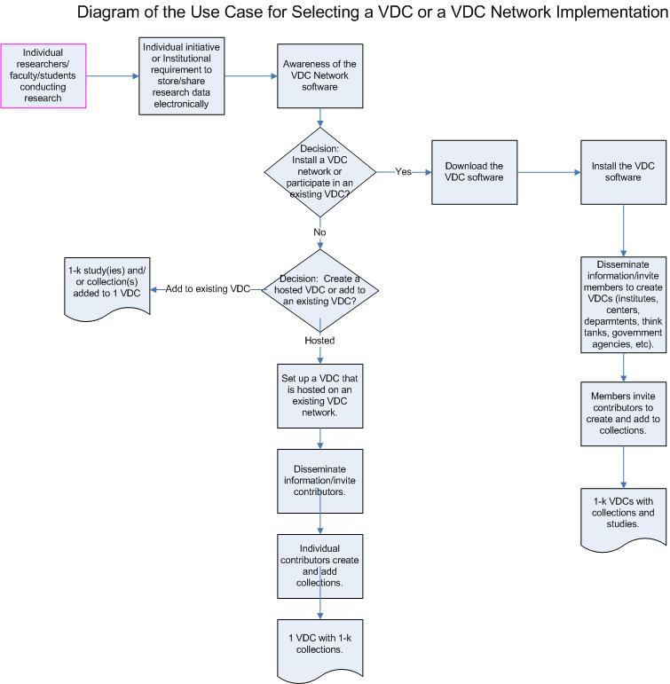

An analysis of table 1 shows us that there are three (3) separate users or consumers of the VDC Network Hubs. Institutional sponsors are generally the consumers of the VDC Network software. The individual contributing departments and affiliated institutions, colleges, and other organizations are the curator users of the VDCs. Finally, the individual contributors are the end users of the VDCs. The intent of this design is to discover the differences and the similarities of the two gateways into the VDC Network – the VDC Network Hubs and the VDCs themselves.

From this analysis, it becomes clear that the VDC Network Hubs behave much like subnets on a network, where the individual VDCs are the members of the subnets.

4. Requirements for the VDC Network Hub Home Page
From the needs and content analysis above, some assumptions can be made about the requirements of this phase of the project.

4.1 The VDC Network Hub page must be a gateway to other member VDCs.
4.2 Member VDCs on the VDC Network Hub home page will be browsable to the 1st level of its collections, which are also gateway links to the member VDCs.
4.2 The VDC Network Hub must provide the means for an interested member user to create a VDC.
4.3 The VDC Network Hub must provide access a defined set of administrative functions including managing a VDC and also inviting users to visit and register for a particular VDC.
4.4 The VDC Network Hub page must provide branding for the VDC Network.
4.5 The VDC Network Hub page must provide access to the VDC Network.
4.6 The VDC Network Hub page must provide a mean for the user to search the collections of its member VDCs.

5. Design
5.1 VDC Network Home Page – tbd
5.2 VDC Network Hub Home Page
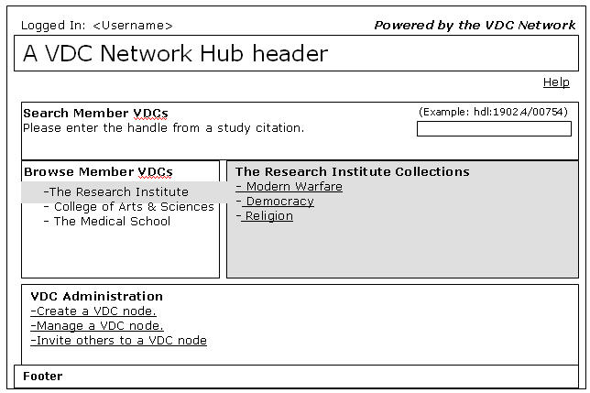
Figure 1. The VDC Network Hub Home Page

5.2.1 A user who browses to the VDC Network Hub will see a listing of the member VDCs.
5.2.2 Selecting any VDC member, via a mouse over, in the list of member VDCs will reveal a list of the collections of that VDC member.
5.2.3 Clicking on a VDC member will take the user to the VDC member’s home page.
5.2.4 Clicking on any of the collections of a VDC member will take the user to the collection page of the VDC member.
5.2.5 A user will login via the login link in the upper left-hand corner of the page. When logged in, the link will be replaced with a “Logged In:” message followed by the user’s name.
5.2.6 A user on the network hub header page will have the means to learn more about the VDC network via branding, which is located in the top right of the page, and which is a link back to the VDC root network currently known as thedata.org.
5.2.7 The VDC Network hub administrator will customize the hub banner.
5.2.8 The Network hub banner will also contain a link which can also be customized by the VDC Network Hub administrator.
5.2.9 A user will access Help via a link located immediately below the banner, labeled “Help”, and flushed right.
5.2.10 The VDC Network Hub will allow the user to search the VDCs for studies which belong to its publicly accessible member VDCs. The results of this search will appear on a separate search result page that will ultimately link back to the VDC site where the study was found. That page design is not covered in this document.
5.2.11 The VDC Network Hub will allow the user to browse its publicly accessible VDCs.
5.2.12 A privileged user who is authenticated will, in addition to having the option to create a VDC, have access to other VDC Network Hub administrative features. These other features are currently identified as “Manage a VDC Node” and “Invite others to a VDC Node”.
5.2.13 Create a VDC page.
5.2.14 There will be page footer – TBD.

5.3 Create a VDC
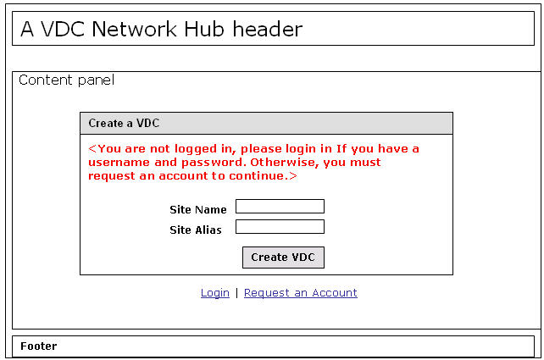
Figure 2. Create a VDC with the Request an Account option.

    - Any user will have the option to create a VDC. Initially, this will be done through requesting an account via email.
    - This page will require the user to be authenticated. If the user is not authenticated, a message will appear which instructs the user to login or request an account. See figure 2. The result of following this path to the login page should result in finally being returned to the “Create a VDC” page upon successful authentication.
    - Requires a login link below the form.
    - Requires a Request an Account link below the form.

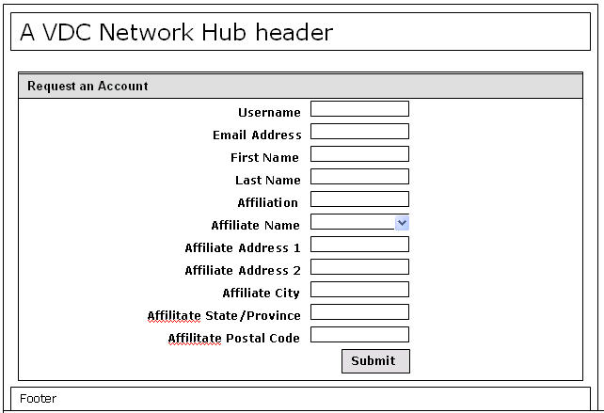
Figure 3. The Request an Account form.

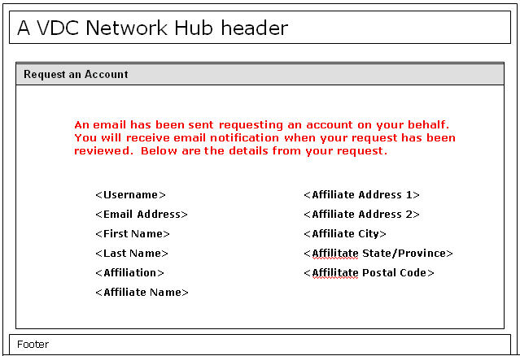
Figure 4. The Request an Account result page.

    - The default action is that an unregistered user who wants to create a member VDC must request an account. See figure 2, 3 and 4.

Extra Credit
These represent extensions to the above “Request an Account” process, not changes to the business rule that the user must be a registered and logged in user to create a vdc.

    - Configurable option to Register via a form and receive an automated reply and confirmation. See figures 5, 6 and 7.
      - This option is manually configurable.
      - Extra-extra credit. This option is configurable via an admin page.

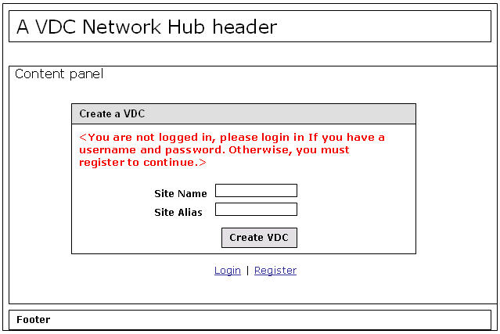
Figure 5. Create a VDC with the registration option.

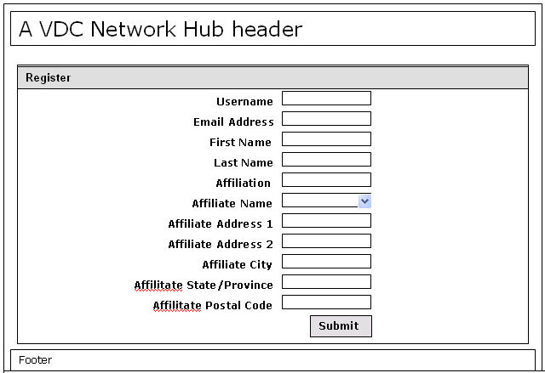
Figure 6. The Register form.

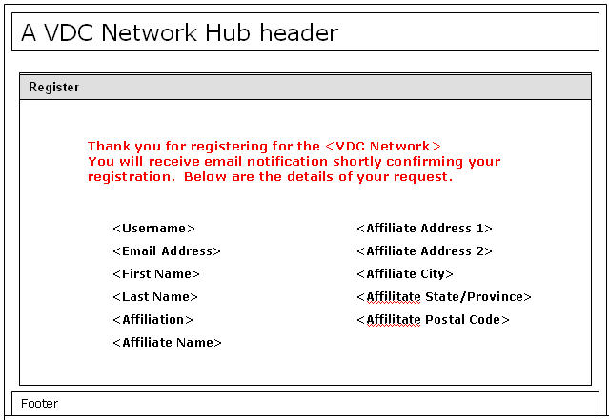

Figure 7. The Register confirmation page.

