# Escape IR

## User documentation

### Fire movements

To fire a weapon you need to click on the ship, and then just drag on the wanted direction. All weapons are different and does different damage so don’t waste all good weapon at the begin or you won’t pass the boss of each levels.

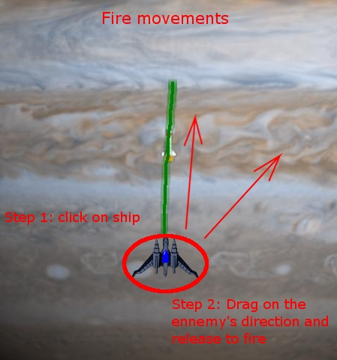

### Change weapon

To change the weapon you just have to click on the top right HUD and choose the desired one. You can see how much ammo is left near each weapon. The Weapon choose is displayed on the top of the Hud, and you have unlimited Missile if you uses all your other weapons.

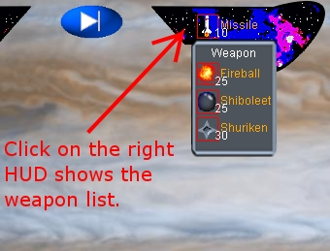

### Do a break

If you want to do a break during the game, you only have to click on the button on the middle of the screen.



### Movements

To move your ship you have to click somewhere else than on it, then just drag on the direction you want to move. The drag length will change the time and the speed of your ship move.

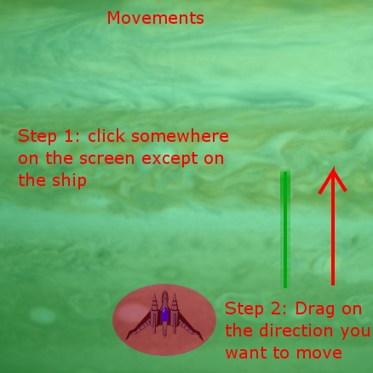

You have many gesture which are been recognized, but not all!! Be care.

You can move : (all time of movement depend of the size of the trace that you draw)

* Left Drift : a movement from bottom to the top, in diagonal to the left.
* Right Drift : a movement from bottom to the top, in diagonal to the right.
* Bot Left Drift : a movement from top to the bottom, in diagonal to the left.
* Bot Right Drift : a movement from top to the bottom, in diagonal to the right.
* Backoff : A movement from top to the bottom.
* 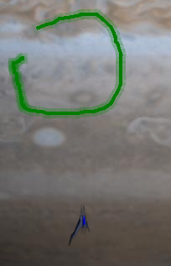
* Right Looping : A left loop, that generate a tendril : you can avoid missile and enemies with it.
* Left Looping : A left loop, that generate a tendril : you can avoid missile and enemies with it.
* Arrow Movement : The arrow movement, like the keyboard : From right to the left, from left to the right, and from bot to the top.

Be care, we only accept an incline of angle of the trace to 40 degree.

### Enemies

Each enemy is different. Even if they have the same color and form they don’t have the same life and the same comportments. So be careful when you choose your weapon. A bad choice can make you lose.

At the end of each level a Boss will try to kill you. Boss has a lot of life so keep a good weapon if you want to live.

### Level

Each enemy is different. Even if they have the same color and form they don’t have the same life and the same comportments. So be careful when you choose your weapon. A bad choice can make you lose.

At the end of each level a Boss will try to kill you. Boss has a lot of life so keep a good weapon if you want to live.

Please, enjoy this game.