**App.py Code Walk Through**

**Source Code:**

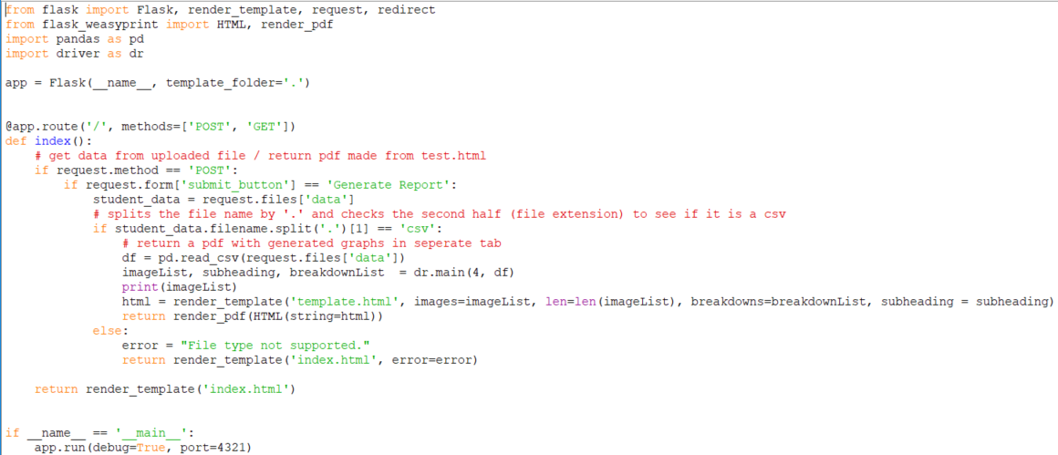

**Process:**

1. The program waits for the user to upload the .csv and click submit.



1. Next the inputted file is placed in student_data.



1. Next the program checks to see if the file name is a .csv.
   1. If this statement is true then the data is read and driver is called to generate the .png files. The names of the .png files are stored in the array ImageList, the breakdowns are stored in breakdownList, and the subheadings are stored in subheading. Following this render_pdf is called to create the breakdown pdf with the image list(used to identify which .png files are needed in the report), the breakdowns and the subheadings.

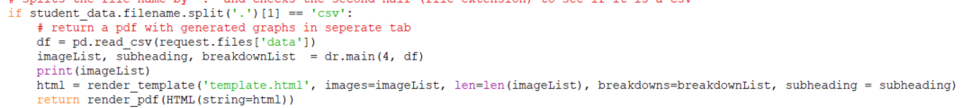

* 1. If the statement is false, then an error is raised that the file is not supported.



**Flask Lines of Code:**

* The following line of code is used to say where the application will be going and what methods can be used. In our case the route is in the home directory and the allowed methods are post and get.



* Render template is used to create the next page in the code.



* This segment of code is used to run the program locally.

