**Driver.py Code Walk Through**

**graphGrades function**

**Source Code for graphGrades:**

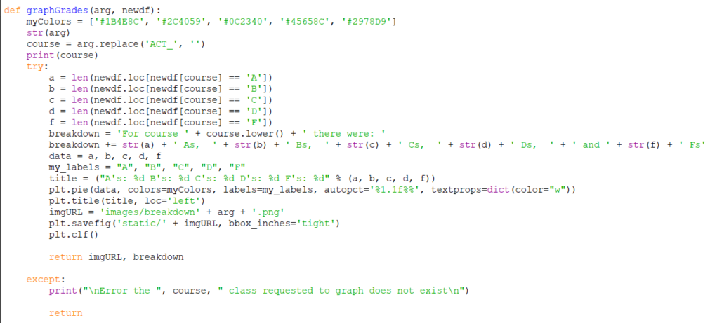

**Input Parameters**:

|  |  |  |
| --- | --- | --- |
| Variable name in code | Data type | Description of the stored data |
| Arg | String | The name of the course that is going to be graphed. |
| Newdf | Pandas Data frame | the datafile containing previous student data. This is used to generate the graph. |

**Process (the following is done in the try block on 11):**

1. First the program will calculate how many students achieved each letter grade in that class. This done in the following lines. If a student has not taken that class they are not added graph.

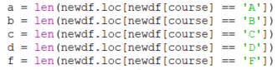

1. Once the totals are calculated the Break down statement is created in breakdown.



1. Next an array is created containing the letter grades this variable is called data. This is necessary to use matplotlib.pyplot.pie.



1. Follow this the Labels (necessary to create the graph) are created for the data and the title statement is created.



1. Next the pie function is called which creates the graph. Then the tittle is added to the graph.



1. Following this the graph is saved as a png and stored in the breakdown folder in the images/breakdown folder in following statements. Additional the filename for the graph is stored in imgURL.



1. Before the .png filename is returned to the user the plot must be cleared. The function then returns the filename for the graph as well as the breakdown statement.



**Output:**

|  |  |  |
| --- | --- | --- |
| Variable in Code | Data Type | Description of the stored data |
| imgURL | String | The full filename for the generated .png file of the graph |
| breakdown | string | The statement that identifies the course and the totals for each letter grade. |

**main function**

**Source Code of Main:**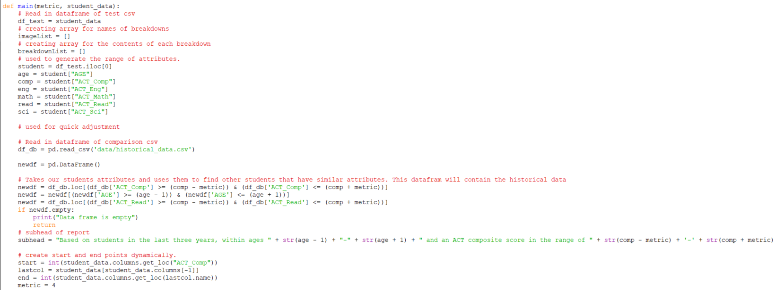

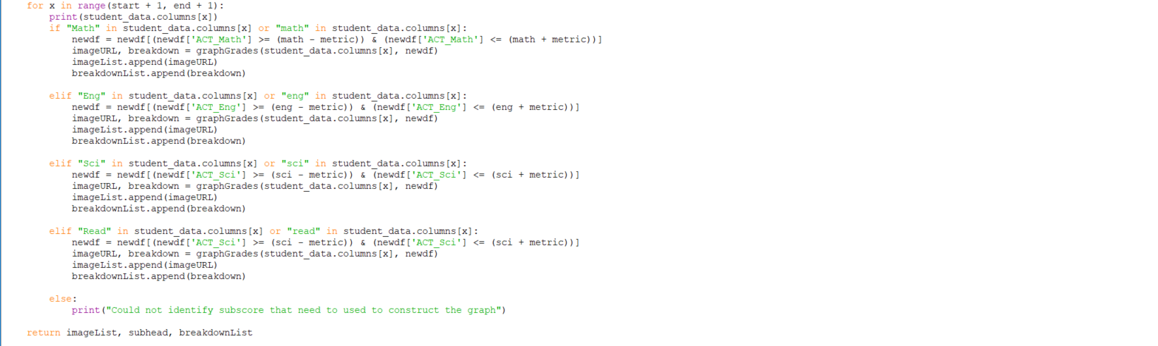

**Input Parameters**:

|  |  |  |
| --- | --- | --- |
| Variable name in code | Data Type | Description of the data it contains |
| metric | Integer | The numerical value that is used to create the range of act sub scores. |
| filename | string | Contains the name of the inputed .csv file. Inside the file is the student’s act sub scores and the classes there are registered for. |

**Process:**

1. The student file is read into the program and the values are stored in their appropriate variables.

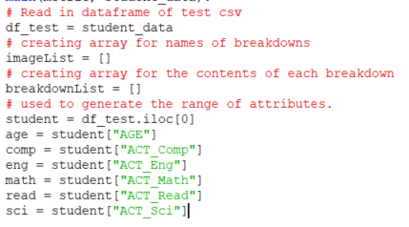

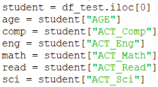

1. the historical student .csv file is stored as a data frame. Additional this data frame is parsed to only include students that have the same act composite and reading score + or – the metric. If the data frame is empty then the program reports that the Data frame is empty.

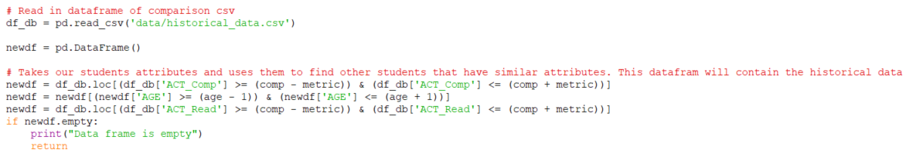

1. Once the data frame is parsed the program will call graphgrades for each class the student is registered for and add the outputs to their respective arrays. Additionally, each registered class is examined to find key words to determine the appropriate Act Sub score and the data frame is parsed. This is done by look at the last few parameters that are entered in the student.csv below is an example .csv file. Main will return imageList, subhead, and breakdownList



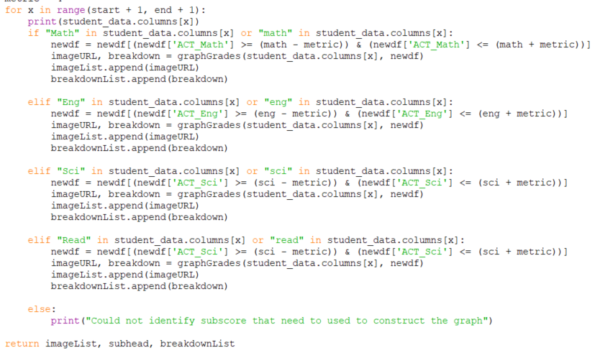

**Output:**

|  |  |  |
| --- | --- | --- |
| Variable name in code | Data Type | Description of the data it contains |
| imageList | Array of Strings | An array that contains all of the filenames for the generated graphs. |
| subhead | String | The statement that explains the parameters for the graphs that were generated. |
| breakdownList | Array of Strings | An array that contains the breakdown statements for each graph. |