Team Names: Irvin Rafael, Anne Edwards, Joshua Villareal

Class: CPSC 323-07

Lexical Analyzer - Design Doc

Token FSAs

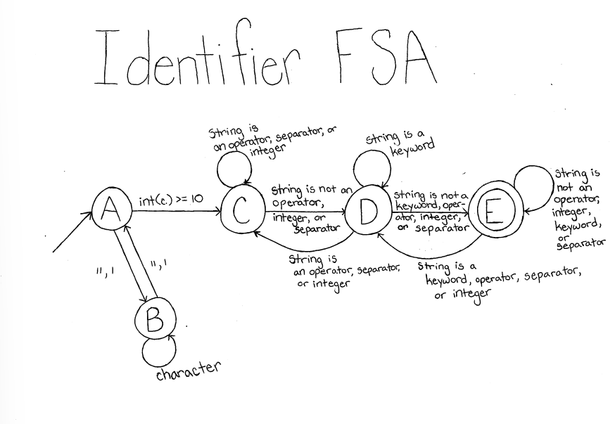

Key:

int(c): integer representation of a single character

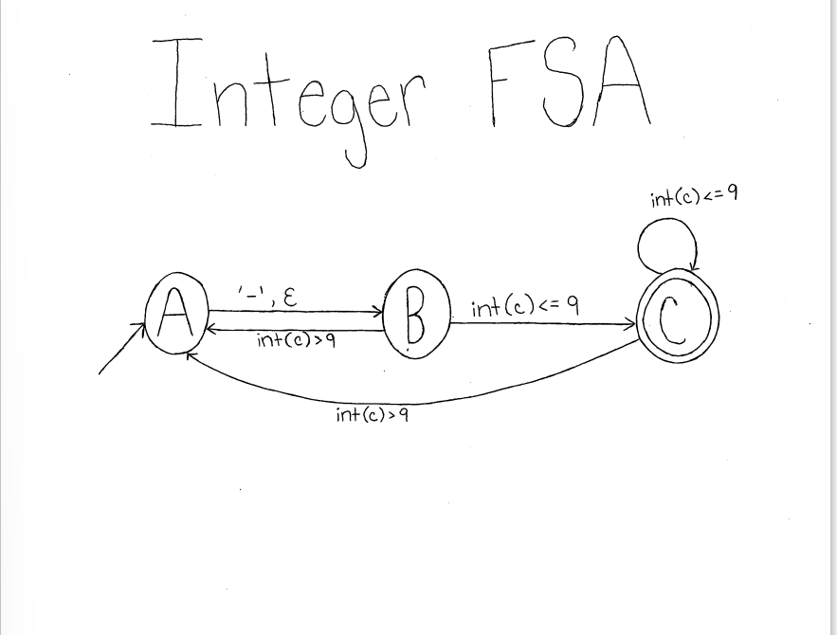

Key:

int(c): integer representation of a single character

‘-’: the negative symbol for negative numbers

Regular Expressions:

Identifier:

((a-z)+(A-Z)* | (a-z)+(A-Z)*_*)((a-z)+(A-Z)* | (a-z)+(A-Z)*_*)*

Integer:

(-|ε)(0-9)+