Force Knight Build Instructions
BoomBox Robotics LLC
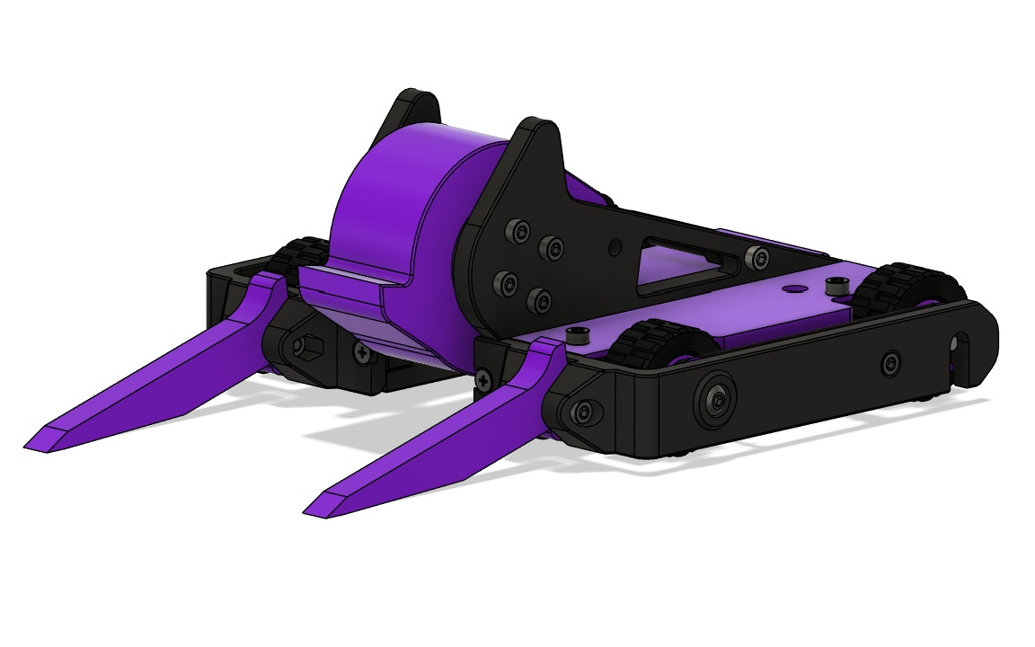

Scan for Force Knight Kit Files
Parts List
 | Qty. | Desc.
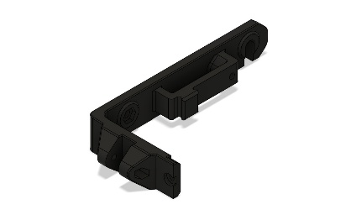 | 2 | Side Armor
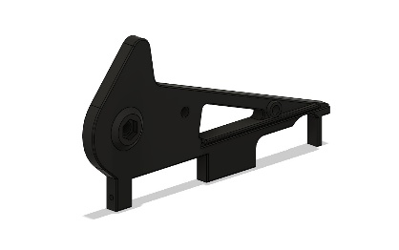 | 1 | Bearing Upright
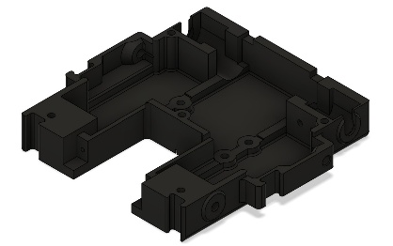 | 1 | Main Chassis
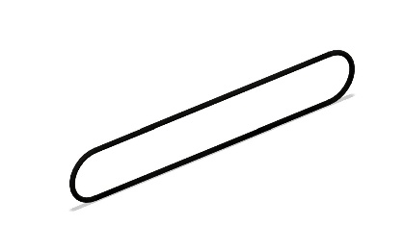 | 8 | Drive Belts
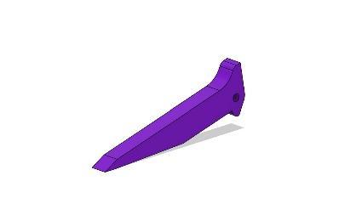 | 2 | Forks
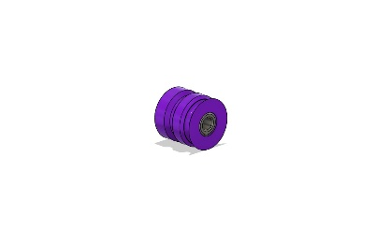 | 2 | Front Wheel Hub
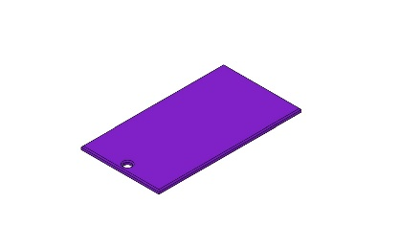 | 1 | Lid, Center
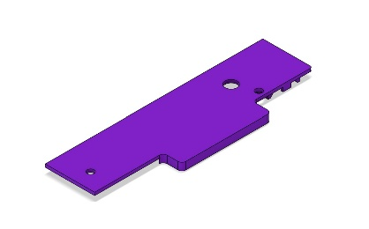 | 1 | Lid, Left
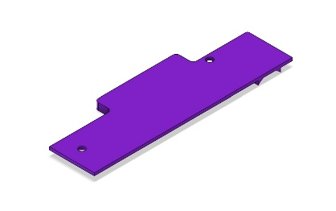 | 1 | Lid, Right
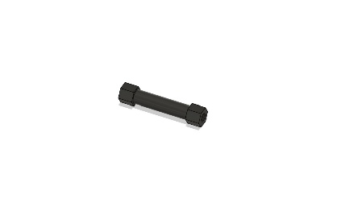 | 1 | M3 x 30mm Aluminum Standoff
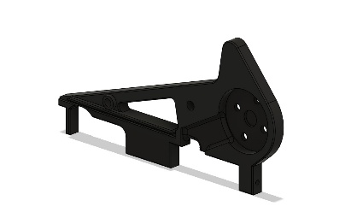 | 1 | Motor Upright
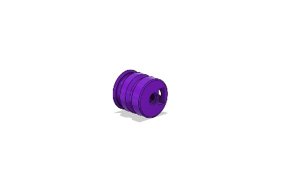 | 2 | Rear Wheel Hub
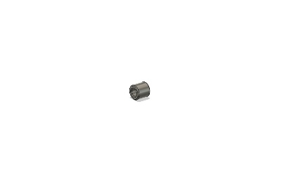 | 2 | HK0408 Roller Bearings
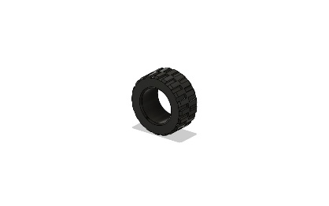 | 4 | 30 x 14 mm Lego Tires
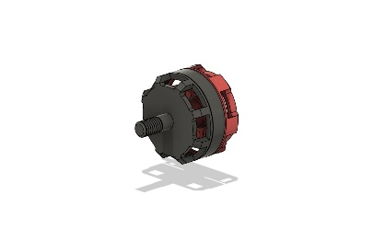 | 1 | RS2205 Brushless Motor
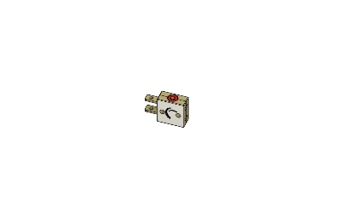 | 1 | FingerTech Mini Power Switch
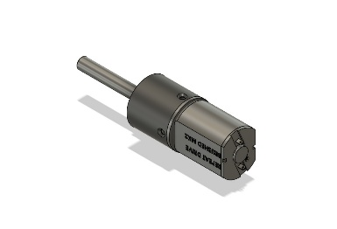 | 2 | Repeat Robotics Brushed Mk2 Drive Motors
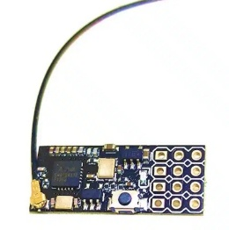 | 1 | FS2A Receiver
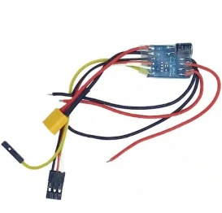 | 1 | Drive ESC
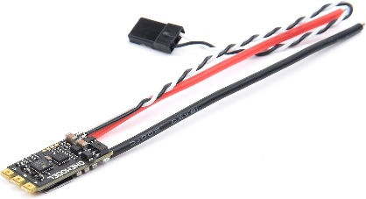 | 1 | 35a Weapon ESC
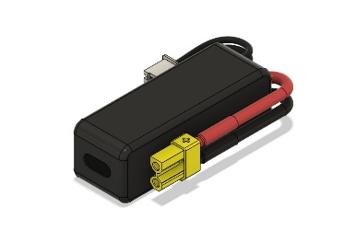 | 1 | 300mAh 3s Battery
 | 1 | FlySky FS-i6 Transmitter

Step 1. Install the (2x) M4 x 25mm Screws and (2x) M4 Hex Nuts through both sides of the Side Armor as shown in the image below. Do not tighten them all the way yet, leave about 5 turns out.
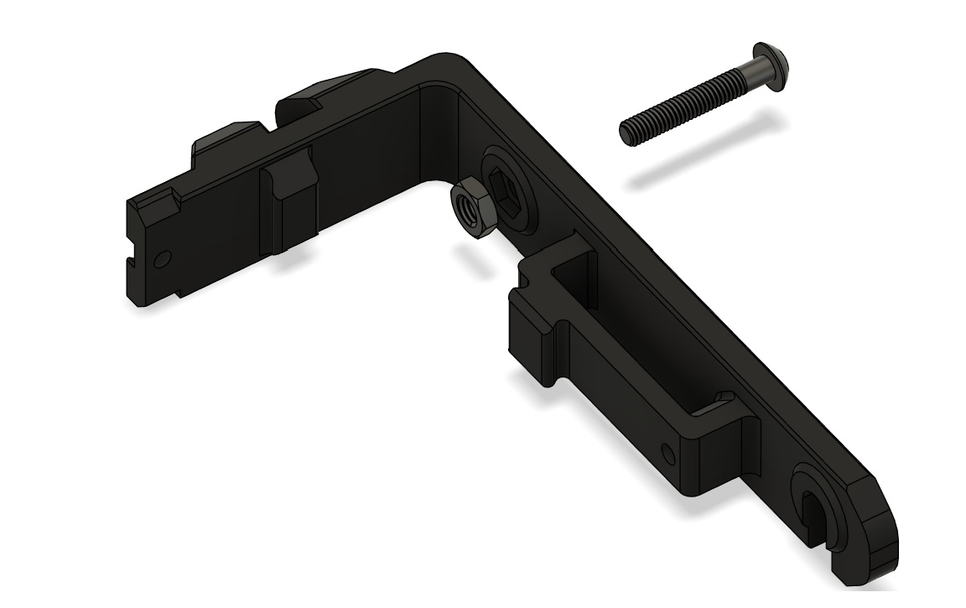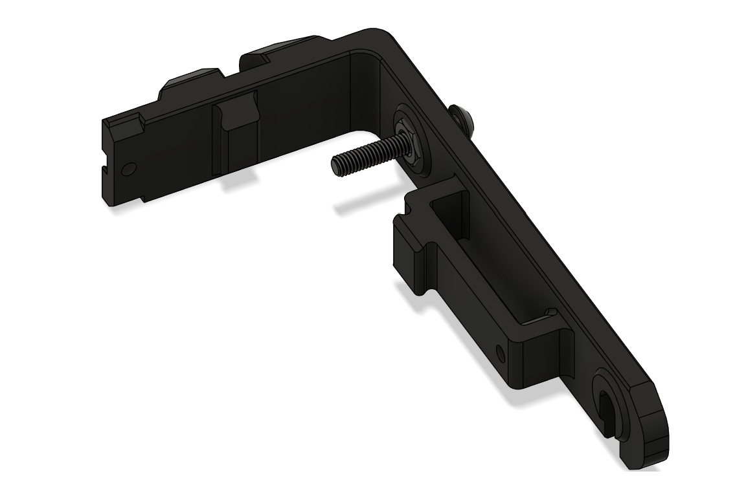

Step 2. Install the Forks onto the Side Armor pieces using the (2x) M3 x 20mm screws and M3 Hex Nuts as shown in the image below. Set these aside for now.
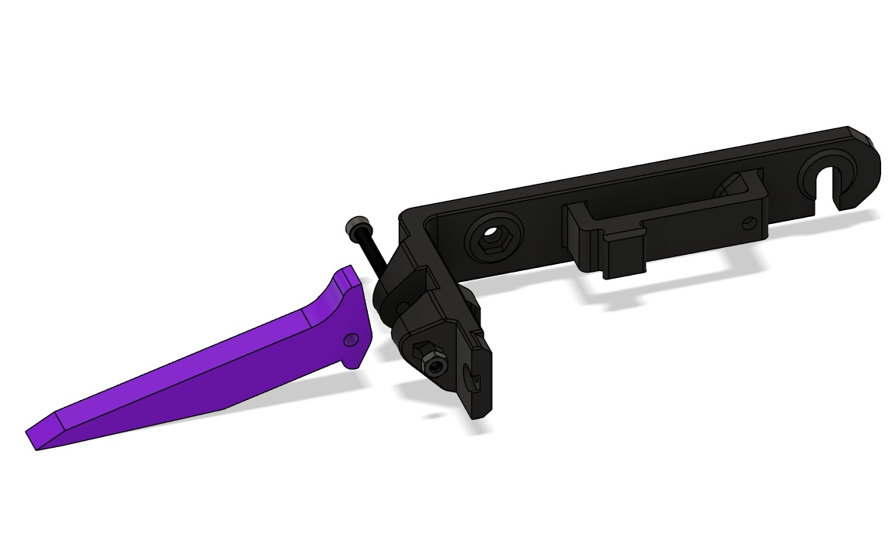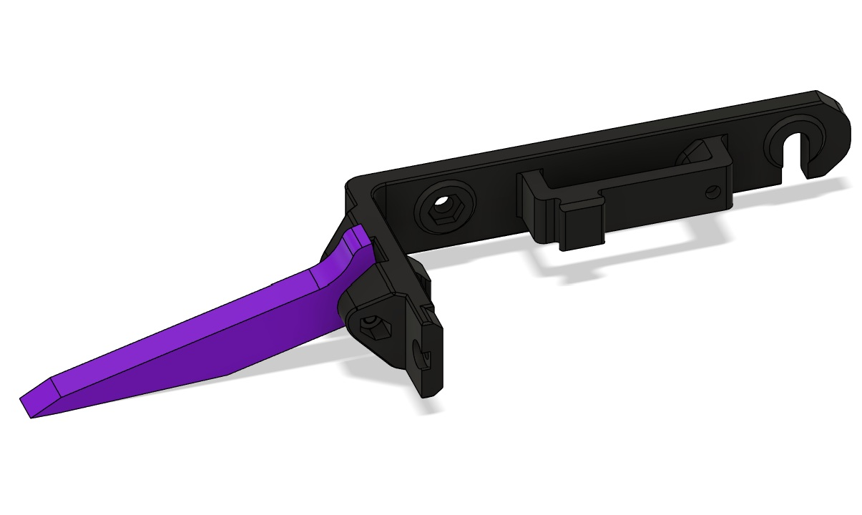

Step 3. Secure the FingerTech Mini Power Switch to the left side of the Force Knight Chassis using the (2x) M2 x 10mm Screws and (2x) M2 nuts with the nuts installed into the indents on the backside as shown below. Set this aside for now.
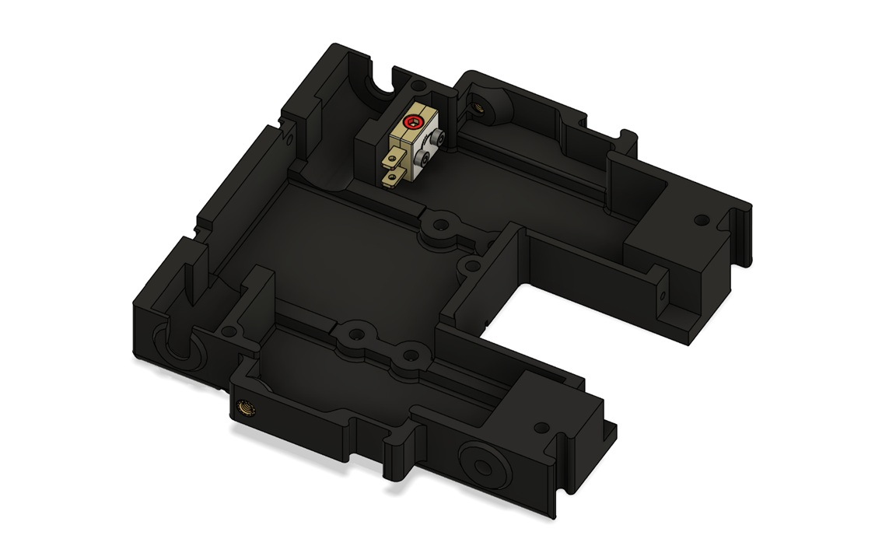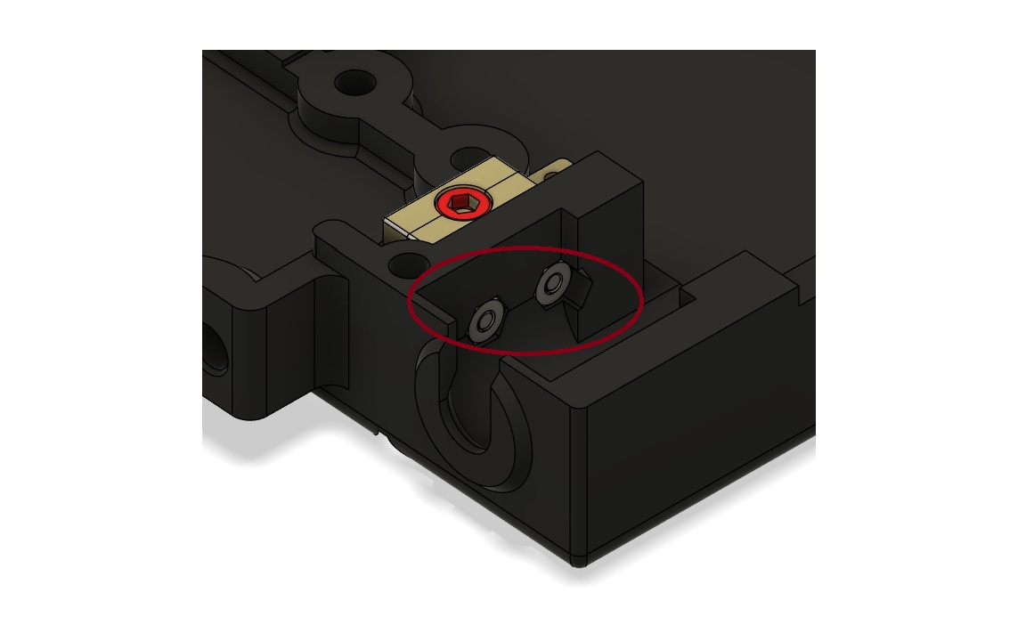
Step 4. Install the MT2206 Brushless Motor onto the Motor Upright using the (4x) M3 x 4mm Screws (Loctite is recommended before combat for these screws.). Set this aside for now.

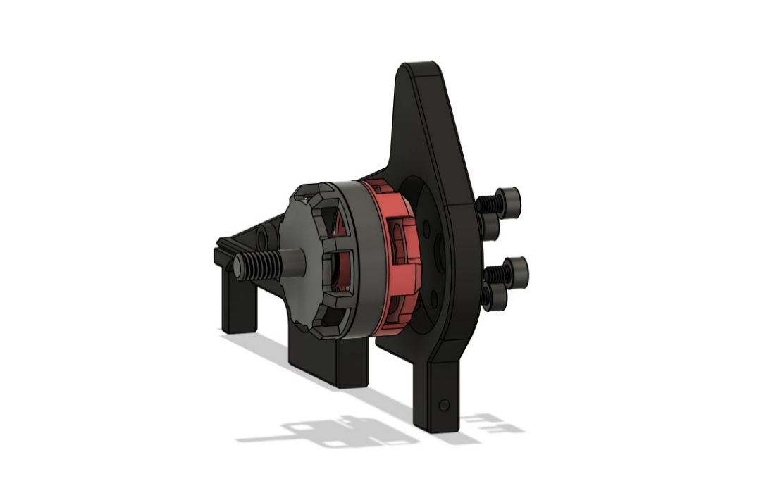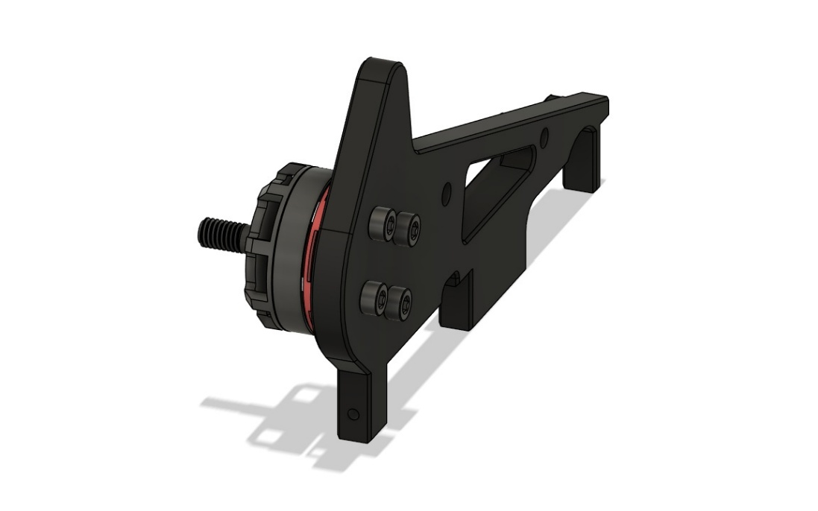

Step 5. Install the M4 x 12mm and M4 Hex Nut onto the Bearing Upright as shown in the images below. Set this aside for now.
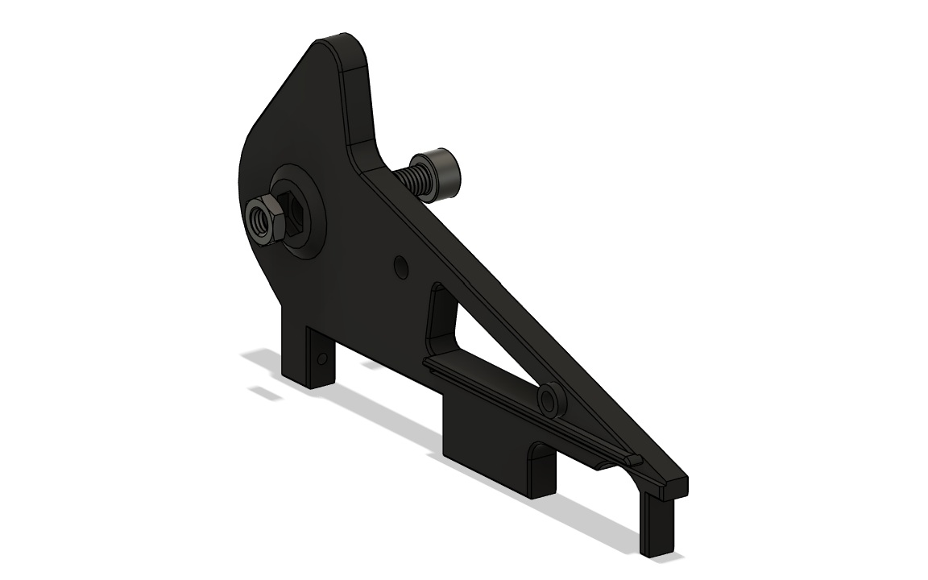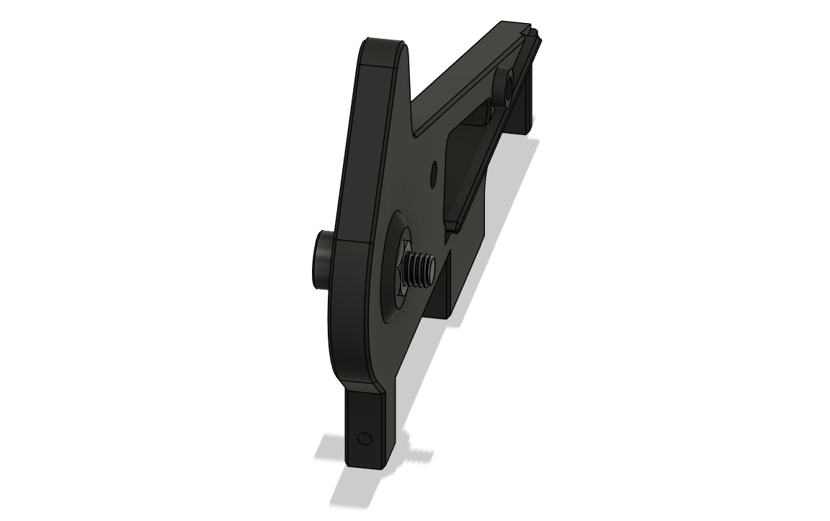

Step 6. Insert the two M4 Hex Nuts and M4 x 4mm set screws into the Rear Wheel Hubs. (Do not screw the M4 x 4mm set screw in too far, or you will not be able to fit the drive motor shaft into the Rear Wheel Hub.) Insert the Repeat Robotics Brushed Mk2 motor shaft into the Rear wheel hub, lining up the flat of the motor shaft with the set screw and securing it in place as close to the motor hub as possible without touching. Once secured, install the (2x) 30mm Lego Tires onto the Rear Wheel Hubs as shown in the images below.
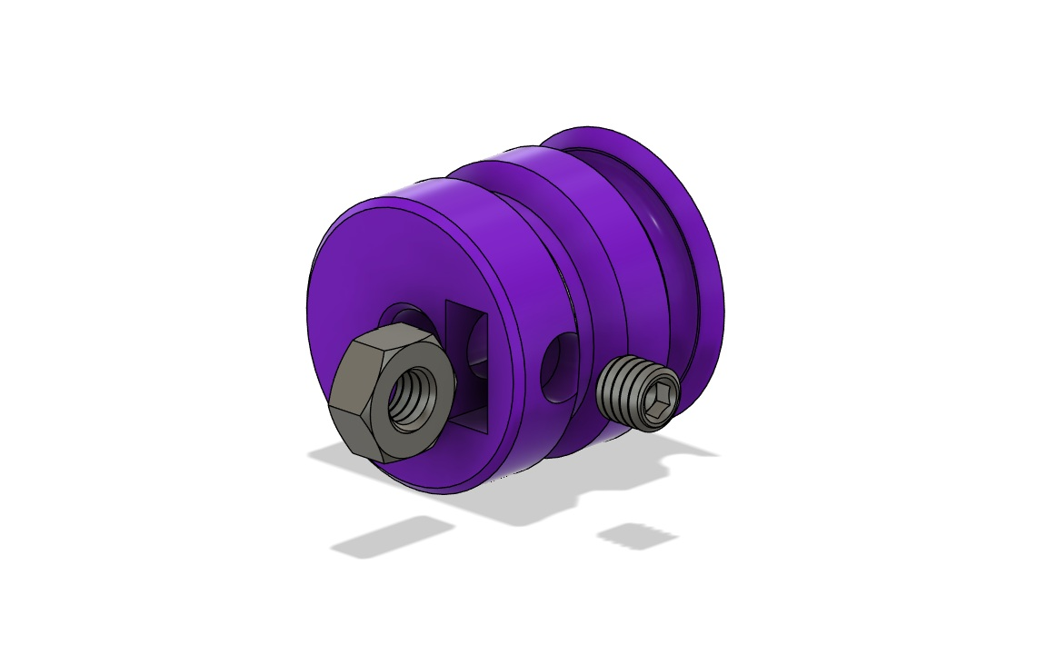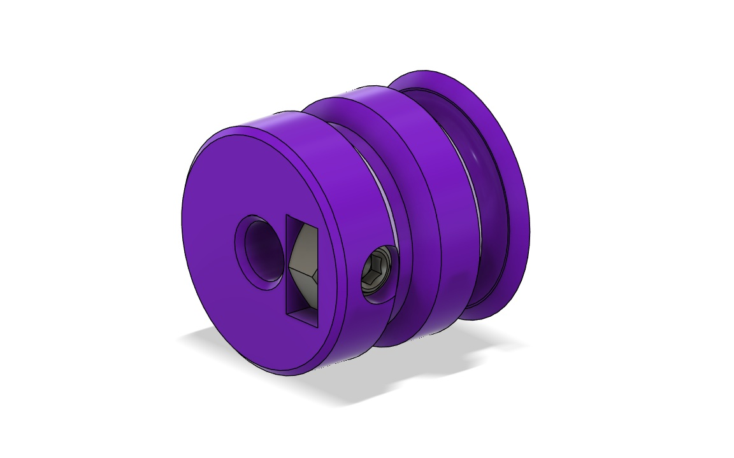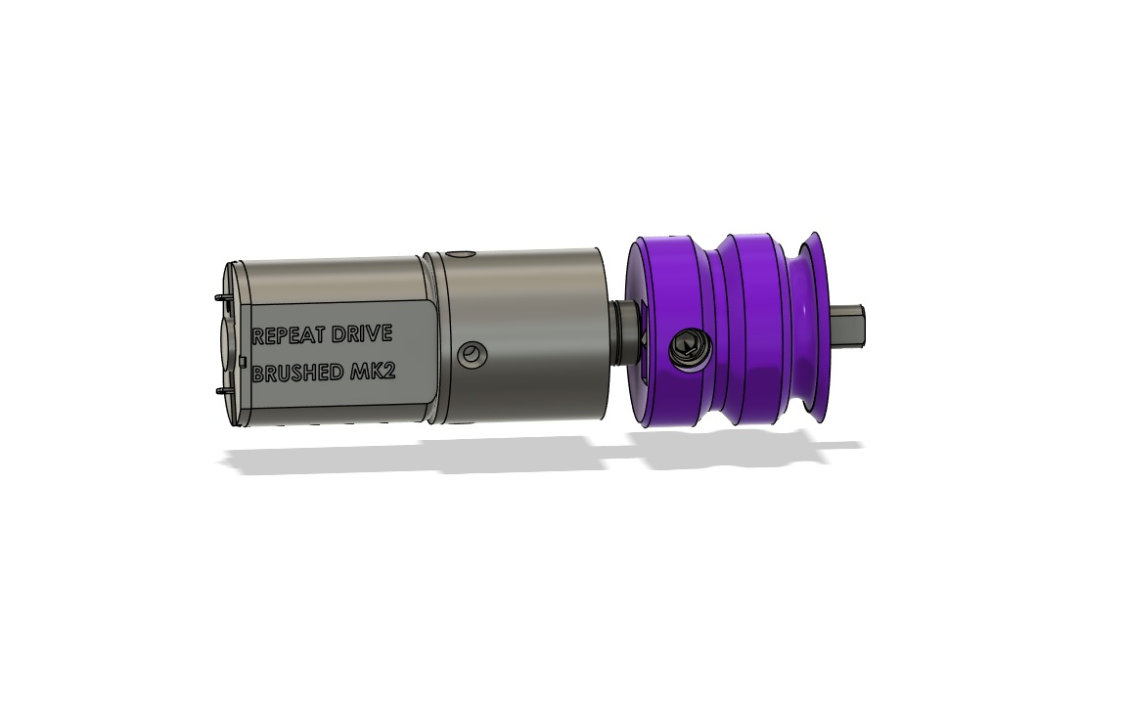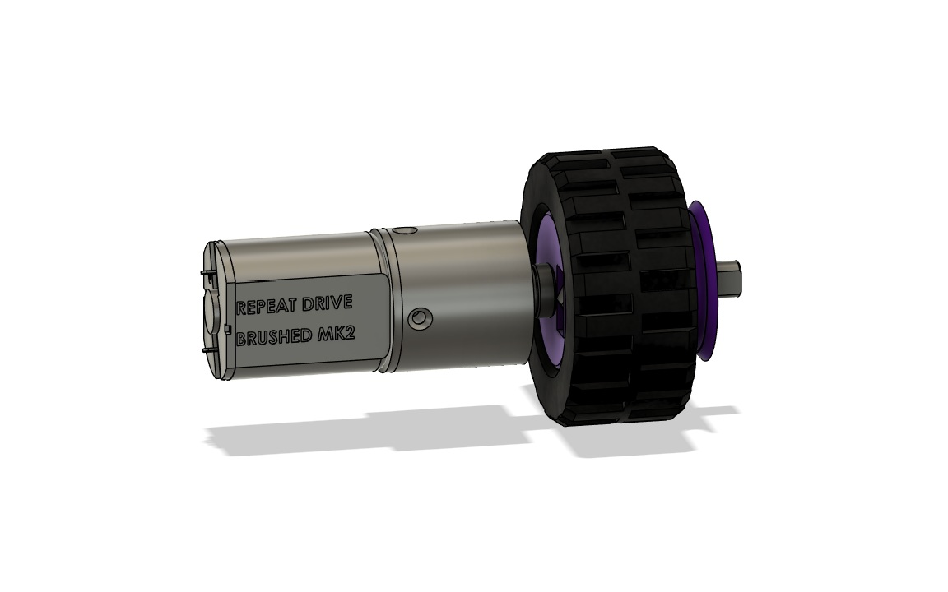

Step 7. Install the drive motor assemblies into the Force Knight Chassis with the wires facing toward the front.
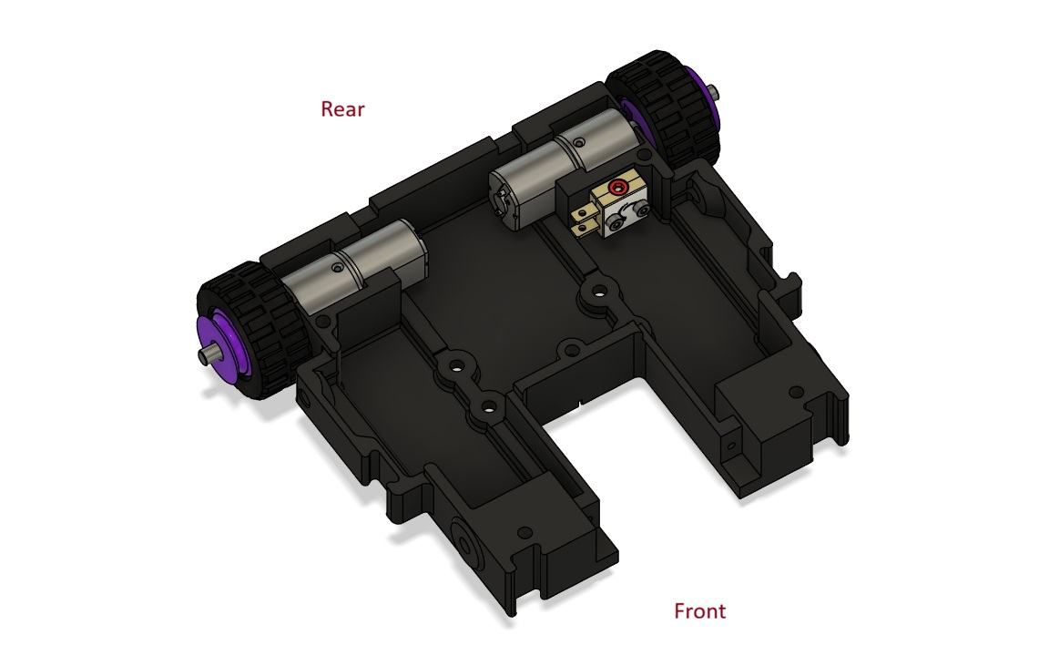

Step 8. Insert the 4x8x8 Roller Bearing into the Front Wheel Hub. (This may require quite a bit or force and a solid flat surface to press against.) Install the (2x) 30mm Lego Tires onto the Front Wheel Hubs and install them onto the M4 x 25mm screw attached to the Side Armor. Place the belts on the Side Armor by looping them around the rear of the armor, pulling them up to in front of the tire and to the side
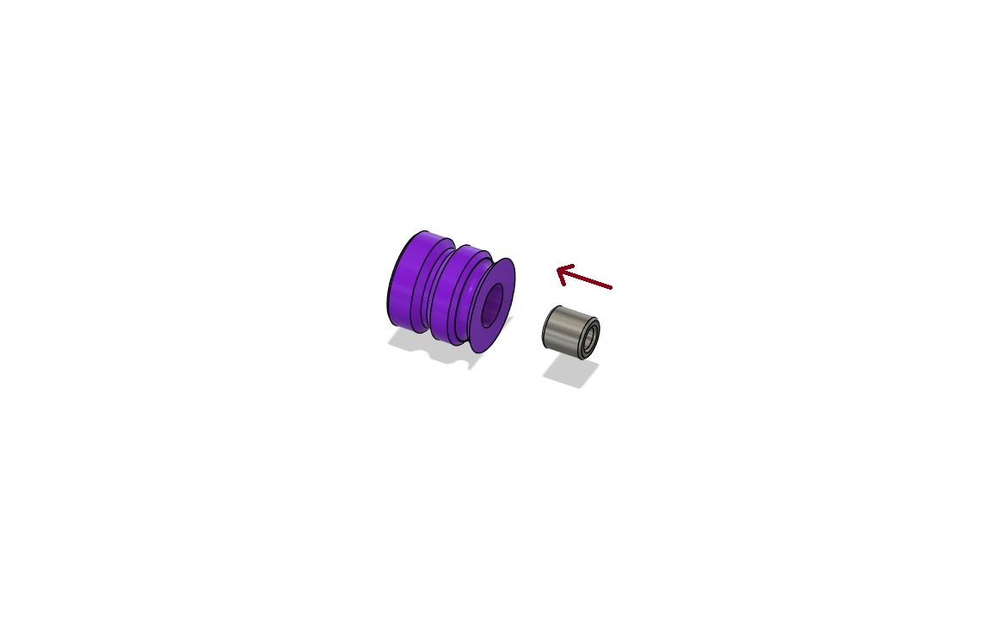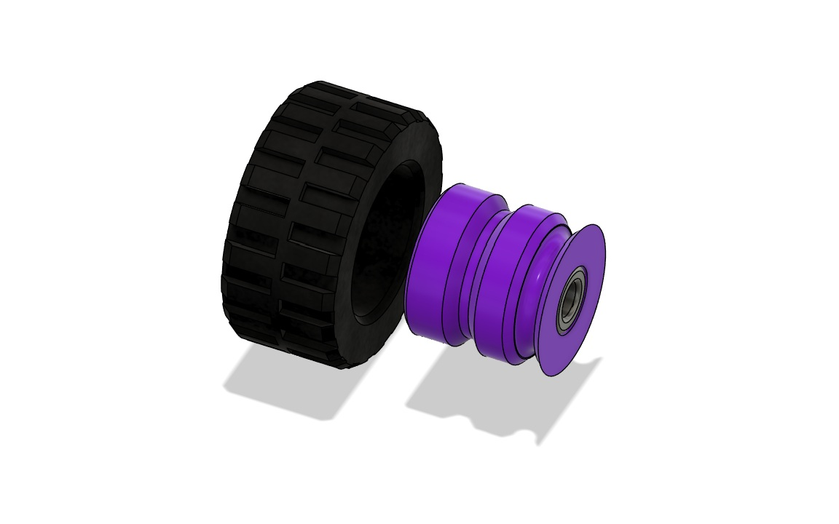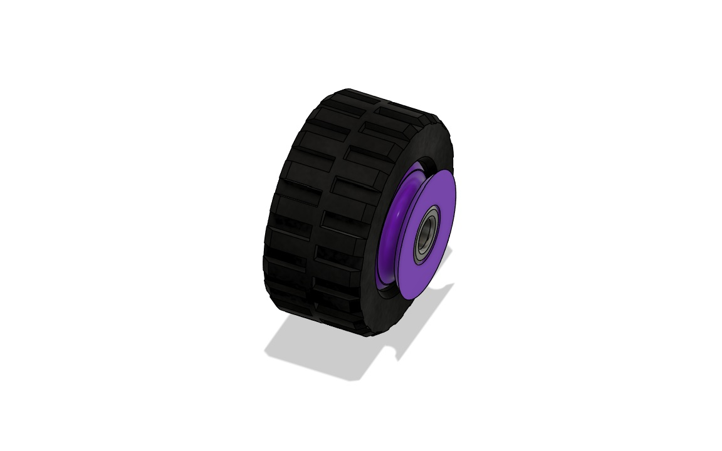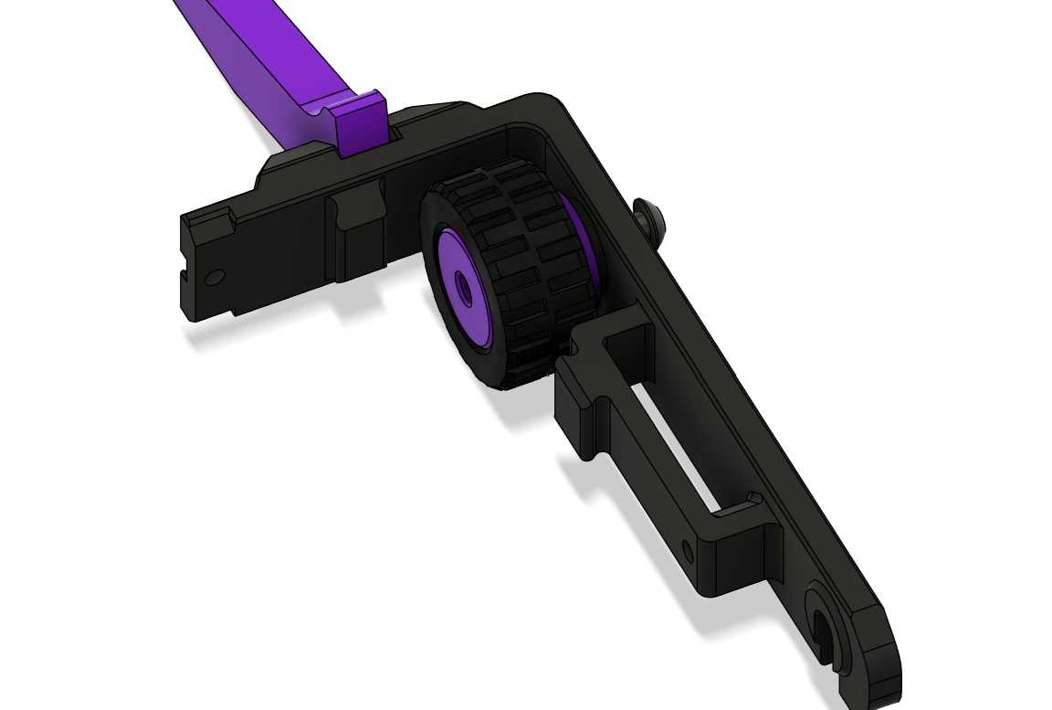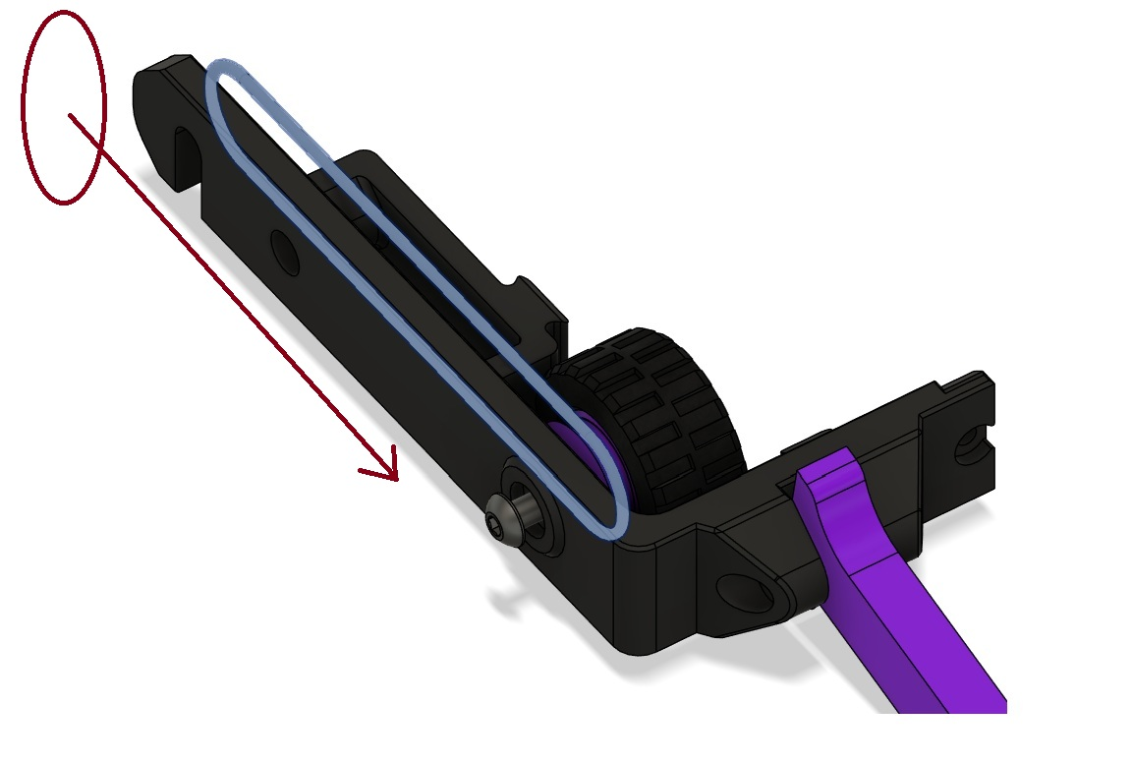

Step 9. Install the Side Armor assembly by lining up the notches with the corresponding indents in the Force Knight Chassis and sliding them together with the Side Armor assembly sliding down from the top. You may need to wiggle the parts to get them to slide past each other. Once aligned, secure the (2x) M4 x 25mm screws and install the (2x) M3 x 20mm screws into the Side Armor assemblies as shown below. Loop the drive belts around the front and rear pulleys on each wheel.
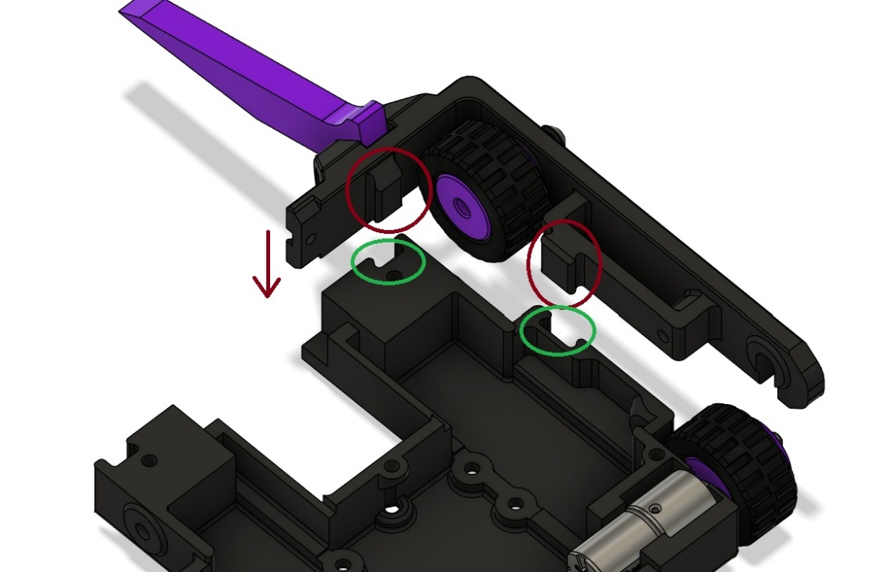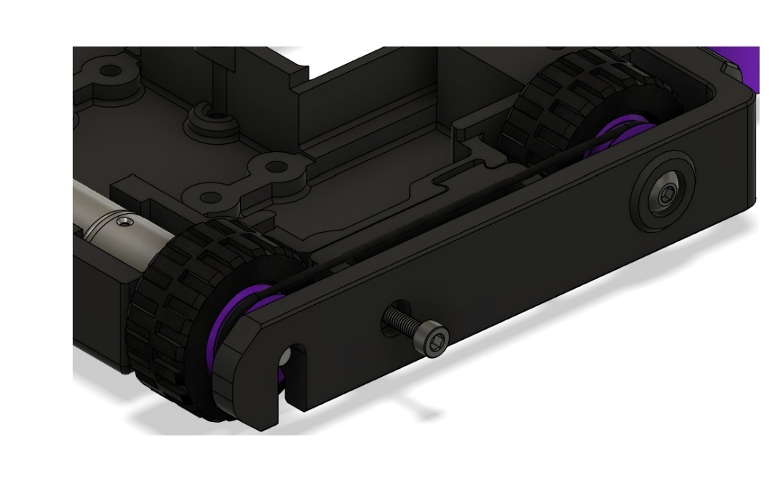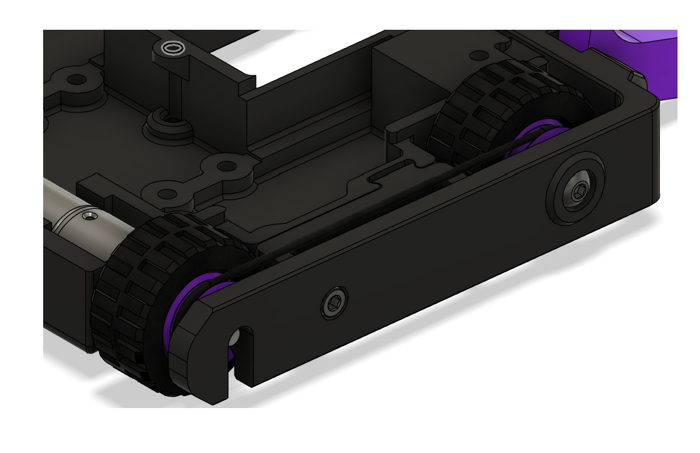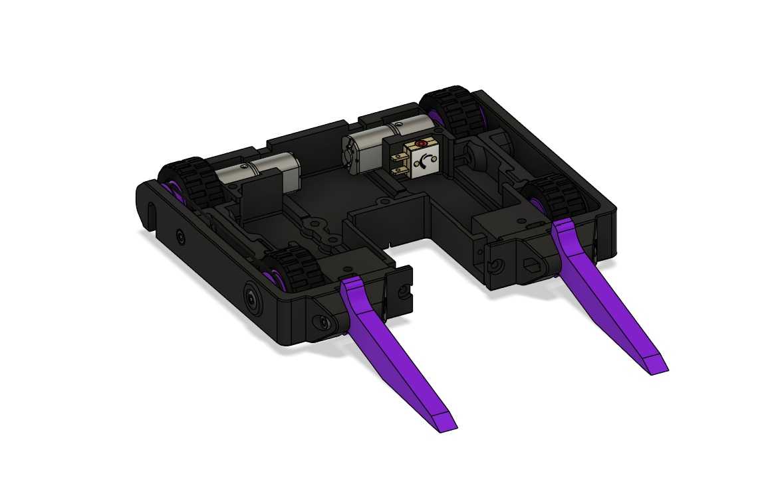

Step 10. Install the Flange Bearing into the Symmetrical Spinner. You may need to press the bearing into place using the bottom of the chassis as a wide flat surface. Install the Symmetrical Spinner onto the RS2205 Brushless motor by lining up the notches inside the spinner with the indents on the motor housing. Once pressed in place, install the M3 x 30mm aluminum standoff into the rear of the Motor Upright using the M3 x 12mm screw. Join the Bearing Upright and Motor Uprights using the other M3 x 12mm screw into the M3 x 30mm aluminum standoff.
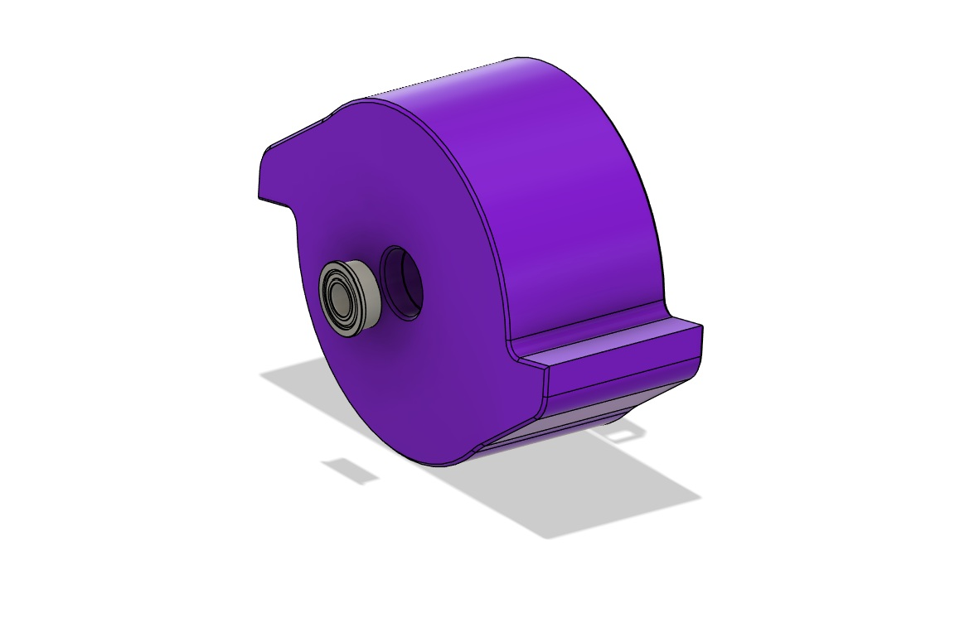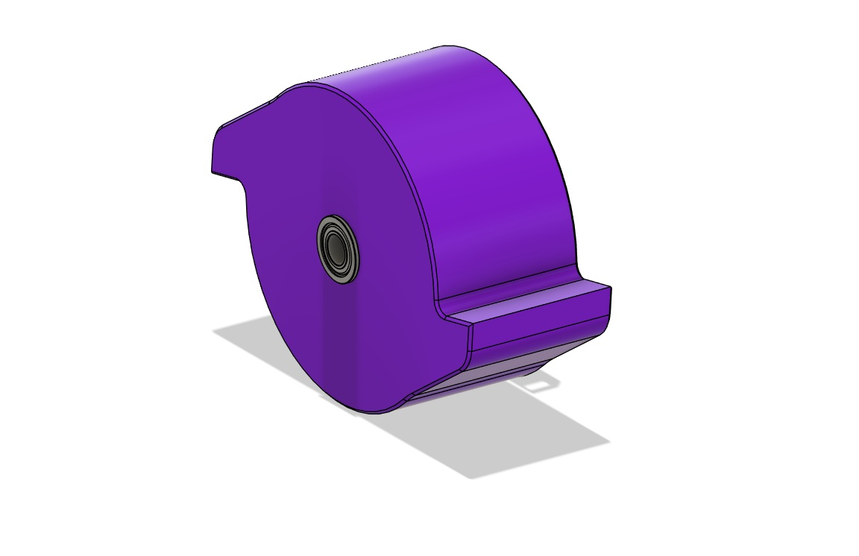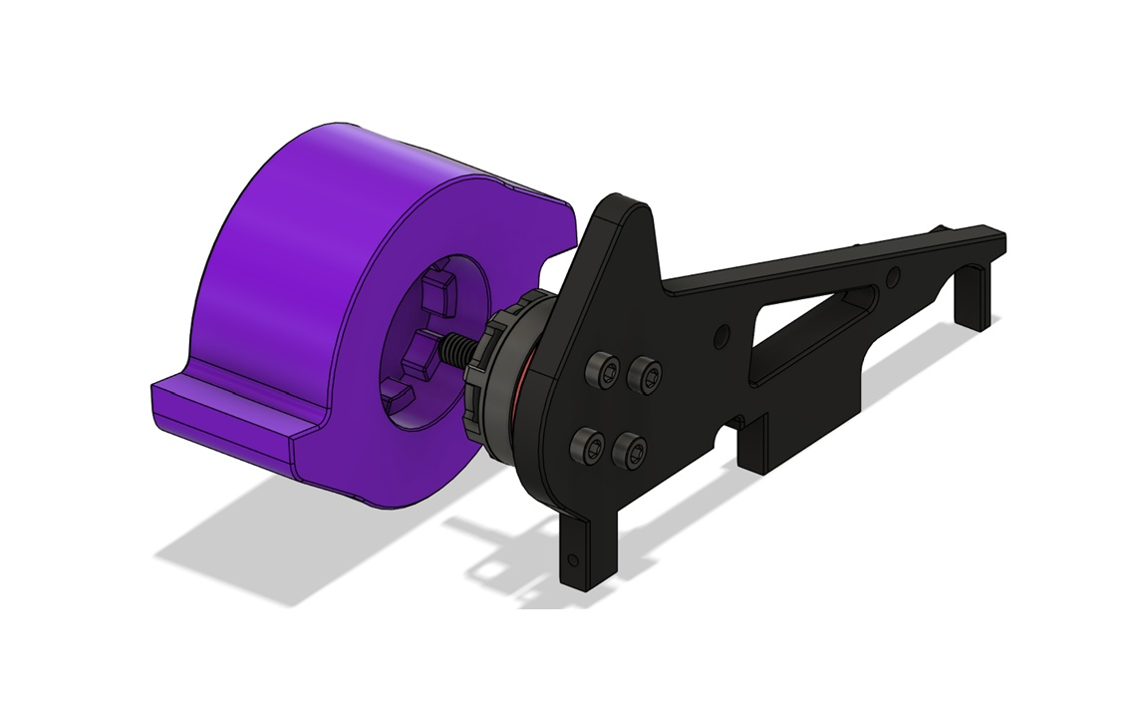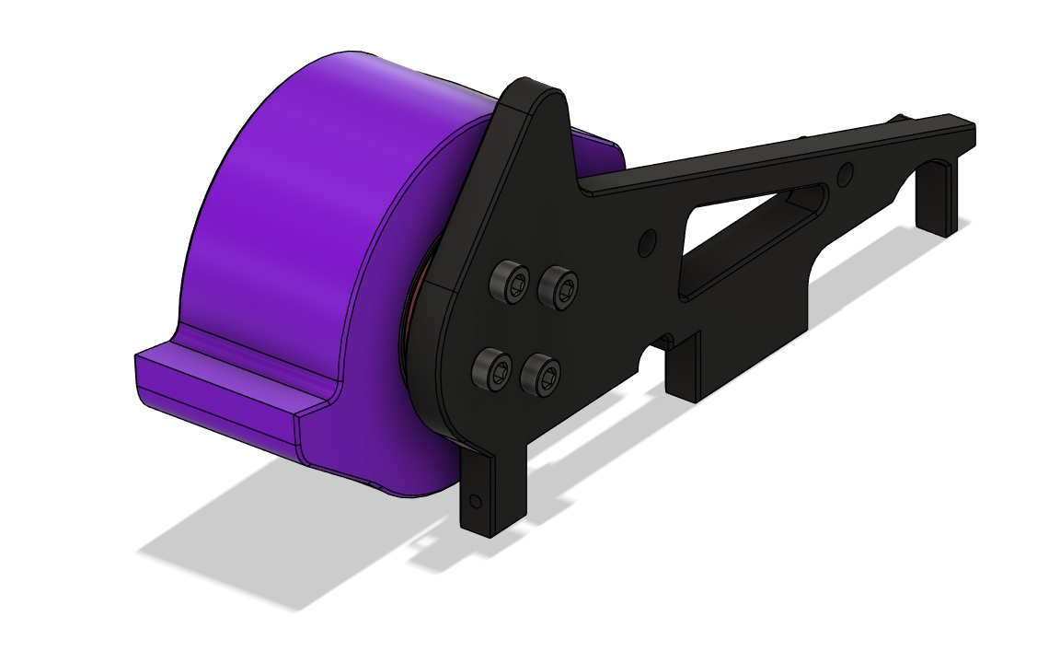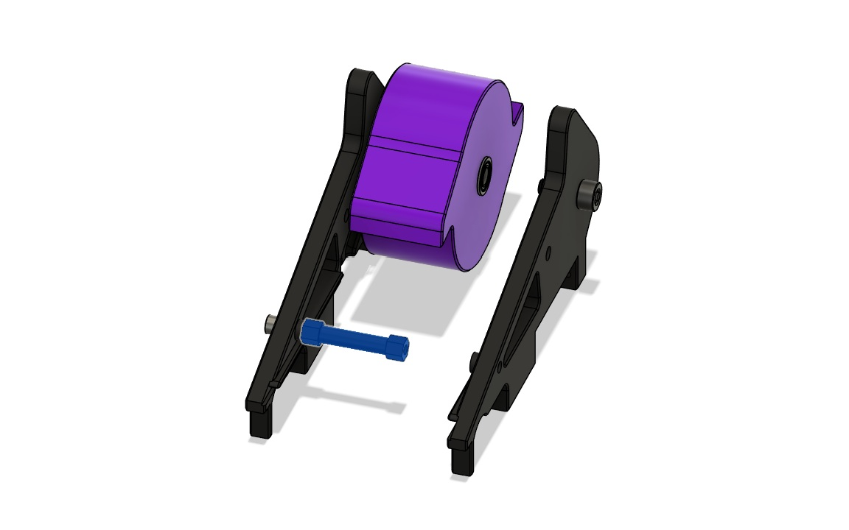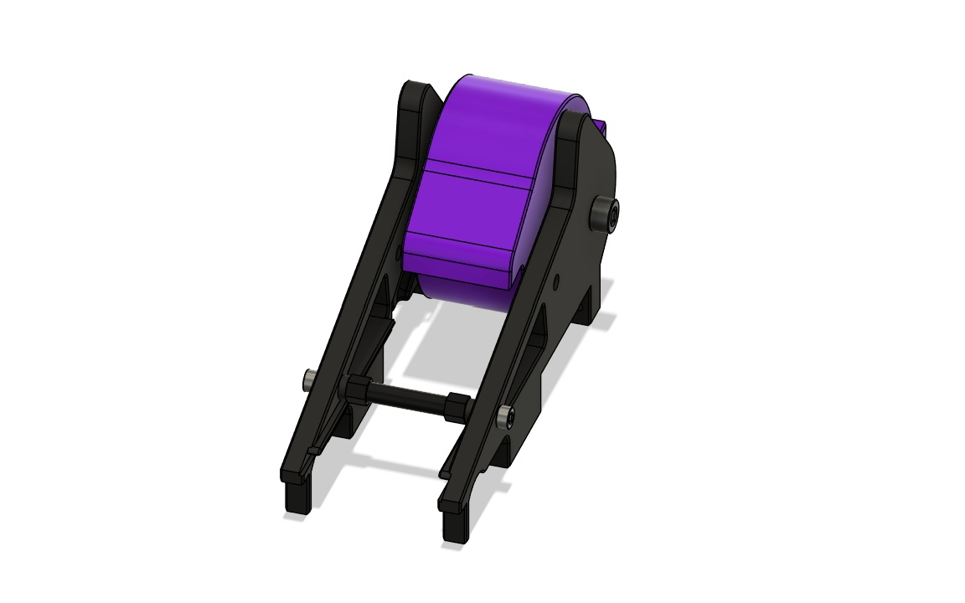

Step 11. Run the wires of the RS2205 under the Motor Upright and bend at the gap for the wires to pass through. !!IMPORTANT!! Before you install the weapon assembly, be sure that the wires running between sections (Left, Center, Right) will not be pinched by the uprights and adjust them if needed.
Lower the weapon assembly into the Force Knight Chassis assembly. Secure in place with the (4x) #5 x ½” wood screws from the bottom of the chassis. Secure the front of the Side Armor and weapon assembly with the (2x) #5 x ½” wood screws.
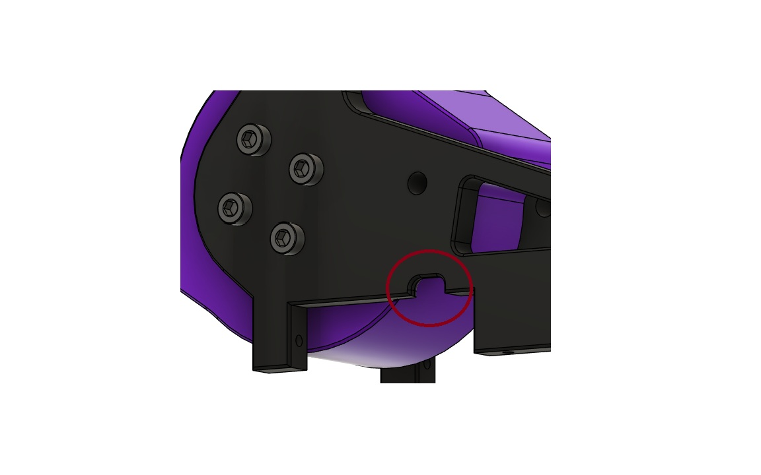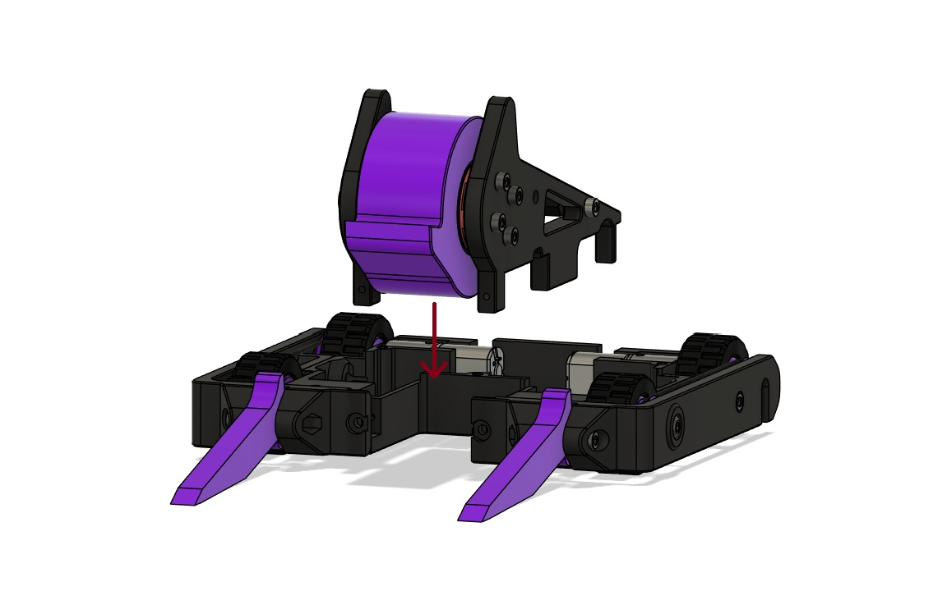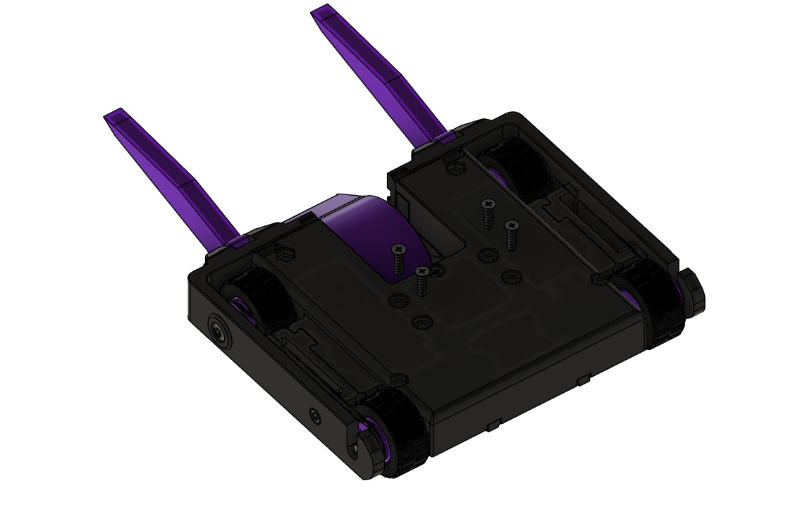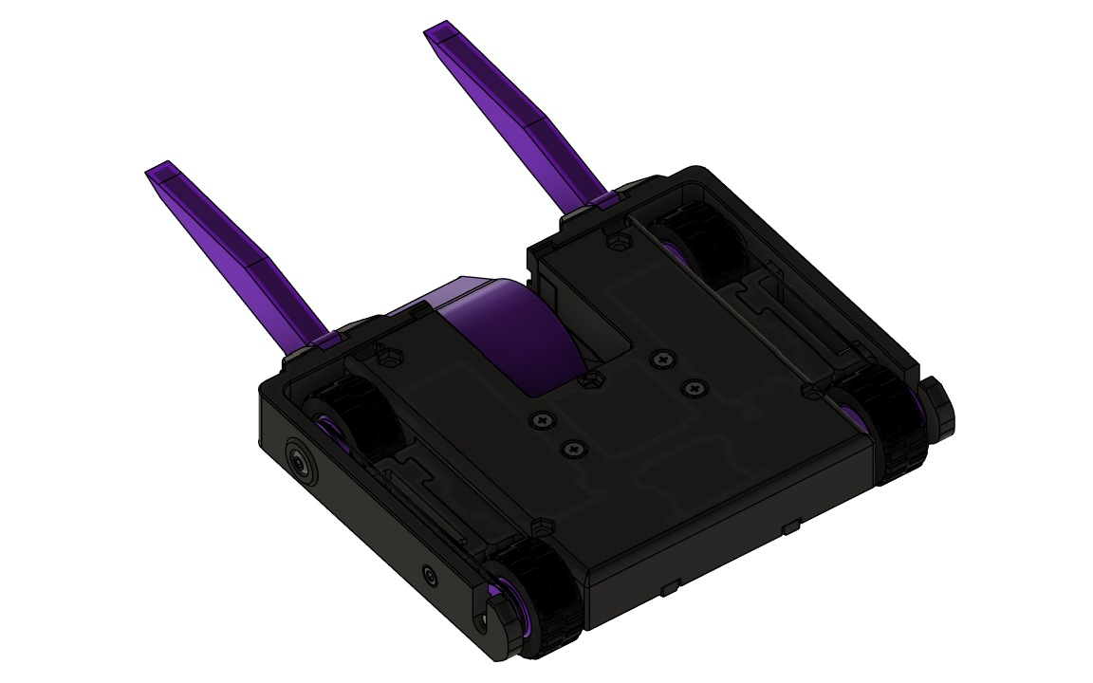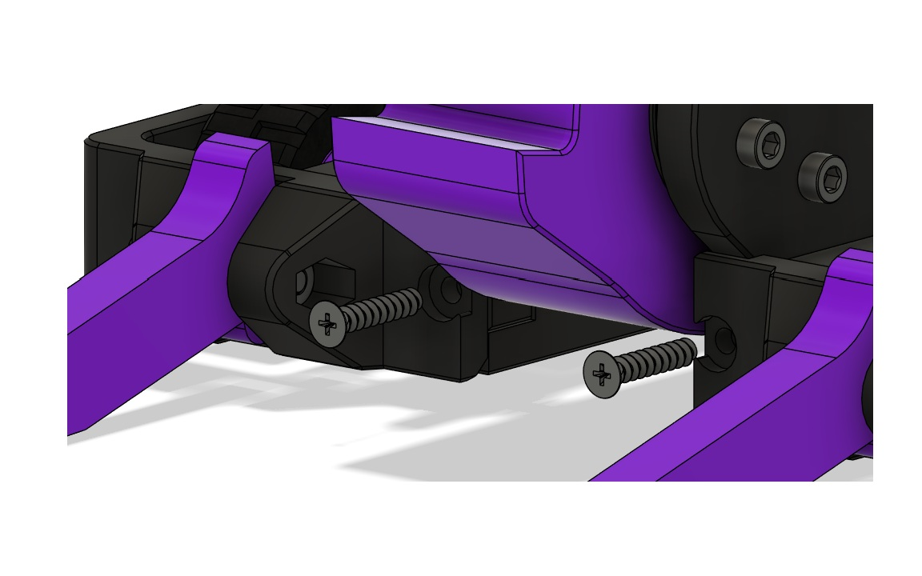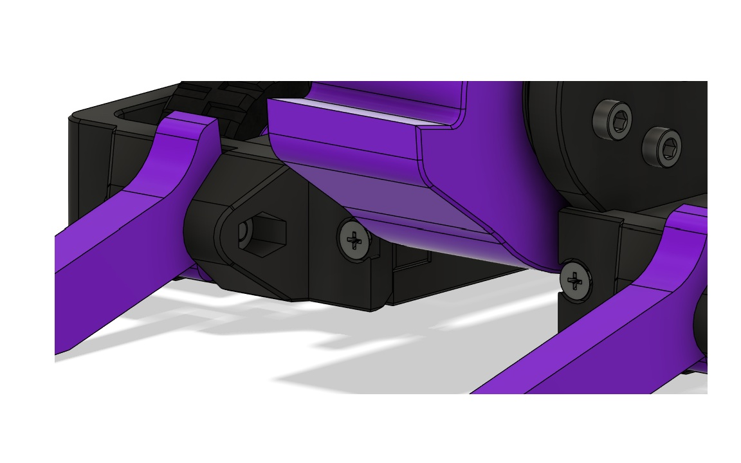

Step 12. The wiring of the Force Knight Kit is fairly intuitive, but the diagrams below shows where each component should plug in.
- The Main Wire Harness should stretch across all three compartments with the switch in the far-left compartment, the two red plugs in the center compartment, and the yellow battery plug in the far-right compartment.
- The Drive ESC should be housed in the Center compartment underneath the Main Wire Harness with the power and data wires toward the weapon blade and the motor wires towards the motors.
- The Weapon ESC should be housed in the Left compartment with the wires facing the weapon and wrapping around the ESC and in front of the power switch and plugging into the Main Wire Harness in the Center compartment. Wrap the motor wires in a circle and plug the leads into the yellow MT30 connector.
- The Receiver can be housed wherever you find room. The Center compartment is generally the place that will have the most room available, but you can sometimes fit it in the Left compartment as well.
- The battery will be held in the Right compartment as shown in the image below.
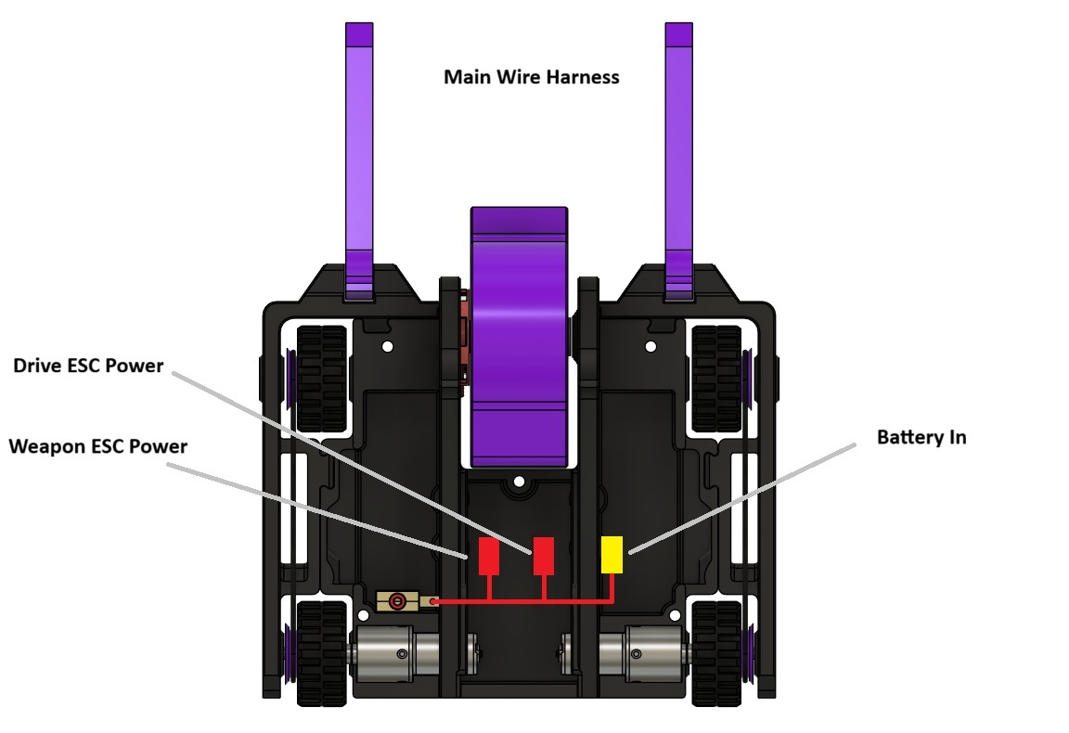
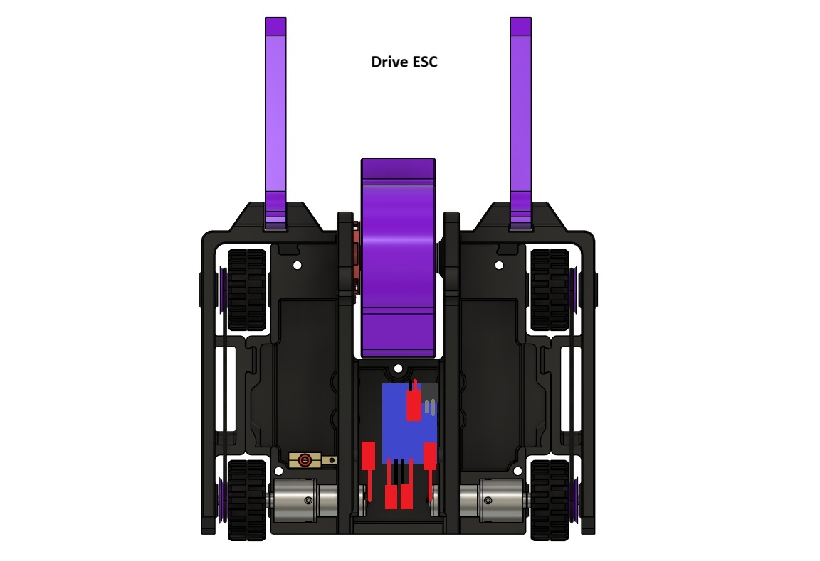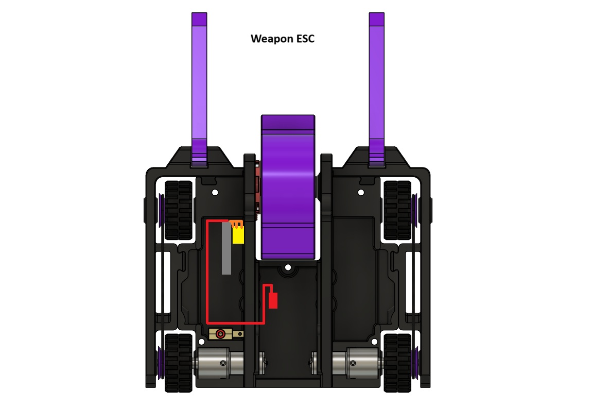
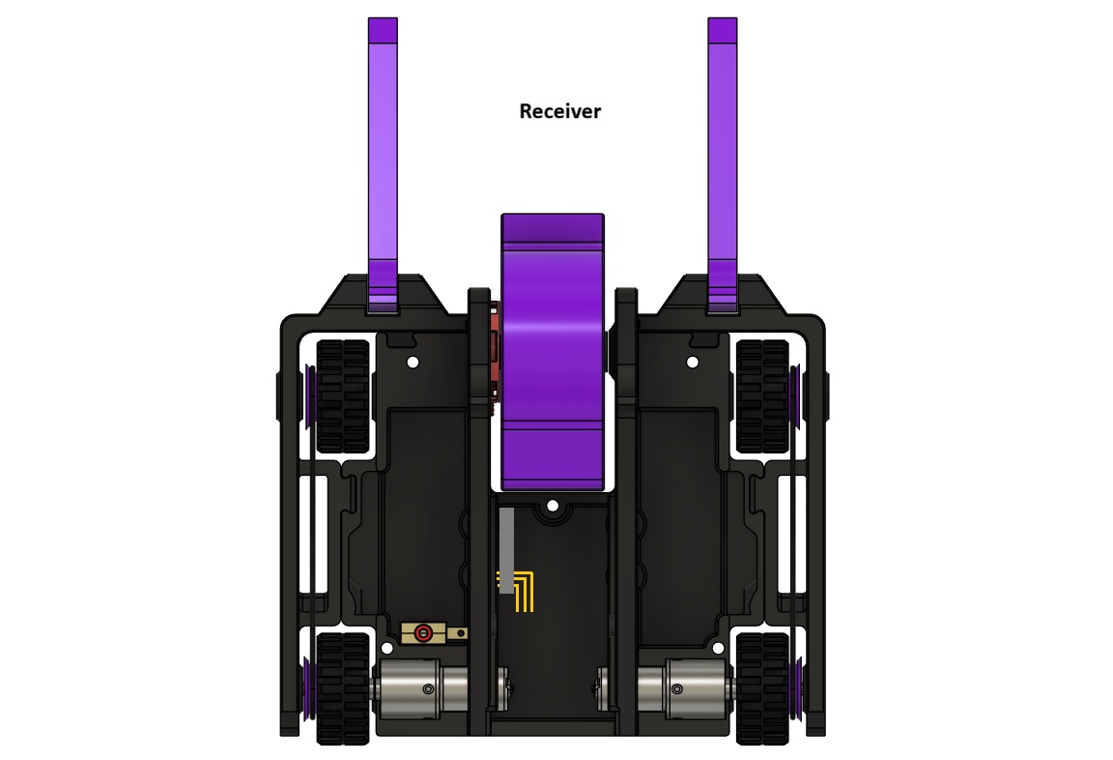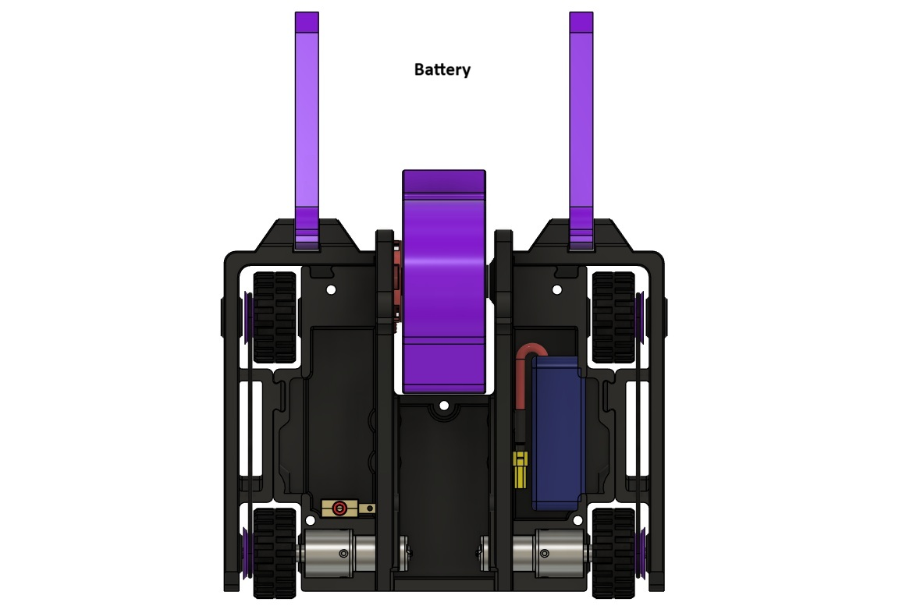
Step 13. Install the Center, Left, and Right Lids and secure them in place with the (5x) M3 x 20mm screws and (5x) M3 hex nuts fit into the indents on the bottom of the chassis.
