9Volt Build Instructions
BoomBox Robotics LLC
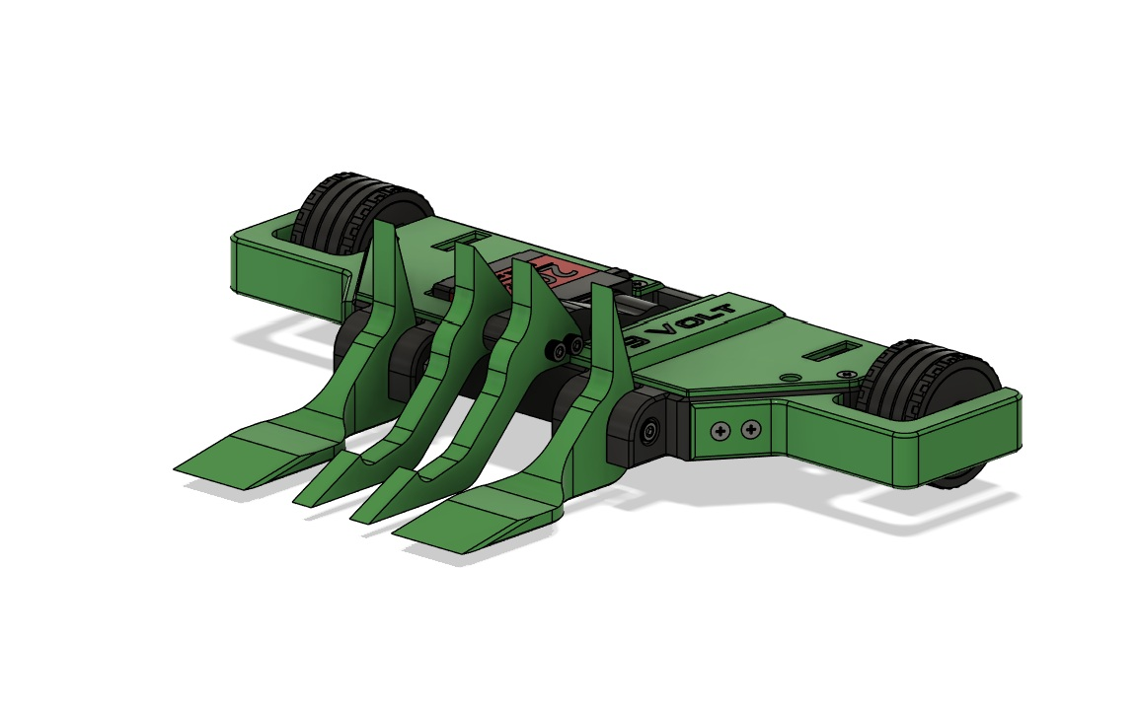

Scan for 9Volt Files

Parts List:
 | Qty. | Description
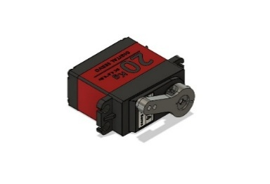 | 1 | 20kg Servo
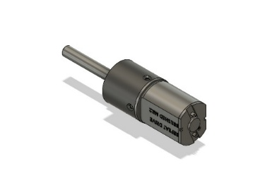 | 2 | Repeat Robotics Mk2 Brushed Drive Motors
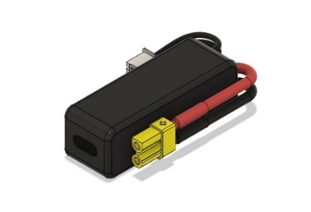 | 1 | 300mAh 3S LiPo Battery
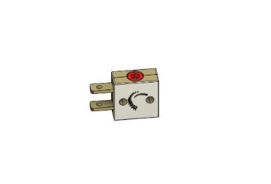 | 1 | FingerTech Mini Power Switch
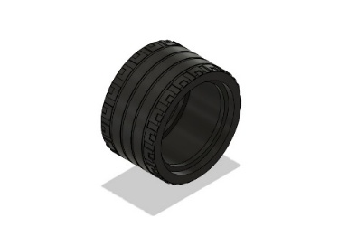 | 2 | 37mm Lego Tire
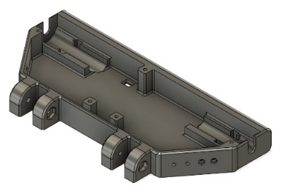 | 1 | 9Volt Chassis
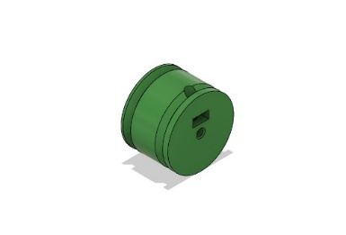 | 2 | Wheel Hub
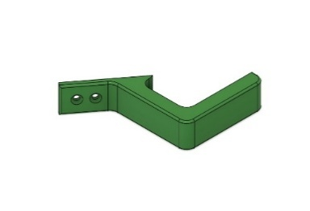 | 2 | Wheel Guard
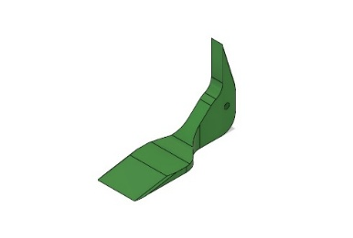 | 2 | Static Fork
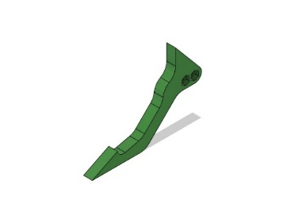 | 2 | Lifter Fork
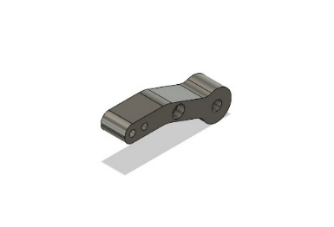 | 1 | Lifter Arm
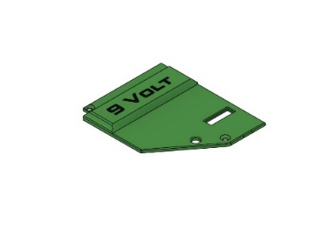 | 1 | Battery Lid
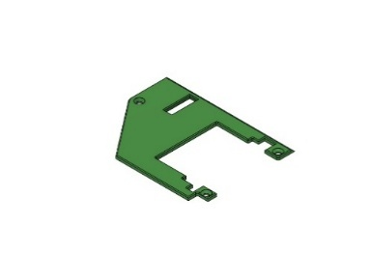 | 1 | Aux Lid
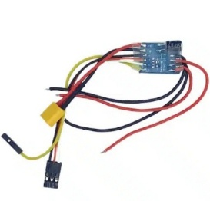 | 1 | Repeat Robotics Budget Dual ESC
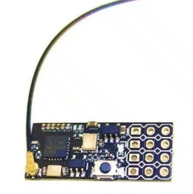 | 1 | FS2A 4ch Receiver
 | 1 | FS-i6 Transmitter

Step 1. Secure the FingerTech Mini Power Switch to the left side of the 9Volt Chassis using the two M2 x 10mm Screws and two M2 nuts with the head of the screws on the outside of the chassis as shown below.

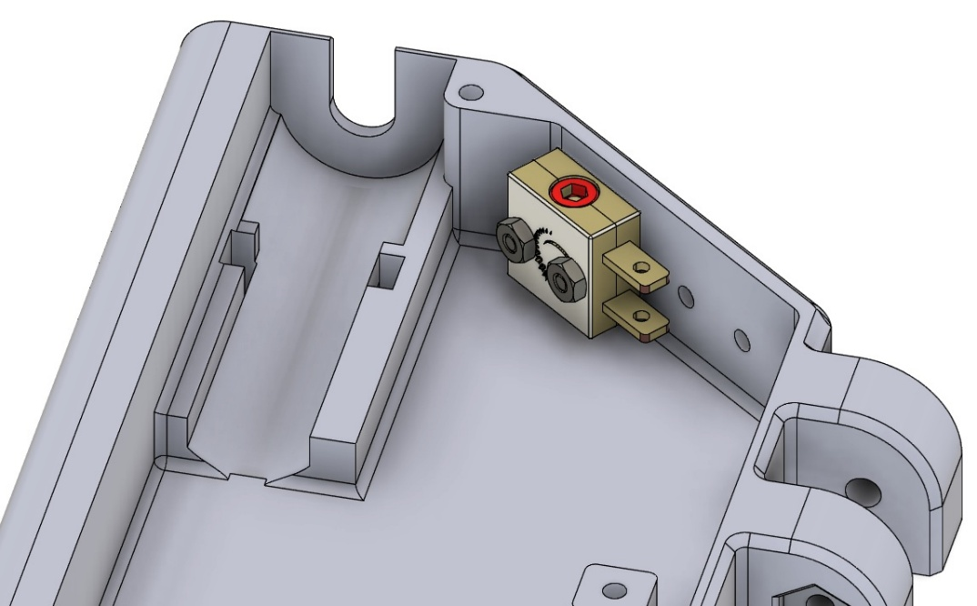
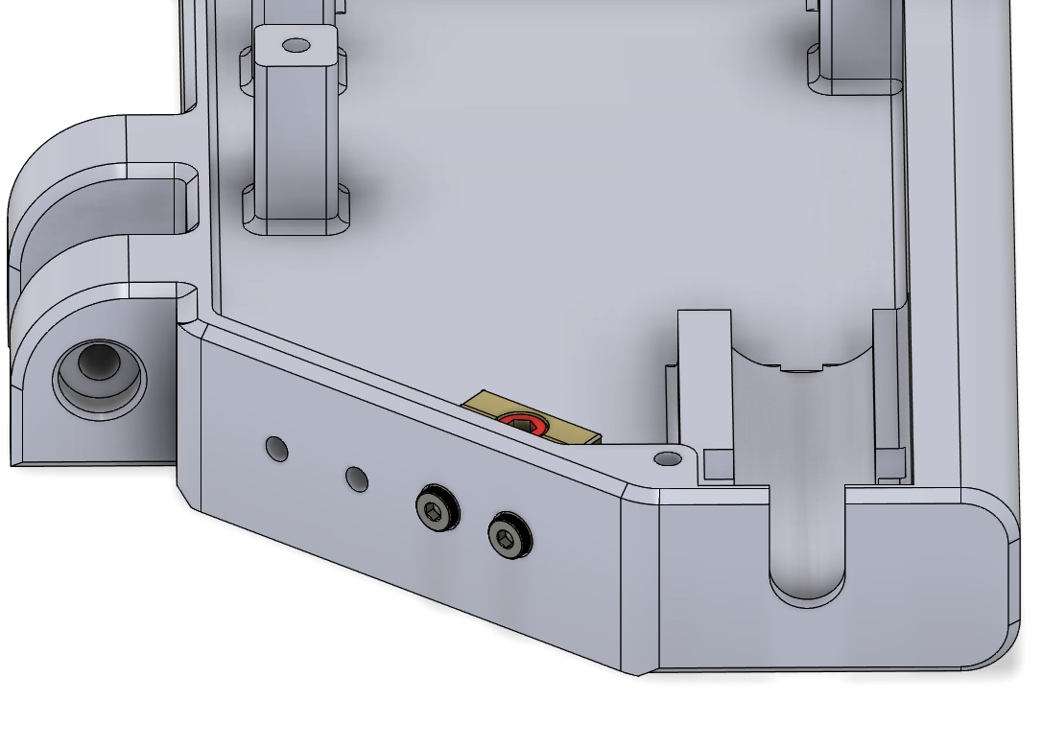

Step 2. Place the two M3 Lock Nuts into the recesses of one of the Lifter Forks, assemble the Lifter Assembly by sandwiching the Lifter Arm between the two Lifter Forks. Insert the M3 x 30mm screws through Lifter Fork and Lifter Arm and into the lock nuts imbedded in the other Lifter Fork as shown below.
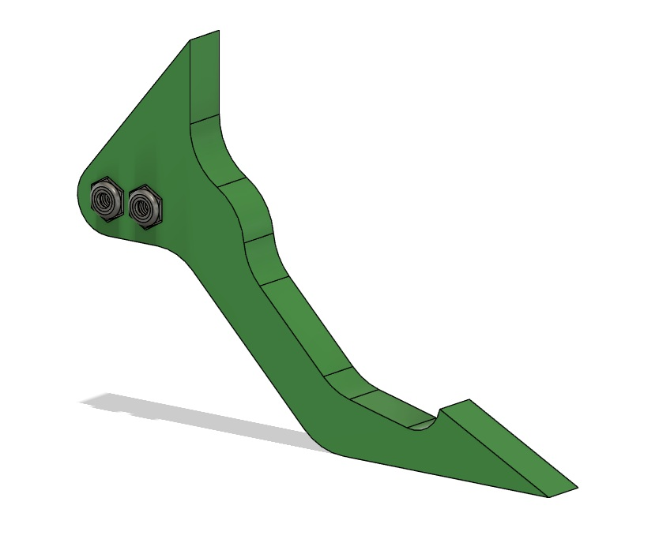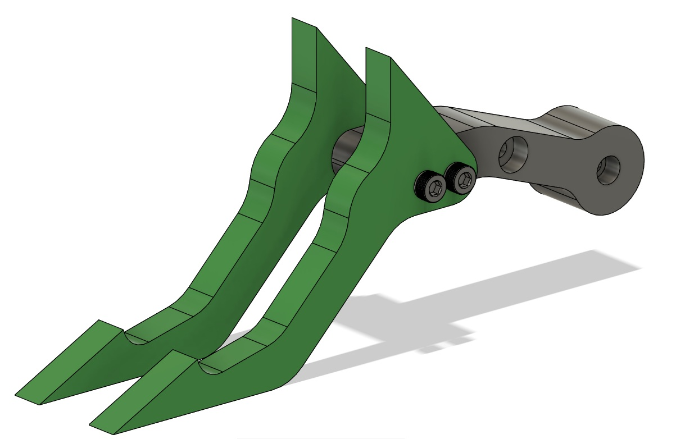

Step 3. Attach the 20kg Servo to the Lifter Arm Assembly using the M3 x 10mm screws as shown below.

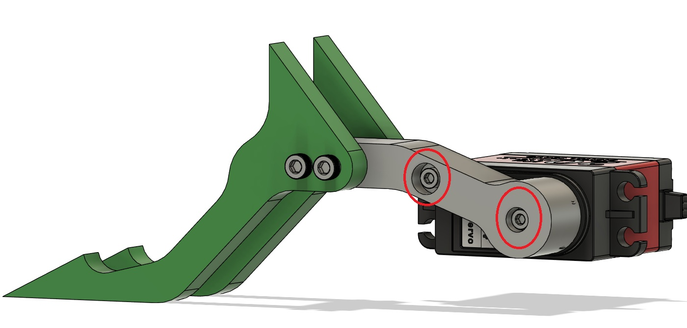

Step 4. Place the 20kg Servo and Lifter Arm Assembly into the 9Volt Chassis as shown below. Secure the servo in place with the provided zip tie(s) going through the chassis and around the servo body. Run the Servo wire across the bottom of the servo and flat between the chassis and the support pillars, underneath the Lifter arm and into the battery compartment area.
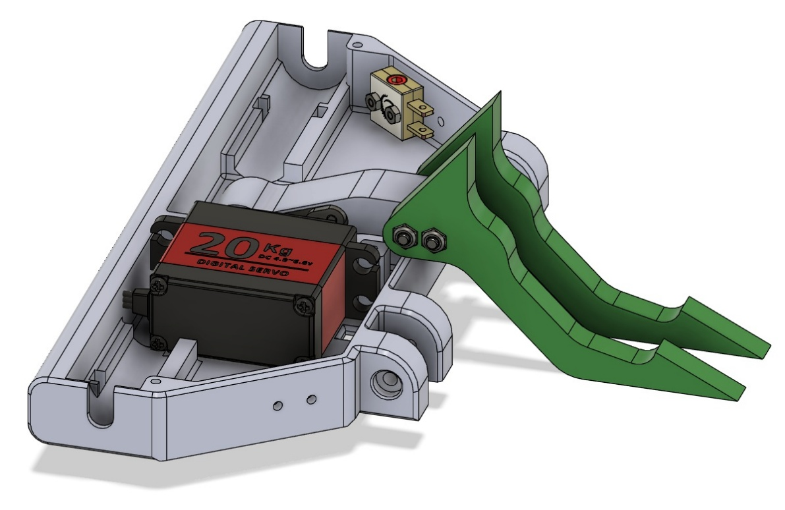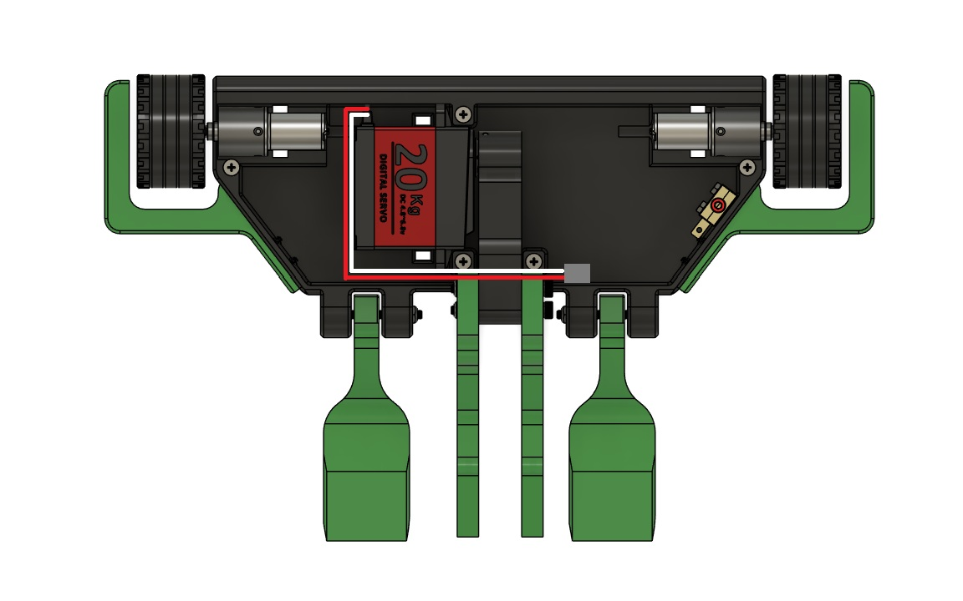

Step 5. Insert the two M3 Locknuts into the 9Volt Chassis as shown below, insert the M3 x 30mm screws through the chassis, Static Forks, and into the M3 locknuts, attaching the Static Forks to the 9Volt Chassis. The forks should move freely to their endpoints without binding.

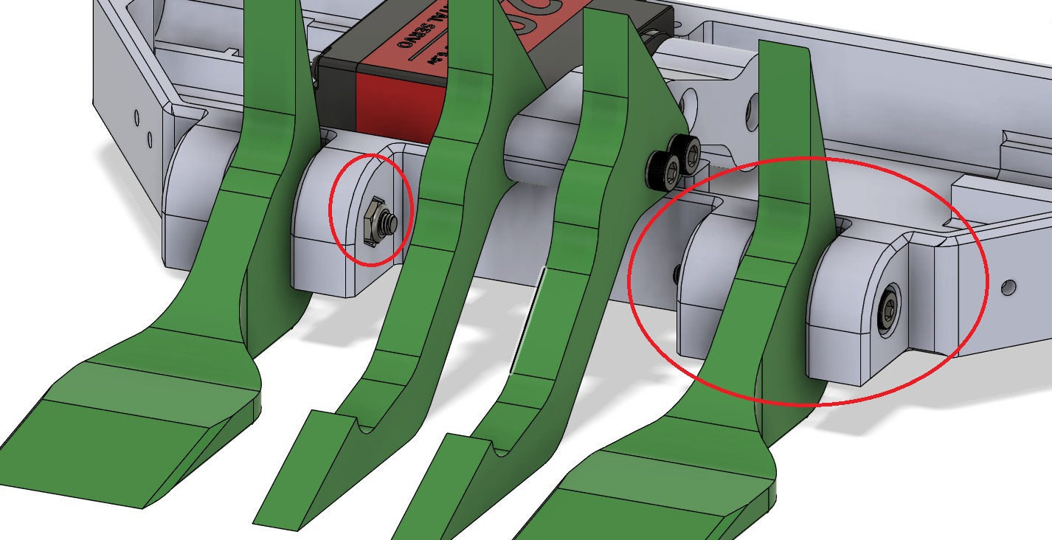

Step 6. Insert the M4 nut (1) into the rectangular hole on the side of the Wheel Hub and secure it in place with a M4 x 8mm set screw (2).
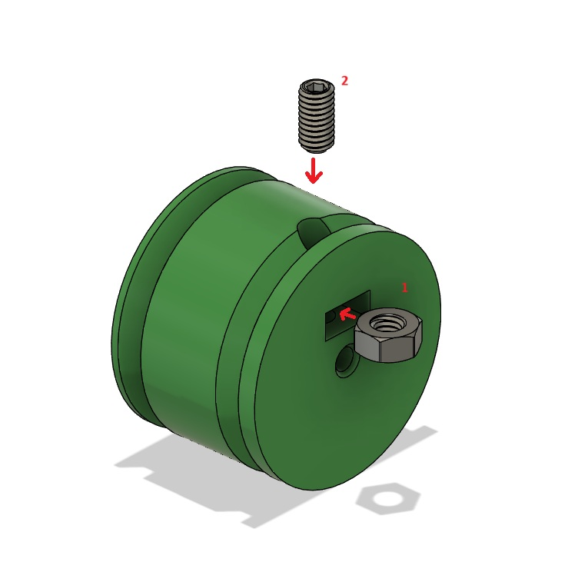

Step 7. Slide the Wheel Hub onto the shaft of the Repeat Robotics Mk2 Brushed drive motor, aligning the flat side of the motor shaft with the set screw. Tighten the set screw down onto the motor shaft, securing the Wheel Hub to the drive motor.

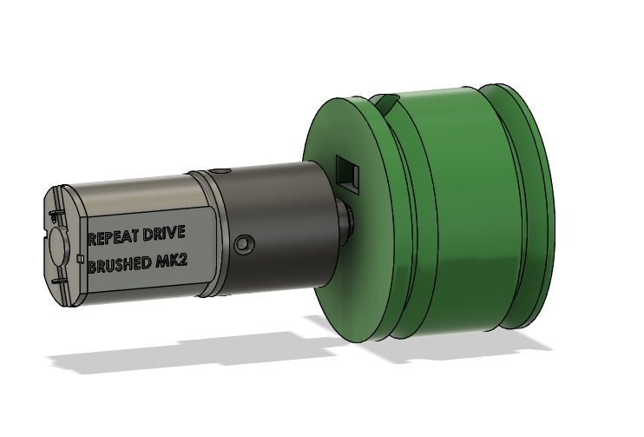

Step 8. Install the 37mm Lego Tire onto the Wheel hub and motor assembly.

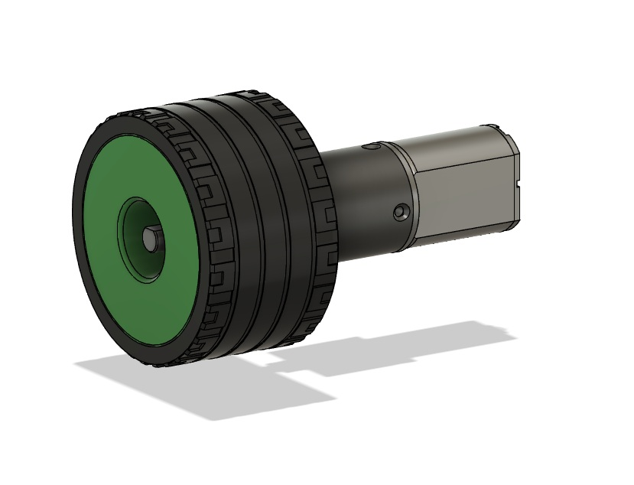

Step 9. Install the Wheel and motor assembly into the 9Volt Chassis as shown in the image below. Secure in place with the provided zip ties.

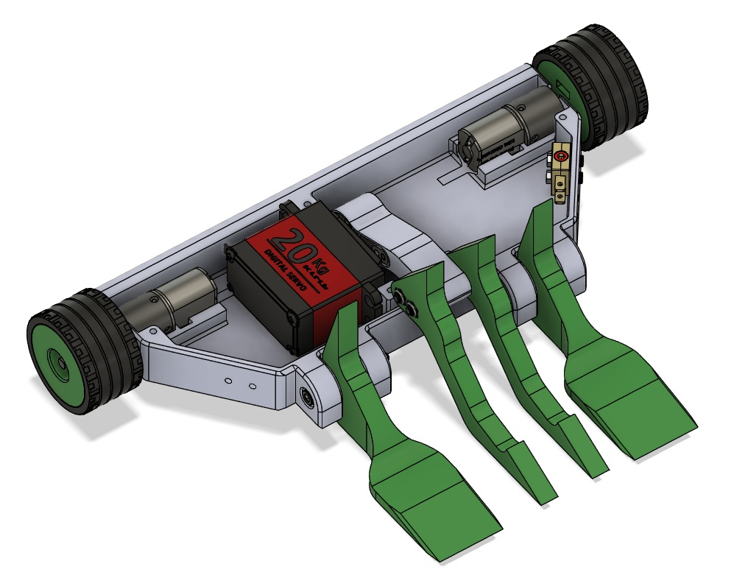

Step 10. Install the Wheel Guards using the four #5 x ½” wood screws. !!IMPORTANT!! There are two different Wheel guards. Be sure to use the correct guard for the side with the Finger Tech Mini Power Switch.
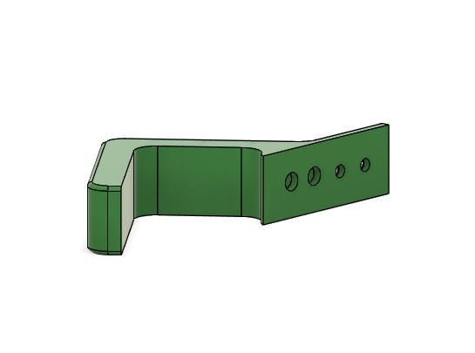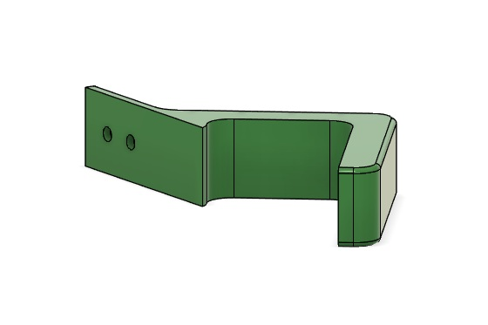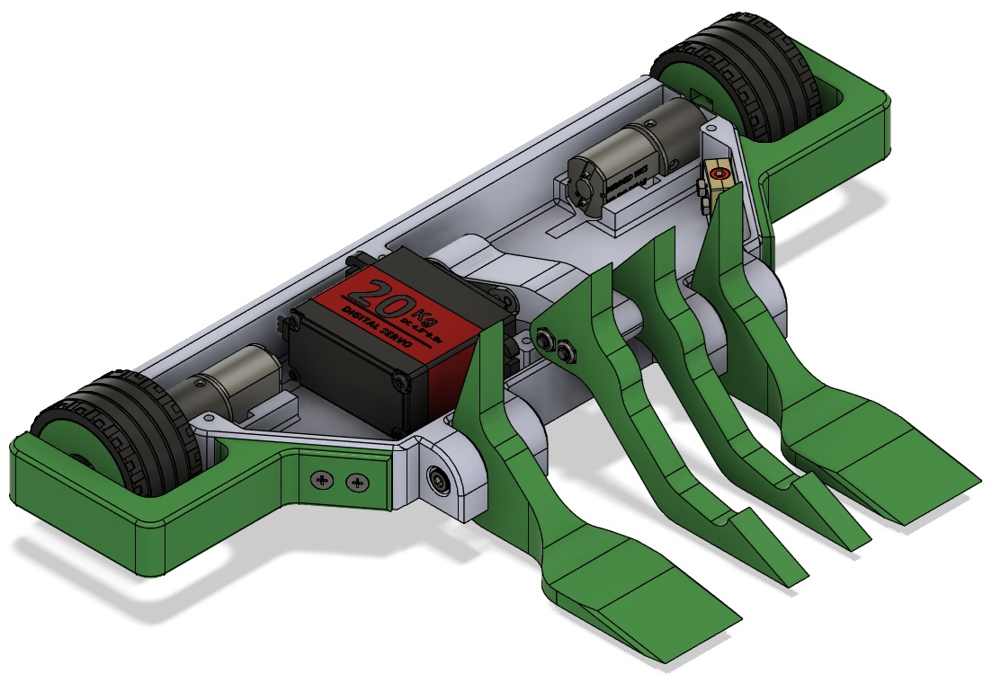
Step 11. The 300mAh 3s Battery should fit nicely on the side with the Finger Tech Mini Power Switch. Be sure it lines up with the space in the Battery Lid.
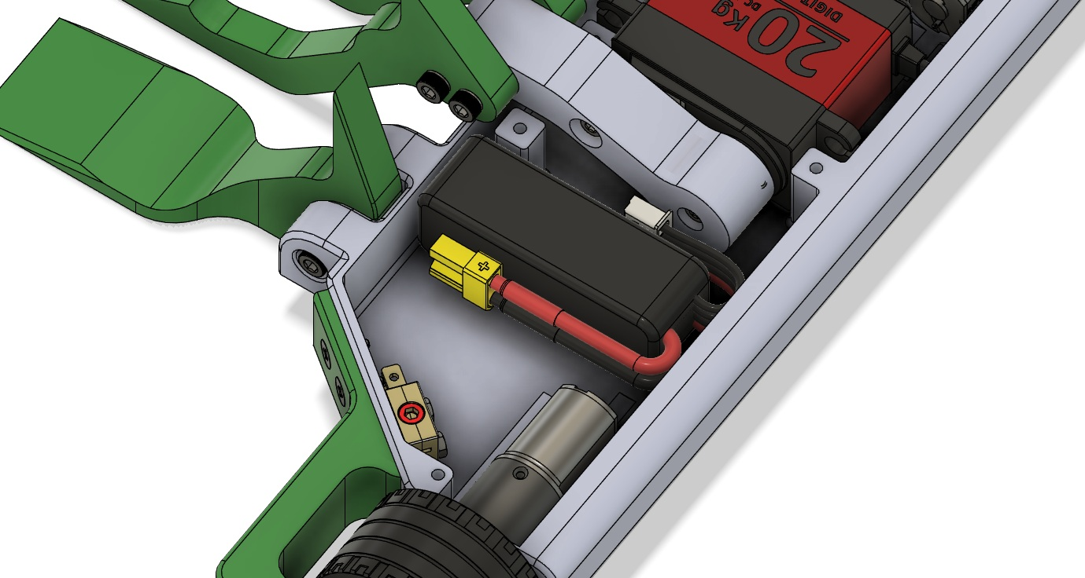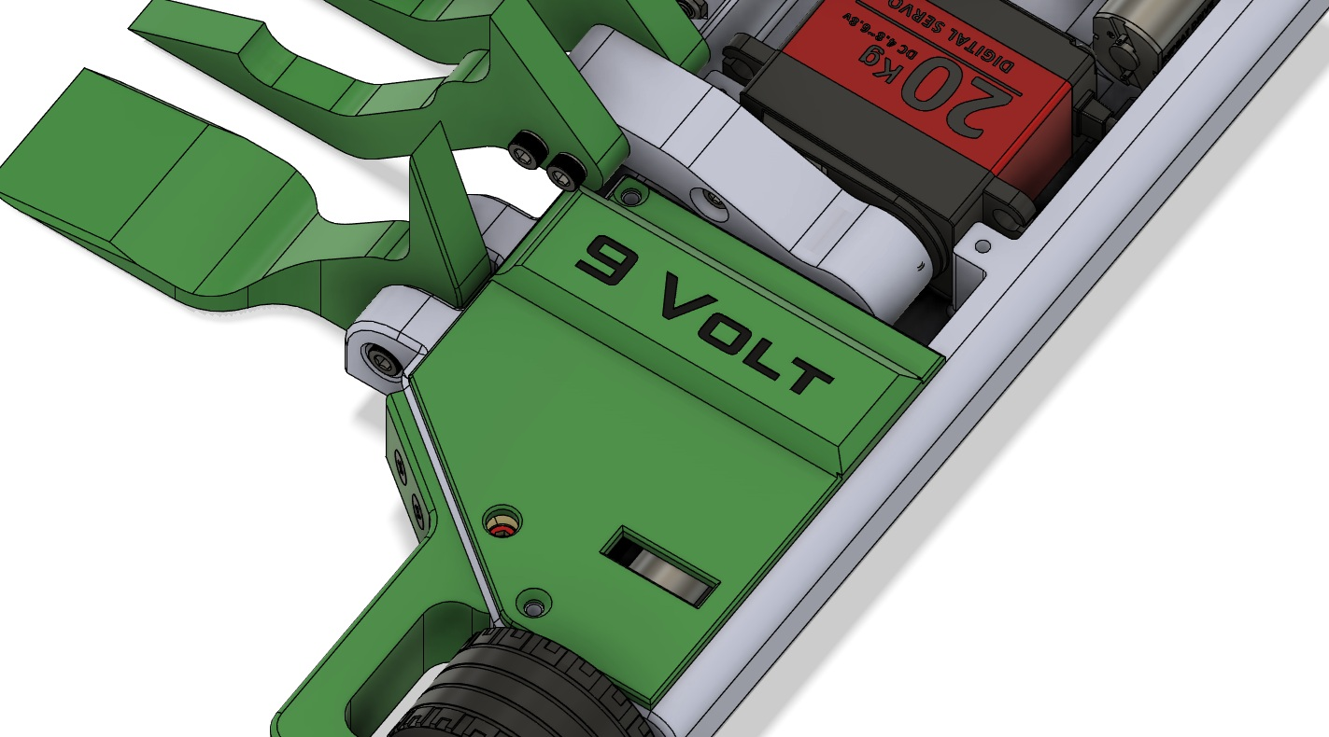

Step 12. The wiring is very simple for the 9Volt kit. The images below should assist in wiring your bot.
- The Battery, Drive ESC, and Receiver should all share the same compartment.
- The Main Wire Harness will stretch across the battery compartment to reach the battery and Drive ESC.
- The motor wires need to be routed as shown below. CH1 (yellow wire) and CH2 (3 wire) will be plugged into the Receiver CH1 and CH2 respectively (Signal wires on top)
- The Servo wires will plug into CH3 of the receiver (Signal wire on top)
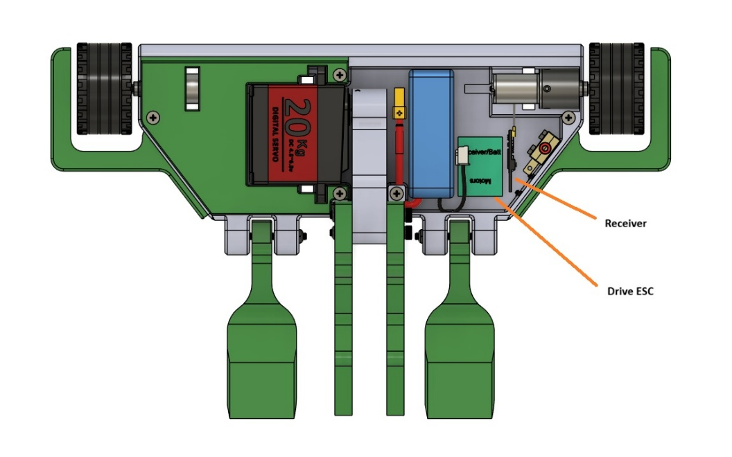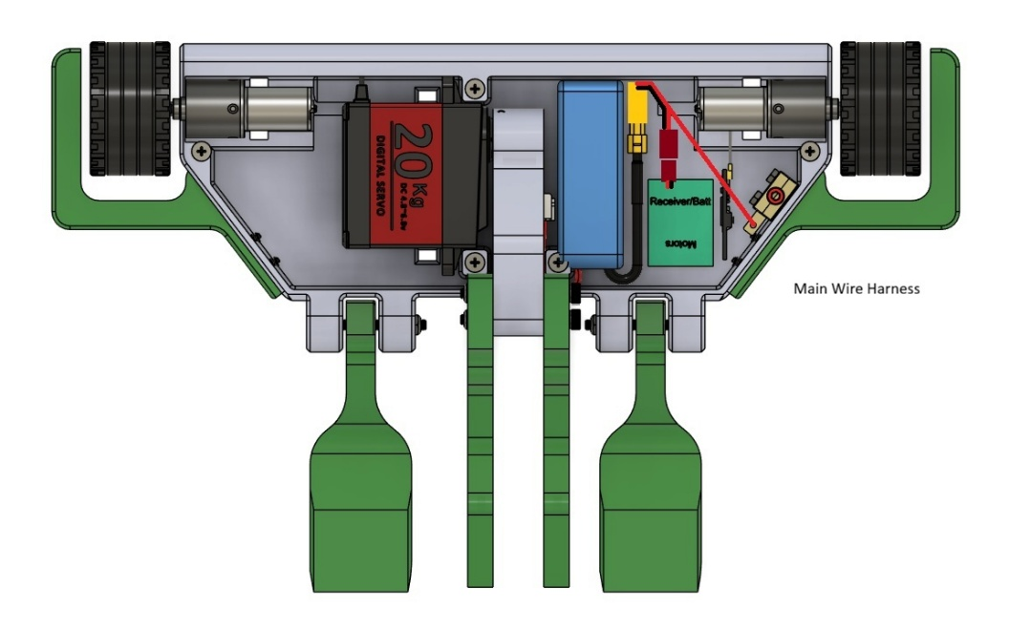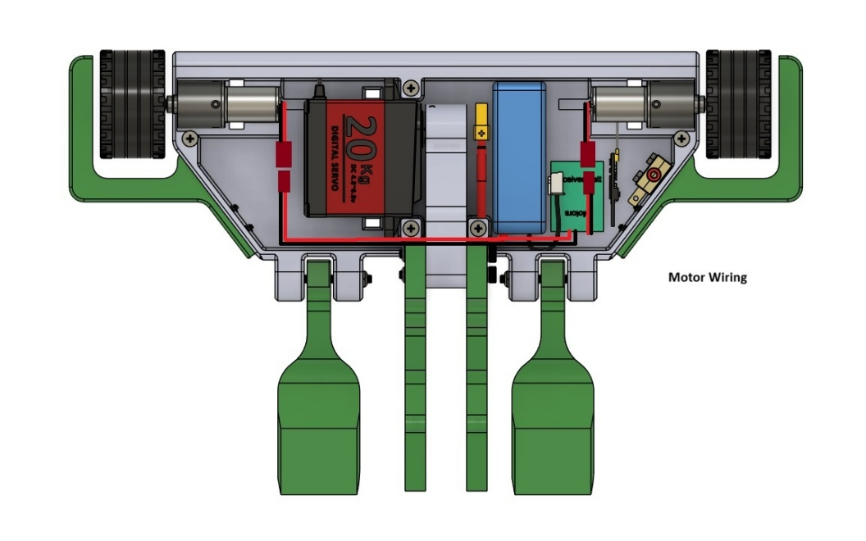

Step 13. Using the (5x) #5 x ½" screws, install the battery and aux lids.

